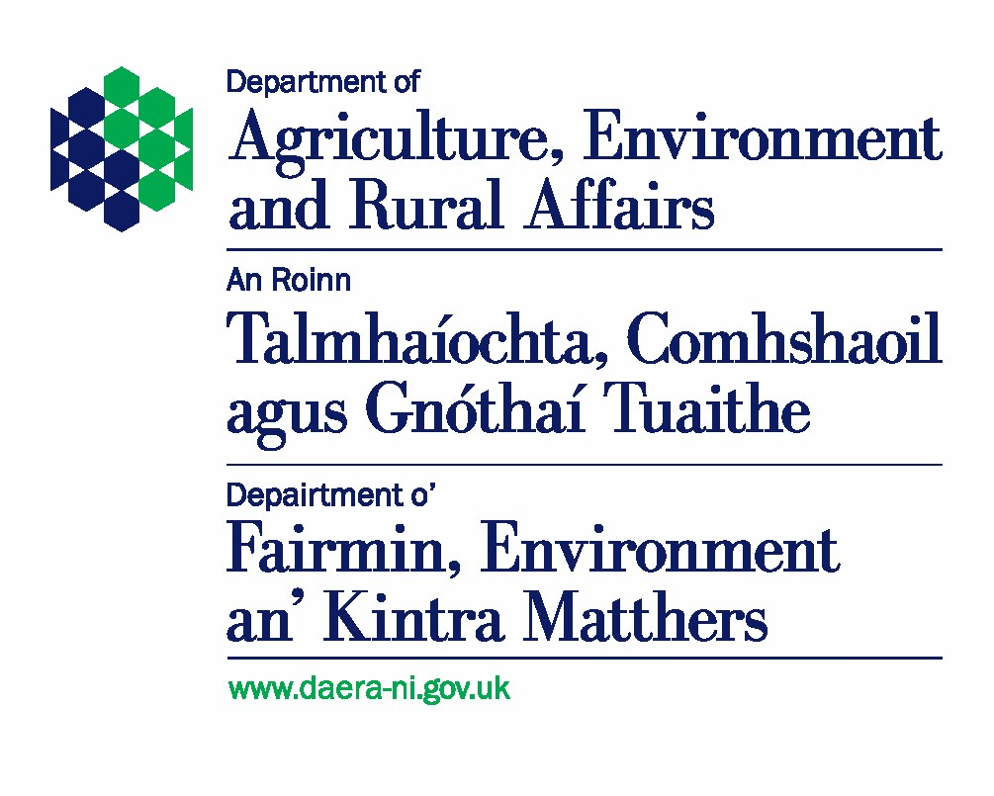
Form FB3

Application for DAERA Business Identifier

(For non-grant or subsidy claiming farm business)

Official Use Only
You are advised to keep a copy of this form

IMPORTANT NOTES
If applicable, references within the declaration to EU regulations are to be taken as references to those provisions, as assimilated in UK law by the Direct Payments to Farmers (Legislative Continuity) Act 2020 and as amended by secondary legislation made under the Direct Payments to Farmers (Legislative Continuity) Act 2020 and the Agriculture Act 2020.

Before completing this form, you should read the booklet “DAERA identification numbers for business customers, animal group number keepers” which can be found at:

Guide to DAERA Identification Numbers for Business Customers, Animal Group Number (AGN) Keepers | Department of Agriculture, Environment and Rural Affairs

You should only complete this form if you require a Category 3 Department of Agriculture, Environment and Rural Affairs (DAERA) Business Identifier (ID) in order to register as a keeper of a small number of animals, typically up to 5 cattle and/or 10 sheep and/or 10 pigs and/or 100 poultry and/or 5 goats and/or you do NOT intend claiming any grant or subsidy from the Department.

You must also contact your local DAERA Direct Office for advice on registering an animal group number (AGN).
The Department primarily uses the DAERA Business ID to manage its obligations in respect of scheme rules, most notably to pay grants and subsidies. It will continually monitor businesses to ensure businesses are set up in accordance with these rules. The DAERA Business ID will also allow us to quickly identify your type of farm business whenever we are conducting business with you.
We will not allocate a DAERA business ID to anyone under the age of 18. If the business is to include persons under the age of 18, at least one member of the business must be 18 years of age or over.
We will complete several checks in respect of your application. If you are associated with another business you will have to demonstrate that you are separate from that business before we will award you a DAERA Business ID.

You can submit this form (along with your supporting evidence) by email to the below address:
 | Email to: TDU.logisticsteam@daera-ni.gov.uk
You can also submit this form (along with your supporting evidence) by post to your nearest DAERA Office listed below.

Or you can submit this form (and any supporting evidence) to any of the DAERA Direct Offices in person.

Details of the DDOs can be found at:

DAERA Direct Regional offices | Department of Agriculture, Environment and Rural Affairs (daera-ni.gov.uk)

DDO Telephone: 0300 200 7840

If your form is incomplete, we will return it to you, and this may delay the processing of your application.

We aim to acknowledge receipt of your form within three working days of receipt.

SECTION 1 – Business Name and Contact Details
Please provide the business name and contact details for your farm business. We will contact you using the details you supply in this section.
Business Name
(Trading name, main stakeholder’s name, charity name, church organisation)
Address
This is the address to which all correspondence is to be sent
Postcode
E-Mail Address
Telephone No  Including STD Code |  | Mobile No:

SECTION 2 - Personal details of all proposed business members
List the details of each member of the business. You must list all family members who are involved in the farm business.
We will not allocate a DAERA business ID to anyone under the age of 18. If the farm business is to include persons under the age of 18, at least one member of the business must be 18 years of age or over.
You should list the head of the business as Member 1. The head of business cannot be under 18 years of age.
 | MEMBER 1
 | Title (Mr/Mrs/Miss) Other (please specify) |  |  | Date of Birth |  | Select Date.
 | Surname: |  |  | Forename(s) (in full)

Postal address

If different from Section 1
 | Post Code
 | Telephone Number  (Including STD Code) |  |  |  | Mobile Number:
Status in the business
(e.g. owner, partner, director, trustee)

 | MEMBER 2
 | Title (Mr/Mrs/Miss) Other (please specify) |  |  |  |  | Date of Birth |  |  | Select Date.
 | Surname: |  |  |  |  | Forename(s) (in full)

Postal address

If different from Section 1
 | Post Code
 | Telephone Number  (Including STD Code) |  |  |  |  |  | Mobile Number:
Status in the business
(e.g. owner, partner, director, trustee)
 | MEMBER 3
 | Title (Mr/Mrs/Miss) Other (please specify) |  |  |  |  | Date of Birth |  |  | Select Date.
 | Surname: |  |  |  |  | Forename(s) (in full)

Postal address

If different from Section 1
 | Post Code
 | Telephone Number  (Including STD Code) |  |  |  |  |  | Mobile Number:
Status in the business
(e.g. owner, partner, director, trustee)
 |  | If there are more than three members, please use a continuation sheet to list details about the other members
 |  | Who has the authority to make business decisions? (Tick all that apply)
 |  | Note: Business Decisions relate to the type of enterprises the business is involved in, the long-term goals of the business and financial investments in the business
 |  | Member 1 |  | ☐ |  |  |  | Member 2 | ☐
 |  | Member 3 |  | ☐ |  |  |  | Other Persons (Please specify below) | ☐

SECTION 3 – Business Details
Have you ever had an application for a DAERA Business ID rejected? | Yes |  |  | ☐ |  | No |  | ☐
If ‘Yes’ please record details below of why your application was rejected?
Have you or any proposed member of the business previously been members of another farm business in N Ireland, Scotland, England, or Wales |  | Yes | ☐ |  | No |  | ☐
If ‘Yes’ please detail below the business(es) and the reasons why you (or the proposed member) left or closed the business(es)?

LAND DETAILS
Please provide details of the land your business owns, leases, or takes in conacre, or any land on which you use / plan to use to conduct your farming business activity.
 | Farm Survey Number | Field Number | Land Status  O = Owned  C = Conacre  L = Leased  U = Use |  | Farm Survey Number | Field Number | Land Status  O = Owned  C = Conacre  L = Leased  U - Use
Please provide details below of any land that is not currently mapped and does not have a field number.

STOCK DETAILS
Please provide details of the animals that your farm business intends to keep

 | Type of Animal | Does the business own / plan to own? | Number of stock owned / plan to own
 | Cattle
 | Sheep
 | Pigs
 | Poultry
 | Other – (Please provide details below)

Please give details below as to where, for each type of animal listed above, they will be grazed and / or housed (including address).

OTHER DAERA BUSINESS INTERESTS
Please complete if you have an interest in any other “DAERA related” farm businesses.
 | DAERA Business ID | Animal Group Number | What is your position in this business (e.g. sole trader, limited or ordinary partnership, limited company director, trust manager) | Who has day-to-day management? Please give names.

SECTION 4 - Declaration
I/We declare that the information given by me/us in this application is true and complete to the best of my/our knowledge and belief and I/we have enclosed all relevant documents relating to this application.
I/We declare that I/we have not created this business to benefit or to allow others to benefit from subsidies contrary to the objectives or rules of any subsidy scheme.
I/We accept that DAERA will take action against me/us for false declarations and/or not notifying the Department of any material changes to the information given.
If any of the members are under 18 years of age, the section below must be completed by the legal guardian.
I/We as legal guardian(s) accept responsibility for all members of this business who are under the age of 18.

 | Member 1
 | Signature |  | Date | Select Date.
 | Name  (Block Letters) |  | Status*

 | Member 2
 | Signature |  | Date | Select Date.
 | Name  (Block Letters) |  | Status*

 | Member 3
 | Signature |  | Date | Select Date.
 | Name  (Block Letters) |  | Status*

If the applicant is unable to sign the form personally the signatory must have Power of Attorney. Evidence of Power of Attorney must be submitted with this form.
*Owner, Partner, Director, Legal Guardian of the Minor listed as a member of the business.
Important
If it is found that your business has been artificially created to benefit or allow others to benefit from subsidies contrary to objectives or rules of any subsidy scheme now or in the future, we reserve the right to revoke any Business ID allocated.
Any person who makes a false declaration or fails to notify us of a material change to the information given in this form is liable to prosecution.
DAERA PRIVACY STATEMENT

The Department takes data protection, freedom of information and environmental information issues seriously. It takes care to ensure that any personal information received from you is dealt with in a way which complies with the requirements of the UK General Data Protection Regulation and the Data Protection Act (2018). This means that any personal information you supply will be processed principally for the purpose for which it has been provided.

However, the Department is under a duty to protect the public funds it administers, and to this end may use the information you have provided for this purpose. It may also share this information with other bodies responsible for the audit or administration of public funds, in order to prevent and detect crime.

In addition, the Department may also use it for other legitimate purposes in line with the UK General Data Protection Regulation, Data Protection Act 2018, Freedom of Information Act 2000 and Environmental Information Regulations 2004.
These include:

- The full range of departmental policy responsibilities;
- The production and safety of food;
- All financial support schemes;
- Management of land and other environmental controls;
- Animal health and welfare;
- Statutory schemes and obligations in the areas of plant health and crop certification;
- Occupational health and welfare;
- Regulatory and natural resources policy;
- Legislation relating to the Northern Ireland Environmental Agency; DAERA Privacy Statement 3
- The prevention and detection of fraud or maladministration (e.g. The Comptroller & Auditor General and HM Revenue & Customs);
- Compilation of statistics;
- Disclosure to other organisations when required by law to do so;
- Disclosure under the Freedom of Information Act 2000 or the Environmental Information Regulations 2004 where such disclosure is in the public interest;
- Administration of UK wide schemes on behalf of the Department for the Environment, Food and Rural Affairs in Great Britain;
- Business development and knowledge advisory service for farmers, growers and food processors;
- Statistical and research purposes; this may include linking or combining the information with data from Arms Length Bodies, government departments or other public bodies;
- Delivering education and training programmes;
- Corresponding with you in connection with the above activities.
The Department uses artificial intelligence to benefit customers and to support the Departmental strategic priorities in accordance with the DAERA Artificial Intelligence Policy: “Securely Maximising the Benefits of Artificial Intelligence”. DAERA will not use artificial intelligence for automated decision-making in relation to your personal data in any way.
The full DAERA Privacy Statement can be viewed on the following link, DAERA Privacy Statement document | Department of Agriculture, Environment and Rural Affairs (daera-ni.gov.uk).

