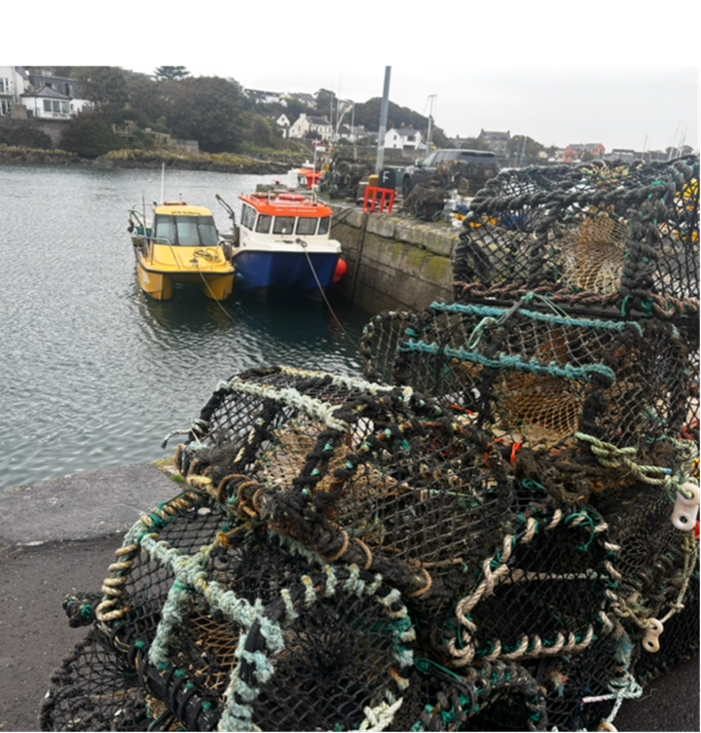

Consultation Document - DRAFT Fisheries Management Plan
for Non-Quota Shellfish in Northern Ireland
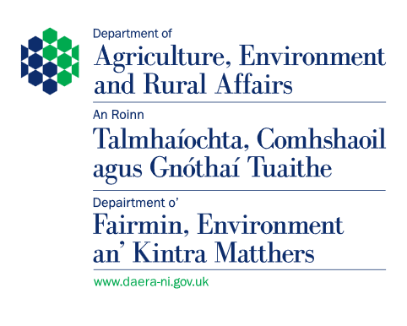

uota S
Photograph Attribute Good Foo Ireland®

You can get a copy of this document in other formats, including
• Paper Copy
• Large Print
• Braille
• Other languages

• Telephone: 028 9056 9269 should you have any queries about the format of the document. If you have a hearing difficulty you can contact the Department via Text Relay. Dial 18001 028 9056 9803

• Email: NonQuotaShellfishFMP@daera-ni.gov.uk

• Write to: Sea Fisheries Policy Branch,
DAERA Marine and Fisheries Division,
Department of Agriculture, Environment and Rural Affairs
Rathkeltair House
Market Street
Downpatrick
BT30 6AJ

Contents

Overview of Consultation 3
What documents should I read to answer the questions? 3
Policy assessments……………………………………………………………………………………4
How to respond………………………………………………………………………..………………5
Accessibility…………………………………………………………………………………………….5
Freedom of Information (FoI), Confidentiality of Responses and Sharing of Information 5
Rationale 7

Consultation Questions………………………..……………………………………………………...8

Overview of Consultation

Thank you for taking the time to consider this consultation paper. The Department welcomes your views on DRAFT Fisheries Management Plan (FMP) for Non-Quota Shellfish in Northern Ireland.

The consultation will last for 12 weeks, commencing on 27 April 2026.

Please ensure that your response reaches us before the closing date 17 July 2026.

What documents should I read to answer the questions?

The consultation questions are contained within this paper.

These should be answered in the context of the DRAFT Fisheries Management Plan for Non-Quota Shellfish in Northern Ireland

You will also wish to consider the following information sources:

- Strategic Environmental Assessment Report
- Conservation Advice Report
- Equality Impact Assessment.
- Rural Needs Assessment

Links to all the relevant documents and the consultation questions can be found at the Department’s website: www.daera-ni.gov.uk/consultations

Consultations | Department of Agriculture, Environment and Rural Affairs

Policy assessments

This draft FMP, including its goals and individual actions is subject to the consideration of this consultation and will be prioritised appropriately, following publication, to ensure realistic and measurable outputs. It was drafted to meet the requirements of section 6(3) of the Act and in accordance with the policies set out in the JFS.

For each goal, the plan sets out:
- a rationale
- ongoing, short and longer-term actions
- how the actions support delivery of the fisheries objectives.

Each goal describes the outcome that is being worked towards, and the actions are intended to support the delivery of those outcomes.

The five goals are:
- The sustainable harvest in Northern Ireland waters of non-quota shellfish stocks within scope of this FMP.
- Recognise and address gaps in evidence necessary to enhance stock assessment
- Identify ecosystem-based fisheries management methods applicable to non-quota shellfish fisheries
- Deliver a framework to support the role of the FMP in realising sustainable fisheries and marine economies
- Develop strategies to adapt to the impact of climate change on non-quota shellfish fisheries

How to respond

While it is preferred that responses are given via the Citizen Space platform, these can also be submitted via email or post.

- By e-mail at: NonQuotaShellfishFMP@daera-ni.gov.uk
- By post to: Sea Fisheries Policy Branch,
DAERA Marine and Fisheries Division,
Department of Agriculture, Environment and Rural Affairs
Rathkeltair House
Market Street
Downpatrick
Co. Down

When responding please provide the following information to the About Yourself section at the end of this document.

- Your name;
- Contact details (preferably email);
- Organisation you represent (if applicable); and
- Your main area of interest (e.g. commercial fisheries, marine conservation, aquaculture, tourism & recreation etc.)

This information will assist in the analysis of responses.

Accessibility

Alternative formats can be made available on request in large print, disc, Braille, audio cassette, or text phone for the hearing impaired. The document may also be made available on request in minority ethnic languages to those who are not proficient in English. The Department will translate executive summaries of key publications into Irish or Ulster Scots upon request. Information and additional copies of the document can be requested by text phone on 028 9056 9269.

Freedom of Information (FoI), Confidentiality of Responses and Sharing of Information

DAERA will publish a summary of responses following completion of the consultation process. We are unable to reply individually to the points you may raise as part of your reply.
Your response, and all other responses to the consultation, may be disclosed on request either as an individual response or composite response by category. The Department can only refuse to disclose information in exceptional circumstances. Before you submit your response, please read the paragraphs below on the confidentiality of consultations and this will provide you with guidance on the legal position about any information submitted by you in response to this consultation.
Section 8(e) of the Data Protection Act 2018 permits processing of personal data when necessary for an activity that supports or promotes democratic engagement. Information provided by respondents to this stakeholder engagement exercise will be held and used for the purposes of the administration of this current exercise and subsequently disposed of in accordance with the provisions of the Data Protection Act 2018 and the General Data Protection Regulation. For more information and to view the DAERA Privacy Statement please go to: https://www.daera-ni.gov.uk/publications/daera-privacy-statement-document
The FOI Act gives the public a right of access to any information held by a public authority, namely, the Department in this case. This right of access to information includes information provided in response to a consultation. The Department cannot automatically consider as
confidential, information supplied to it in response to a consultation. However, it does have the responsibility to decide whether any information provided by you in response to this consultation, including information about your identity should be made public or be treated as confidential. If you do not wish information about your identity to be made public, please include an explanation in your response including any harm you believe such a disclosure might cause.
This means that information provided by you in response to the consultation is unlikely to be treated as confidential, except in very particular circumstances. The Lord Chancellor’s Code of Practice on the FOI Act provides that:
- The Department should only accept information from third parties in confidence if it is necessary to obtain that information in connection with the exercise of any of the Department’s functions and it would not otherwise be provided.
- The Department should not agree to hold information received from third parties “in confidence” which is not confidential in nature, acceptance by the Department of confidentiality provisions must be for good reasons, capable of being justified to the Information Commissioner.
For further information about confidentiality of responses please contact the Information Commissioner’s Office or visit the ICO Website.

Consultation Questions

How to respond

For Questions 1–8, please select Yes / No, then provide comments if you wish.
Question 9 is a free‑text question.

1. Evidence

Q1. Do you have any comments on the evidence used in the draft FMP (including any key gaps or additional evidence that should be considered)?
☐ Yes
☐ No

Please explain (optional):
[Free text box]

2. Stock Status / Assessment

Q2. Do you have any comments on the assessment of stock status and sustainability set out in the draft FMP?
☐ Yes
☐ No

Please explain (optional):
[Free text box]

3. Policies / Management Approach

Q3. Do you agree that the draft FMP includes the right policies or overall management approach to achieve sustainable fisheries?
☐ Yes
☐ No

Please explain (optional):
[Free text box]

4. Objectives

Q4. Do you have any comments on the objectives in the draft FMP (for example, clarity, ambition, or whether they are achievable)?
☐ Yes
☐ No

Please explain (optional):
[Free text box]

5. Actions

Q5. Do you have any comments on the proposed actions in the draft FMP (including whether they are appropriate and deliverable)?
☐ Yes
☐ No

Please explain (optional):
[Free text box]

6. Implementation, Monitoring and Enforcement

Q6. Are the proposals for implementation, monitoring, control and enforcement clear and workable?
☐ Yes
☐ No

Please explain (optional):
[Free text box]

7. Environmental Effects

Q7. Do you have any comments on the assessment of the environmental effects of the draft FMP, as set out in the Environmental Report?
☐ Yes
☐ No

Please explain (optional):
[Free text box]

8. Economic and Business Impacts

Q8. Do you have any comments on the financial implications of the draft FMP?
☐ Yes
☐ No

Please explain (optional):
[Free text box]

9. Additional Comments

Q9. Do you have any additional comments on the draft FMP (including comments on specific sections not covered above)?

Response:
[Free text box]

About Yourself

To assist with the Department's analysis of the responses received to this consultation, please provide answer the following questions.

Your Name

Organisation Name

Postal Address

Contact Telephone No.

Email Address

Area of interest in which you are responding to consultation
Please select only one item – add to text box below
- Commercial sea fisheries - catching sector
- Commercial sea fisheries - processing sector
- Marine conservation
- Fisheries science
- Aquaculture
- Academia
- Recreational fisheries

Other area of interest (not listed at 6)

For further information:

Sea Fisheries Policy Team
DAERA Marine and Fisheries Division,
Department of Agriculture, Environment and Rural Affairs
Rathkeltair House
Market Street
Downpatrick
Bt30 6AJ

Email: NonQuotaShellfishFMP@daera-ni.gov.uk
www.daera-ni.gov.uk

