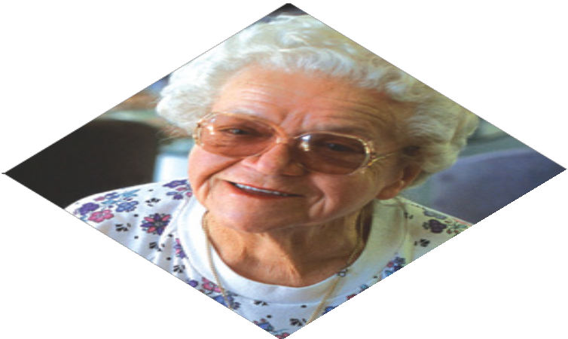
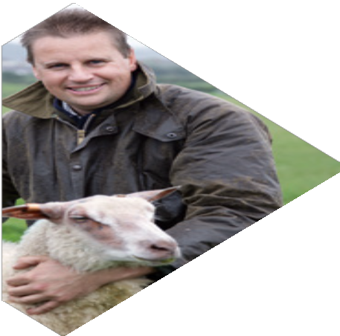

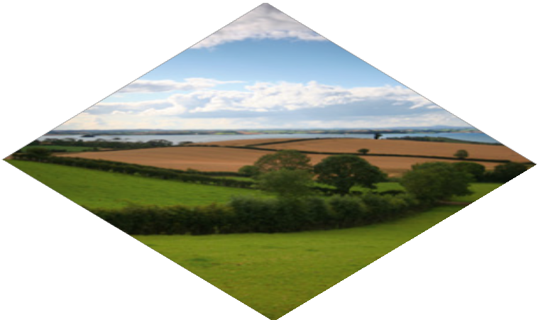
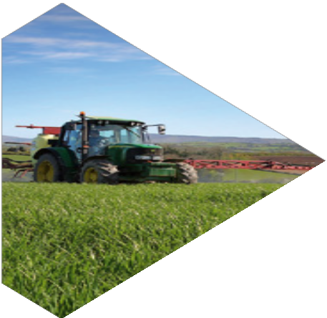

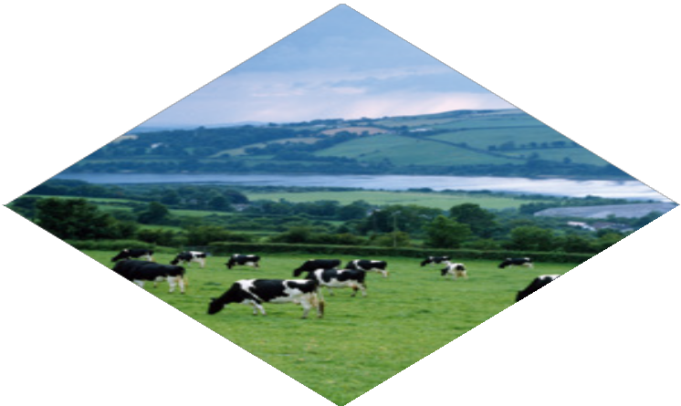

A Guide to the Rural Needs Act
(Northern Ireland) 2016 for Public Authorities (Draft)

April 2026

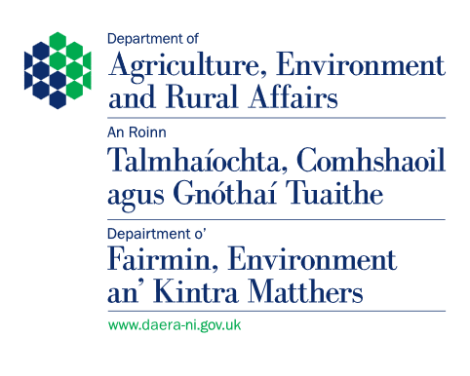

Contents
Foreword |  | 3
Chapter 1 | Introduction | 6
Chapter 2 | The Rural Needs Act (Northern Ireland) 2016 | 9
Chapter 3 | What is meant by ‘rural’? | 15
Chapter 4 | Duty of Public Authorities to have Due Regard to Rural Needs | 21
Chapter 5 | Undertaking a Rural Needs Impact Assessment | 27
Chapter 6 | Monitoring and Reporting Requirements | 37
Chapter 7 | Additional Guidance, Advice and Information | 41
Appendix 1 | Rural Needs Impact Assessment (RNIA) Template | 45
Appendix 2 | Annual Return – Process for Reporting information compiled onto Digital Solution Portal | 54
Appendix 3 | Checklist for Public Authorities | 56
Appendix 4 | Frequently Asked Questions | 57
Appendix 5 | Rural Needs Act (Northern Ireland) 2016 | 61

This document can be made available in alternative formats including:

- Paper Copy
- Large Print
- Easy Read
- Audio CD/MP3
- Braille
- Computer Disk
- Other languages
To get a copy of this document in another format contact:
Rural Legislation Advisory Branch
Jubilee House
111 Ballykelly Road
Ballykelly
Limavady
BT49 9HP
Website: www.daera-ni.gov.uk
Email: rural.needs@daera-ni.gov.uk

Foreword
The Rural Needs Act (Northern Ireland) 2016 (‘the Act’) was implemented on a phased basis with Phase 1 covering government departments and local councils commencing on
1 June 2017 and Phase 2 covering the other public authorities listed in the Schedule to the Act commencing on 1 June 2018.
DAERA has undertaken a review of the implementation of Phase 1. The review looked at how the awareness sessions and the online training had been rolled out and sought views on the Department’s guidance ‘A Guide to the Rural Needs Act (NI) 2016 for Public Authorities’. The Department also took into consideration the report ‘Rural proofing in Northern Ireland: An overview and recommendations on guidance, implementation and governance produced by the Centre for Rural Economy, Newcastle University and the Agri-Food and Biosciences Institute (AFBI).
The review highlighted a number of issues including a perceived lack of clarity around what the due regard duty involves and the difference between the due regard duty, rural proofing and the Rural Needs Impact Assessment (RNIA). A number of stakeholders expressed the view that the RNIA template was not particularly user friendly and that the guidance focused heavily on rural proofing rather than on the due regard duty as set out in the Act. Others commented that the RNIA template was not always appropriate for documenting the wide range of policies, strategies, plans and public services being developed and implemented by public authorities.
Following the completion of the review the Department produced revised guidance. The revised guidance aims to provide more clarity on the statutory duties imposed on public authorities under the Act and to help public authorities ensure that they fulfil their statutory duties. It also incorporates a revised RNIA process together with a revised RNIA template and a ‘Checklist’ to support implementation.
It is hoped that public authorities will find this revised guidance helpful and that the new RNIA template will make it easier for public authorities to effectively document the steps taken in seeking to fulfill their duties under the Act.
The Department also wishes to acknowledge the work carried out by Professor Sally Shortall of Newcastle University and Dr Erin Sherry of AFBI which has helped inform this guidance and the support provided by the Rural Development Council in relation to the implementation of the Act.

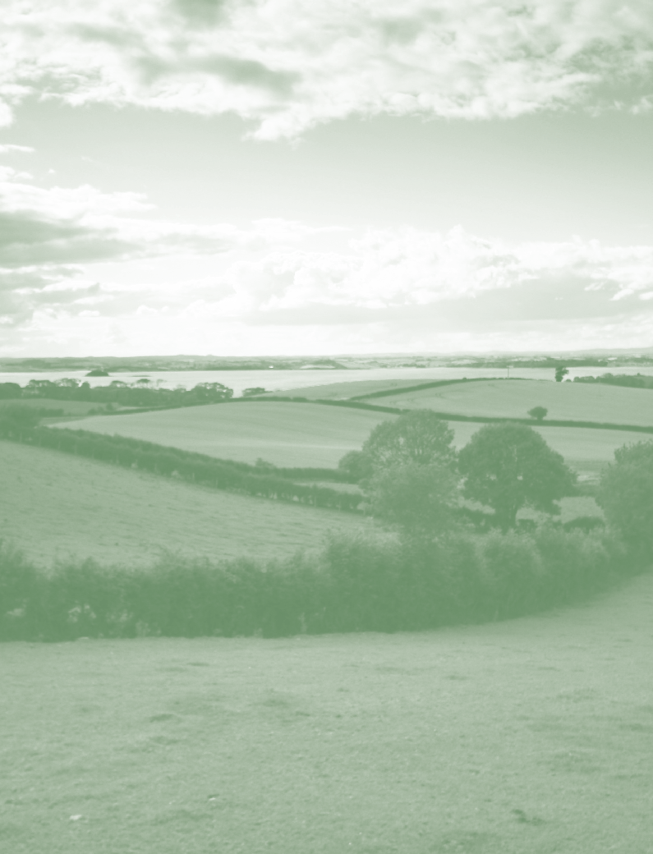
A Guide to the Rural Needs Act (NI) 2016 for Public Authorities
5
(Revised) April 2026

Chapter 1

Chapter 1 - Introduction

Purpose of the Guidance

  - This revised guidance is issued by the Department of Agriculture, Environment and Rural Affairs (DAERA) to assist public authorities in understanding their statutory duties under the Rural Needs Act (Northern Ireland) 2016 (‘the Act’) and in fulfilling their obligations under the Act.

  - This revised guidance replaces the previous guidance that was issued in May 2017 and April 2018.

Status of the Guidance

  - While there is no statutory obligation under the Act to follow this guidance, the guidance is important. In the event of any legal challenge the courts are likely to view this guidance as an authoritative document of persuasive value.

  - A ‘Checklist’ to help public authorities operate in accordance with this guidance is provided at Appendix 3.

Background

  - The Act introduces a duty on Northern Ireland departments, district councils and the other public authorities listed in the Schedule to the Act to have due regard to rural needs when developing, adopting, implementing or revising policies, strategies and plans, and when designing and delivering public services.

  - The purpose of the Act is to ensure that public authorities have due regard to the social and economic needs of people in rural areas when carrying out certain activities and
to provide a mechanism for ensuring greater transparency in relation to how public authorities consider rural needs when undertaking these activities.

  - The Act came into operation for Northern Ireland departments and district councils on 1 June 2017 and came into operation for the other public authorities listed in the Schedule to the Act on 1 June 2018.

  - More information on the contents of the Act is provided in Chapter 2 of this guidance while detailed information on the duties of public authorities under the Act is provided in Chapter 4 and Chapter 6. Each public authority is responsible for ensuring that it fulfils its duties under the Act.

Relationship with Rural Proofing

  - The new due regard duty introduced under section 1(1) of the Act imposes an obligation on public authorities that is different to the commitment to rural proof which the Northern Ireland Executive signed up to in 2002. The policy on rural proofing required government departments to identify the potential impact that a policy or strategy would have on a rural area, to make a proper assessment of those impacts if they were deemed to be significant and, where appropriate, to make adjustments to the policy or strategy to take account of rural circumstances. The scope of the Act is wider than that covered by the previous policy on rural proofing in that it now includes district councils and the other public authorities listed in the Schedule to the Act in addition to government departments.

  - This guidance recommends that public authorities undertake a Rural Needs Impact Assessment when developing, adopting, implementing or revising policies, strategies and plans, and when designing and delivering public services. The principles of rural proofing are incorporated in the Rural Needs Impact Assessment process.

Terms used in this Guidance

  - ‘Public authority’ means a person or body listed in the Schedule to the Act and includes Northern Ireland departments, district councils and any other person or body listed in the Schedule.

  - ‘Due regard duty’ means the duty on public authorities to have due regard to rural needs as set out in section 1(1) of the Act.

  - ‘Rural needs’ means the social and economic needs of persons in rural areas.

  - ‘Section 1 activity’ means an activity subject to the duty i.e. developing, adopting, implementing or revising a policy, strategy or plan or designing or delivering a public service.

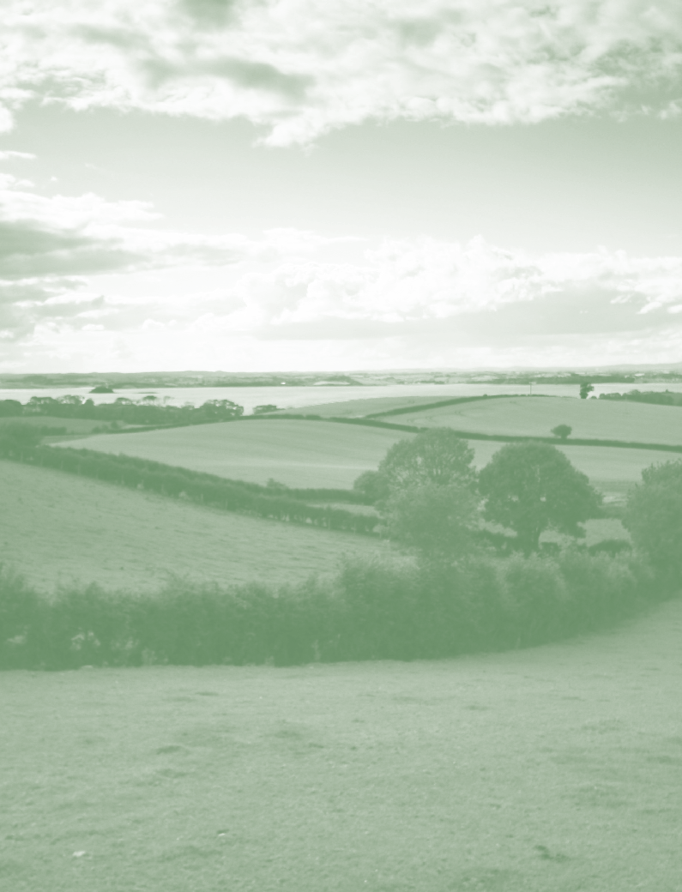
A Guide to the Rural Needs Act (NI) 2016 for Public Authorities
9
(Revised) April 2026

Chapter 2

Chapter 2 - The Rural Needs Act (Northern Ireland) 2016

Introduction

  - The Rural Needs Act (Northern Ireland) 2016 (‘the Act’) introduces a duty on public authorities in Northern Ireland to have due regard to rural needs when developing, adopting, implementing or revising policies, strategies and plans, and when designing and delivering public services. It also requires public authorities to compile information on the exercise of the due regard duty and for this information to be published.

Background

  - Around 670,000 people in Northern Ireland live in a rural area representing approximately 37% of the population (2011 census). Most strategies and policies developed and implemented across government have a rural dimension and it is recognised that they can have a different impact in rural areas than urban areas due to issues relating to,
for example, geographical isolation and lower population densities. It is recognised that as a result of rural circumstances people in rural areas may have different needs and therefore a policy or public service that works well in urban areas may not be as effective in rural areas.

  - Prior to the introduction of the Act, the NI Executive had a commitment to a policy on rural proofing which required all government departments to assess the impact of policies and strategies on rural areas. Under this policy departments were required to
identify the potential impact that a policy or strategy would have on a rural area, to make a proper assessment of those impacts if they were deemed to be significant and, where appropriate, to adjust the policy or strategy to take account of rural circumstances.

  - The policy on rural proofing was signed up to by the Executive in 2002 and the Executive subsequently reaffirmed this commitment in 2009. However there continued to be concerns that rural proofing was not being implemented as effectively as it could be while there was also a lack of information available on how rural proofing was being implemented by departments.

Why was the Act introduced?

  - The Act was introduced to ensure that consideration of the needs of people in rural areas becomes more firmly embedded within public authorities. The Act seeks to help deliver fairer and more equitable treatment for people in rural areas by requiring public authorities to have due regard to rural needs when developing, adopting, implementing

and revising policies, strategies and plans and when designing and delivering public services. This will help to deliver better outcomes for people in rural areas and help make rural communities more sustainable. The Act also seeks to increase transparency by requiring public authorities to compile and publish information on how they comply with the due regard duty when carrying out certain activities and for this information to be published in an annual report.

Which public authorities does the Act apply to?

  - The Act applies to Northern Ireland government departments, district councils and the other public authorities listed in the Schedule to the Act. If a public authority is unclear as to whether the Act applies to it, it should consider seeking its own legal advice.

When did the Act commence?

  - The Act received Royal Assent on 9 May 2016 and came into operation for government departments and district councils on 1 June 2017. It came into operation for the other public authorities listed in the Schedule to the Act on 1 June 2018.

What are public authorities required to do under the Act?

  - Public authorities have two main duties under the Act. The first is a duty to have due regard to rural needs (referred to as the ‘due regard duty’) and the second relates
to monitoring and reporting on how the due regard duty has been exercised. More information on these duties is provided in Chapter 4 and Chapter 6 of this guidance.

Duty on public authorities to have due regard to rural needs

  - Section 1(1) of the Act places a statutory duty on the public authorities listed in the Schedule to the Act to have due regard to rural needs when:

- Developing a policy, strategy or plan;
- Adopting a policy, strategy or plan;
- Implementing a policy, strategy or plan;
- Revising a policy, strategy or plan;
- Designing a public service; and
- Delivering a public service.

  - ‘Rural needs’ is defined in section 6 of the Act as the ‘economic and social needs of persons in rural areas’.

  - For more information on the duty to have due regard to rural needs please refer to Chapter 4 of this guidance.

Duty on public authorities to monitor and report

  - Under section 3(1) of the Act a public authority must, in such manner as may be directed by the Department of Agriculture, Environment and Rural Affairs (DAERA):

- compile information on the exercise of its functions under section 1 of the Act,
- include that information in the public authority’s own annual report; and
- send a copy of that information to DAERA.
  - For more information on the monitoring and reporting requirements please refer to Chapter 6 of this guidance.

Duty on DAERA to publish an annual report

  - Section 3(2) of the Act requires DAERA to publish an annual report containing (a) the information sent to it by public authorities on the exercise of their functions under section 1 of the Act and (b) information on the exercise by DAERA of its functions under the Act. It must lay a copy of the annual report before the Assembly.

Duty on DAERA to make arrangements for co-operation

  - Section 4 of the Act requires DAERA to make arrangements with public authorities with a view to securing co-operation and the exchange of information between public authorities.

Duty on DAERA to review list of public authorities

  - Section 1(3) of the Act requires DAERA to review the list of public authorities set out in the Schedule at least every three years and, if it thinks it appropriate, amend the Schedule to:
- add a body or person to the Schedule;
- remove a body or person from the Schedule; or
- modify any entry in the Schedule.

  - Any amendment to the Schedule must be done by means of an order. Such an order cannot be made unless a draft of the order has been laid before, and approved by resolution of, the Assembly.

Duty on the Minister of Agriculture, Environment and Rural Affairs to make a statement

  - Section 3 of the Act requires the Minister of Agriculture, Environment and Rural Affairs, on or after the day on which the annual report is laid, to make a statement to the Assembly about the content of the report.

DAERA’s powers to provide guidance, advice and information

  - Section 2 of the Act provides DAERA with the power to take such steps as appear to it to be appropriate to -

- provide any person with guidance, advice and information about issues connected with rural needs or ways of meeting those needs;

- undertake, commission or support (by financial means or otherwise) research into any matter relating to rural needs.

DAERA’s powers to direct public authorities on the manner in which information is compiled

  - DAERA has powers under section 3(1) of the Act to direct public authorities on the manner in which;

- information on the exercise of their functions under Section 1 (1) is compiled;
- that information is included in a public authority’s annual report;
- that information is sent to DAERA;

  - Where DAERA issues such a direction public authorities are required to comply with the direction. Any directions issued by DAERA will be in writing.

Interpretation

‘Rural needs’

  - The Act defines ‘rural needs’ as “the social and economic needs of persons in rural areas”.

  - For more information on what is meant by ‘rural’ please refer to Chapter 3 of this guidance.

  - For more information on what ‘rural needs’ means in the context of the due regard duty please refer to Chapter 4 of this guidance.

A Guide to the Rural Needs Act (NI) 2016 for Public Authorities
15
(Revised) April 2026

Chapter 3

Chapter 3 - What is meant by ‘rural’?

Introduction

  - Urban and rural issues are of some considerable importance for government. The European Union pays grants for urban and rural development. Rurality is a factor in allocation of health and social care funding; housing, roads, water and sewerage and the provision and maintenance of schools all present different issues in urban and rural areas. Employment in rural areas has its own distinctive features, and urban and rural leisure facilities are often quite dissimilar.

  - In order to identify and consider ‘rural needs’, a public authority must have a clear understanding of how it classifies whether an area is urban or rural in relation to a policy, strategy or plan being developed, adopted, implemented or revised or a public service being designed or delivered.

Default Definition of ‘Rural’

  - The default definition of “rural” used in Northern Ireland is that developed by the Inter- Departmental Urban-Rural Definition Group. Initially proposed in 2005, and amended in the Review of the Statistical Classification and Delineation of Settlements, NISRA, March 2015, this definition classifies those settlements with populations of less than 5,000 together with the open countryside as rural. Settlements have been classified into a number of bands (see Table 1), with bands A-E classified as urban and bands F-H classified as rural.

Table 1: Settlement Development Limit Classification

Classification | Population
Band A - Belfast | 280,211 (2011 census)
Band B - Derry City | 83,125 (2011 census)
Band C - Large Town | >18,000
Band D - Medium Town | 10,000 - 17,999
Band E - Small Town | 5,000 - 9,999
DEFAULT URBAN-RURAL SPLIT
Band F - Intermediate Settlements | 2,500 - 4,999
Band G - Village | 1,000 - 2,499
Band H - Open Countryside | <1,000 and open countryside
Source: Adapted from Table 2 of the Review of the Statistical Classification and Delineation of Settlements.

  - Map 1 shows the proportion of land mass in Northern Ireland which is categorised as ‘rural’ under the default definition.

Map 1: Rural settlements and wider countryside
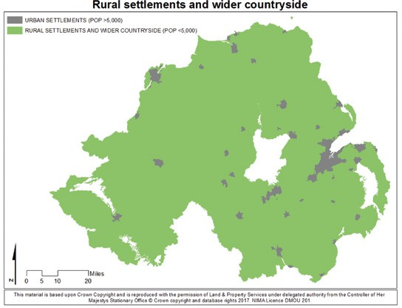

Alternative Definitions of Rural

  - Whilst a default definition of rural is provided, it was also recommended that a prescriptive urban-rural definition should not be given. Rather, it was advised that users should consider defining urban and rural areas in ways which are appropriate for different projects and programmes.

  - Where a public authority is considering using an alternative to the default definition in respect of a policy, strategy, plan or public service, it should seek to ensure that the elements contained within the alternative definition are restricted to those incorporated in the official settlement classification set out in the Review of the Statistical Classification and Delineation of Settlements, NISRA, March 2015. Only alternative definitions of rural based on population bands, 20 and 30 minute drive times to service centres, and drive times to Belfast/Derry should be used. Any definition based on alternative or substitute components would not conform to the official classification.

  - In instances where a public authority uses a definition of rural other than the default definition in respect of a policy, strategy, plan or public service, it should provide details of the alternative definition used, together with a clear rational for using the alternative definition, on the Rural Needs Impact Assessment Template.

20 and 30 Minute Drive-Time Limits

  - The Review of the Statistical Classification and Delineation of Settlements, NISRA, March 2015, expanded the classification to include a service provision element by categorising rural areas based on their drive time from a town centre of a settlement with a population of 10,000 or more (a large service centre). Using this approach, areas have been classified as being either “within” or “outside” of 20-minute or 30-minute drive times of their nearest town centre. Approximately 93% of Northern Ireland’s population live within 30 minutes drive-time of the town centre of a settlement containing a population of at least 10,000. Map 2 shows a comparison of 20-minute and 30-minute drive times from those settlements containing a population of at least 10,000.

Map 2: Comparison of 20-minute and 30-minute drive-time boundaries
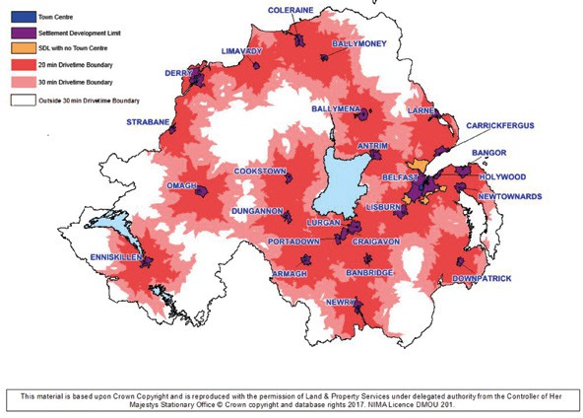

A Guide to the Rural Needs Act (NI) 2016 for Public Authorities
21
(Revised) April 2026

Chapter 4

Chapter 4 - Duty of Public Authorities to have Due Regard to Rural Needs

Introduction

  - This chapter provides information on the due regard duty imposed on public authorities under section 1(1) of the Rural Needs Act (Northern Ireland) 2016 (‘the Act’).

What is the due regard duty?

  - The due regard duty requires public authorities to have due regard to rural needs when developing, adopting, implementing or revising policies, strategies and plans, and when designing and delivering public services.

What does ‘rural needs’ mean in the context of the due regard duty?

  - The Act defines rural needs as ‘the social and economic needs of persons in rural areas’.

  - It is important to be clear what this means and to be able to distinguish between a ‘need’ and something that is desirable. In general terms, a ‘need’ can be considered to be something that is essential to achieve a standard of living comparable with that of the population in general. For example, it can relate to the ability to access key public services such as health and education, the ability to access suitable employment opportunities, and the ability to enjoy a healthy lifestyle.

Which public authorities are required to comply with the due regard duty?

  - The due regard duty applies to Northern Ireland departments and district councils from 1 June 2017 and to those other public authorities listed in the Schedule to the Act from 1 June 2018.

Which activities does the due regard duty apply to?

  - The due regard duty applies when a public authority is engaging in the following activities (‘section 1 activities’);

- Developing a policy, strategy or plan;
- Adopting a policy, strategy or plan;
- Implementing a policy, strategy or plan;
- Revising a policy, strategy or plan;
- Designing a public service;
- Delivering a public service.
  - It is the responsibility of public authorities to ensure that they meet their due regard duty when carrying out section 1 activities. If a public authority is unclear as to whether an activity it is engaged in falls within the scope of the due regard duty, it should consider seeking its own legal advice on the matter.

What does ‘due regard’ mean in the context of the Act?
  - It means that when carrying out section 1 activities public authorities must consciously consider the social and economic needs of persons in rural areas and ensure that such consideration is exercised in such a way that it appropriately influences the section 1 activity which is subject to the due regard duty.

What must a public authority do to have due regard?
  - What a public authority is required to do in order to fulfil its due regard duty will depend on the particular circumstances and will be determined on a case by case basis.

  - The question as to whether a public authority has fulfilled its due regard duty in relation to a relevant activity will ultimately be a matter for the Courts to determine in the event that a public authority is challenged. Each case will turn on its own merits and will be open to the Court’s interpretation.

The ‘Brown Principles’

  - There are many cases in which the Courts have considered whether a body has complied with a “due regard” duty in relation, for example, to equality duties on race,

disability and gender. In R (Brown) -v- Secretary of State for Working Pensions, the Court considered what a relevant body has to do to fulfil an obligation to have due regard to the needs set out in a general equality duty. The 6 “Brown principles” established by this case have been accepted by the Courts in later cases.

  - While these are principles that have been established by the Courts in the different context of determining whether public bodies have fulfilled their ‘due regard’ obligations in respect of equality issues, they are principles that public authorities might find helpful to follow when attempting to fulfil their due regard duty in the context of section 1(1) of the Act.

  - Those principles include that:

    - in order to have due regard, those in a body subject to the duty who have to take decisions that do or might affect people with different protected characteristics must be made aware of their duty and have “due regard” to the aims of the duty;

    - due regard is fulfilled before and at the time a particular policy that will or might affect people with protected characteristics is under consideration as well as the time a decision is taken. Due regard involves a conscious approach and state of mind.

    - A body subject to the duty cannot satisfy the duty by justifying a decision after it has been taken. Attempts to justify a decision cannot be consistent with the exercise of the duty when it was not, in fact, considered before the decision are not enough to discharge the duty.

    - The duty must be exercised in substance, with rigor and with an open mind in such a way that it influences the final decision. The duty has to be
integrated within the discharge of the public functions of the body subject to the duty. It is not a question of “ticking boxes”. However, the fact that a body subject to the duty has not specifically mentioned [the duty], in carrying out the particular function where it is to have “due regard” is not determinative of whether the duty has been performed. But it is good practice for the policy or decision maker to make reference to [the duty] and any code or

non-statutory guidance in all cases where [the duty] is in play. In that way the decision maker is more likely to ensure that the relevant factors are taken into account and the scope for argument as to whether the duty has been performed will be reduced.

    - The duty in a non-delegable one. The duty will always remain the responsibility of the body subject to the duty. In practice, another body may actually carry out the practical steps to fulfil a policy stated by a body
subject to the duty. In those circumstances, the duty to have “due regard” to the needs identified will only be fulfilled by the body subject to the duty if -

      - It appoints a third party that is capable of fulfilling the “due regard” duty and is willing to do so;

      - The body subject to the duty maintains a proper supervision over the third party to ensure it carries out its ‘due regard’ duty.

    - The duty is a continuing one.

    - It is good practice for those exercising public functions to keep an accurate record showing that they had actually considered the duty and pondered relevant questions. Proper record keeping encourages transparency and will discipline those carrying out the relevant functions to undertake the duty conscientiously. If records are not kept, it may make it more difficult, evidentially, for a public body to persuade a Court that it has fulfilled the duty imposed by [the legislation].

Complying with the due regard duty in practice

  - A Rural Needs Impact Assessment is the process recommended by this guidance to assist public authorities in fulfilling their due regard duty. While there is no statutory duty to undertake a Rural Needs Impact Assessment, nor does undertaking a Rural Needs Impact Assessment equate to having due regard to rural needs, going through the
step by step process outlined in the Rural Needs Impact Assessment will help public authorities to ensure that the duty due regard is fulfilled.

  - Guidance on undertaking a Rural Needs Impact Assessment is provided in Chapter 5.

  - Where a public authority chooses not to undertake a Rural Needs Impact Assessment it should have a sound rationale for departing from the guidance and ensure that when adopting the alternative approach it fulfils the due regard duty.

  - It is the responsibility of public authorities to ensure they comply with the due regard duty under section 1(1) of the Act. Officials within public authorities responsible for ensuring that the public authority fulfils the due regard duty should therefore be familiar with this guidance. In the event of any legal challenge the Courts are likely to view this guidance as an authoritative document of persuasive value.

Failure to comply with the due regard duty

  - The Act does not provide for any sanctions in relation to a failure by a public authority to have due regard to rural needs in respect of a relevant activity.

  - If a public authority undertakes a section 1 activity without complying with the due regard duty then, in principle, Judicial Review is available to challenge the decision.

A Guide to the Rural Needs Act (NI) 2016 for Public Authorities
27
(Revised) April 2026

Chapter 5

Chapter 5 - Undertaking a Rural Needs Impact Assessment

Introduction

  - This guidance recommends that public authorities undertake a Rural Needs Impact Assessment when developing, adopting, implementing or revising polices, strategies and plans and when designing and delivering public services. A Rural Needs Impact Assessment is a step by step process aimed at helping public authorities to ensure that the due regard duty imposed under section 1(1) of the Rural Needs Act (Northern Ireland) 2016 (‘the Act’) duty is fulfilled.
  - Public authorities should be aware that the completion of a Rural Needs Impact Assessment does not in itself equate to fulfilling the due regard duty however it is a tool which can be used to help ensure that the due regard duty is fulfilled. Officials undertaking a Rural Needs Impact Assessment should therefore be aware of their obligation to comply with the due regard duty and consequently should consider the guidance on the due regard duty set out in Chapter 4 of this guidance.
  - A public authority may choose not to undertake a Rural Needs Impact Assessment and instead adopt an alternative approach. Where a public authority chooses to adopt an alternative approach it should have good reasons for departing from the guidance and ensure that it documents the reasons. It should also ensure that when adopting the alternative approach it fulfils the due regard duty.
  - There are six steps involved in completing a Rural Needs Impact Assessment. The level of analysis undertaken in a Rural Needs Impact Assessment should be proportionate to both the scale of the potential impact of the policy, strategy, plan or public service and its relevance to people in rural areas.
  - A Rural Needs Impact Assessment Template (RNIA Template) is the document which should be completed when a Rural Needs Impact Assessment is carried out. A copy of the RNIA Template is attached at Appendix 1. The amount of detail included in an RNIA Template should be proportionate to both the scale of the potential impact of the policy, strategy, plan or public service and its relevance to people in rural areas.

Step 1: Defining the Activity

  - The first step in completing a Rural Needs Impact Assessment is to define the activity being undertaken.

  - Public authorities should be clear on the nature of the activity which they are undertaking and ensure that it is one which falls within the scope of the Act. The Act only applies to the development, adoption, implementation and revising of policies, strategies and plans and to the design and delivery of public services. If the activity that a public authority is engaged in does not fall within the scope of section 1(1) of the Act, then no Rural Needs Impact Assessment is required to be carried out. If necessary public authorities should seek their own legal advice on whether a particular activity is subject to the duty imposed under section 1(1) of the Act.

  - Public authorities should also have a clear understanding of the aims and/or objectives of the proposed policy, strategy, plan or public service.

  - Public authorities should also be clear on what definition of rural they are using in relation to the policy, strategy, plan or public service. Details of the default definition of rural proposed in the Report of the Inter-Departmental Urban-Rural Definition Group is provided in Chapter 3 of this guidance.

  - If a definition other than the default definition is chosen to be used then the public authority should detail clearly the alternative definition of rural being used and provide a clear rationale for using the alternative. Guidance on the use of alternative definitions of rural is also provided in Chapter 3 of this guidance.

Step 2: Understanding the Impact

  - The second step of a Rural Needs Impact Assessment is understanding the impact that the policy, strategy, plan or public service is likely to have on people in rural areas. In considering the impact a public authority should consider both the direct and indirect impacts and both the positive and negative impacts.

  - If a public authority intends a particular policy, strategy, plan or public service to deliver similar outcomes for people in rural areas as in urban areas, then it should be aware of how rural areas differ from urban areas and that a policy, strategy, plan or public service may have a different impact on people in rural areas, or be experienced differently by people in rural areas, due to rural circumstances.

  - If a proposed policy, strategy, plan or public service is intended to have a different impact on people in urban areas than in rural areas then a public authority should have a clear rationale as to how it is intended to have a different impact.

  - It may be that the proposed policy, strategy, plan or public service is intended to be entirely urban focussed and is not intended to impact on people in rural areas. If so, public authorities should be clear as to why no equivalent is being introduced in rural areas. In general all public authorities’ functions cover both urban and rural areas and if a policy, strategy, plan or public service is intended to only relate to people in urban areas, public authorities should seek to identify whether people in rural areas have a corresponding need.

  - For policies, strategies, plans and public services which are wholly or mainly aimed at rural communities, consideration should be given to whether there are variations across rural communities. It should be borne in mind that rural areas are not homogeneous and that there can be a large degree of variation which will be affected by rural circumstances such as proximity to services, transport links and infrastructure.

  - Where a policy, strategy, plan or public service is an area-based one and is intended to have the same impact across a region, consideration should be given to whether there are potential local circumstances which will result in a different outcome.

  - Where a public authority is unclear as to the potential impact on people in rural areas it should seek to determine the impact by utilising the evidence and information available to it. Where a public authority does not have access to the necessary evidence and information then it should seek to gather it. Details of potential sources of evidence and information are provided in Chapter 7 of this guidance.

Step 3: Identifying Rural Needs

  - The third step of a Rural Needs Impact Assessment is to identify the social and economic needs of people in rural areas that are relevant to the policy, strategy, plan or public service.

  - It is important to be clear what a ‘need’ is and to distinguish between a need and something that is desirable. In general terms a ‘need’ can be considered to be something that is essential to achieve a standard of living comparable with that of the population in general. For example it can relate to the ability to access key public services such as health and education, the ability to access suitable employment opportunities and the ability to enjoy a healthy lifestyle.

  - The social and economic needs of people in rural areas may include the needs of people living in rural areas, people working in rural areas, people operating businesses in rural areas and people visiting rural areas for the purposes of tourism or recreation.

  - In seeking to identify rural needs public authorities should consider to what extent the policy, strategy, plan or public service will meet the social and economic needs of people in rural areas and whether the outcomes delivered for people in rural areas will be similar to the outcomes delivered for people in urban areas.

  - Examples of the types of questions which should be considered in seeking to identify rural needs might include the following:
    - Is appropriate infrastructure in place to enable people in rural areas to access the service?
    - Will people in more remote rural areas be able to access the service?
    - Could it cost people in rural areas disproportionately more to access the service?
    - Could there be a disproportionate effect on people in rural areas who rely on public transport services?
    - Could there be a disproportionate effect on people in rural areas who don’t have access to high quality broadband?
    - Could there be a disproportionate effect on people in rural areas whose access to mobile communications is variable or limited in areas.
    - Could the policy, strategy, plan or public service have a different outcome for people in rural areas due to lower population densities?

    - Could there be a disproportionate effect on people operating businesses in rural areas?
    - Will the policy, strategy, plan or public service affect people travelling to rural areas for tourism or recreation purposes?
    - Could there be a disproportionate effect on people in rural areas who have to travel longer distances to avail of employment opportunities?
    - Could there be a disproportionate effect on people in rural areas who require access to childcare facilities?
    - Will the policy, strategy, plan or public service affect certain groups of people in rural areas disproportionally e.g. seasonal workers, farmers and farm families or older people, younger people or people with disabilities who do not have access to transport?
    - Are there pockets of hidden poverty or deprivation within rural areas which need to be taken account of in determining the effects of the policy, strategy, plan or public service on people in rural areas?

  - In seeking to identify the social and economic needs of people in rural areas public authorities will normally be required to gather evidence and information. Information on rural needs can be obtained through various sources including the following:

- Consultation with rural stakeholders;
- Consultation with public sector or other organisations;
- Published statistics or research papers;
- Surveys or questionnaires.

  - A public authority may have an in-house statistician or a GIS Officer who can conduct analyses and prepare comparative reports to inform the analysis. A public authority may also hold data relevant to the policy, strategy, plan or public service which can be utilised. Details of potential sources of evidence and information is provided in Chapter 7 of this guidance.

  - This guidance recommends that, where appropriate, public authorities should seek to engage with rural stakeholders early in, and during, the process of developing, adopting, implementing or revising policies, strategies and plans and designing and delivering public services.

Step 4: Considering Rural Needs

  - The fourth step of the Rural Needs Impact Assessment is the consideration of the social and economic needs of people in rural areas as they relate to the policy, strategy, plan or public service.

  - In considering rural needs is important to determine any potential barriers to the delivery of a fair and equitable outcome for people in rural areas taking into account the characteristics of rural areas, and to consider how these barriers can be mitigated or overcome.

  - When considering rural needs public authorities should also seek to ensure that a policy, strategy, plan or public service does not indirectly impact on rural areas in ways that are likely to disadvantage people in rural areas compared to people in urban areas.

  - Examples of the types of questions which should be reflected upon when considering rural needs include the following:
    - Could the costs of providing or accessing the service be disproportionately higher in rural areas?
    - Is there a need to implement a different delivery model in rural areas e.g. mobile services or virtual services?
    - Is there an opportunity to work in partnership with other public authorities or service providers to achieve greater efficiency or economies of scale?
    - Is there an opportunity to avail of local facilities e.g. community facilities, local libraries, rural post offices, rural schools etc.?
    - Is an exemption or reduction on levies appropriate for rural areas e.g. rates relief on ATMs?
    - Is an equitable proportion of the funding programme being allocated to rural areas?
    - Is there a need to align with public transport services or timetables?
    - Is there a need to have a rural specific dimension tailored to meet the particular circumstances pertaining to rural areas?
    - Could there be a role for the voluntary and community sector in helping to deliver more equitable outcomes for people in rural areas?

  - The level of consideration required should be proportionate to the relevance of the policy, strategy, plan or public service to people in rural areas and the impact it is likely to have on rural needs.

Step 5: Influencing the Outcome

  - The fifth step of the Rural Needs Impact Assessment deals with influencing the policy, strategy, plan or public service.

  - Having considered the social and economic needs of people in rural areas, public authorities should consider how the rural needs identified should be taken account of in the development, adoption, implementation or revising of the policy, strategy or plan or in the design or delivery of the public service. The ways in which rural needs can be taken account of will vary according to the nature of the policy, strategy, plan or public service and the circumstances pertaining to rural areas.

  - In determining how a policy, strategy, plan or public service should take account of rural needs, public authorities should always seek to ensure fair and equitable treatment
of people in rural areas and be aware that a ‘one size fits all’ approach may not be appropriate.

  - Public authorities should also be open to new and innovative ideas and approaches when considering how to take account of rural needs.

  - Case Studies showing examples of how rural needs have been taken into account in the development of policy, delivery of public services etc. are available on the “Rural Needs” page of the DAERA website (see chapter 7).

  - Once the development, adoption, implementation or revision of a policy, strategy or plan has been completed, public authorities should continue to monitor the situation to ensure that the policy, strategy or plan continues to take account of rural needs.
The same approach should apply in relation to the design and delivery of public services.

Step 6: Documenting and Recording

  - Public authorities should ensure that all information relevant to the Rural Needs Impact Assessment is documented on the RNIA Template (Appendix 1). The amount of detail recorded should be proportionate to the potential impact and relevance of the activity being undertaken.

  - Public authorities should determine their own policy as regards what position or grade should be required to approve completed RNIA Templates.

  - Public authorities should also ensure that a copy of the RNIA Template is retained in line with the public authority’s records management policy. They should also ensure that details of the Rural Needs Impact Assessment are included in the information to be compiled by the public authority under section 3(1) of the Act (see Appendix 2) and recorded on the public authority’s Rural Needs Annual Monitoring Return.

  - Any other information which helps demonstrate how a public authority has fulfilled its due regard duty should also be documented and retained.

  - There is no specific requirement within the Act to consult in relation to rural needs. However, if a public consultation is being undertaken on the policy, strategy, plan or public service, it is recommended that the completed RNIA Template be included as part of the public consultation documentation.

  - If the policy, strategy, plan or public service is to be amended following the public consultation, then the RNIA Template should be reviewed and revised as necessary to ensure that any further action to take account of rural needs is properly documented and recorded.

A Guide to the Rural Needs Act (NI) 2016 for Public Authorities
37
(Revised) April 2026

Chapter 6

Chapter 6 - Monitoring and Reporting Requirements

Introduction

  - This section provides guidance on the monitoring and reporting requirements set out in section 3 of the Rural Needs Act (Northern Ireland) 2016 (‘the Act’).

Which public authorities are required to monitor and report?

  - The requirement to monitor and report applies to Northern Ireland departments and district councils from 1 June 2017 and to those other public authorities listed in the Schedule to the Act from 1 June 2018.

What does the Act require public authorities to do in relation to monitoring and reporting?

  - Section 3(1) of the Act requires public authorities to:

- compile information on the exercise of their functions under section 1(1) of the Act;
- include that information in their annual report; and
- send that information to DAERA.

What information do public authorities need to compile?

  - Public authorities are required to compile information on how they have exercised the due regard duty under section 1 (1) of the Act.

  - The information to be compiled by public authorities relates to all policies, strategies and plans which have been developed, adopted, implemented or revised and all public services which have been designed and delivered (section 1 activities).

  - DAERA has the power to issue a direction directing public authorities on the manner in which they compile this information and if a direction has been issued by DAERA, public authorities are required to comply with it.

  - DAERA requires all public authorities to compile the following information:
1. | Reporting Period
2. | Name of Public Authority | This information should normally be contained in section 1A of the RNIA Template
3. | A description of the activity undertaken by the public authority which is subject to section 1(1) of the Rural Needs Act (NI) 2016. | This information should normally be contained in section 1B of the RNIA Template
4. | Category the activity specified in section 3 above relates to. | This information should normally be contained in section 1C of the RNIA Template
5. | Detail the social and economic needs of people in rural areas which have been identified by the public authority. | This information should normally be contained in section 3D of the RNIA Template
6. | Detail the issues considered in relation to the social and economic needs of people in rural areas. | This information should normally be contained in section 4A of the RNIA Template
7. | Has the development, adoption, implementation or revising of the policy, strategy or plan or when designing or delivering the public service, been influenced by the rural needs identified | The information should be contained in sections 5B or 5C dependent on response to section 5A of the RNIA Template.
  - The process for recording this information is provided at Appendix 2. The amount of detail recorded should be proportionate to the potential impact and relevance of the activity undertaken.
  - Public authorities should establish their own internal systems for collating Rural Needs Impact Assessments. The summary of each Rural Needs Impact Assessment should be compiled as per Appendix 2.

What information do public authorities need to send to DAERA?

  - Public authorities are required to send the information compiled under section 3(1)(a) of the Act to DAERA for inclusion in a Rural Needs Annual Monitoring Report.

  - DAERA will request this information on an annual basis by issuing a Rural Needs Annual Monitoring Return. The reporting period will align with the financial year i.e. 1 April to 31 March. Public authorities should ensure they submit their Rural Needs Annual Monitoring Return to DAERA within any deadline specified.

  - Public authorities will be expected to provide a single Rural Needs Annual Monitoring Return to DAERA and therefore should consider establishing a single point of contact in relation to the monitoring and reporting requirements set out in the Act.

What information do public authorities need to include in their own annual report?

  - Public authorities are required to include the information compiled under section 3(1)(a) of the Act in their own annual report. It is the responsibility of individual public authorities to ensure that this is done.

What is the Rural Needs Annual Monitoring Report?

  - The Rural Needs Annual Monitoring Report is the annual report which is required to be published by DAERA under section 3 of the Act. This report is required to contain:
    - the information sent to it by public authorities (i.e. the information compiled by public authorities on how they have fulfilled their duties under section 1 of the Act);
    - information on how DAERA has fulfilled its functions under the Act.

  - The Rural Needs Annual Monitoring Report aims to provide public representatives, rural stakeholders and other interested parties with information on how public authorities have exercised their duties under the Act and will help to improve transparency in regard to how public authorities have considered rural needs.

  - DAERA will issue requests to public authorities for input to the Rural Needs Annual Monitoring Report and following publication a copy is required to be laid before the Assembly.

  - The Minister of Agriculture, Environment and Rural Affairs is also required to make a statement to the Assembly about the content of the report on or after the day on which the report has been laid.

A Guide to the Rural Needs Act (NI) 2016 for Public Authorities
41
(Revised) April 2026

Chapter 7

Chapter 7 - Additional Guidance, Advice and Information

For advice in relation to this guidance please contact:
Rural Legislation Advisory Branch
Jubilee House
111 Ballykelly Road
Ballykelly
Limavady
BT49 9HP
Website: www.daera-ni.gov.uk Email: rural.needs@daera-ni.gov.uk

For online versions of the guidance and templates and for other related information please go to the “Rural Needs” page of the DAERA website:
www.daera-ni.gov.uk/articles/rural-needs

For help on statistics please contact:
Northern Ireland Statistics and Research Agency (NISRA) Colby House, Stranmillis Court
Belfast
BT9 5RR
Tel: 028 9038 8400
Website: www.nisra.gov.uk Email: info@nisra.gov.uk

Rural Stakeholder Organisations

A list of rural stakeholder organisations is maintained on the “Rural Needs” page on the DAERA website https://www.daera-ni.gov.uk/articles/rural-needs

Other Information Sources

Rural Statistics

DAERA’s Rural Statistics pages (https://www.daera-ni.gov.uk/topics/statistics/rural-statistics) contains rural/urban comparisons across a range of social and economic issues. These pages host information collected from the census, and from surveys and administrative databases across government with a rural/urban classification applied to the data.

NISRA’s Neighbourhood Information Service (NINIS)

Detailed profiles for specific geographic areas can be accessed using NISRA’s Neighbourhood Information Service (NINIS) at www.ninis2.nisra.gov.uk. The website is continually updated and provides valuable information on a range of key public statistics.

A Guide to the Rural Needs Act (NI) 2016 for Public Authorities
45
(Revised) April 2018

Appendices

Appendix 1 - Rural Needs Impact Assessment (RNIA) Template

SECTION 1 - Defining the activity subject to Section 1(1) of the Rural Needs Act (NI) 2016
1A. Name of Public Authority.
1B. Please provide a short title which describes the activity being undertaken by the Public Authority that is subject to Section 1(1) of the Rural Needs Act (NI) 2016.
1C. Please indicate which category the activity specified in Section 1B above relates to.
Developing a | Policy | Strategy | Plan
Adopting a | Policy | Strategy | Plan
Implementing a | Policy | Strategy | Plan
Revising a | Policy | Strategy | Plan
Designing a Public Service
Delivering a Public Service
1D. Please provide the official title (if any) of the Policy, Strategy, Plan or Public Service document or initiative relating to the category indicated in Section 1C above.
1E. Please provide details of the aims and/or objectives of the Policy, Strategy, Plan or Public Service.

1F. What definition of ‘rural’ is the Public Authority using in respect of the Policy, Strategy, Plan or Public Service?
Population Settlements of less than 5,000 (Default definition).
Other Definition (Provide details and the rationale below).
A definition of ‘rural’ is not applicable.
Details of alternative definition of ‘rural’ used.
Rationale for using alternative definition of ‘rural’.
Reasons why a definition of ‘rural’ is not applicable.

SECTION 2 - Understanding the impact of the Policy, Strategy, Plan or Public Service
2A. Is the Policy, Strategy, Plan or Public Service likely to impact on people in rural areas?
Yes | No | If the response is NO GO TO Section 2E.
2B. Please explain how the Policy, Strategy, Plan or Public Service is likely to impact on people in rural areas.
2C. If the Policy, Strategy, Plan or Public Service is likely to impact on people in rural areas differently from people in urban areas, please explain how it is likely to impact on people in rural areas differently.

2D. Please indicate which of the following rural policy areas the Policy, Strategy, Plan or Public Service is likely to primarily impact on.
Rural Businesses
Rural Tourism
Rural Housing
Jobs or Employment in Rural Areas
Education or Training in Rural Areas
Broadband or Mobile Communications in Rural Areas
Transport Services or Infrastructure in Rural Areas
Health or Social Care Services in Rural Areas
Poverty in Rural Areas
Deprivation in Rural Areas
Rural Crime or Community Safety
Rural Development
Agri-Environment
Other (Please state)
If the response to Section 2A was YES GO TO Section 3A.
2E. Please explain why the Policy, Strategy, Plan or Public Service is NOT likely to impact on people in rural areas.

SECTION 3 - Identifying the Social and Economic Needs of Persons in Rural Areas
3A. Has the Public Authority taken steps to identify the social and economic needs of people in rural areas that are relevant to the Policy, Strategy, Plan or Public Service?
Yes | No | If the response is NO GO TO Section 3E.
3B. Please indicate which of the following methods or information sources were used by the Public Authority to identify the social and economic needs of people in rural areas.

Consultation with Rural Stakeholders | Published Statistics
Consultation with Other Organisations | Research Papers
Surveys or Questionnaires | Other Publications
Other Methods or Information Sources (include details in Question 3C below).
3C. Please provide details of the methods and information sources used to identify the social and economic needs of people in rural areas including relevant dates, names of organisations, titles of publications, website references, details of surveys or consultations undertaken etc.

3D. Please provide details of the social and economic needs of people in rural areas which have been identified by the Public Authority?
If the response to Section 3A was YES GO TO Section 4A.
3E. Please explain why no steps were taken by the Public Authority to identify the social and economic needs of people in rural areas?

SECTION 4 - Considering the Social and Economic Needs of Persons in Rural Areas
4A. Please provide details of the issues considered in relation to the social and economic needs of people in rural areas.

SECTION 5 - Influencing the Policy, Strategy, Plan or Public Service
5A. Has the development, adoption, implementation or revising of the Policy, Strategy or Plan, or the design or delivery of the Public Service, been influenced by the rural needs identified?
Yes | No | If the response is NO GO TO Section 5C.
5B. Please explain how the development, adoption, implementation or revising of the Policy, Strategy or Plan, or the design or delivery of the Public Service, has been influenced by the rural needs identified.
If the response to Section 5A was YES GO TO Section 6A.

5C. Please explain why the development, adoption, implementation or revising of the Policy, Strategy or Plan, or the design or the delivery of the Public Service, has NOT been influenced by the rural needs identified.

SECTION 6 - Documenting and Recording
6A. Please tick below to confirm that the RNIA Template will be retained by the Public Authority and relevant information on the Section 1 activity compiled in accordance with paragraph 6.7 of the guidance.
I confirm that the RNIA Template will be retained and relevant information compiled.

Rural Needs Impact Assessment undertaken by:
Position/Grade:
Division/Branch
Signature:
Date:
Rural Needs Impact Assessment approved by:
Position/Grade:
Division/Branch:
Signature:
Date:

Appendix 2 – Annual Return

Process for Reporting onto Digital Portal

DAERA have designed a Rural Needs Act (NI) 2016 - Annual Monitoring Report User Guide

The User Guide is maintained on the “Rural Needs” page on the DAERA website https://www.daera-ni.gov.uk/articles/rural-needs

The User guide is designed to help everyday users to work confidently within the system.
It explains how to:

- Set up an account;

- Log in;

- Navigate the Public Authority Portal;

- Create and manage summaries;

- Use the dashboard (including viewing, editing and managing submissions); and

- Understand the key features available

How to Register

- Visit the Dashboard - Rural Needs Act (NI) 2016 - Annual Monitoring Report

Dashboard - Rural Needs Act (NI) 2016 - Annual Monitoring Report
and click ‘Start Now’

- Register through using NI Direct (NIDA) or Government Gateway (GG)

- Contact your organisation’s Rural Needs Coordinator to confirm your registration

- The Rural Needs Team will confirm Registration has been accepted or declined via email.

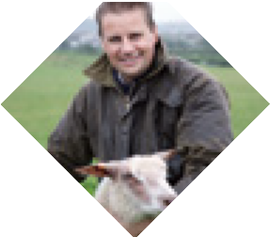

A Guide to the Rural Needs Act (NI) 2016 for Public Authorities
(Revised) April 2026

Appendix 3 - Checklist for Public Authorities

CHECKLIST FOR PUBLIC AUTHORITIES
1. Are you aware of the duty to have regard to rural needs under section 1(1) of the Rural Needs Act (NI) 2016?
2. Have you familiarised yourself with the contents of the guidance document
- A Guide to the Rural Needs Act (NI) 2016 for Public Authorities (Revised)?
3. Are you clear as to what definition of rural you are using in relation to the Policy, Strategy, Plan or Public Service?
4. Have you undertaken a Rural Needs Impact Assessment in a manner that is proportionate to the scale of the potential impact and relevance of the activity being undertaken?
5. Are you satisfied that the due regard duty has been fulfilled in respect of the activity being undertaking?
6. Have you completed a Rural Needs Impact Assessment (RNIA) Template?
7. Are you satisfied that the RNIA Template contains sufficient detail to help demonstrate that due regard has been given to rural needs?
8. Has the RNIA Template been approved at the appropriate level?
9. Has the RNIA Template been retained in line with your Public Authority’s record management policy?

10. Has information on the activity been compiled by your Public Authority in line with Chapter 6 of the guidance?

Appendix 4 - Frequently Asked Questions

Which activities does the due regard duty under section 1 (1) of the Rural Needs Act (NI) 2016 apply to?
Section 1(1) of the Rural Needs Act (NI) 2016 (‘the Act’) requires public authorities to have due regard to rural needs when developing, adopting, implementing or revising a policy, strategy or plan and when designing or delivering a public service. If a public authority is unclear as to whether the activity which it is engaged in falls within the scope of the Act then it should seek its own legal advice on the matter.

Does a Rural Needs Impact Assessment need to be carried out in respect of every policy, strategy, plan and public service?
Section 1(1) the Act requires public authorities to have due regard to rural needs when developing, adopting, implementing or revising a policy, strategy or plan and when designing or delivering a public service. If the activity which a public authority is engaged in falls within the scope of section 1(1) of the Act, then the guidance recommends that a Rural Needs Impact Assessment is carried out and an RNIA Template completed. Prudent public authorities should follow the guidance otherwise in the event of a legal challenge, they may face the prospect of having to demonstrate good reasons for not following it. The level of analysis undertaken in a Rural Needs Impact Assessment should be proportionate to both the scale of the potential impact of the policy, strategy, plan or public service and its relevance to people in rural areas. If a public authority chooses not to undertake a Rural Needs Impact Assessment, then it should have a clear rationale for not doing so and should ensure that in taking an alternative course of action, the due regard duty is fulfilled.

How detailed does a Rural Needs Impact Assessment (RNIA) Template need to be?
The RNIA Template has been designed to ensure that information relevant to each stage of the Rural Needs Impact Assessment process is captured. The documenting of this information will help to provide evidence that the due regard duty has been complied with. It should therefore contain sufficient information to demonstrate that the Rural Needs Impact Assessment process has been undertaken appropriately. Proportionality and relevance are core concepts. It follows that the more relevant the policy, strategy, plan or public service has for people in rural areas the greater the amount of detail that should be included. If a policy, strategy, plan or public service has little or no relevance for people in rural areas then less detail will be required than if a policy, strategy, plan or public service is very relevant.

If a policy, strategy, plan or public service does not have an impact on people in rural areas - can it be ‘screened out’?
The process for undertaking a Rural Needs Impact Assessment does not include an option to ‘screen out’. If a public authority concludes that a policy, strategy, plan or public service does not have an impact on people in rural areas, and that there are no rural needs to have due regard to, then this should be documented in the RNIA Template and retained as evidence that the impact on people in rural areas has been considered. If a particular policy, strategy, plan or public service is intended to be entirely urban focussed then public authorities should also consider whether there is an equivalent need among people in rural areas that should be addressed.
- At what stage should the Rural Needs Impact Assessment be carried out?
The undertaking of a Rural Needs Impact Assessment should be an integral part of the development, adoption, implementation or revising of a policy, strategy or plan or the design or delivery of a public service. It should therefore be part of the ongoing process. It is not appropriate to wait until the activity has been completed before undertaking the Rural Needs Impact Assessment. It is therefore good practice to begin completing the RNIA Template early in the process and add additional information throughout the process.
- Who is responsible for approving or quality assuring Rural Needs Impact Assessment (RNIA) Templates?
Public authorities are responsible for ensuring that Rural Needs Impact Assessments are undertaken to a satisfactory standard and that the RNIA Templates contain sufficient information to help demonstrate how the due regard duty has been fulfilled. DAERA does not have an approval or quality assurance role. However DAERA can provide advice and guidance on the process.
- Does undertaking a Rural Needs Impact Assessment mean that the due regard duty under section 1(1) of the Rural Needs Act (NI) 2016 has been fulfilled?
No. The duty on public authorities under section 1(1) of the Act is to have due regard to rural needs. The guidance recommends that public authorities should undertake a Rural Needs Impact Assessment and complete a RNIA Template as a way of helping to ensure that the due regard duty has been fulfilled. However public authorities need to consider on a case by case basis what is required in order to fulfil the due regard duty and there should not be an automatic presumption that by undertaking a Rural Needs Impact Assessment (or completing an RNIA Template) the due regard duty has been fulfilled. If a public authority is unclear it should seek its own legal advice.

- If the delivery of a public service is outsourced or contracted out, does a public authority still have to carry out a Rural Needs Impact Assessment?

Section 1(1) of the Act requires public authorities to have due regard to rural needs when delivering public services. The duty to have due regard cannot be devolved and therefore responsibility for ensuring that due regard is given to rural needs in relation to the delivery of the public service remains with the public authority even where it is outsourced or contracted out. The guidance recommends that a Rural Needs Impact Assessment is carried out (and an RNIA Template completed) in respect of the delivery of public services and therefore the public authority should ensure that a Rural Needs Impact Assessment is undertaken in respect of any public services outsourced or contracted out.
- Who is responsible for undertaking a Rural Needs Impact Assessment in respect of cross-cutting policies or strategies involving multiple public authorities?

Each public authority listed in the Schedule to the Act has a duty to have due regard to rural needs when developing, adopting, implementing or revising policies, strategies and plans and when designing and delivering public services. This will apply to any cross- cutting policy, strategy, plan or public service which a public authority contributes to.
Where a public authority is required to have due regard to rural needs in respect of its element of a cross cutting policy or strategy, then it should undertake a Rural Needs Impact Assessment (and complete a RNIA Template) in respect of that element. Where the nature of a particular cross cutting policy or strategy is such that the completion
of a single RNIA Template is appropriate, then responsibility for completing this should normally lie with the lead public authority.
- Does the Rural Needs Act (NI) 2016 require the same level of service to be provided in rural areas as urban areas?

No. The Act aims to help deliver fairer and more equitable treatment for people in rural areas by requiring public authorities to have due regard to rural needs when developing, adopting, implementing or revising policies, strategies and plans and when designing and delivering public services. It is important to be clear what a ‘rural need’ is and to be able to distinguish between a ‘need’ and something that is desirable. In general terms, a ‘need’ can be considered to be something that is essential to achieve a standard of
living for people in rural areas comparable with that of the population in general. In having due regard to rural needs a public authority should consider all relevant information and ensure that the policy, strategy, plan or public service is influenced appropriately.

- Can the Rural Needs Impact Assessment (RNIA) Template be amended?

The Rural Needs Impact Assessment process has been designed to assist Public Authorities in complying with their duty under section 1(1) of the Act. The RNIA Template provided at Appendix 1 has been designed to ensure that information relevant to each stage of the Rural Needs Impact Assessment process is captured. The documenting of this information will help to provide evidence that the due regard duty has been complied with. This guidance therefore recommends that the RNIA Template provided at Appendix 1 is used. Where a Public Authority chooses to use an amended version of the RNIA Template it should ensure that it captures all relevant information.

- What is the information contained in the Rural Needs Impact Assessment (RNIA) Template used for?

The RNIA Template is used to record information relating to the Rural Needs Impact Assessment. A properly completed RNIA Template should contain sufficient information to help demonstrate that the due regard duty under section1 (1) of the Act has been fulfilled. The information on the RNIA Template should be used to compile the information required under section 3(1)(a) of the Act. This information should be included in the Public Authority’s own annual report and in the Rural Needs Annual Monitoring Return which is sent to DAERA for inclusion in its Rural Needs Annual Monitoring Report.

Appendix 5 - Rural Needs Act (Northern Ireland) 2016



Rural Needs Act (Northern Ireland) 2016
CHAPTER 19

CONTENTS
  - Duty of public authorities to have due regard to rural needs
  - Guidance, advice and information, etc.
  - Monitoring and reporting
  - Co-operation with other bodies
  - Commencement
  - Interpretation
  - Short title

Schedule Public authorities

c. 19 ELIZABETH II

Rural Needs Act (Northern Ireland) 2016

2016 CHAPTER 19

An Act to impose a duty on public authorities to have due regard to rural needs; and for connected purposes. [9th May 2016]
B
E IT ENACTED by being passed by the Northern Ireland Assembly and assented to by Her Majesty as follows:
Duty of public authorities to have due regard to rural needs
- —(1) A public authority must have due regard to rural needs when—
  - developing, adopting, implementing or revising policies, strategies and plans, and
  - designing and delivering public services.
- For the purposes of this Act, “public authority” means any body or person listed in the Schedule.
- The Department must, at least every three years from the coming into operation of this section, review the list of bodies and persons set out in the Schedule and, if it thinks it appropriate, by order amend the Schedule to—
  - add a body or person to the Schedule;
  - remove a body or person from the Schedule; or
  - modify any entry in the Schedule.
- An order under subsection (3) may provide for a body or person to be a public authority for all or any of the purposes of this Act.
- The Department must not exercise the power conferred by subsection (3) so that a body or person becomes a public authority for any of the purposes of this Act unless the body or person is a body or person appearing to the Department to exercise functions of a public nature.
- An order under subsection (3) may contain such transitional provision as the Department thinks appropriate.

c. 19 Rural Needs Act (Northern Ireland) 2016

- An order under subsection (3) must not be made unless a draft of the order has been laid before, and approved by a resolution of, the Assembly.
Guidance, advice and information, etc.
- The Department may take such steps as appear to it to be appropriate to—
  - provide any person with guidance, advice and information about issues connected with rural needs or ways of meeting those needs;
  - undertake, commission or support (by financial means or otherwise) research into any matter relating to rural needs.
Monitoring and reporting
- —(1) A public authority must, in such manner as may be directed by the Department—
  - compile information on the exercise of its functions under section 1;
  - include that information in its annual report; and
  - send that information to the Department.
- The Department must publish an annual report containing—
  - the information sent to it under subsection (1)(c); and
  - information on the exercise by the Department of its functions under this Act,
and lay a copy of the report before the Assembly.
- The Minister of Agriculture and Rural Development must, on or after the day on which the report is laid before the Assembly, make a statement to the Assembly about the content of the report.
Co-operation with other bodies
- The Department must make arrangements with public authorities with a view to securing co-operation and the exchange of information between public authorities.
Commencement
- Sections 1 to 4 come into operation on such day or days (not being later than 1 June 2018) as the Department may by order appoint.
Interpretation
- In this Act—
“the Department” means the Department of Agriculture and Rural Development;
“rural needs” means the social and economic needs of persons in rural areas.
Short title
- This Act may be cited as the Rural Needs Act (Northern Ireland) 2016.

c. 19 Rural Needs Act (Northern Ireland) 2016

SCHEDULE

Section 1(2).

PUBLIC AUTHORITIES
A Northern Ireland department A district council
The Chief Constable of the Police Service of Northern Ireland The Council for Catholic Maintained Schools
The Education Authority
A Health and Social Care Trust Invest Northern Ireland
The Northern Ireland Fire and Rescue Service Board The Northern Ireland Housing Executive
The Northern Ireland Library Authority The Northern Ireland Tourist Board
The Regional Agency for Public Health and Social Well-Being
The Sports Council for Northern Ireland

© Crown copyright 2016
Printed and published in the UK by the Stationery Office Limited under the authority and superintendence of Carol Tullo, Controller of Her Majesty's Stationery Office, being the Government Printer for Northern Ireland and the officer appointed to print the Acts of the Northern Ireland Assembly

ISBN 978-1-84807-854-3

23.24.164

https://www.afbini.gov.uk/publications/rural-proofing-northern-ireland-overview-and-recommendations
http://www.legislation.gov.uk/nia/2016/19/contents
Report of the Inter-Departmental Urban-Rural Definition Group, Statistical Classification and Delineation of Settlements, NISRA, February 2005
http://www.ninis2.nisra.gov.uk/public/documents/ur_report.pdf
https://www.nisra.gov.uk/sites/nisra.gov.uk/files/publications/review-of-the-statistical-classification-and-delineation-of-settlements- march-2015%20%281%29.pdf
https://www.nisra.gov.uk/sites/nisra.gov.uk/files/publications/review-of-the-statistical-classification-and-delineation-of-settlements- march-2015%20%281%29.pdf
Equality Act 2010, Technical Guidance on the Public Sector Equality Duty; England, EHRC.
R. (Brown) v Secretary of State for Work and Pensions [2008] EWHC 3158 at paras 90-96.
Including cases about the duty in s.149 of the Equality Act 2010. See, for example, R (on the application of Greenwich Community Law Centre) v Greenwich London Borough Council [2012] EWCA Civ 496
The Equality duty in Brown was the Disability Equality Duty in s.49A of the Disability Discrimination Act 1995. Later cases have confirmed that the principles in Brown also apply to the duty in s.149 of the Equality Act 2010.
Section 149 of the Equality Act 2010.
Section 149 of the Equality Act 2010.
Section 149 of the Equality Act 2010.
https://www.nisra.gov.uk/sites/nisra.gov.uk/files/publications/review-of-the-statistical-classification-and-delineation-of-settlements-

