Rural Needs Act (NI) 2016 - Annual Monitoring Report
User Guide
March 2026

Contents
Overview

User Guide Overview | 2
Account Setup

Accessing the Rural Needs Annual Monitoring Report Portal  NI Direct (NIDA) Government Services Account Setup  Government Gateway Setup | 3  4  10
Using the Public Authority Portal
How to Access the Public Authority Portal  Using the Submissions Dashboard  Creating a new Summary  Viewing and Managing Summaries  Reassign a Summary  Sending a Summary to Rural Needs Coordinator  Return Summary to Draft After Submission to Rural Needs Coordinator | 14  16  17  20  23  24  25
Rural Needs Coordinator Only Functions
Rural Needs Coordinator Summary Page  How to Return a Summary to the Policy Lead (Pre-Approval Stage)  Rural Needs Coordinator Summary approval  Rural Needs Coordinator Overall Submission Approval | 27  28  30  31
Policy Lead & Rural Needs Coordinator
Reviewing and Applying Suggested Changes from the DAERA Rural Needs Team  Resubmitting a Submission to DAERA Rural Needs Team by Rural Needs Coordinator  Submission Approval by DAERA Rural Needs Team | 32  35  36
Downloading and Printing Your Summary

Downloading and Printing Your Summary (Policy Lead or Rural Needs Coordinator) | 38
Submission at a Glance
A Quick Guide to the Submission Workflow | 40

Overview

User Guide Overview

Purpose
This guide introduces the Rural Needs Act (NI) 2016 – Annual Monitoring Online Report, explains its purpose, and provides step-by-step instructions to help end users complete common tasks correctly and efficiently.

Intended Audience
• New users getting started
• Occasional users who need a refresher
• Support and training teams

Roles and Responsibilities
This guide outlines responsibilities of:-
- Policy Leads who create and update summaries within the submission.
- Rural Needs Coordinators, who review, approve, and manage the overall submission process to the DAERA Rural Needs Team.

Scope of this Guide
This guide is designed to help everyday users to work confidently within the system. It explains how to set up an account, log in, navigate the Public Authority Portal, create and manage summaries, use the dashboard (including viewing, editing and managing submissions), and understand the key features available. Configuration, administrative tasks, and any technical or system-level setup are out of scope.

Account Setup

Accessing the Rural Needs Annual Monitoring Portal

Go to the Rural Needs Act (NI) 2016 – Annual Monitoring Report page by selecting the following link:
Dashboard - Rural Needs Act (NI) 2016 - Annual Monitoring Report
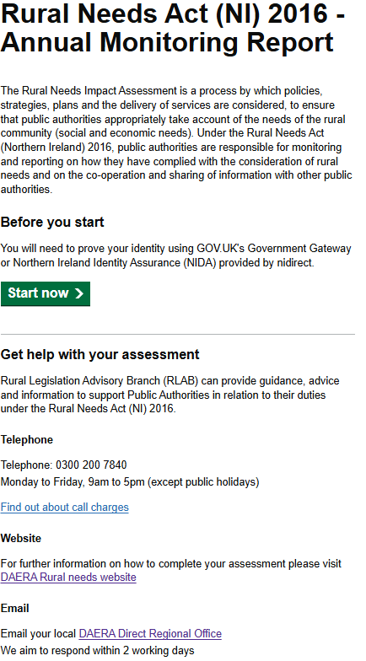

When the page loads, read the information provided and select the green Start Now button.

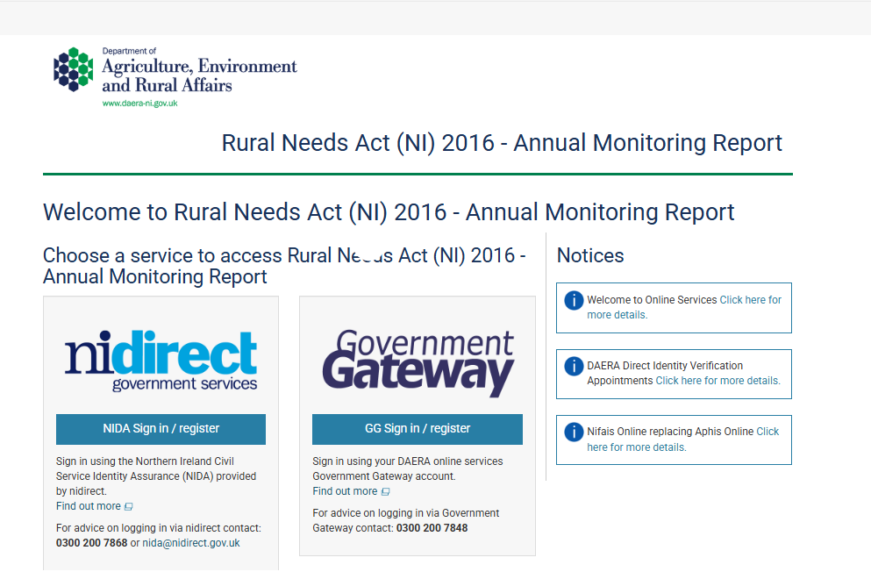
This will take you to an access page where you can choose to set up an account using either NI Direct Government Services or Government Gateway, using your Public Authority Credentials. The choice is based on personal preference.
If you already have existing login credentials with your Public Authority email address, you can use them and proceed to Page 14.

NI Direct (NIDA) Government Services Account Setup
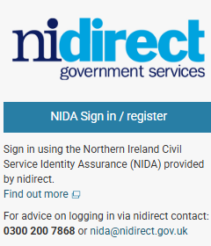
- Select NIDA Sign in / Register.

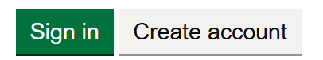
- If you do not already have a NIDA account, select Create account. If you already have a login, press Sign In.

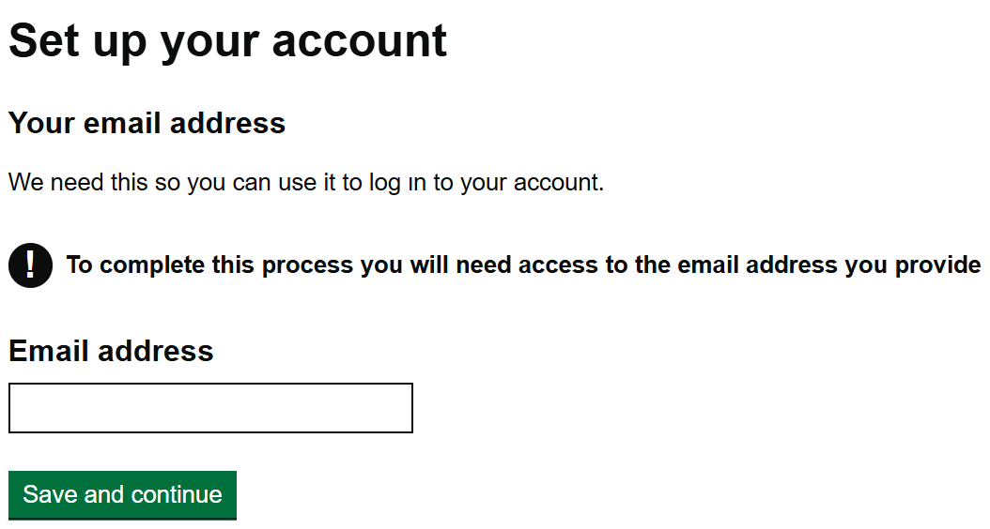

- Enter your Public Authority email address, then select Save and Continue.

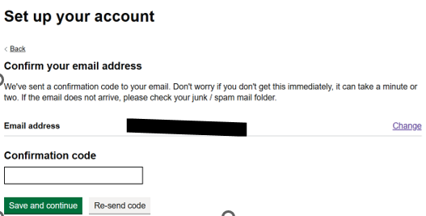
- You’ll receive a confirmation code by email. Enter the code into the on-screen box, then select Save and Continue.
Tip: Check your junk or spam folder if you don’t see it.

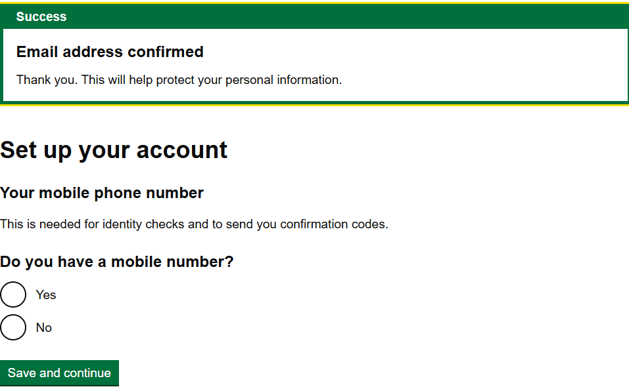
- A message will appear confirming “Email confirmed”. Continue setting up your account by answering the questions on screen. Select Save and Continue.

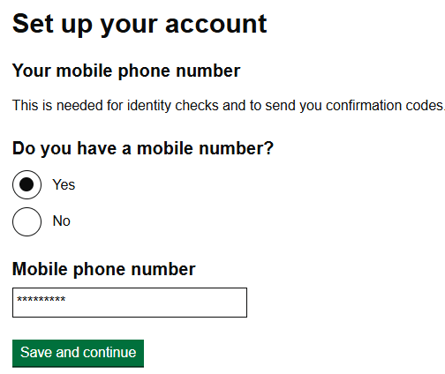

- You will be asked to enter your mobile number, then select Save and Continue.

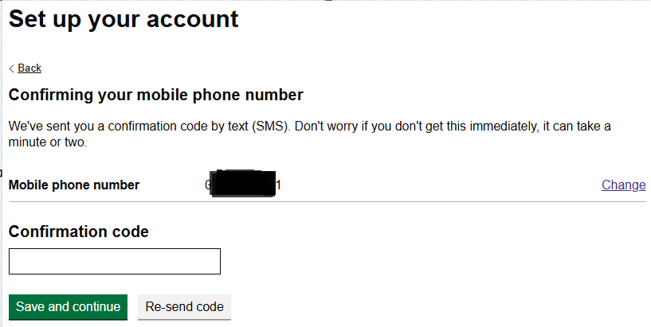

- A confirmation code will be sent to the mobile phone number you provided. Enter the code into the on-screen box when it arrives, then select Save and Continue.
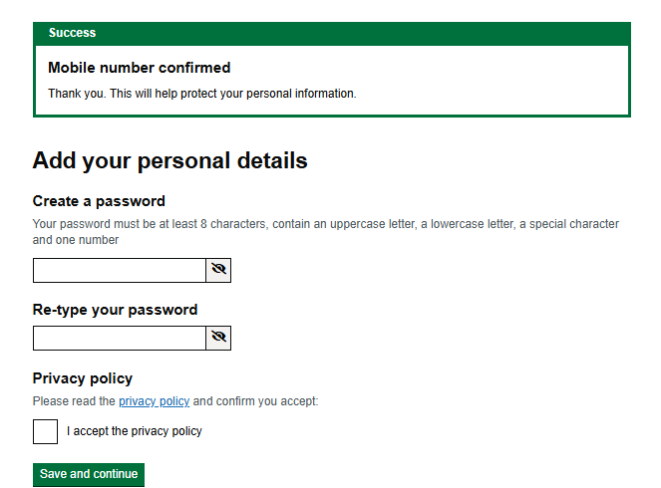
- A “Mobile number confirmed” message will appear. You will then be prompted to create a password and confirm it by re-entering it. You should read the Privacy Policy and, if you are content, then choose Save and Continue.

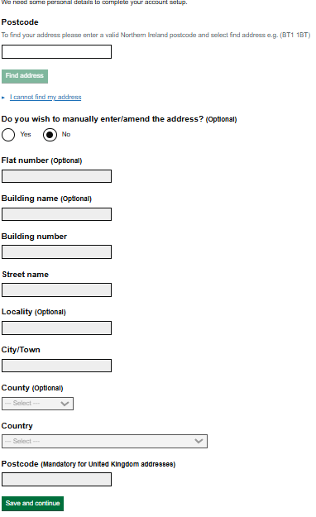
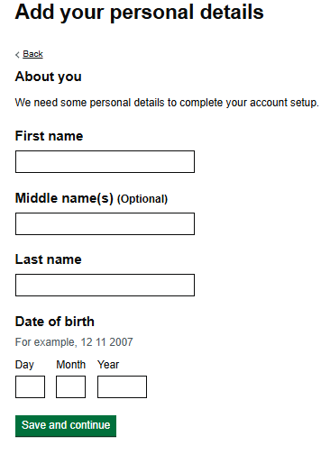

- Enter your personal details including Name, DOB and Address details, selecting Save and Continue at the end of each page.

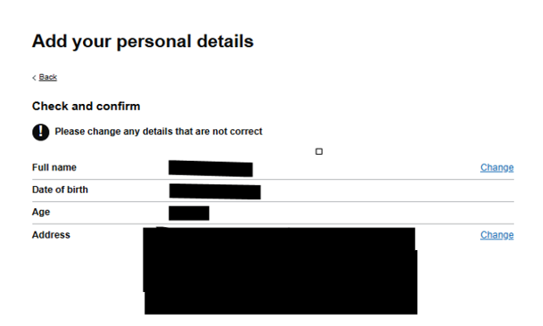
- Check your details, then select Confirm and Send when you are content.

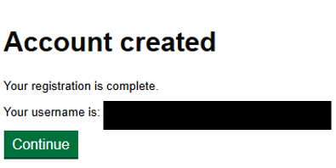
- You will be taken to the final page showing “Account created” along with your username. Select Continue.

Please take note of your Username and Password as you will need these to access the system in future.
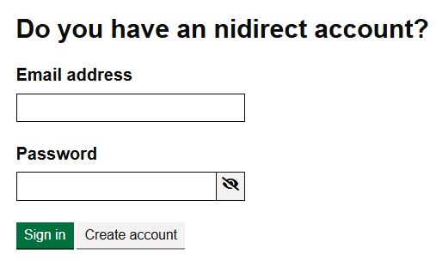
- Now Enter your new account details by typing your email address and password.

Select Sign in.

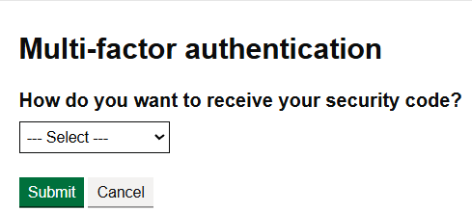

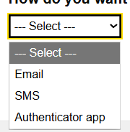
- Choose how you want to receive your multi-factor authentication code. Select an option and press
Submit.

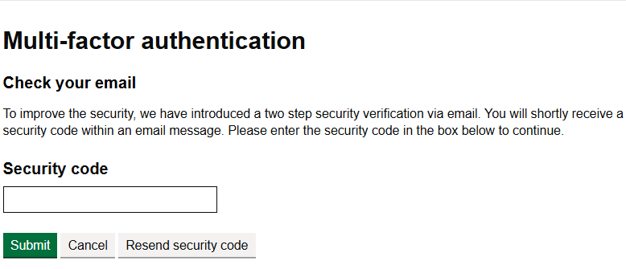
- You will receive a security code using the method you selected. Enter the code into the security code box, then press Submit.

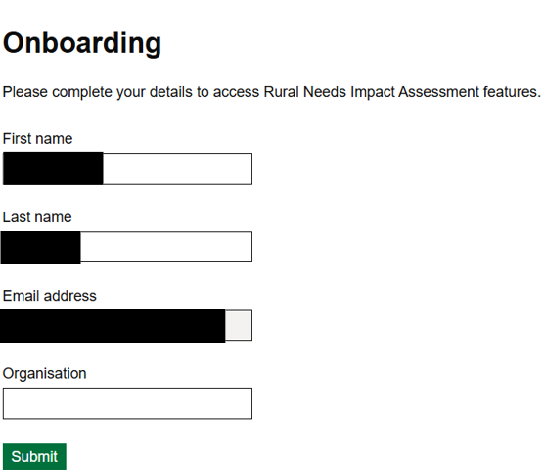

You have now reached the Onboarding page. Your information has pre-populated, but you must enter the Public Authority you belong to in the organisation box on screen. Select Submit to continue.

- Your Onboarding request is now complete. Once approved, DAERA will grant you access to the Rural Needs Assessment submission page. This can take up to one working day for this update to be processed.

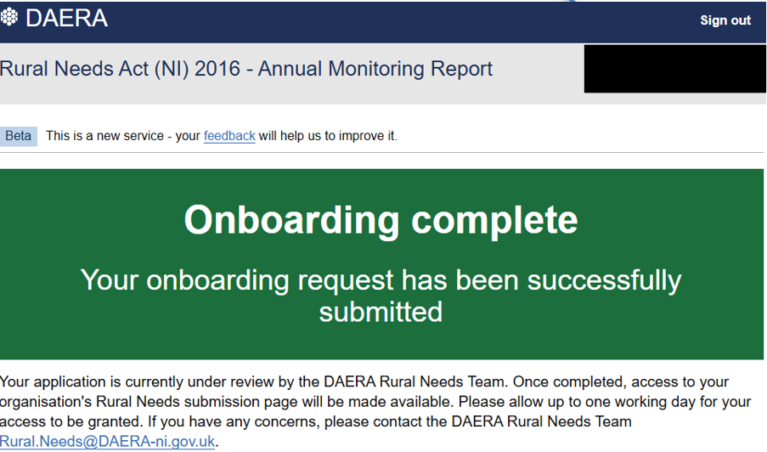

- Leave the Page by selecting Sign Out at the top right of the screen.

You are now setup with a NIDA account and should be able to access the Rural Needs submission page going forward.

If you experience any issues while setting up your account, please contact NI Direct:

Telephone: 0300 200 7868
Email: nida@nidirect.gov.uk

To setup a Government Gateway account, please see next page, otherwise please advance to Page 14 to continue with accessing the system

Government Gateway (GG) Account Setup

- Select Government Gateway on the access page.

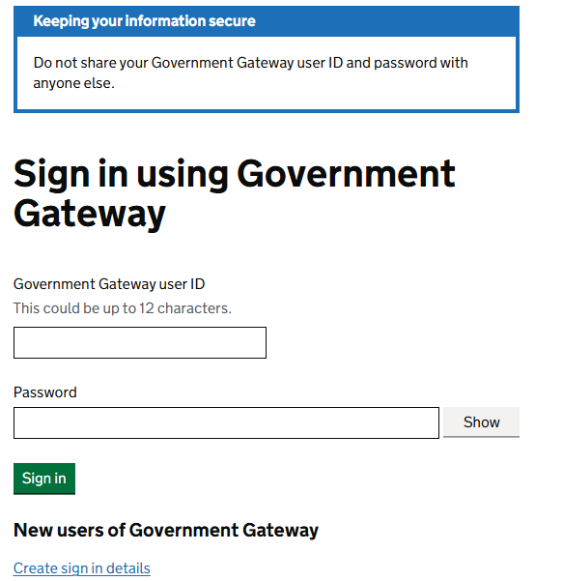
- Select Create Sign in details.

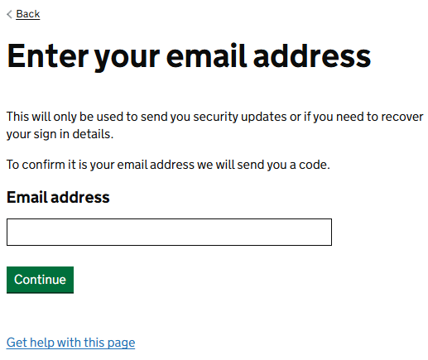

- Enter your Public Authority email address, then select Continue.

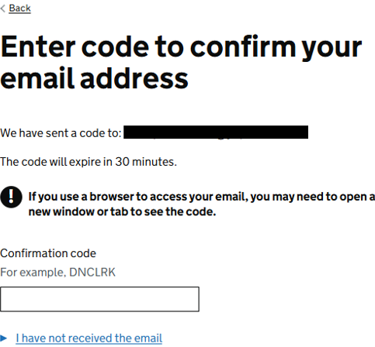

- A confirmation code will be sent to your email. Enter the code on the screen and select Confirm.
- Tip: Check your junk/spam folder if the email does not arrive.

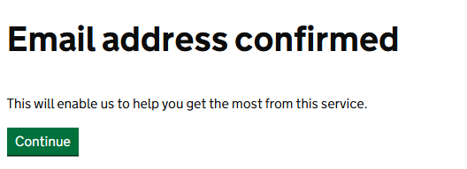
- You should now see that your email has been successfully confirmed. Select Continue.

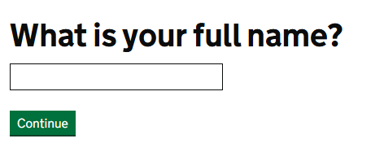

- Enter your name and select Continue.

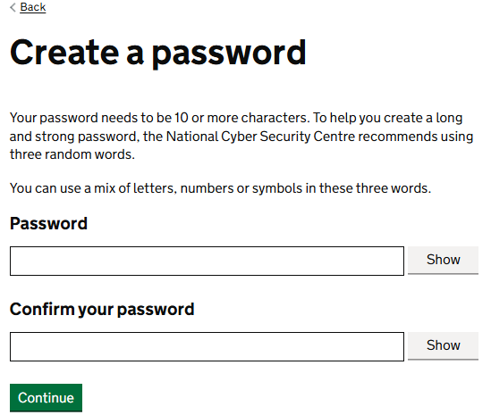

- Create a password and confirm it by re-entering it. Select Continue.

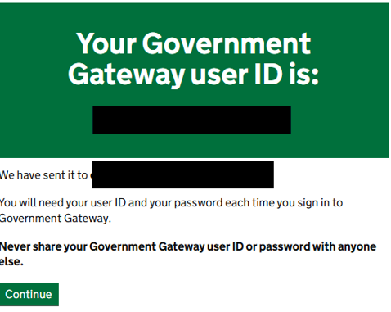

- Your Government Gateway account should now be set up. On screen, you will see your User ID number and confirmation of the email address it has been sent to. Select Continue.

Please take note of your Government Gateway ID and Password as you will need these to access the system in future.
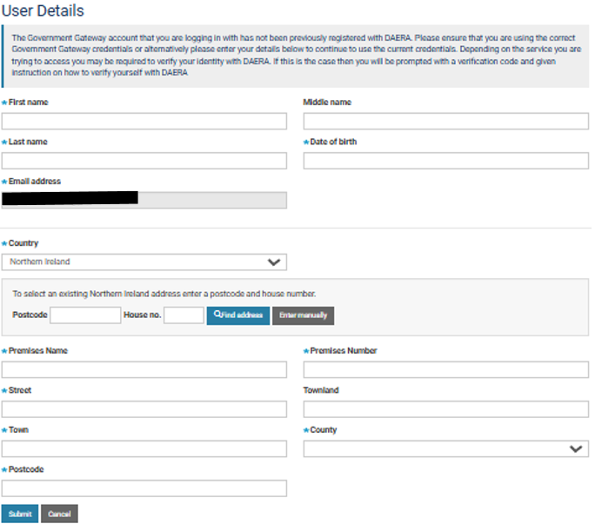

- Enter your personal details (name, date of birth, etc.), when you are satisfied it is correct select Submit.

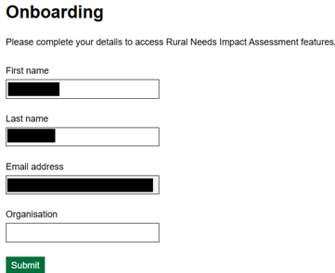

- You have now reached the Onboarding page. Enter the Public Authority you belong to in the organisation box on screen. Select Submit.

- Your Onboarding request is now complete. Once approved, DAERA will grant you access to the Rural Needs Assessment submission page. This can take up to one working day for this update to be processed.

- Leave the Page by selecting Sign Out at the top right of the screen.

You are now setup with a Government Gateway account and should be able to access the Rural Needs submission page going forward.

If you experience any issues while setting up your account, please contact Government Gateway.

Telephone: 0300 200 7848

Using the Public Authority Portal

How to Access the Public Authority Portal

Dashboard - Rural Needs Act (NI) 2016 - Annual Monitoring Report

- To access the Public Authority Portal, log in using either your NIDA account or your Government Gateway account.

A confirmation code will be sent to your email. Enter the code on the screen and select Confirm.

Tip: Check your junk/spam folder if the email does not arrive.

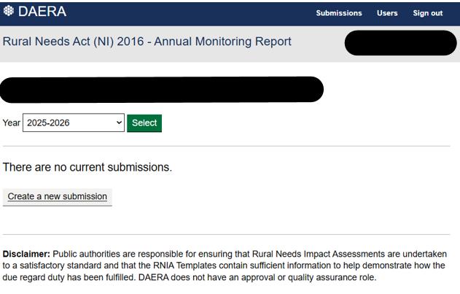
- Once logged in, you will be brought to the first page of the Submissions Dashboard.

Select the year for which you want to create a submission.

Click Create a New Submission to begin.

DAERA Rural Needs team ask each Public Authority to submit an Annual Rural Needs Monitoring Return, usually between April and June each year. During this time, a summary of any Rural Needs Impact Assessments created in the previous year can still be added.
Drafts of RNIA summaries can be created for the current financial year at any time, but these cannot be submitted to DAERA Rural Needs team until the following year when the system is opened for submissions.

Using the Submission Dashboard

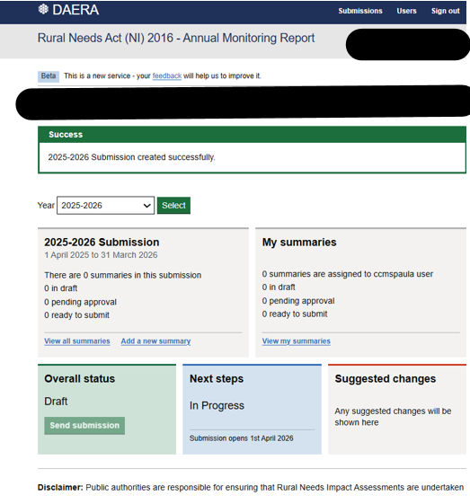
- The ‘Submission Dashboard’ reflects all the summaries of Rural Needs Impact Assessments created by your Public Authority. You can view summaries that are not assigned to you, but you cannot edit them unless you re-assign them to yourself. Each Public Authority will submit one Annual Rural Needs Monitoring Return to DAERA. This submission can only be made by your Rural Needs Coordinator.

The next page will outline each section of the Dashboard, explain its purpose, and provide guidance on how to use it effectively.
Creating a new Summary

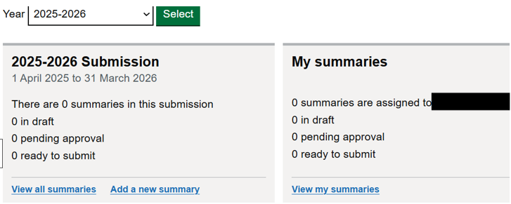

- To create a new summary, select Add a new summary.

To view all summaries for your Public Authority, select View all summaries.

To view your own summaries, select View my summaries.

- This page allows you to start to create your summary.
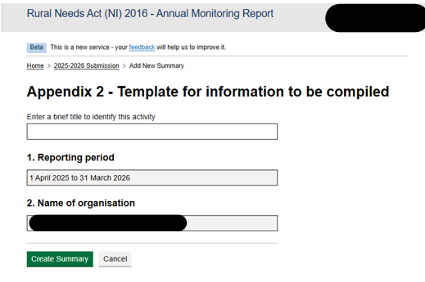

Enter a brief title. Sections 1 and 2 are already pre-populated with the reporting period and your Public Authority.

Select Create Summary.

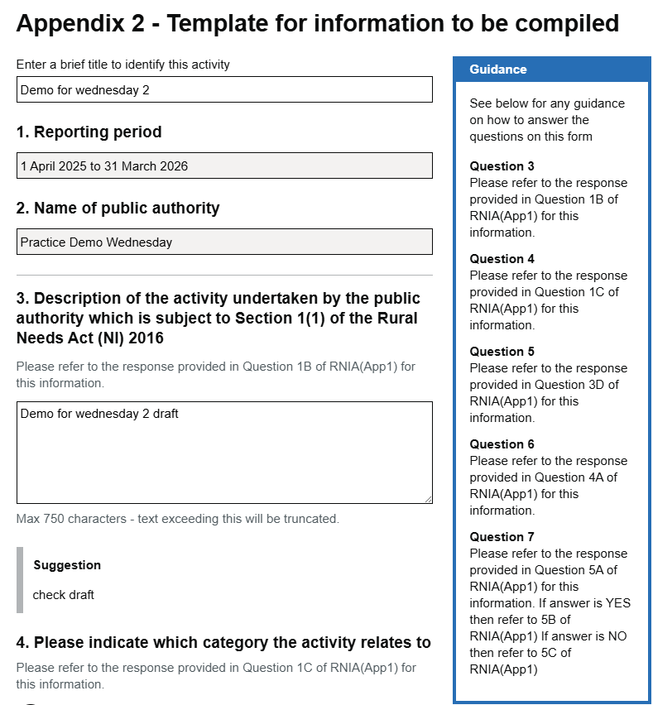
- The template is now available for you to complete your summary. It includes questions with radio buttons (select one) and text boxes for written responses.

*Please note that text boxes have character limits*
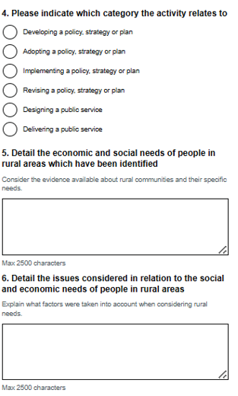

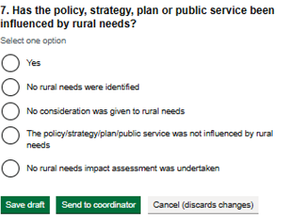
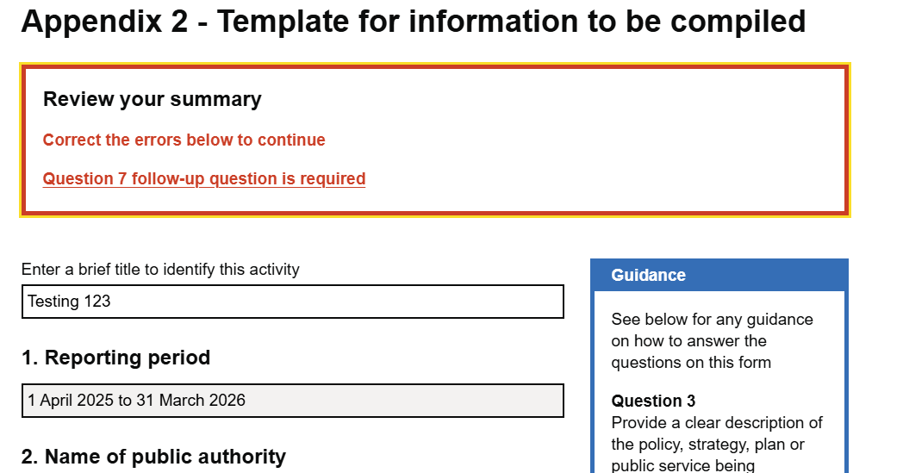
- If you try to save your draft or send it to the Rural Needs Coordinator without completing all required questions and text boxes, you will receive an error message.

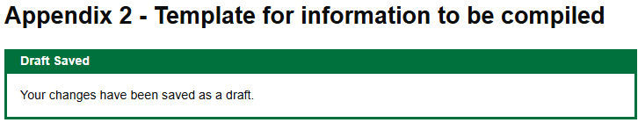
- You can save your draft at any time and return to continue editing later. When saved, you will see a confirmation message like the example here.

Viewing and Managing Summaries
- After you save your draft or send it to the Rural Needs Coordinator, the Submissions Dashboard will refresh. It will display the number of summaries that you have created, the number included in the overall submission and their current status, including:
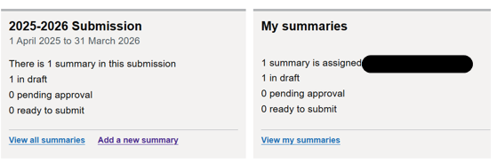
• Number of summaries assigned to you
• Draft
• Pending approval
• Ready to submit

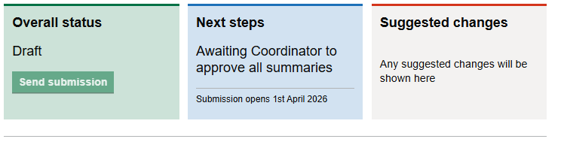
- The lower section of the Submission Dashboard updates automatically as your summary progresses.

- The Overall Status will update to Send Submission once all summaries have been approved and set to Ready by the Rural Needs Coordinator. Only the Rural Needs Coordinator can submit the completed return to the DAERA Rural Needs Team

- The Next steps box will indicate when the submission is awaiting Rural Needs Coordinator approval of all summaries

- The Suggested Changes box indicates that DAERA have proposed amendments to your summary. The summary will be reviewed by the Rural Needs Coordinator who can then return to its owner or retain ownership and then choose to accept or ignore the suggested changes.
- Select View my Summaries to see all Summaries you have created.

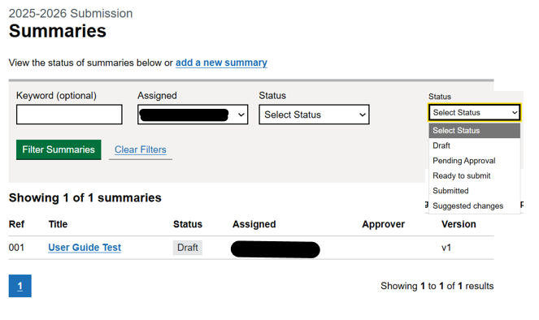

- If you have multiple summaries in progress, you can use the filter options at the top of the page to help you find the one you need.

Select from the dropdown menus available and then Filter Summaries.

To revisit your summary, select the blue link under title column

- When you access a saved submission through the View My Summaries page, if you click on any summary the system will take you to the Review Summary page, where you can:

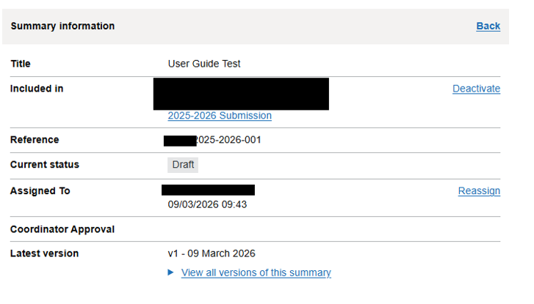
- Deactivate the Submission (this will remove it from your dashboard)

- Reassign the summary to another member of your Public Authority (see next page)

- View all versions of this summary

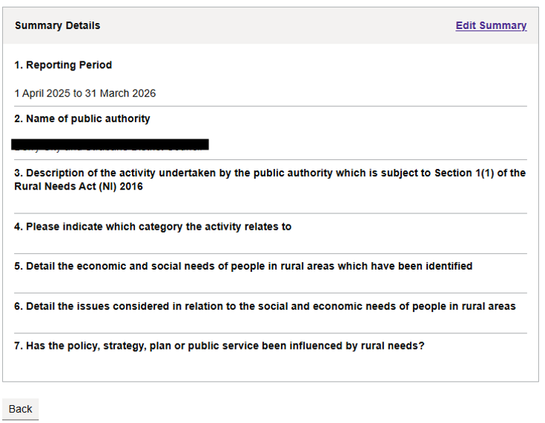
- Edit Summary

- Go Back to Dashboard

Reassign A Summary
- To reassign a summary to another member of your Public Authority, select the Reassign button on the Summary Information Page.

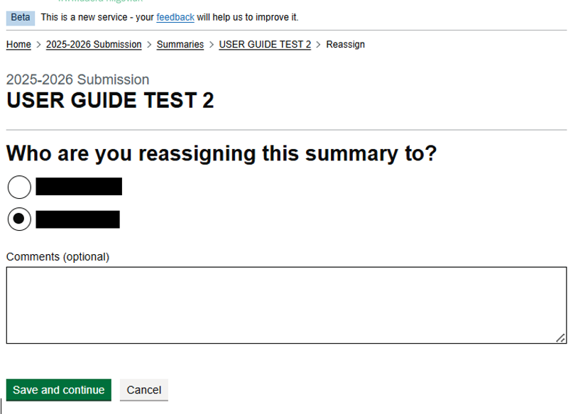

- Choose the member of your Public Authority you wish to assign the summary to, then enter an optional comment.

Select Save and Continue to confirm.

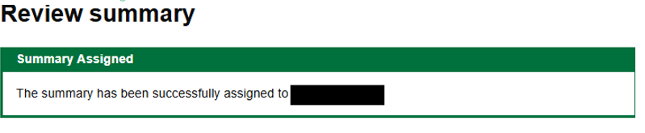
You will get a Summary assigned statement confirming the change

Sending a Summary to a Rural Needs Coordinator
The Rural Needs Coordinator is the individual assigned to review and approve your Public Authority summaries.
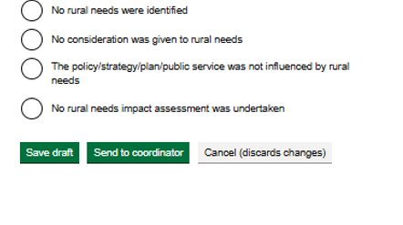
- Once you are satisfied that your summary is complete, you can Send to Rural Needs Coordinator for review. A cancel option is also available if do not wish to proceed. The Rural Needs Coordinator will review your summary.

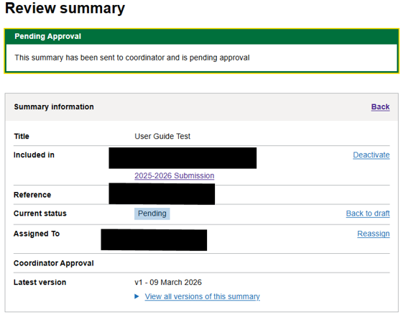
- Once you send your summary to the Rural Needs Coordinator, your review summary will update to show that it is pending approval.

The ‘Current Status’ line will display Pending, and your Summaries homepage will also show the submission as Pending.
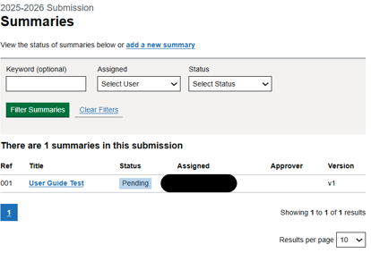

Return Summary to Draft After Submission to Rural Needs Coordinator

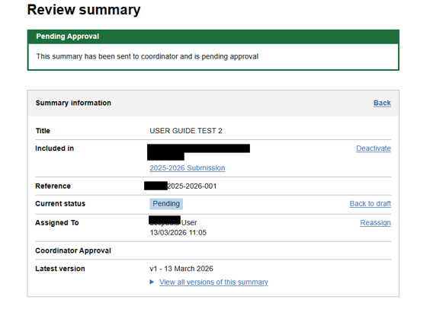

- If you realise you have made a mistake after sending your summary to the Rural Needs Coordinator for review, you can select Back to Draft, provided the Rural Needs Coordinator has not yet submitted the overall submission. If the submission has already been submitted, you will need to contact DAERA to request that it be reopened.

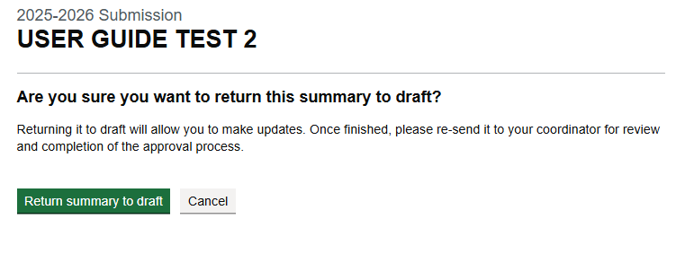
- Confirm by selecting Return Summary to Draft.

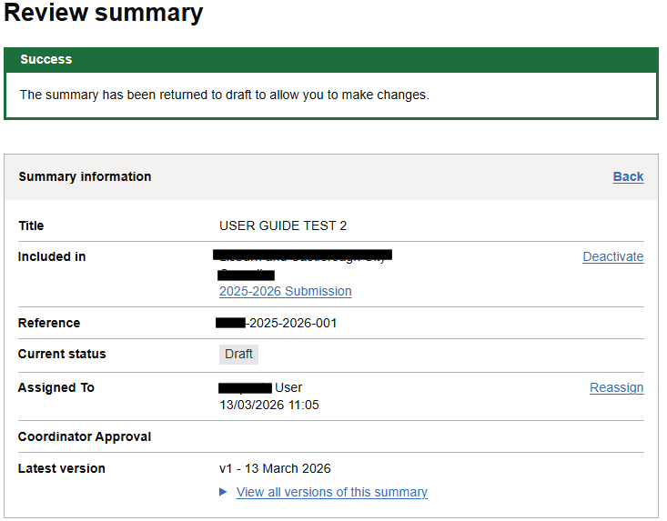

- A success message will appear at the top of the Review Summary, and the ‘Current Status’ will change back to Draft.

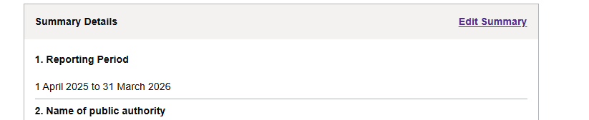
- Select Edit Summary to make your changes

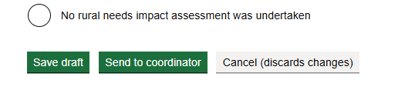
- When you have made your changes, resend it to the Rural Needs Coordinator for review

Rural Needs Coordinator Only Functions

Rural Needs Coordinator Summary Page

- Rural Needs Coordinators can carry out all administrative functions, including reassigning colleagues’ submissions to themselves. The only difference is that they can approve submissions and send the overall submission to the DAERA Rural Needs Team.
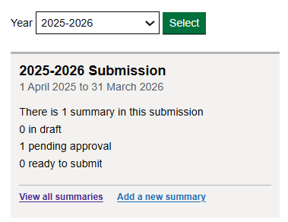

- As Rural Needs Coordinator, select View all Summaries to open a full list of submissions for your Public Authority.

- Choose the summary you want to review by selecting the blue link in the Title column.

How to Return a Summary to the Policy Lead (Pre-Approval Stage)
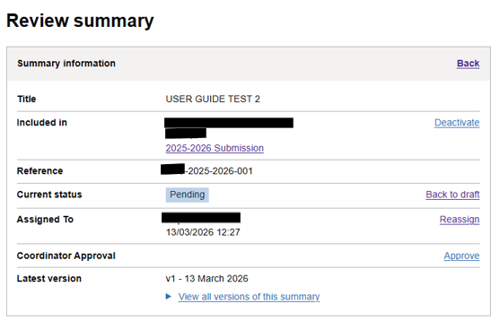

- If, as the Rural Needs Coordinator, you are not satisfied with any part of the summary, you can return it to Draft and amend it as required, or reassign it to the Policy Lead, who can then return it to Draft mode and make the necessary edits.

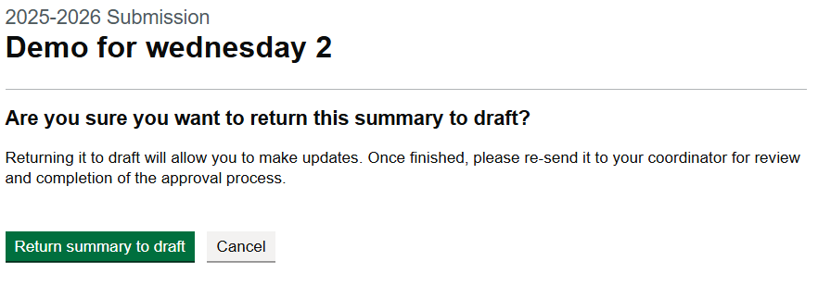
- If you return the summary to Draft, you will receive a message confirming the change. This message explains that returning to Draft allows you to make updates and reminds you to resend the summary to your Rural Needs Coordinator for review once the changes are complete.

Select Return summary to draft.

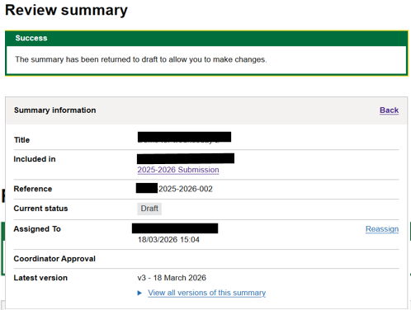

- The Summary has now been returned to draft to allow changes.

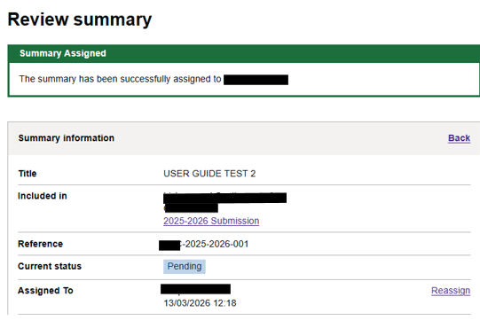
- If the Rural Needs Coordinator chooses to reassign the summary rather than return it to Draft, the Review Summary page will display a ‘summary assigned’ message, and the ‘Current Status’ will update to Pending. The Policy Lead can then return the summary to Draft and make any changes required.

Remember that all summaries must be resubmitted to the Rural Needs Coordinator for approval before the overall submission can be sent to the DAERA Rural Needs team.

Rural Needs Coordinator Summary Approval

- As a Rural Needs Coordinator, an additional option will appear in your Review Summary allowing you to approve it.

If you are satisfied with the content, select Approve.

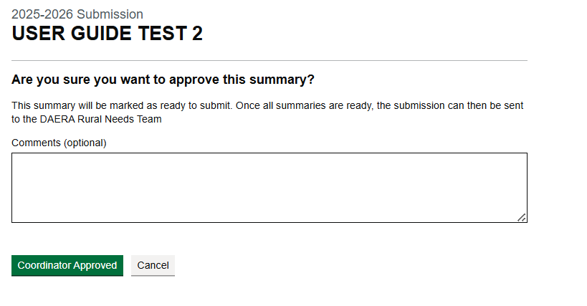

- Once you have added any optional comments, select Rural Needs Coordinator Approved.

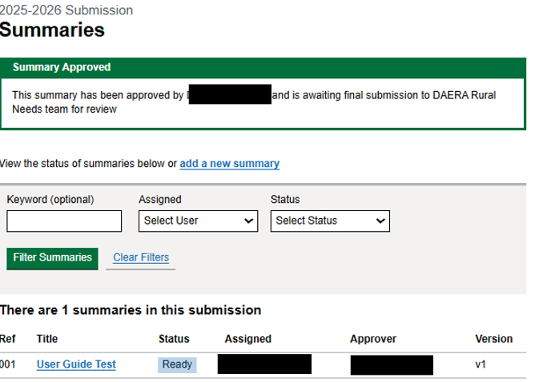

- The summary will then be marked as Ready and will be awaiting final submission.

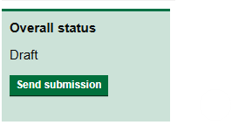
Rural Needs Coordinator Overall Submission Approval

- When all summaries for the Public Authority show as Ready, the Overall Status box on your Submission Dashboard will activate the Send Submission button.
Select Send Submission.

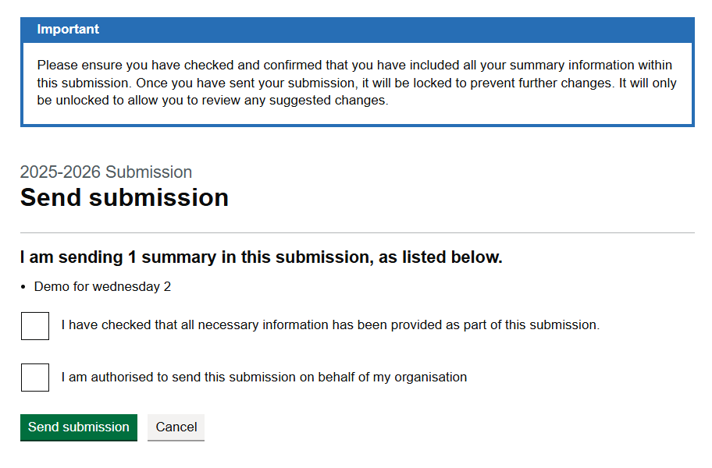

- Read the statement at the top of the page and select the checkboxes to verify that you have checked each submission and are authorised to submit the return on behalf of your Public Authority. Once completed, select Send Submission.

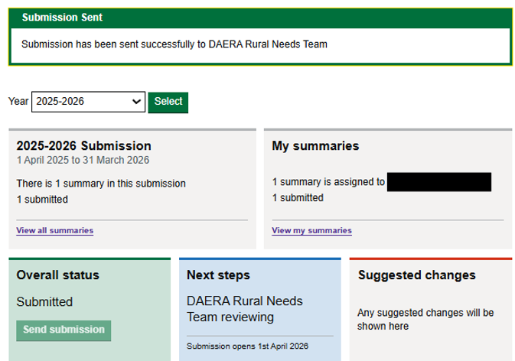

- Your Submission Dashboard will now display a confirmation message showing that the submissions have been sent to the DAERA Rural Needs Team. The Overall Status box will update to reflect this, and the Next Steps section will change to ‘DAERA Rural Needs Team reviewing’.

Policy Lead & Rural Needs Coordinator

Reviewing and Applying Suggested Changes from the Rural Needs Team

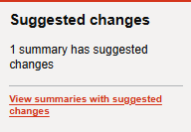
When the DAERA Rural Needs Team reviews the submission, they may suggest changes. If this happens, the submission will be returned to you as the Rural Needs Coordinator. The ‘Suggested Changes’ box at the bottom of your Submission Dashboard will update to show how many summaries require amendments. For example, if there are four summaries and only one requires a change, the remaining summaries cannot be edited.

Select View Summaries with suggested changes to review.

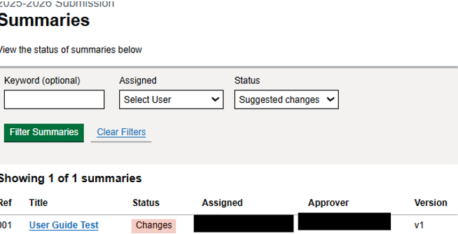
- Your Summaries page will now display an updated status column showing what summaries require Changes.

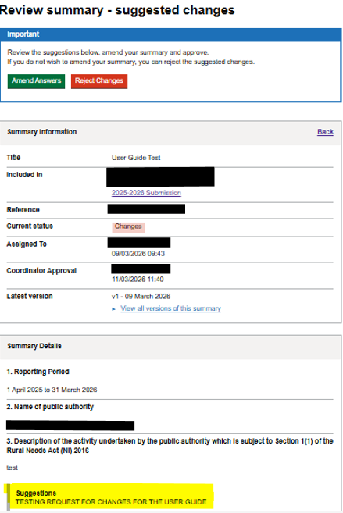
- When you open a summary that requires changes, you—as the Rural Needs Coordinator—can either reassign it back to the original Policy Lead in your Public Authority or make the changes yourself.

Whoever has been assigned to make the changes should select either the green amend answers or the red reject changes button at the top of the Review Summary Screen on their Submission Dashboard.

All suggested changes will appear in a text box beneath each relevant question in the Summary Details, as highlighted in yellow.

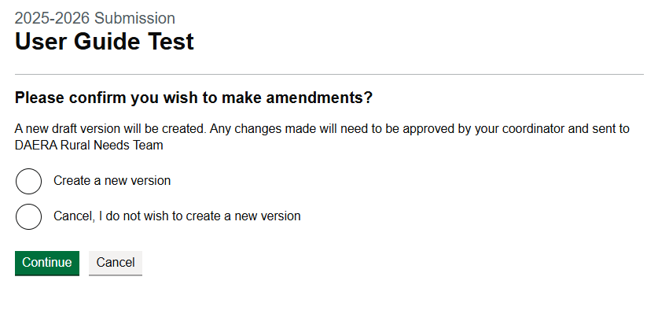
- If you agree to amend the answers as suggested by the DAERA Rural Needs Team, select Create a new version.

Select Continue.

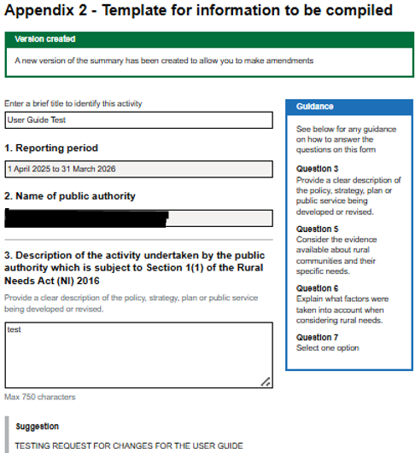

- A new version of the summary has been created, and all suggested changes will appear in a text box beneath each relevant question. It is then the responsibility of the Public Authority to update the summary in line with the suggested changes.

- Once the relevant changes have been made - either by the Public Authority Policy Lead who created the summary or by the Rural Needs Coordinator who is content to make the changes - the summary must be returned to the Rural Needs Coordinator’s Submission Dashboard by selecting Send to Rural Needs Coordinator.


Resubmitting a Submission to DAERA Rural Needs Team by Rural Needs Coordinator

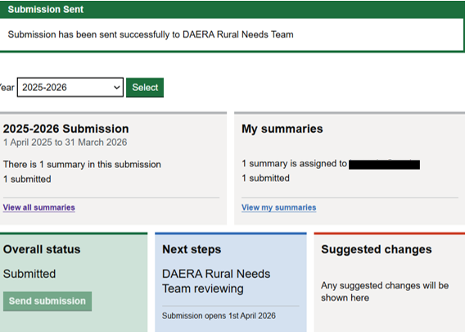

- As in the previous steps, the Rural Needs Coordinator will resubmit the overall submission for review by the DAERA Rural Needs Team, and the Rural Needs Coordinator Submission Dashboard will update to reflect this.

Submission Approval by DAERA Rural Needs Team
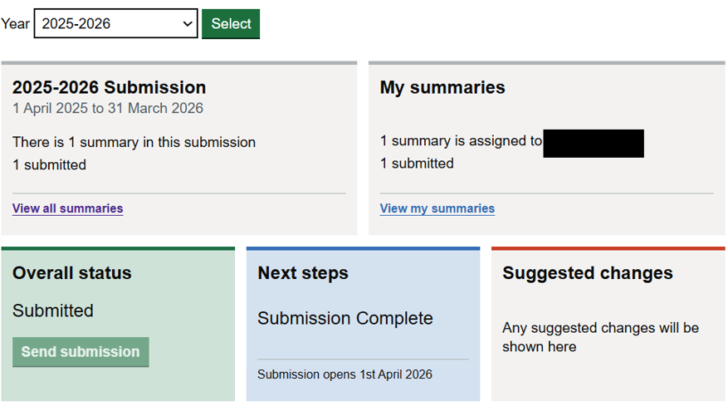
- If the DAERA Rural Needs Team accepts the changes on their dashboard, the Public Authority dashboards will update to show the Overall Status as Submission Complete.

The submission for this Public Authority, for the selected reporting year, is now complete.

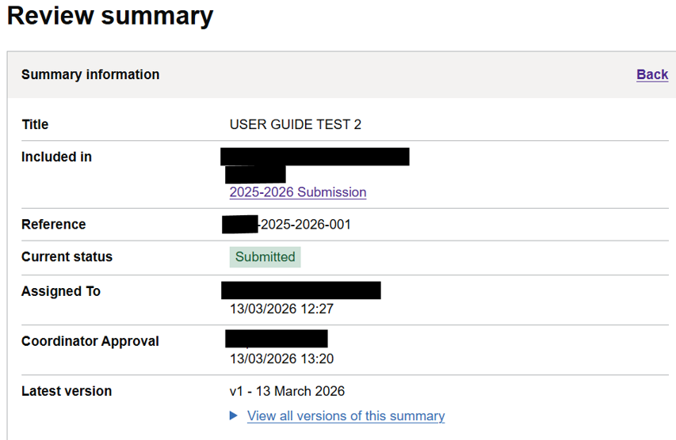

- Once submitted and accepted by the DAERA Rural Needs Team, the Public Authority can no longer edit or re-assign their summaries; however, the summaries will still remain viewable.

Downloading and Printing Your Summary
Downloading and Printing Your Summary (Policy Lead or Rural Needs Coordinator)

You can download a copy of a summary at any stage (Draft, Pending, Ready or Submitted) for your own records or internal review.

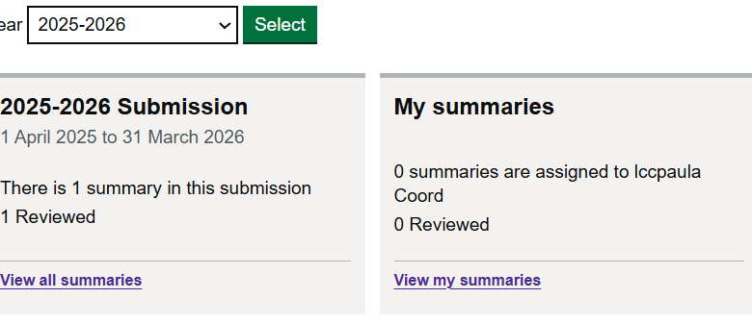
- From the Submission Dashboard, open your summary by selecting View my summaries (or view all summaries if you are a Rural Needs Coordinator), then select the blue link in the Title column.

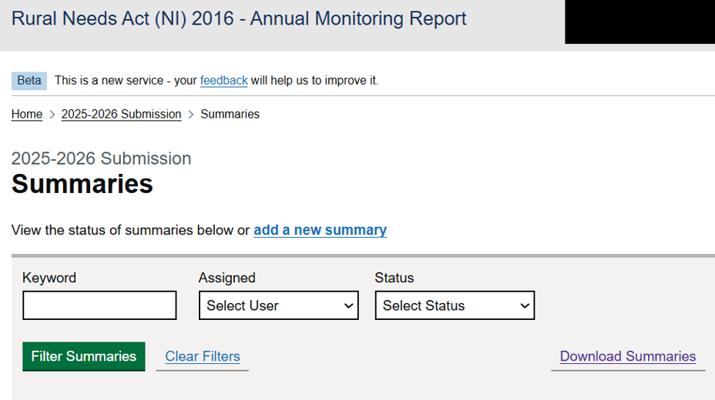

- On the Summaries page, select Download Summaries.

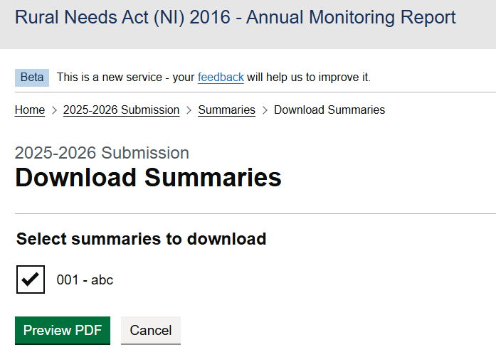

- Tick the summary or summaries you want to download, then select Preview PDF.

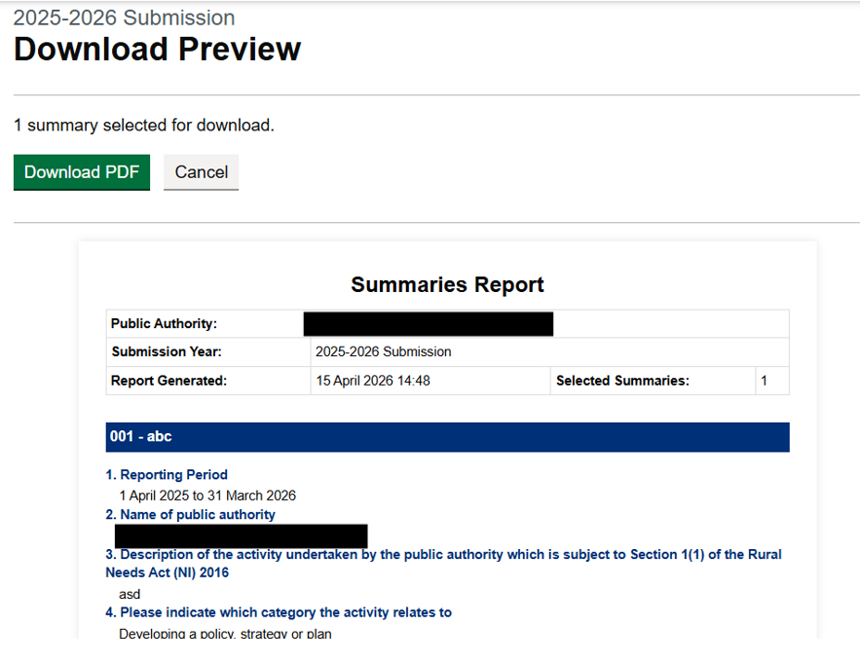

- If you are content, select Download PDF.

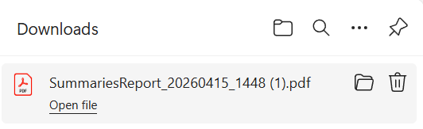

- The download will appear at the top right of your screen. Select Open file.

- To print, select Print (or press Ctrl + P).

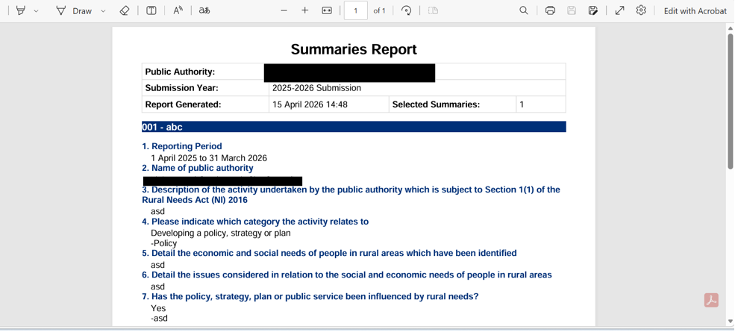
Submission Process at a Glance

A Quick Guide to the Submission Workflow

- Log on to the Submissions Dashboard

- Create a New Summary

- Once content Send it to your Public Authority Rural Needs Coordinator.

- The Rural Needs Coordinator will review your summary along with any others. Once all summaries are approved and set to Ready, the overall submission will be issued to the DAERA Rural Needs Team for review.

- If the Rural Needs Team returns the submission with Suggested Changes, these must be either accepted or rejected following the correct process.

- If changes are made, the updated summary should be resubmitted to the Rural Needs Coordinator for re-issue to the Rural Needs Team.

- The Rural Needs Team will review the updated submission and, if content, will accept the changes and the overall submission.

- Once accepted, the overall status on your Public Authority Dashboard will update to reflect that the submission has been approved by the Rural Needs Team.

For any further queries please contact: -
rural.needs@daera-ni.gov.uk

For further information:

Rural Legislation Advisory Branch
Jubilee House
111 Ballykelly Road
Ballykelly
BT49 9HP

Email: rural.needs@daera-ni.gov.uk
www.daera-ni.gov.uk

