Annex A – Application system screenshots
To make your application to FwNH go to the DAERA website and log in to the online services.
There is one application portal for both the FwNH Scheme and the FwNT Scheme. I you want to apply for both schemes make sure you DO NOT submit your application until you have selected everything you want to apply for.
Once you click ‘Submit Application’ you will not be able to make any further changes to your application.
Information from your expired EFS T4 agreement will be pre-populated.
When you log in you will see an icon ‘Farming with Nature’ on your dashboard, select this to proceed and you will see the following screen:
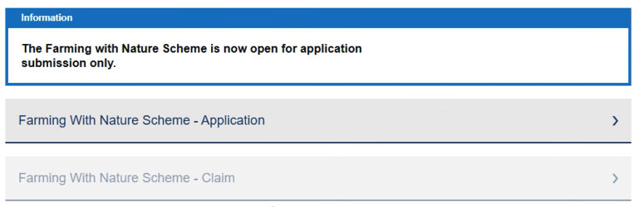
From here select ‘Farming with Nature Scheme – Application’ and you will be brought through to the welcome screen.
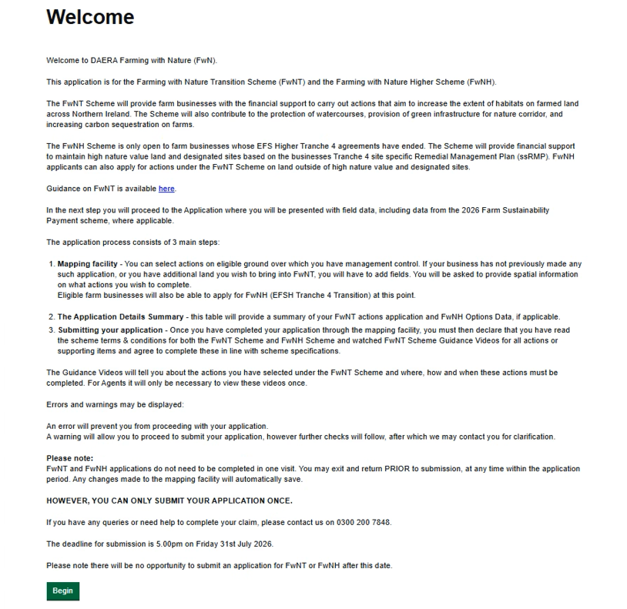
Once you have read the information provided select the green button that says ‘Begin’ to proceed. You will be brought through to the application screen where you will see a data table showing fields associated with your farm business underneath a map of Northern Ireland. The data is from the 2025 Farm Sustainability Transition Payment Scheme.
Information from your expired EFS T4 agreement will be pre-populated on the map and the fit table.
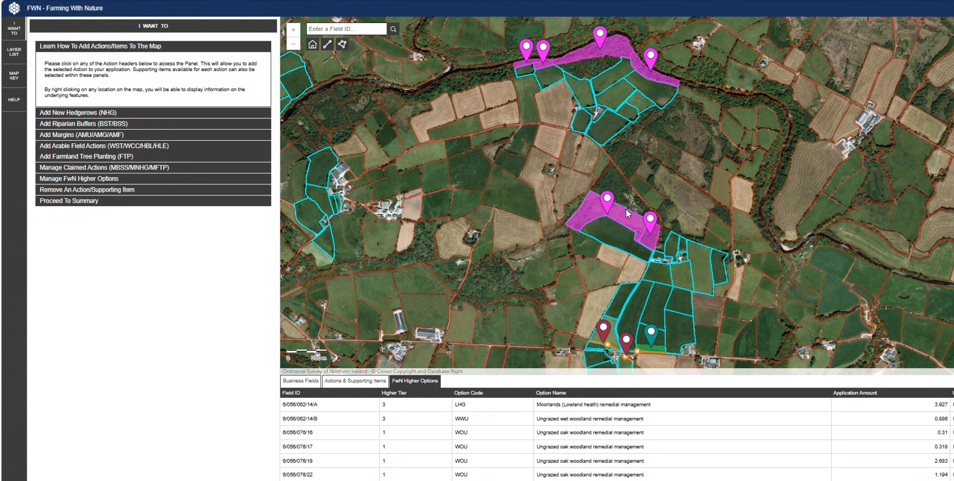

On the left hand side of the screen you will see a number of options. ‘I want to’ will guide you through what to do. You can select actions you wish to carry out on your non priority habitat land and also remove an action or supporting item should you need to adjust your application.
A full guide on how to do this can be accessed here How do I Apply for the FwNH Scheme?
If you do not want to apply for the FwNT Scheme, click on ‘Manage FwN Higher Options’ on the left hand side of the screen.
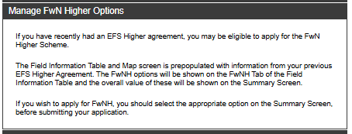
You will not be able to make any changes to the pre-populated information on the screens.
Click on the Proceed to Summary tab. This will bring you to a summary of your application.
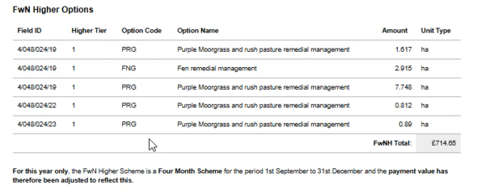
Applicants will have a decision to make prior to submitting their application. These are:
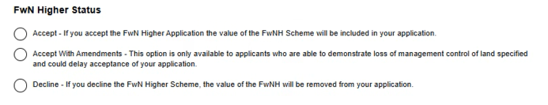
You then need to click on the appropriate links that tick the relevant boxes prior to submitting your application.

