Arable - Grass Margin (3 m - 12 m) – Requirements and Guidance
Objective
Establishing grass margins on arable land provides habitat for overwintering invertebrates, some of which prey on pests of cereals. It also offers nesting and foraging sites for birds and mammals. Thick grass margins along wide hedgerows support small mammals, making them ideal hunting areas for Barn Owls and Kestrels.
The minimum requirements to comply with this action are detailed in the green box below. Additional guidance is also provided to help you to adopt best practice.

Arable - Grass Margin (3 m-12 m) Requirements

- This action must not be carried out on:
  - Fields within an area designated as a Special Area of Conservation, a Special Protection Area, a RAMSAR site or an Area of Special Scientific Interest.
  - Northern Ireland priority habitat and species areas*; or
  - Permanent Grassland Sensitive areas.
- A grass margin, 3 m wide to 12 m wide, must be created along part or for an entire field boundary, where the main field crop is cereal, in line with normal husbandry practice.
- The area allowed is a minimum of 0.1 ha up to the maximum funding available per applicant.
- Establish a grass margin using an untreated seed mix of tussock forming grasses and fine grasses from the Grass Seed Mix List.
- Fertilisers (organic and inorganic), lime and plant protection products, except for the spot treatment of noxious and invasive weeds, must not be applied.
- The margin must not be grazed or damaged by livestock or machinery.
- The margin must be established by the last day of February of the same scheme year.
- Evidence of the seed mix used (labels, invoices detailing mix contents and quantity supplied) must be retained.
- The margin must be retained for at least 5 years.

Table 1 Grass Seed Mix List
Tussock-forming grasses (15% of mix) | Fine grasses (85% of mix)
Cocksfoot (Dactylis glomerata) | Red Fescue (Festuca rubra)
Timothy (Phleum pratense) | Sheep’s Fescue (Festuca ovina)
Yorkshire Fog (Holcus lanatus) | Creeping Fescue (Festuca rubra)
 | Rough‑stalked Meadow Grass (Poa trivialis)
 | Smooth Meadow Grass (Poa pratensis)
 | Common Bent (Agrostis capillaris)
 | Creeping Bent (Agrostis stolonifera)
 | Sweet Vernal Grass (Anthoxanthum odoratum)
 | Crested Dog’s‑tail (Cynosurus cristatus)
 | Meadow Foxtail (Alopecurus pratensis)

What success looks like
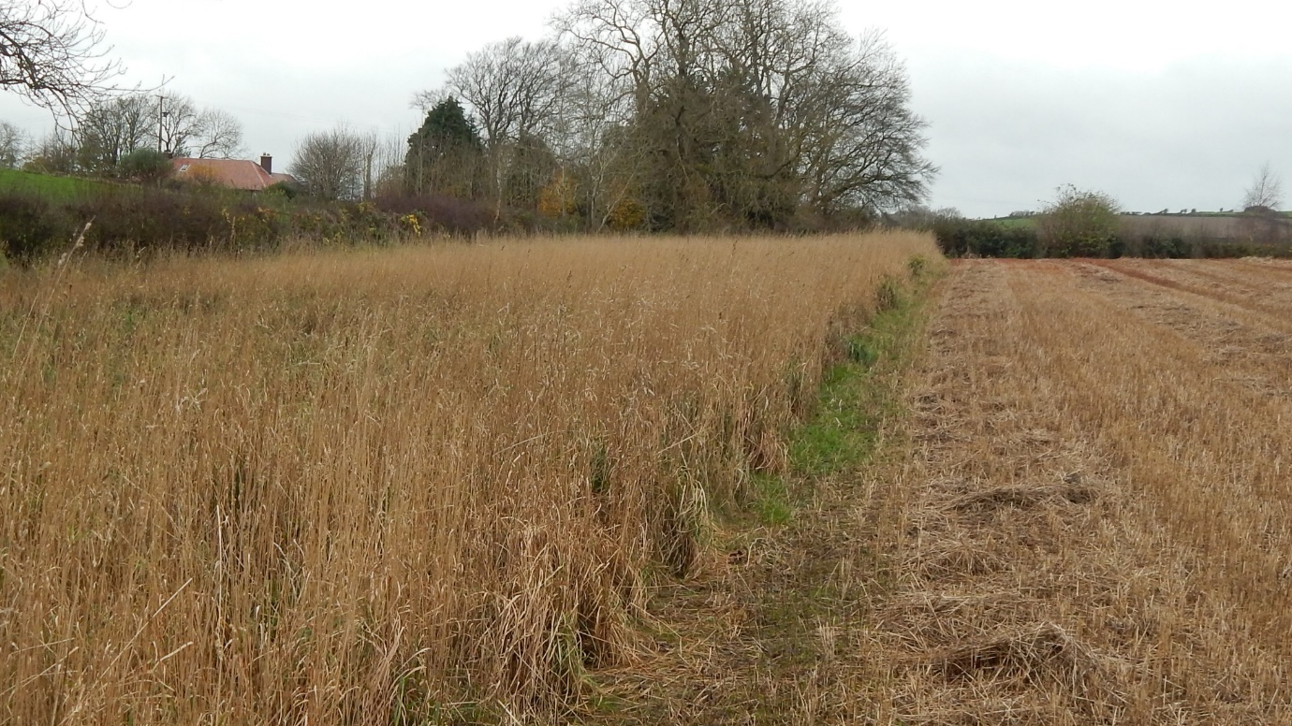
Figure 1: Arable – Grass Margin

GUIDANCE

Where to create margin
Arable grass margins should be created alongside a short, dense hedge to provide ideal habitat for birds such as yellowhammers, which nest on or close to the ground and rely on thick vegetation for nesting cover, and to support foraging opportunities for barn owls and kestrels. These margins also play an important role around arable fields by boosting natural pest control and reducing the need for insecticides.
Sowing a seed mix
Using the seed mix from Table 1, sow on a seedbed that is firm, consolidated, fine, level, weed free and moist, any time post-harvest of the preceding crop, at a rate of 20 kg/ha. You can either broadcast the seeds onto the surface of the seedbed to help germination or shallow-drill the seeds up to a depth of 1 cm. Small seeds may struggle to germinate when sown deeper than 1 cm.
Establishment
You should cut the margin three times in the 12-month period following sowing. This will encourage tillering and minimise weed development. Aim to cut when the sward reaches 10 cm high.
You must not apply fertilisers and lime to the margin. Additionally, plant protection products must not be used except for the spot treatment of noxious and invasive weeds. You must not graze or damage the margin, including by regular vehicular access, turning or storage. Take care when applying nutrients and pesticides to adjacent crops to avoid ‘drift’ into grass margin.
Management
Once established the grass margin should not be disturbed and must be retained for a minimum of 5 years. These margins are permanent low-maintenance habitats, requiring little disturbance and should not be cut more than once every three years to allow mature tussocks to develop and support a host of farmland wildlife.
Through the Farming with Nature Scheme, you can apply for the Management of Arable - Grass Margins in the year after establishment, to support retention and management.
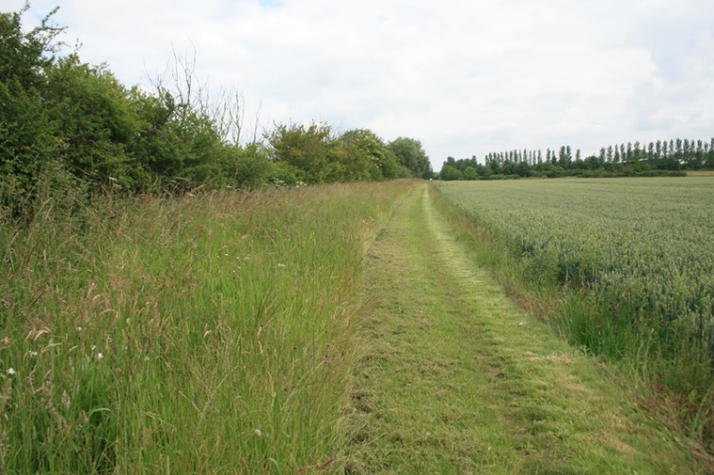
Figure 2: Cutting part of grass buffer
Following the bird breeding season (1 March – 31 August), you can cut half of the grass margin’s width next to the edge of the crop (Figure 2), leaving both short and mid-length grass. Cutting in this manner can help to provide:
- Short grass for birds to forage in
- Mid-length grass for species like Irish hare
- Long, rarely cut tussocky grass to give shelter and nesting places for birds and invertebrates
To ensure continued habitat availability for invertebrates and small mammals, avoid cutting all margins in the same year by adopting a rotational cutting approach. As a guide, no more than one‑third of margins should be cut in any one year, and cutting should only take place after 1 September. This creates a three‑year rotation, helping to retain long, undisturbed tussocks while still preventing scrub encroachment

When cutting the margin:
- Where possible cut and remove vegetation to prevent the build‑up of a dense thatch, which can suppress grass structure and increase nutrient loading. This helps maintain the tussocky habitat. If it is impractical to do this, finely chop and spread cuttings as thinly as possible.
* Care must be taken to ensure that these actions are not implemented in sensitive semi-natural and species-rich habitats such as Grasslands, Wetlands, Coastal and Moorland habitats. Data from Northern Ireland Environment Agency (NIEA) records of habitats and species has been used within the Farming with Nature application system, but this does not infer the complete coverage of these environmental assets in Northern Ireland.

