Arable - Unharvested Cereal Margin (3 m - 12 m) – Requirements and Guidance

Objective
The action involves leaving an unharvested cereal crop margin along field margins to provide a summer and winter food source and a habitat for insects and food for seed-eating farmland birds.
The minimum requirements to comply with this action are detailed in the green box below. Additional guidance is also provided to help you to adopt best practice.

Arable - Unharvested Cereal Margin (3 m - 12 m) Requirements

- This action must not be carried out on:
  - Fields within an area designated as a Special Area of Conservation, a Special Protection Area, a RAMSAR site or an Area of Special Scientific Interest;
  - Northern Ireland priority habitat and species areas*;
  - Permanent Grassland Sensitive areas; or
  - A maize crop.
- A cereal crop margin, 3 m wide to 12 m wide, must be created along part of or for an entire field boundary, where the main field crop is cereal, in line with normal husbandry practice.
- The area allowed is a minimum of 0.1 ha up to the maximum funding available per applicant.
- Fertilisers (organic and inorganic), lime and plant protection products, except for the spot treatment of noxious and invasive weeds, must not be applied.
- The margin must not be grazed or damaged by livestock or machinery.
- The margin must be retained until the last day of February of the same scheme year.

What success looks like
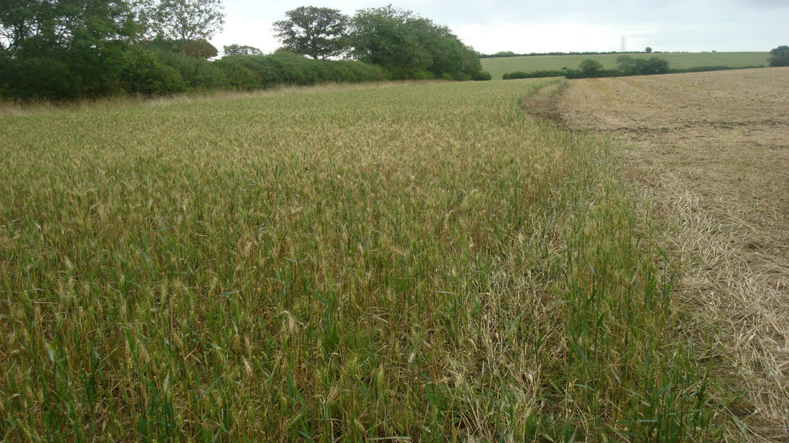
Figure 1: Arable - Unharvested Cereal Margin

GUIDANCE

Where to create margin

The action requires leaving an unharvested cereal margin of between 3 m and 12 m along field margins where the main crop is a cereal crop until the end of February.
To maximise the benefits for wildlife, it is recommended that you choose sites that are not highly fertile to reduce lodging, get plenty of sunlight, have a low weed burden and are close to complementary habitats such as hedgerows, scrub and arable grass margins to provide food and shelter all year round.
Distributing unharvested cereal crop margins across your farm can help farmland birds and other wildlife find food and shelter and move easily and safely between complementary habitats (such as hedgerows, ponds and field margins).
How long must the margin be kept?
You must retain all unharvested cereal crop margins until the last day of February. This will help to maximise the availability of food and shelter for farmland birds and other wildlife over winter. This is more feasible for plots located on light or medium soils that can be cultivated more easily in the spring.

Management

You must not apply fertilisers and lime to the margin. Additionally, plant protection products must not be used except for the spot treatment of noxious and invasive weeds. You must not graze or damage the margin, including by regular vehicular access, turning or storage. Take care when applying nutrients and plant protection products to adjacent crops to avoid ‘drift’ into the unharvested cereal crop margin.
Removal of margin after February
At the end of the retention period, you can flail areas of tall vegetation to make it easier to prepare the seed bed for the following crop.

*Care must be taken to ensure that these actions are not implemented in sensitive semi-natural and species-rich habitats such as Grasslands, Wetlands, Coastal and Moorland habitats. Data from Northern Ireland Environment Agency (NIEA) records of habitats and species has been used within the Farming with Nature application system, but this does not infer the complete coverage of these environmental assets in Northern Ireland.

