Creation of Riparian Buffer Strip (2 m or 7 m) - Requirements and Guidance

Objective

The aim of this action is to create a vegetated riparian buffer strip which will protect watercourses from livestock access, and to reduce the risk of potential pollutants, such as sediment, plant protection products and nutrients, being transported to watercourses in surface water runoff. It will also provide habitat for wildlife and form links to other habitats.

A riparian buffer strip must be established alongside a watercourse, as defined by DAERA. There are two Riparian Buffer Strip actions available, a 2 m and a 7 m.

The minimum requirements to comply with these actions are detailed in the green boxes below. Also provided is additional guidance to help you adopt best practice.

Creation of a 2 m Riparian Buffer Strip

- A 2 m riparian buffer strip must be established alongside a watercourse, as defined by DAERA.
- The entire length of the watercourse along a field boundary must be fenced to ensure exclusion of livestock.
- In the case of internal watercourses, a riparian buffer strip must be created and fenced on both sides.
- Access to watercourses must not be obstructed to allow for maintenance.
- Work must be completed by the last day of February of the same scheme year.
- Riparian Buffer Strip(s) must be retained for at least 15 years.

Creation of a 7 m Riparian Buffer Strip

- A 7 m riparian buffer strip must be established alongside a watercourse, as defined by DAERA.
- The entire length of the watercourse along a field boundary must be fenced to ensure exclusion of livestock.
- In the case of internal watercourses, a riparian buffer strip must be created and fenced on both sides.
- Access to watercourses must not be obstructed to allow for maintenance.
- A gate (at least 4.27 m wide) must be installed.
- Where the buffer strip is greater than 150 m in length, a gate (at least 4.27 m wide) must be installed after each 150 m length of fencing, or part thereof.
- Work must be completed by the last day of February of the same scheme year.
- Riparian Buffer Strip(s) must be retained for at least 15 years.

What success looks like

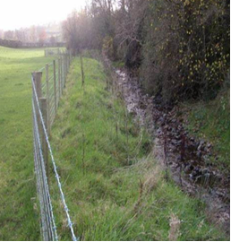

Figure 1: Example of a 2 m ungrazed riparian buffer strip

Additional Guidance

Location
This action is suitable for watercourses alongside grassland or arable fields to protect watercourses from potential damage from agricultural activities (Figure 1). It is particularly suitable where livestock have access to a watercourse to drink or cross, where there is poaching of the bank, where there is increased likelihood of nutrient, sediment or pesticides entering a waterbody and where there is little or no riparian vegetation present.

There are two options for Riparian Buffer Strips, 2 m wide or 7 m wide (Figures 2 and 3). To achieve the best environmental and biodiversity benefits the 7 m riparian buffer is recommended. Do not create this action where livestock could cross over from the other side of the watercourse, which you do not control, and graze the strip.

The fence should be located 2 m or 7 m from the edge of the watercourse. If there is a steep bank the fence should be erected 2 m or 7 m from the top of the bank (Figure 4). Avoid locations where banks are likely to be undermined by erosion from the watercourse. If this happens, you will need to move the fence back and put it up again 2 m or 7 m from the top of the bank.

Figure 2: Creation of a riparian buffer strip – 2 m ungrazed

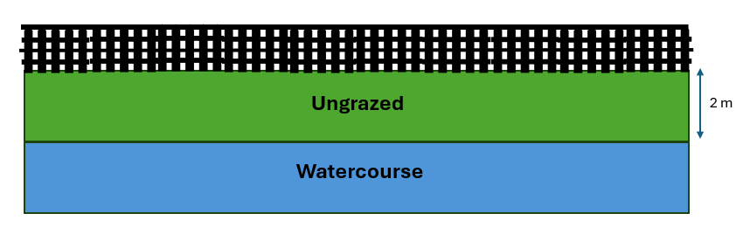

Figure 3: Creation and management of riparian buffer strip – 7 m ungrazed
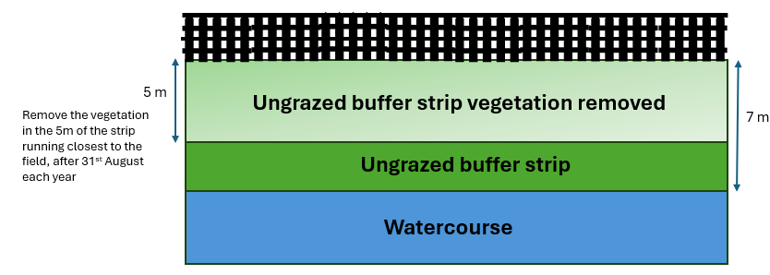

Figure 4: Location of fence for watercourse with sloped bank

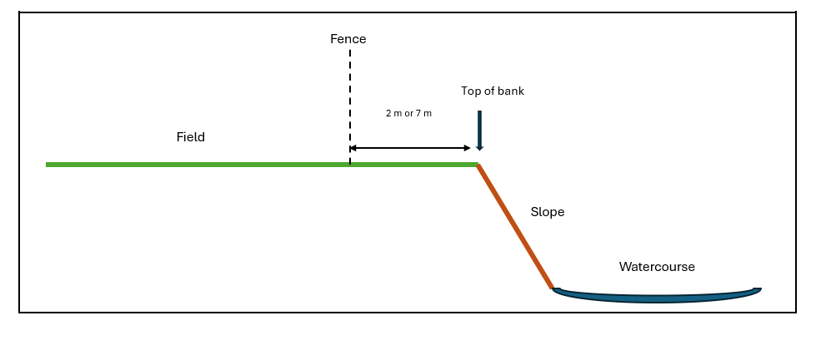
Gate
Where this action or any associated supporting items are installed along a roadway, approval should be sought from DFI Transport NI (Telephone 0300 2000 100).

Drinkers
Where a drinking trough or pasture pump is installed to replace drinking from the watercourse, it should be located as far away from the watercourse as possible and must be located at least 10 m from any watercourse.

Application of Chemical Fertilisers and Organic Manures
In line with current NAP (Nutrient Action Programme) Regulations, chemical fertiliser and organic manure must not be applied within 2 m of surface waters and 10 m of any other waterway, including open areas of water, open field drains or any drain which has been backfilled to the surface with permeable material such as stone/aggregate.

This may be reduced in certain circumstances – check regulations for these situations 20.21.177 Nutrients Action Programme 2019-2022 Guidance Booklet Final.PDF.

Management of the Riparian Buffer Strip
For the 7 m Riparian Buffer Strip it is required to cut and remove the vegetation in the 5 m of the strip running closest to the field, after 31st August each year. By removing the vegetation natural plant species will be established, encouraging biodiversity, reducing invasive species’ spread and supporting watercourse bank stabilisation. Through the Farming with Nature Scheme, you can apply for the Management of 7 m Riparian Buffers Strips action in the year after planting, to support their management.

Employing good soil management in the adjacent field will reduce the run-off pressure on the buffer strip, which will improve and prolong its effectiveness and reduce the costs of managing and repairing it. Further actions may be implemented to reduce any potential run-off from entering the watercourse, especially in fields where uninterrupted slopes fall in the direction of the watercourse. These include but are not limited to:
- establishing a hedge within the field along the newly erected fence along a 7 m riparian buffer strip.
- establishing individual trees or areas of trees within sloping fields to intercept any overland flow.

Weed Control
Plant protection products which are approved to be used near a watercourse may only be applied to the area of the riparian buffer if justified as part of the implementation of IPM (Integrated Pest Management), including for the control of noxious weeds or invasive species by spot spraying with an approved herbicide.

Historic Monuments

Northern Ireland farmland boasts tens of thousands of historic monuments. If you are undertaking new actions near historic monuments, the Historic Environment Division, Department for Communities’ website provides guidance on their protection (Monuments advice and guidance | Department for Communities).

Supporting Items

To support this action protective fencing, gates and associated posts and drinkers are available. Protective fencing is mandatory for the 2 m and 7 m Riparian Buffer Strip actions. A gate or gates are mandatory for the 7 m Riparian Buffer Strip action. A drinker is optional and can be either a drinking trough or pasture pump.

Protective Fencing
To support this action protective fencing is mandatory. Fencing will only be available in association with riparian buffer strips approved under this scheme. The minimum requirements to comply with the protective fencing are detailed in the green box below.

Protective Fencing Requirements

(i) All fencing materials should be new, commercially available and protect the environmental action from grazing livestock.

(ii) Fencing must be permanent.

(iii) The wire must be galvanised and strained to straining posts.

(iv) There must be a minimum of 5 strands of wire or sheep mesh with two strands of wire.

To allow for future adjustments and to prevent damage to the galvanising, it is recommended that staples should be driven in at an angle, but not fully home.

The height of the fence should be at least 1.20 m from the ground to the top wire. Posts should be no more than 3.00 m apart and straining posts should be no more than 150 m apart. Straining posts should also be added at each change in direction or gradient.

Gate and two posts
For 7 m wide riparian buffer strips a gate (at least 4.27 m wide) must be installed. For all 7 m riparian buffer strips greater than 150 m in length, a gate (at least 4.27 m wide) must be installed after each 150 m length of fencing, or part thereof (Figure 5).

Figure 5: Location of gates along a 7 m riparian buffer strip
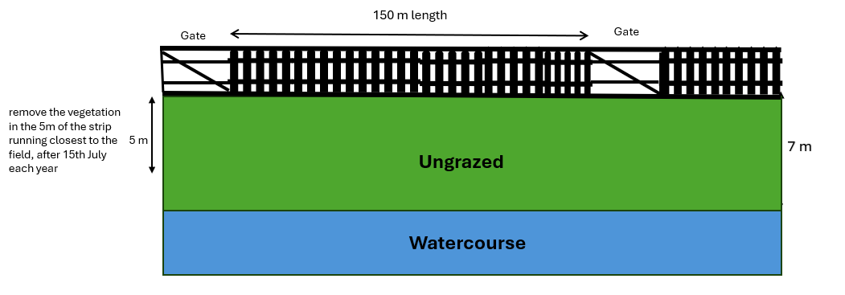

A gate and two posts are optional for 2 m wide riparian buffer strips approved under this scheme.

Gate hanging and closing posts should be set in concrete and, for health and safety reasons, the gate must not open outwards on to a public road.

The minimum requirements to comply with a gate and two posts are detailed in the green box below.

Gate and two posts Requirements
(i) The farm gate and posts must be new, commercially available and protect the environmental action from grazing livestock.

(ii) Posts must not be wooden.

(iii) The gate must be at least 4.27 m (14 ft) in width.

Drinking Trough
The minimum requirements to comply with a drinking trough are detailed in the green box below.

Drinking Trough Requirements
(i) The drinking water trough must be new, commercially available and placed on a concrete base.

(ii) The drinking water trough and base must be located at least 10 m from any watercourse.

It is recommended that the concrete base be intact and extend to a minimum 1.5 m² x 150 mm deep. Troughs should be located away from wet or waterlogged ground which is easily poached or eroded.

Pasture Pump
The minimum requirements to comply with a pasture pump are detailed in the green box below.

Pasture Pump Requirements
(i) The pasture pump must be new and commercially available.
(ii) The pasture pump must be located at least 10 m from any watercourse.

It is recommended that the pipe work be buried with a tubular steel guard if crossing an open drain (25 m of pipe work included in costing). It is recommended that a hardstanding area be installed around the pasture pump of at least 1 m by 1 m to reduce poaching.

