Farmland Tree Planting – Requirements and Guidance

Objective

The aim of this action is to establish native trees on farms. Native trees can be integrated across farmland and may be placed downwind of livestock buildings or as a shelter belt for livestock.

DAERA will undertake a pre-approval check for this action, which will also include an assessment of the distance from powerlines.

The minimum requirements to comply with this action are detailed in the green box below. Also provided is additional guidance to help you adopt best practice.

Farmland Tree Planting Specifications

- This action must not be carried out on:
  - Fields within an area designated as a Special Area of Conservation, a Special Protection Area, a RAMSAR site or an Area of Special Scientific Interest.
  - Northern Ireland priority habitat and species areas*.
  - Within 5 m of watercourses designated under The Drainage (Northern Ireland) Order 1973.
  - Flood defence areas.
  - Riparian buffer strips; or
  - Within hedgerows.
- Three or more native species must be planted from the native tree species list.
- A minimum of 0.05 ha in the same plot must be planted at 2.5 m spacing (80 trees). The maximum area that can be planted is equal to the maximum funding available per applicant at a planting rate of 1,600 trees/ha.
- Each newly planted native tree must be supported and protected from damage by grazing livestock and wildlife on all sides.
- Livestock must be excluded from the planted area.
- Management must be carried out to successfully establish and manage tree planting. This must include the removal of grass and weeds impacting tree growth.
- Access to watercourses must not be obstructed to allow for maintenance.
- Work must be completed by the last day of February of the same scheme year.
- Evidence of the tree species used (invoices detailing species and quantity supplied) must be retained.
- Farmland Tree Planting(s) must be retained for at least 20 years.

What success looks like

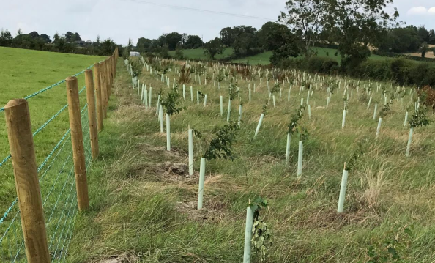

Figure 1: Trees planted in a corridor to create a shelterbelt for livestock

Additional Guidance

Location
Trees should not impede overhead powerlines or other overhead and underground services. They should not be planted close to buildings or where they would interfere with future farm development. If there is a power line within your site or sufficiently close to your boundary where newly planted trees could have a potential impact on the line, contact Northern Ireland Electricity for advice on 03457 643 643.

The planting area must be a minimum of 0.05 ha up to the maximum funding available per applicant (Figure 2). It is recommended that the native trees are planted in a staggered arrangement. The planting design can vary to suit your farm; trees can be planted in the corner of a field, as blocks within fields, as shelterbelts along field edges or positioned downwind of livestock buildings to capture ammonia.

Figure 2: Farmland Tree Planting Plan

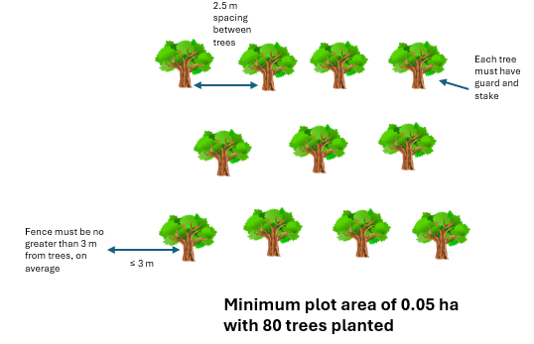

Planting
Three or more native species must be planted from the list of approved species. Mixed woodlands are essential for biodiversity, pest and disease resilience and improved soil structure and health (Appendix 1). For successful planting it is important to select native tree species that are most suitable for your site, and which will grow well on your farm. Ideally all trees/shrubs should be Irish sourced and grown (ISG) or alternatively UK sourced and grown (UKISG). More information is provided by The Woodland Trust (Why Plant UK Sourced and Grown Trees? - Woodland Trust - Woodland Trust).

The three main types of mixed native woodland are: -

- Mixed wood
- Oakwood
- Wet woodland

For each woodland type, the recommended planting species mixes are detailed in Table 1.

Table 1: Species mix for Native Woodland Types

 | Native Woodland
 | Mixed wood (%) | Oakwood (%) | Wet woodland (%)
Dominant Species | Sessile Oak – 20  Hazel – 15  Downy Birch – 10  Rowan – 10 | Sessile Oak – 20  Downy Birch – 15 | Native Willow – 35  Common Alder – 20 Downy Birch – 15  Sessile Oak – 10
Minor Species | Pedunculate Oak – 10  Wild Cherry – 5  Crab Apple – 5  Whitebeam – 5  Hawthorn/Blackthorn – 5  Scot’s Pine – 5 | Pedunculate Oak – 10  Silver Birch – 10  Hazel – 10  Rowan – 10  Holly – 10  Scot’s Pine – 5
Open space/  Unplanted | 10 | 10 | 20

Plant trees from November to February, during the plants’ dormant season. Purchase sufficient trees to plant at a planting rate of 1600 trees/ha. Do not plant in waterlogged or frozen soils. Buy trees that are in good condition with a strong straight stem and a well-balanced branch and root system. Wherever possible, use planting stock of local provenance. Bare-root feathered ‘whips’ or cell grown plants should be planted and have advantages over larger containerised trees.

When using bare-rooted trees, make sure that they have a good fibrous root system, which has been kept moist. For successful planting follow these guidelines:

- Always keep the roots moist. If there is a delay in planting, keep the whips’ roots moist, by heeling them into soil or sand but do not store in water.
- Keep in a plastic bag during transport. If the roots dry out, the whips may die.
- Make the planting pits big enough for the roots. The soil in compacted areas should be loosened prior to planting.
- Plant trees at the same depth at which they were grown in the nursery, shown by a change in colour on the stem, above the roots (Figure 3).

Figure 3: Photograph indicating the root collar - plant to this point

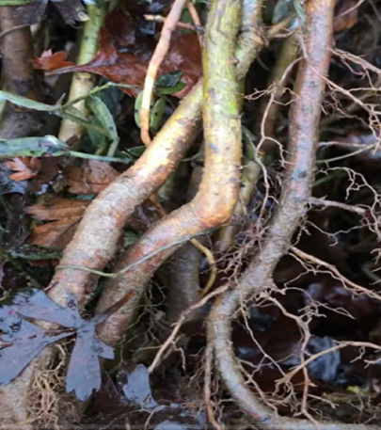
Plant to this point - the root collar

- Plant the trees with the stems upright.
- Firm the soil around the plants by treading it firmly with your heel.
- On normal soils dig holes/pits for planting or cut an L - or T- shaped notch in the ground where the tree is to be planted.
- On wet sites, planting on mounds can aid faster establishment through improved local site conditions and reduced weed competition in the first year.

Tree Protection
Each tree must have a guard and stake, ideally biodegradable. In most cases a spiral guard and stake will be adequate. Ensure the height of the guard is appropriate to protect the trees from the wildlife species present on your farm.

Aftercare
Management must include the removal of grass and weeds within the tree guards. Weeds and grass should be controlled, one metre diameter around each tree for two - three years after planting, or until the trees have successfully established. Replace dead trees between November and mid-March to maintain a stocking rate of 1600 trees/ha. Through the Farming with Nature Scheme, you can apply for the Management of Farmland Tree Planting action in the year after planting, to support aftercare.

Historic Monuments

Northern Ireland farmland boasts tens of thousands of historic monuments. If you are undertaking new actions near historic monuments the Historic Environment Division, Department of Communities’ website provides guidance on their protection (https://www.communities-ni.gov.uk/articles/advice-monument-owners).

More information

Native woodlands definitions and guidance | Department of Agriculture, Environment and Rural Affairs

How to Plant Trees - Plant Trees - Woodland Trust

Tree Shelter Belts for Ammonia Mitigation | Tree Shelter Belts

Supporting Items

To support this action protective fencing and a gate and two posts are available.

Protective Fencing
Fencing will only be available in association with farmland tree planting approved under this scheme. The minimum requirements to comply with the protective fencing are detailed in the green box below.

Protective Fencing Requirements

(i) All fencing materials must be new, commercially available and protect the environmental action from grazing livestock.

(ii) Fencing must be permanent.

(iii) The wire must be galvanised and strained to straining posts.

(iv) There must be a minimum of 5 strands of wire or sheep mesh with two strands of wire.

(v) When planting farmland trees fencing must be no more than 3 m from the trees on average. The maximum fencing that will be funded is 150 m per plot.

Figure 4: Photograph of protective fencing - sheep mesh with three strands of wire

Approval should be sought from DFI TransportNI before new protective fencing is erected along a roadway.

The height of the fence should be at least 1.20 m from the ground to the top wire. Posts should be no more than 3.00 m apart and straining posts should be no more than 150 m apart. Straining posts should also be added at each change in direction or gradient.

Gate and two posts
Gate hanging and closing posts should be set in concrete and, for health and safety reasons, the gate must not open outwards on to a public road. The minimum requirements to comply with a gate and two posts are detailed in the green box below.

Gate and two posts Requirements
(i) The farm gate and posts must be new, commercially available and protect the environmental action from grazing livestock.

(ii) Posts must not be wooden.

(iii) The gate must be at least 4.27 m (14 ft) in width.

Appendix 1

DAERA Approved Species Native Trees

 | Tree Corridor | Ammonia Recapture
Alder (Alnus glutinosa) | Yes | Yes
Aspen (Populus tremula) | Yes | Yes
Bay Willow (Salix pentandra) | Yes | Yes
Bird Cherry (Prunus padus) | Yes | Yes
Blackthorn / Sloe (Prunus spinosa) | Yes
Crab Apple (Malus sylvestris) | Yes | Yes
Damson (Prunus Insititia) | Yes
Downy Birch (Betula pubescens) | Yes | Yes
Dog Rose (Rosa canina) |  | Yes
Goat Willow (Salix caprea) |  | Yes
Gorse / Whin (Ulex europaeus) |  | Yes
Grey Willow (Salix cinerea) |  | Yes
Guelder Rose (Viburnum opulus) | Yes
Hawthorn (Crataegus monogyna) | Yes
Hazel (Corylus avellana) | Yes | Yes
Holly (Ilex aquifolium) | Yes | Yes
Juniper (Juniperus communis) | Yes
Pedunculate Oak (Quercus robur) | Yes | Yes
Poplar (Populus spp.) |  | Yes
Rowan (Sorbus aucuparia) | Yes | Yes
Scots Pine (Pinus sylvestris) | Yes | Yes
Sessile Oak (Quercus petraea) | Yes | Yes
Silver Birch (Betula pendula) | Yes | Yes
Spindle (Euonymus europaeus) | Yes
Whitebeam (Sorbus aria) | Yes | Yes
Wild Cherry (Prunus avium) | Yes | Yes
Wild Pear (Pyrus communis) | Yes
Wild Plum (Prunus domestica) | Yes
Willow (Salix spp.) | Yes
Wych Elm (Ulmus glabra) | Yes

*Care must be taken to ensure that these actions are not implemented in sensitive semi-natural and species-rich habitats such as Grasslands, Wetlands, Coastal and Moorland habitats. Data from Northern Ireland Environment Agency (NIEA) records of habitats and species has been used within the Farming with Nature application system, but this does not infer the complete coverage of these environmental assets in Northern Ireland.

