Management of 7 m Riparian Buffer Strip - Requirements and Guidance

Objective
The aim of this action is to manage a 7 m vegetated riparian buffer strip created under Farming with Nature in a previous scheme year which has been established to prevent livestock access to the watercourse, reduce bankside erosion and reduce the transport of pollutants to the watercourse. It also provides habitat for wildlife and form links between other habitats.
The minimum requirements to comply with this action are detailed in the green box below. Additional guidance is also provided to help you to adopt best practice.
Management of 7 m Riparian Buffer Strip

- The riparian buffer protective fence and access gate(s) and gateposts must be maintained in stock-proof condition.
- Access to watercourses must not be obstructed to allow for maintenance.
- The vegetation in the 2 m width next to the watercourse must not be cut.
- The vegetation in the 5 m width next to the field must be cut after 31 August and cuttings removed.
- Fertilisers (organic and inorganic), lime and plant protection products, except for the spot treatment of noxious and invasive weeds, must not be applied.
- Work must be completed by the last day of February of the same scheme year.

What success looks like
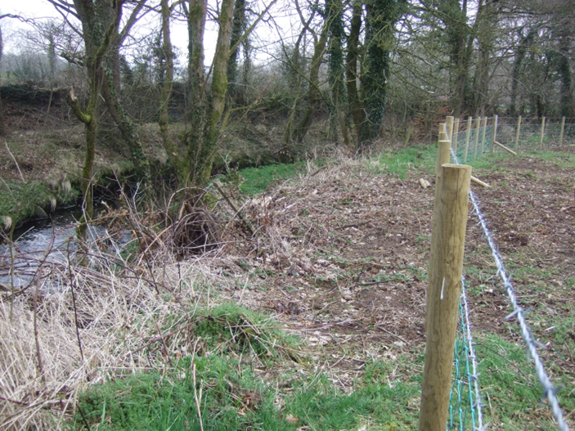
A successfully managed 7 m riparian buffer will have the 5 m closest to the field managed by cutting and collecting the cuttings on a yearly basis while leaving the remaining 2 m to nature. This will help to reduce any pollutants from entering watercourses and contribute to improving water quality. A successfully managed 7 m riparian buffer will provide habitat and refuge for a range of native insects, small mammals and ground nesting birds.

GUIDANCE
Cutting the buffer
The vegetation that has grown on the buffer up to 31 August must be cut to allow grass species to tiller out and produce denser vegetation, thus improving the buffer’s ability to slow overland nutrient flow. A range of sward height is encouraged e.g. habitat with short grass for birds to forage in, mid-length grass for species like Irish hares and long, less frequently cut tussocky grass to give shelter and nesting places for birds and invertebrates.
Livestock grazing must not be used to control the buffer as this could cause damage through poaching, soil erosion and manure entering the watercourse.

Removing the cuttings
The cuttings must be collected and can be used silage bales to feed livestock over the winter.
As per the specification, fertilisers (organic or inorganic), lime or plant protection products (except for the spot treatment of noxious and invasive weeds) must not be applied within the buffer. The riparian buffer cannot be used for storage.

Maintaining the fence
The fence that separates the buffer from the field is the first line of protection for the buffer. The fence (and any associated gates and posts) should be inspected regularly and any damage rectified as soon as possible to prevent livestock access.
The Rivers Agency (within the Department of Infrastructure) undertakes regular maintenance of designated watercourses to ensure the free flow of water. This is necessary to alleviate flooding and to assist land drainage. It is important that access to these watercourses is not obstructed at any time.

