Management of Farmland Tree Planting Requirements and Guidance
Objective
The aim of this action is to manage farmland trees established under Farming with Nature in a previous scheme year.
The minimum requirements to comply with this action are detailed in the green box below. Additional guidance is also provided to help you to adopt best practice.
Management of Farmland Tree Planting Requirements

- Each tree must be protected from damage by grazing livestock and wildlife.
- Protective fencing and access gate(s) and gateposts funded by FwNT must be maintained in stock-proof condition.
- Dead trees must be replaced with trees from the native trees list to maintain a minimum planting density of 1280 trees/ha.
- Growth must not be negatively affected by weeds.
- Work must be completed by the last day of February of the same scheme year.

What success looks like
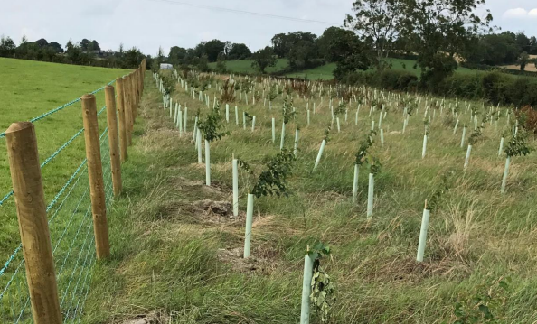

Success means ensuring that trees establish strong trunks and root systems and remain free from damage. Long term benefit is achieved by weeding and protecting and replacing any dead trees to maintain a quality canopy in the future.

GUIDANCE
Management of Farmland Trees
To ensure the success of trees established under the Farming with Nature Transition Scheme (FwNT), management needs to be carried out. This includes weeding, protection, maintaining plant density and, where necessary, watering.
Weeding
Weeding is the most important step to ensure your trees establish successfully. Weeds and grasses compete with trees for moisture and nutrients and may eventually kill the trees by outcompeting them.
Best practice is to keep a 1 m diameter around the tree clear of weeds and grass for the first 2-3 years. This will reduce competition for moisture and nutrients, improving the tree’s chance to survive and flourish.
Weed suppression using mulch in a 1 m diameter around the tree is acceptable and this can take the form of:
- Grass clippings;
- Compost or well-rotted manure;
- Woodchips or bark chips; or
- Mulch mats pegged into the ground.
Mulch should be applied to a depth of around 10 cm to prevent it being blown away or dispersed and topped up annually, if required.
Plant protection products should not be used to suppress weeds, except for the spot treatment of noxious and invasive weeds.
Regular grass cutting is not advised as it invigorates grass growth and increases competition for moisture.
Maintaining protection
Protecting trees from the effects of their surrounding environment is essential to their success and survival, and protection can take many forms:
- Stakes
Newly planted trees are weak and prone to damage by strong winds. It is essential that trees remain staked to ensure that they grow strong trunks and deep roots which help anchor them into the ground. It is recommended that you inspect the trees regularly and replace any missing or damaged stakes.
- Guards
Trees guards are essential to protect trees from being damaged by wildlife and livestock. Many types of guards are acceptable and provide different levels of protection. As noted for stakes, it is recommended that trees are inspected regularly to ensure that the trees are successfully protected from damage and that any missing or damaged guards are replaced. Any grass growing inside the guard must be removed and the guard carefully returned to its position. Regular inspection within tree guards is recommended so that any damage from pests is identified. The area surrounding each tree must be kept free from weeds.
- Fencing
Livestock fencing may be used to prevent livestock and wildlife (e.g. deer) from accessing and damaging the trees. Any fencing, gates and gate posts must be maintained correctly and any damage repaired.
Ensuring a planting density
It is important that a minimum planting density of 1280 trees per hectare is maintained. You should regularly walk around the trees to identify those which have failed to grow. These trees need to be replaced over the autumn and winter months before the last day of February. Trees must be selected from the list below to include a minimum of 3 native tree species, where possible. All trees should be Irish sourced and grown or alternatively UK sourced and grown (UKISG). More information is provided on The Woodland Trust website.
Native Tree Species List
Alder (Alnus glutinosa) | Hawthorn (Crataegus monogyna)
Aspen (Populus tremula) | Hazel (Corylus avellana)
Bay Willow (Salix pentandra) | Holly (Ilex aquifolium)
Bird Cherry (Prunus padus) | Juniper (Juniperus communis)
Blackthorn / Sloe (Prunus spinosa) | Pedunculate Oak (Quercus robur)
Crab Apple (Malus sylvestris) | Poplar (Populus spp.)
Damson (Prunus Insititia) | Rowan (Sorbus aucuparia)
Downy Birch (Betula pubescens) | Scots Pine (Pinus sylvestris)
Dog Rose (Rosa canina) | Sessile Oak (Quercus petraea)
Goat Willow (Salix caprea) | Silver Birch (Betula pendula)
Gorse / Whin (Ulex europaeus) | Spindle (Euonymus europaeus)
Grey Willow (Salix cinerea) | Whitebeam (Sorbus aria)
Guelder Rose (Viburnum opulus) | Wild Cherry (Prunus avium)
Wild Plum (Prunus domestica) | Wild Pear (Pyrus communis)
Wych Elm (Ulmus glabra) | Willow (Salix spp.)

Watering
Trees will adapt to natural conditions so should not need to be watered. Watering can encourage roots to grow up towards the soil surface rather than down towards groundwater. If there is a particularly long dry spell and you feel watering is necessary, saturate the ground to ensure water soaks deep into the soil.

Additional Guidance
Woodland Trust - https://www.woodlandtrust.org.uk/plant-trees/advice/

