Multi-species Winter Cover Crop – Requirements and Guidance

Objective

The aim of this action is to establish a multi-species cover crop on arable land over the winter months to protect the soil surface, provide root growth that benefits soil structure, support soil biology, enhances biodiversity and minimises nutrient leaching, soil erosion, and runoff.

The minimum requirements to comply with this action are detailed in the green box below. Also provided is additional guidance to help you adopt best practice.
Multi Species Winter Cover Crop Requirements

- This action must not be carried out on:
  - Fields within an area designated as a Special Area of Conservation, a Special Protection Area, a RAMSAR site or an Area of Special Scientific Interest.
  - Northern Ireland priority habitat and species areas*; or
  - Permanent Grassland Sensitive areas.
- Minimum area of multi-species winter cover crop allowed is 0.1 ha up to the maximum funding available per applicant, where the main field crop is arable, in line with normal husbandry practice.
- A seed mix with species from 2 or more of the following plant families must be used:
    - Brassicas
    - Legumes
    - Cereals or grasses
    - Herbs
- The seed mix must contain at least 4 species.
- Inorganic fertilizer must not be applied.
- Evidence of the seed mix used (labels, invoices detailing mix contents and quantity supplied) must be retained.
- The cover crop must be established, retained until 15 February of the same scheme year, and then destroyed, in line with normal husbandry practice.

What success looks like

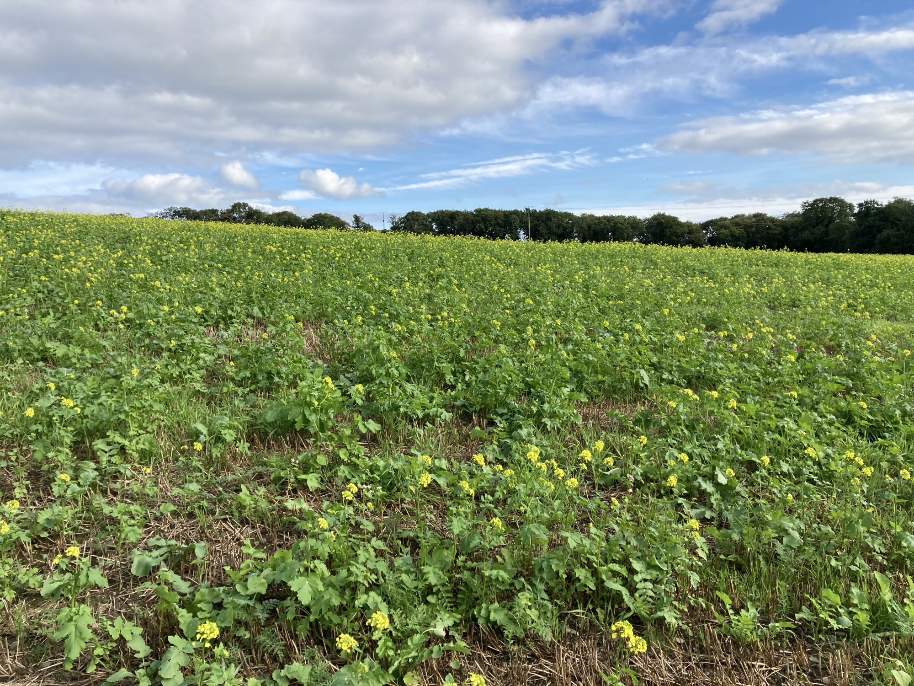

Figure 1: An example of a multi species winter cover crop successfully established by direct drilling after winter barley harvest

Guidance
Multi-species winter cover crops generate a large mass of herbage which intercepts rainfall, helping protect the soil from exposure to heavy rainfall during the winter period. Actively growing plants with a living root mass aid water infiltration, reducing the potential for soil erosion and surface run-off. Cover crops utilise residual nutrients in the soil following the harvest of the preceding crop. Desirable species for winter cover crops are those which can actively grow at lower temperatures, preventing leaching of soluble nutrients while also helping to protect water quality.
The vigorous root systems of some crop species condition and break up the soil, making it more friable for ease of cultivation. The residual herbage that remains from cover crops enhances the soil organic carbon content, water holding capacity and soil structure.
Winter multi species cover crops provide diversity of habitat and feed source for wildlife above ground whilst maintaining soil biology ecosystems in the period between harvest and the following spring sown crop (Figure 1).
A successful cover crop should establish evenly across the field, fully covering the soil or stubble, and remain until 15th February of the year following establishment.

Cover Crop Establishment
The crop must be established in line with normal husbandry practice which means that the required seed mix must be sown and established in a manner and at a seed rate that would be expected to produce a viable multi-species winter cover crop and then destroyed in preparation for the following crop.

If you wish this action can be a partial field action. This will allow it to be established along other field crops and support the creation of arable margin actions also offered through Farming with Nature.
To maximise growth of over winter cover crop, aim to establish the cover crop as early as possible following the harvest of the previous crop. Preceding crops with early harvest such as winter barley or oats, cereals harvested by whole crop, early potatoes or early harvested vegetable crops potentially all allow cover crop to be sown before mid- August, giving the longest possible growing window, maximising biomass produced and hence the environmental benefits of this action.
Following later harvested crops such as spring cereals a successful cover crop can be established but will be more dependent on field location, soil type, ground and weather conditions at sowing and during the establishment phase. To achieve complete field cover it may be necessary to increase cover crop seed rates incrementally as establishment date moves from late July through to late September. Application of organic manures at or just after sowing should boost growth of the emerging cover crop.
Cover crops established after the end of September are likely to produce limited environmental benefits and should be avoided.
Cultivation
To protect the soil and minimise the risk of soil and nutrient run-off, use the minimum amount of tillage necessary to establish the crop. This will vary depending on farm, soil type, conditions at sowing and cultivation equipment available. With any establishment method aim for good seed-soil contact. If soil conditions are dry at sowing, rolling conserves moisture and improves seed-soil contact, aiding good cover crop establishment.
If weather or other conditions are not favourable during the optimum sowing window and the crop cannot be successfully established, do not claim during the March claim period.
Seed Mix
A seed mix containing at least 4 species from 2 or more of the following plant families must be used:
- Brassicas such as mustard, forage rape, stubble turnips, tillage radish
- Legumes such as vetch, red clover, white clover, crimson clover and berseem clover
- Cereals or grasses such as Italian ryegrass, festulolium, black oats, forage rye, barley, winter triticale
- Herbs such as phacelia, buckwheat, linseed
Choice of species will depend on each individual farmer’s crop rotation and the benefits they are aiming to achieve. Off-the shelf seed mixtures are available e.g. soil structure improvement mixtures, with strong rooting species that root to different depths or nitrogen fixing mixtures, containing legumes such as clovers or vetch (Figure 2). Alternatively, seed can be purchased as straights to create a unique mixture for your own situation. Take advice from your agronomist or seed supplier for the best cover crop species mix and appropriate seed rate for your farm situation. Your agronomist will also be able to identify any cover crop species which could have negative impacts on your rotation such as acting as vector for pests, a host for disease or difficulty controlling as a weed for other crops in your rotation.
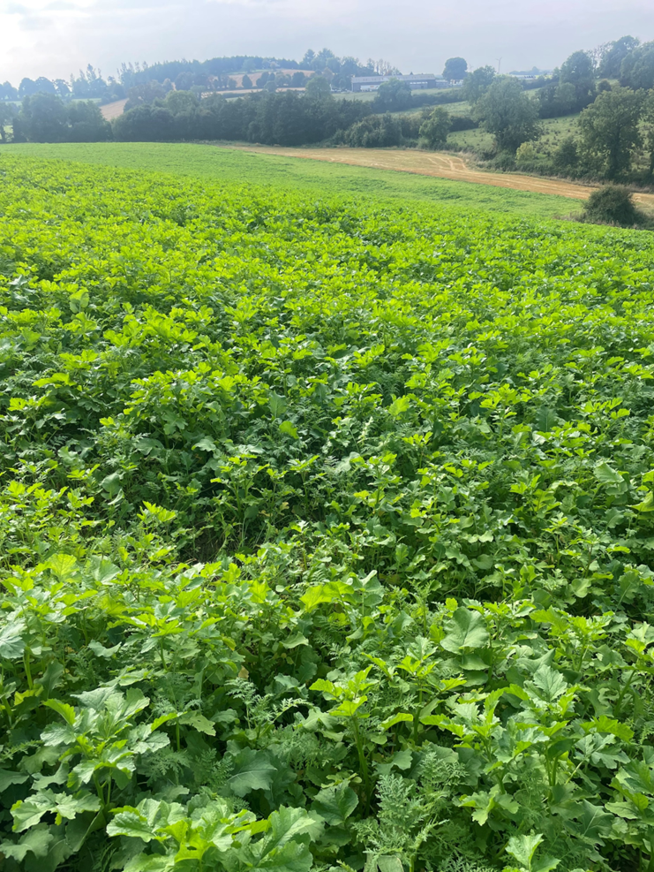

Figure 2: A multi-species cover crop consisting of fodder rape fodder, radish, mustard, vetch, crimson clover, phacelia and linseed
Management
Additional biodiversity, benefits of this action will be enhanced if the following activities are not undertaken from cover crop establishment during the retention period until February 15th.
• Application of chemical fertiliser or herbicides to the growing cover crop
• Application of insecticides or molluscicides to the growing cover crop
• Grazing the cover crop with livestock
• Application of organic manures where field traffic could damage the growing cover crop
Cover Crop Destruction
The cover crop should remain until after 15th February of the year following establishment. Timing and method of destruction depend on the desired drilling date of the following crop. Maintaining cover crop later into the spring has the potential to extend the scope of this action’s environmental benefits. Several methods of cover crop destruction are possible including grazing by livestock, mulching, cultivation or chemical destruction. The method of destruction chosen depends on what the cover crop is being grown to achieve and will take into account the quantity of herbage remaining, speed of kill desired, presence of weeds, the following crop and the method of its establishment.
Historic Monuments
Northern Ireland farmland boasts tens of thousands of historic monuments. If you are undertaking new actions near historic monuments the Historic Environment Division, Department of Communities’ website provides guidance on their protection (Monuments advice and guidance | Department for Communities).

Supporting Items

There are no Supporting Items available for this Environmental Action.

Additional Guidance and further reading

An Introduction to Cover Crops - https://ahdb.org.uk/cover-crops

* Care must be taken to ensure that these actions are not implemented in sensitive semi-natural and species-rich habitats such as Grasslands, Wetlands, Coastal and Moorland habitats. Data from Northern Ireland Environment Agency (NIEA) records of habitats and species has been used within the Farming with Nature application system, but this does not infer the complete coverage of these environmental assets in Northern Ireland.

