Planting New Hedgerows – Requirements and Guidance

Objective

The aim of this action is to create new lengths of hedgerows planted with native species where no hedge currently exists.

The minimum requirements to comply with this action are detailed in the green box below. Also provided is additional guidance to help you adopt best practice.

Planting New Hedgerows Requirements

- This action must not be carried out on:
  - Fields within an area designated as a Special Area of Conservation, a Special Protection Area, a RAMSAR site or an Area of Special Scientific Interest.
  - Northern Ireland priority habitat and species areas*; or
  - Permanent Grassland Sensitive areas.
- Hedgerows must not be planted:
  - Against an existing hedgerow.
  - Against a stone wall.
  - Under the shade of an existing treeline/woodland; or
  - On field side of a 2 m riparian buffer strip.
- Planting must be carried out where no hedgerow currently exists, or a continuous gap of at least 10 m exists.
- A minimum of 10 m to be planted to the maximum funding available per applicant (each individual length of hedgerow must be a minimum of 10 m).
- Only native species must be planted, with an average of 6 plants per metre. Three or more native species must be planted from the hedge plant species list.
- Hedgerows must be protected from damage by grazing livestock and wildlife on all sides, as required.
- Growth must not be negatively affected by weeds.
- Management must be carried out to establish successfully and manage the full length of hedgerow.
- Evidence of the hedgerow species used (invoices detailing species and quantity supplied) must be retained.
- Work must be completed by the last day of February of the same scheme year.

What Success Looks Like

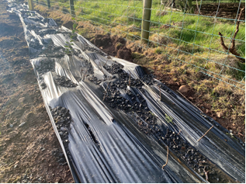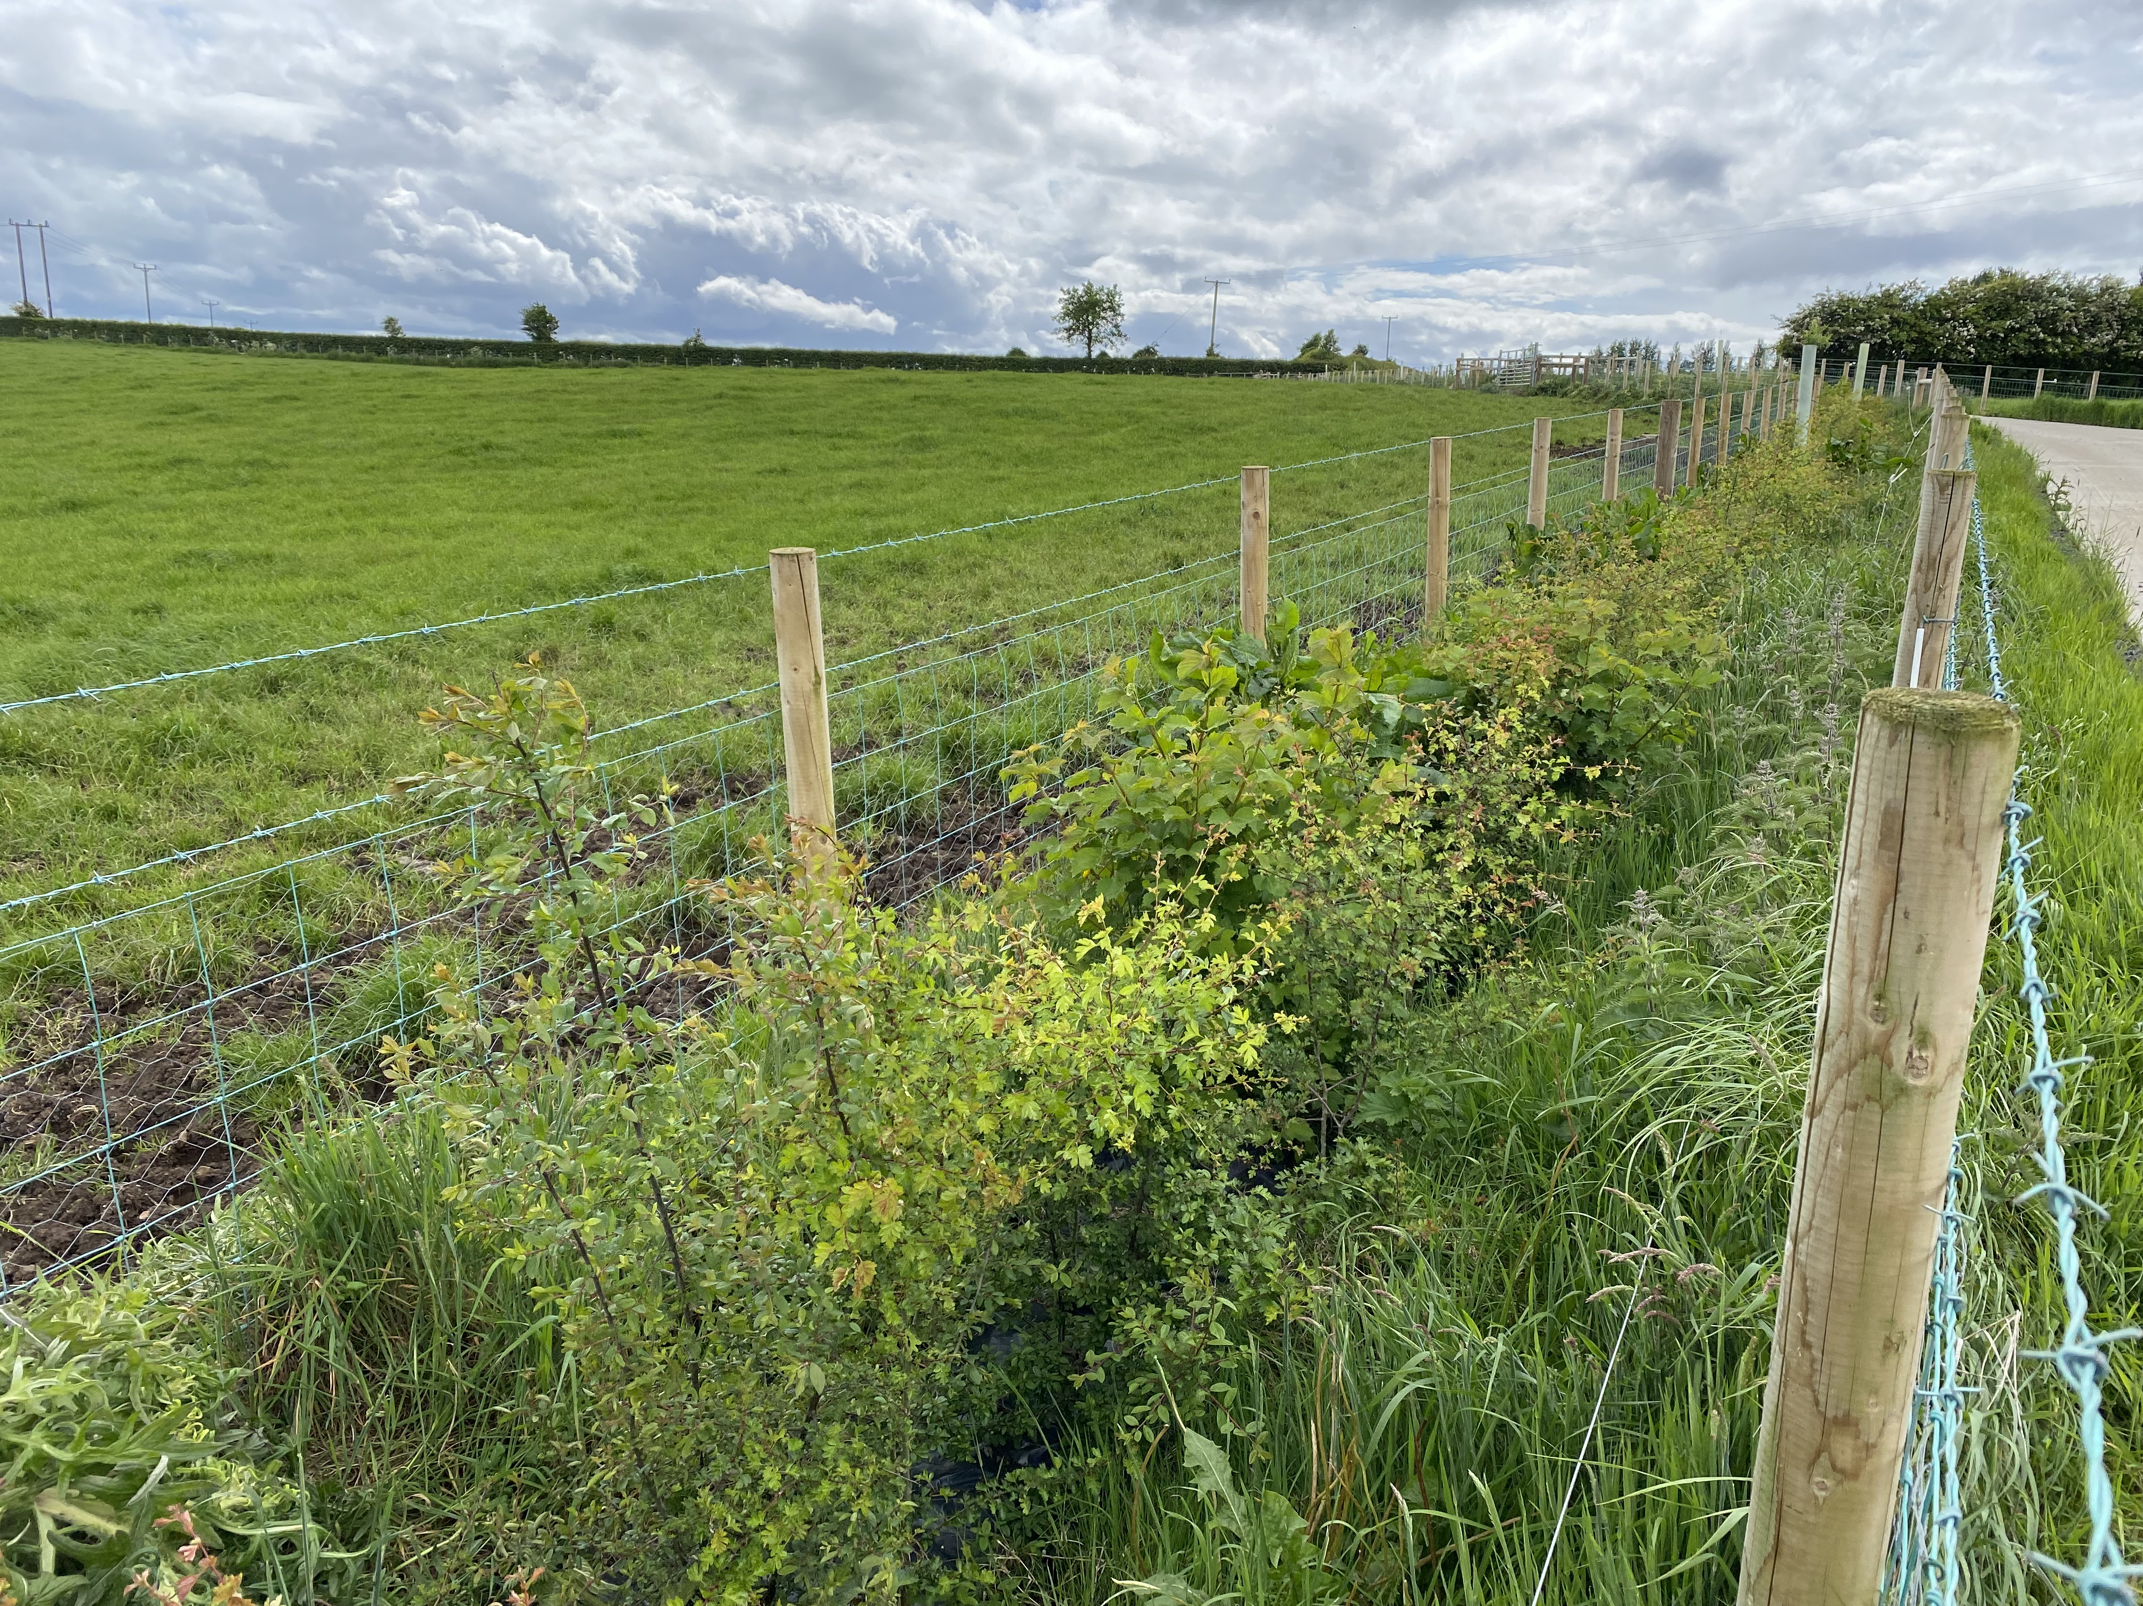

A newly planted hedgerow An established hedgerow

Guidance

Planting Site
The new hedge should aim to link with existing habitats, such as hedges, woodland or ponds. The new hedge will act as a wildlife corridor between habitats. Do not plant in front of an existing stone wall (Figure 1). In Figure 2 it would be preferable to the restore the stone wall to retain its historic and biodiversity value.

Figure 1: Do not plant a new hedgerow in front of an existing stone wall

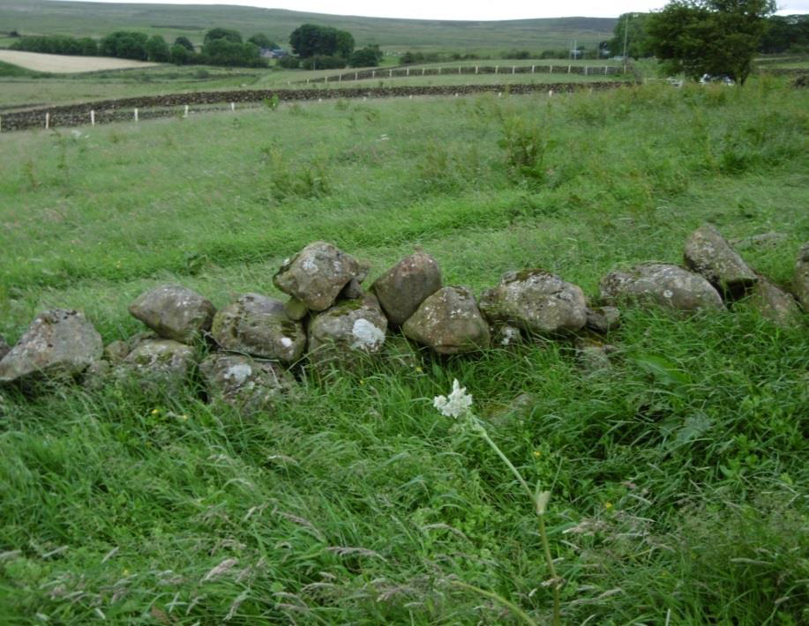

Figure 2: Do not plant a new hedgerow; instead repair the existing stone wall

If you intend to plant a new hedgerow along a march boundary, you must ensure that you have fully discussed and agreed that you can carry out the option requirements on the march boundary with the person who has control of the neighbouring land.

Site Preparation
Spray a 1 m wide strip with a systemic herbicide in the autumn. Planting is much easier if a 0.5 m wide trench is dug to a depth of 0.3 m with a small excavator. The top sod should be flipped and placed at the bottom of the trench with the subsoil placed on top of the flipped sod (Figure 3). On low nutrient soils, add some well-rotted farmyard manure into the bottom of the trench.

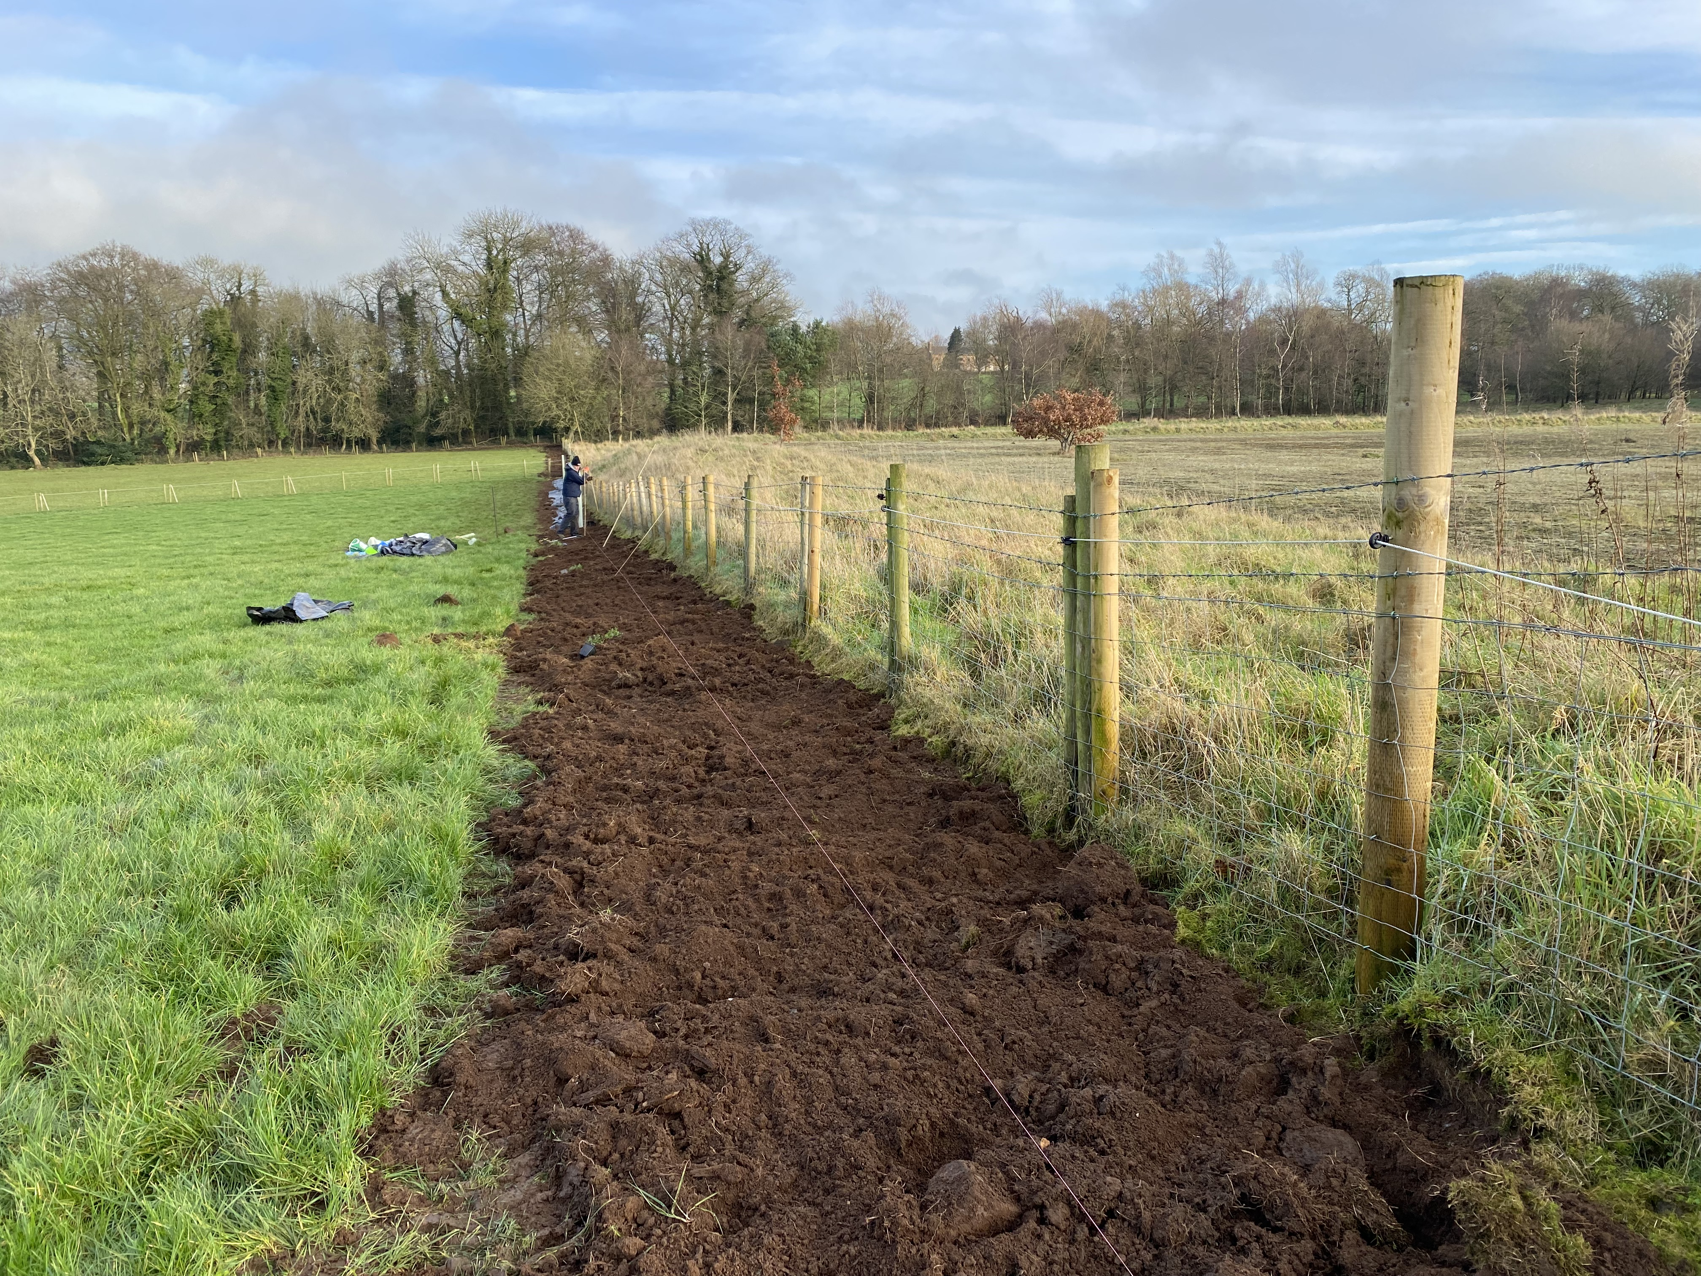
Figure 3: Site preparation of new hedgerow

Planting Mix
The specification requires three or more native hedge species (whips) to be planted (Table 1). To optimise the biodiversity benefit, it is strongly recommended to plant a mix of 6 different native species, with 75% of the hedge consisting of hawthorn and 25% of other woody species. Mix the species across the length of hedgerow to ensure a diverse hedgerow. Wherever possible, use planting stock of local provenance and species that already grow in the local area. Ideally all trees/shrubs should be Irish sourced and grown (ISG) or alternatively UK sourced and grown (UKISG). More information is provided by The Woodland Trust (Why Plant UK Sourced and Grown Trees? - Woodland Trust - Woodland Trust).

Select species from the list below. For shaded areas, it is recommended that Holly be planted.

Table 1: DAERA list of approved hedgerow species

Native Hedgerow Species
Blackthorn/sloe
Dog Rose
Gorse/Whin
Guelder Rose
Hawthorn/Whitethorn
Hazel
Holly
Spindle

Planting Density
To comply with the action an average of 6 native plants must be planted per metre. Alternatively, for a more stockproof hedge, it is recommended to plant a double staggered row with 30 cm between the rows and 25 cm between plants in a row. This is approximately 7- 9 plants/metre. This planting arrangement is shown in Figure 4.

Figure 4: Double staggered row hedge planting
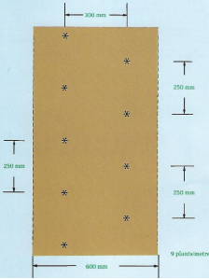
300mm
250mm
600mm
250mm
250mm
* 9 plants/ metre

Planting
Plant hedgerows between November and late winter, during the plants’ dormant season. Do not plant in waterlogged or frozen soils. If planting on a dry bank, it is recommended that you plant in November or December to allow adequate root establishment before bud burst.

- If there is a delay in planting, keep the whips’ roots moist, by heeling them into soil or sand but do not store in water.
- Keep in a plastic bag during transport. If the roots dry out, the whips may die.
- Plant whips at the same depth at which they were grown in the nursery, shown by a change in colour on the stem, above the roots (Figure 5).
- Plant the whip with the stems upright.
- Firm the soil around the plants by treading it well with your heel, removing air pockets.
- During prolonged dry spells, the planted area may require watering.
- Once planted, prune all hedge plants to 4-5 inches off the ground. Do not prune holly and trees. Pruning the plants allows the whips to develop into a multi stemmed shrub rather than a single stemmed tree.

Figure 5: Photo indicating the root collar, plant to the point

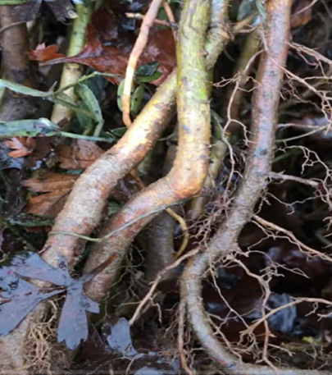
Plant to this point - the root collar

Hedgerow Trees
Hedgerow trees are an important component of hedgerows across Northern Ireland, it is recommended that they are included. Select tree species from Table 2.

Table 2: DAERA list of approved hedgerow tree species

Native Hedgerow Tree Species
Alder (Alnus glutinosa) | Oak (Quercus robur) | Silver Birch (Betula pendula)
Crab Apple (Malus sylvestris) | Rowan (Sorbus aucuparia) | Wild Cherry (Prunus avium)
Downy Birch (Betula pubescens) | Scot’s Pine (Pinus sylvestris) | Willow (Salix spp)

Hawthorn whips can also be left to grow on as trees. The use of local provenance planting stock is strongly recommended.

Hedgerow trees must not be planted in the proximity of under or above ground cables. It is important to consider the size of the tree when fully grown and any impact this may have on visibility at field entrances.

The frequency of trees will depend on future management, 4 trees in a 100 m length of hedgerow is suggested. Protect each tree from browsing livestock with a minimum 1.2 m tree guard and stake. This will allow identification of the tree, so it is not trimmed during hedge cutting in future years.

Weed Control
To aid successful establishment, a form of weed control is recommended immediately following planting.

- Ideally, use biodegradable film over the entire planted area which is tucked under the soil and/or held down using stones or gravel (Figure 6).
- Alternatively, use biodegradable film along both sides of the newly planted hedge. The film can be held down using stones or gravel (Figure 7).
- Composted bark chipping mulch can also be used instead of film.

Figure 6: Biodegradable film placed over the planted hedge held down with gravel

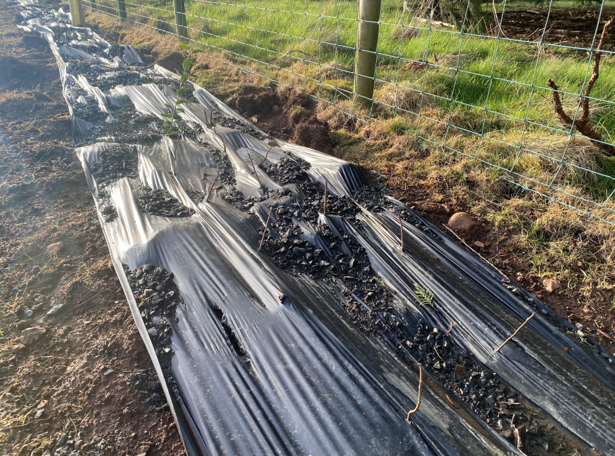

Figure 7: Film placed on either side of hedge held down with stones
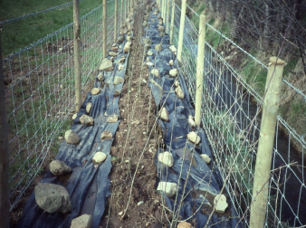

Protective Fencing
It is a requirement to look after a newly planted hedge to ensure successful establishment.
- The hedge must be protected from grazing livestock
- If rabbits and/or hares are present, it is recommended to include chicken wire as part of the protective fence.
- The protective fencing if claimed within the scheme must be no more than 3m from the centre of the hedgerow on average. It is also recommended that the fencing is at least 1m from the centre of the hedgerow on average. This will allow weed control to take place in the initial years after planting (Figure 8).
- When fully established, you are aiming for tall and wide hedgerows for greatest environmental benefits.

Figure 8: Diagram showing where protective fencing should be installed, if required

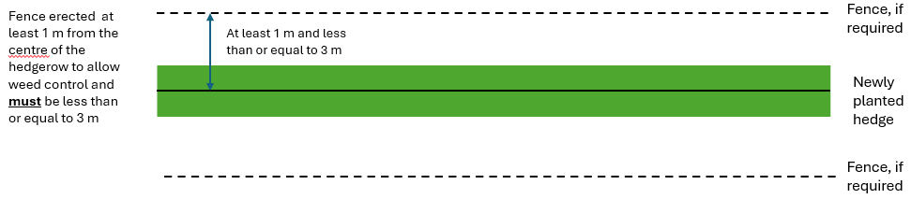

Aftercare
- Weeds must be suppressed.
- Failed or dead plants need to be replaced in the following planting season to ensure a minimum of 6 plants per metre.
- Check that tree guards are intact.
- To grow a dense hedge, cut the hedge shrubs in the early years of growth and thereafter as part of your hedge management but do not cut holly or hedgerow trees.

Weed Control in the initial years of growth
- During the first 3 - 4 years, it is important to manage the weeds throughout the growing season. This can be done by trampling and flattening the weeds on both sides of the hedge and hand pulling the grass and weeds away from the centre of the hedge.
- It is advised to not cut the grass and weeds on either side of the hedge as this will encourage regrowth of the weeds.
- A pre-emergence granular herbicide may be used.
- It is advised to avoid using other herbicides as you may kill off the hedge.
- If a composted bark mulch was used initially, top up as required.

Through the Farming with Nature Scheme, you can apply for the Management of Hedgerows action in the year after planting, to support their aftercare.

Historic Monuments

Northern Ireland farmland boasts tens of thousands of historic monuments. If you are undertaking new actions near historic monuments the Historic Environment Division, Department of Communities’ website provides guidance on their protection (https://www.communities-ni.gov.uk/articles/advice-monument-owners).

Supporting Items

To support this action protective fencing is available.

Protective Fencing
Protective fencing will only be available in association with hedging approved under this scheme (Figure 9). The minimum requirements to comply with the protective fencing are detailed in the green box below.

Protective Fencing Requirements

- All fencing materials must be new, commercially available and protect the environmental action from grazing livestock.
(iii) Fencing must be permanent.
(iv) The wire must be galvanised and strained to straining posts.
(v) There must be a minimum of 5 strands of wire or sheep mesh with two strands of wire.
(vi) When planting new hedgerows fencing must be no more than 3m from the centre of the hedgerow on average. The maximum fencing that will be funded will be twice the length of this action.

Approval should be sought from DFI Transport NI before new protective fencing is erected along a roadway.

The height of the fence should be at least 1.20 m from the ground to the top wire. Posts should be no more than 3 m apart and straining posts should be no more than 150 m apart. Straining posts should also be added at each change in direction or gradient.

Figure 9: Protective fencing associated with hedge

Additional Guidance and further reading

- Hedge management - https://hedgerowsurvey.ptes.org/hedge-management

- Hedgerow Management for Biodiversity | Dairying Technical Support - CAFRE https://www.cafre.ac.uk/business-support/agriculture/environment/environment-technical-support/hedgerow-management-for-biodiversity/

*Care must be taken to ensure that these actions are not implemented in sensitive semi-natural and species-rich habitats such as Grasslands, Wetlands, Coastal and Moorland habitats. Data from Northern Ireland Environment Agency (NIEA) records of habitats and species has been used within the Farming with Nature application system, but this does not infer the complete coverage of these environmental assets in Northern Ireland.

