Retention of Winter Stubble – Requirements and Guidance

Objective

The aim of this action is to benefit wildlife by retaining the stubble from an arable crop over the winter. This action can be completed on arable land that is growing a cereal, oilseed rape, protein crop or linseed.

The minimum requirements to comply with this action are detailed in the green box below. Also provided is additional guidance to help you adopt best practice.

Retention of Winter Stubble
- This action must not be carried out on:
- Fields within an area designated as a Special Area of Conservation, a Special Protection Area, a RAMSAR site or an Area of Special Scientific Interest.
- Northern Ireland priority habitat and species areas*.
- Permanent Grassland Sensitive areas.
- Stubble following the harvest of maize; or
- Under-sown crops.
- The area allowed is a minimum of 0.1 ha up to the maximum funding available per applicant.
- Stubble must be retained following harvest in line with normal husbandry practice to 15 February of the same scheme year.
- Pre - or post - harvest non - selective herbicides must not be applied.
- Straw must be removed post-harvest or stored in field as bales or left as chopped straw.
- Stubble must not be grazed or cut.
- Inorganic fertiliser must not be applied post-harvest.

What does success look like

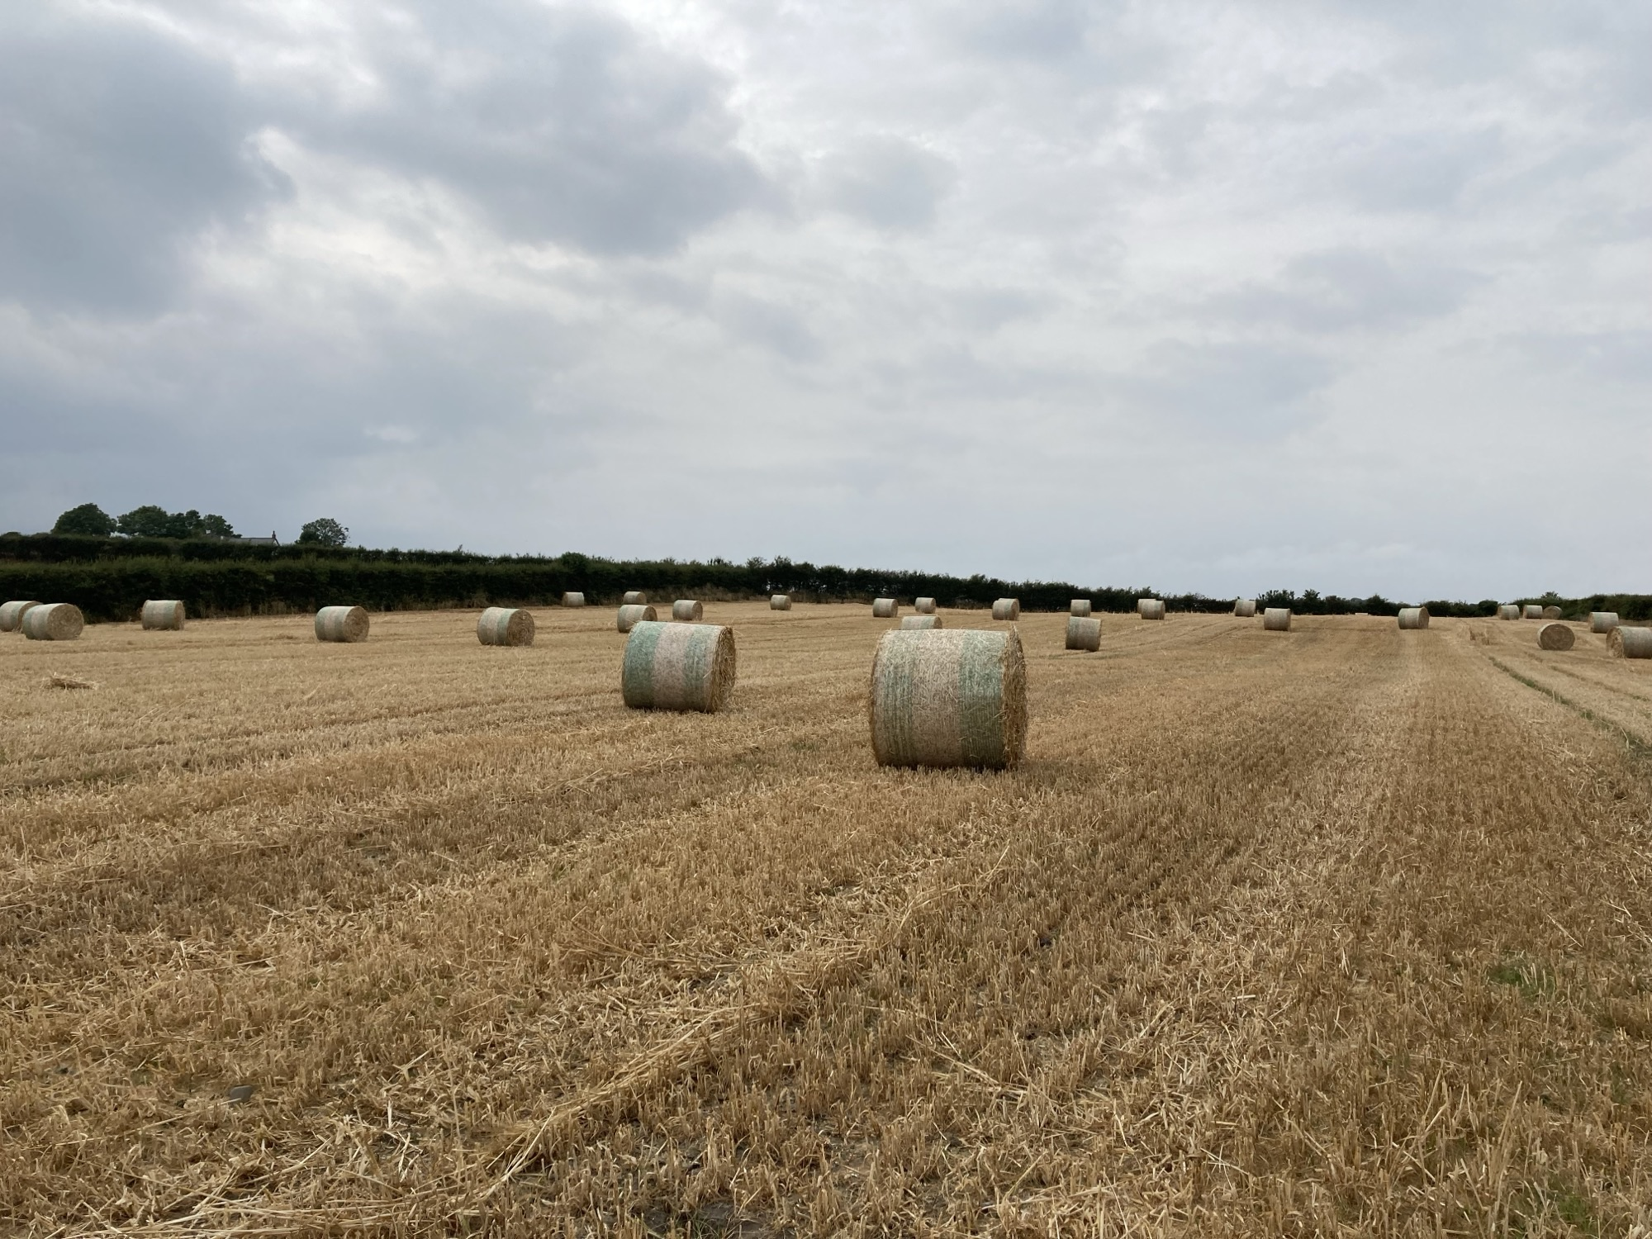
Post harvest straw should either be chopped or baled (field stored or removed)
Guidance
This Environmental Action provides a winter food source for seed-eating birds which feed on heads of grain lost before harvest, grains not gleaned during harvest, and the seeds of broad-leaved weeds. It also provides a foraging habitat for hare and other wildlife species.
The action must be undertaken in line with normal husbandry practice. Normal husbandry practice means that stubble must be produced from a crop grown and harvested in a manner that would be expected to produce a viable crop i.e. you must have prepared the land and sown the seeds in a manner and at a seed rate that would be expected to produce a normal marketable crop and harvested that crop.

Benefits of this action will be enhanced if organic manures or lime are not applied to the stubble in the period post-harvest until February 15th.
Further benefits can be achieved by broadcasting beneficial seed and nectar-producing plants, such as mustard and fodder radish, after harvest on up to 10% of the stubble area.
Localised drainage repairs or maintenance is permitted, but field scale drainage which requires significant soil disturbance should be avoided in fields intended for this environmental action.

Historic Monuments

Northern Ireland farmland boasts tens of thousands of historic monuments. If you are undertaking new actions near historic monuments the Historic Environment Division, Department of Communities’ website provides guidance on their protection (Monuments advice and guidance | Department for Communities).

Supporting Items
There are no Supporting Items available for the Environmental Action.

* Care must be taken to ensure that these actions are not implemented in sensitive semi-natural and species-rich habitats such as Grasslands, Wetlands, Coastal and Moorland habitats. Data from Northern Ireland Environment Agency (NIEA) records of habitats and species has been used within the Farming with Nature application system, but this does not infer the complete coverage of these environmental assets in Northern Ireland.

