Herbal Ley and Herbal Ley - Enhanced Requirements and Guidance

Objective
The Herbal Ley actions aim to establish herbal leys to reduce the reliance on nitrogen fertilisers and promote more sustainable farming practices. Herbal leys help improve and maintain the soil’s structure, carbon, biology and fertility and improve resilience to drought, they provide valuable habitat and food sources for pollinators and other wildlife, supporting on-farm biodiversity. A herbal ley should only be established on arable or improved grassland.
There are two herbal ley actions available, Herbal Ley and Herbal Ley - Enhanced. Enhanced action requires the planting of a more diverse species mix which is best suited to being managed through grazing and must not be cut for forage.
The minimum requirements to comply with these 2 actions are detailed in the green boxes below. Additional guidance is also provided to help you to adopt best practice.

Herbal Ley Requirements

- This action must not be carried out on:
  - Fields within an area designated as a Special Area of Conservation, a Special Protection Area, a RAMSAR site or an Area of Special Scientific Interest;
  - Northern Ireland priority habitat and species areas; or
  - Permanent Grassland Sensitive areas.
- A herbal ley containing a minimum of two grass species, two herbs and two legumes from the herbal ley seed mix list (Table 1), must be established, in line with normal husbandry practice.
- The area allowed is a minimum of 0.1 ha up to a maximum of 10 ha per applicant.
- Inorganic fertilisers containing nitrogen must not be applied.
- Plant protection products must not be applied, except for the spot treatment of noxious and invasive weeds.
- Establishment must be completed by the last day of February of the same scheme year.
- Evidence of the seed mix used (labels, invoices detailing mix contents and quantity supplied must be retained.
- The herbal ley must be retained for at least 3 years.

Herbal Ley - Enhanced Requirements

- This action must not be carried out on:
  - Fields within an area designated as a Special Area of Conservation, a Special Protection Area, a RAMSAR site or an Area of Special Scientific Interest;
  - Northern Ireland priority habitat and species areas; or
  - Permanent Grassland Sensitive areas.
- A herbal ley containing a minimum of four species of grass, four herbs, and four legumes from the herbal ley seed mix list (Table 1), must be established in line with normal husbandry practice.
- The area allowed is a minimum of 0.1 ha up to the maximum of 10 ha per applicant.
- Inorganic fertilisers containing nitrogen must not be applied.
- Plant protection products must not be applied, except for the spot treatment of noxious and invasive weeds.
- The crop must not be cut for forage.
- Establishment must be completed by the last day of February of the same scheme year.
- Evidence of the seed mix used (labels, invoices detailing mix contents and quantity supplied) must be retained.
- The herbal ley must be retained for at least 3 years.

Table 1 Herbal Ley Seed Mix
Plant Species | Required Number of Species for Herbal Ley | Required Number of Species for Herbal Ley – Enhanced
Grasses
Perennial Ryegrass (Lolium perenne) | At least 2 species of grass. | At least 4 species of grass.
Timothy (Phleum pratense) | At least 2 species of grass. | At least 4 species of grass.
Italian ryegrass (Lolium multiflorum) | At least 2 species of grass. | At least 4 species of grass.
Hybrid ryegrass (Lolium hybridum) | At least 2 species of grass. | At least 4 species of grass.
Tall Fescue (Festuca arundinacea) | At least 2 species of grass. | At least 4 species of grass.
Meadow Fescue (Lolium pratense) | At least 2 species of grass. | At least 4 species of grass.
Cocksfoot (Dactylis glomerata) | At least 2 species of grass. | At least 4 species of grass.
Sheep’s Fescue (Festuca ovina) | At least 2 species of grass. | At least 4 species of grass.
Festulolium (Festuca x Lolium) | At least 2 species of grass. | At least 4 species of grass.
Legumes
Bird’s foot trefoil (Lotus corniculatus) | At least 2 species of legumes | At least 4 species of legumes
Red clover (Trifolium pratense) | At least 2 species of legumes | At least 4 species of legumes
White clover (Trifolium repens) | At least 2 species of legumes | At least 4 species of legumes
Alsike clover (Trifolium hybridum) | At least 2 species of legumes | At least 4 species of legumes
Sweet clover (Melitotus officinalis) | At least 2 species of legumes | At least 4 species of legumes
Lucerne (Medicago sativa) | At least 2 species of legumes | At least 4 species of legumes
Sainfoin (Onobrychis sativa) | At least 2 species of legumes | At least 4 species of legumes
Meadow Vetchling (Lathyrus pratensis) | At least 2 species of legumes | At least 4 species of legumes
Tufted Vetch (Vicia cracca) | At least 2 species of legumes | At least 4 species of legumes
Herbs
Chicory (Cichorium intybus) | At least 2 species of herbs | At least 4 species of herbs
Burnet (Sanguisorba minor) | At least 2 species of herbs | At least 4 species of herbs
Plantain (Plantago) | At least 2 species of herbs | At least 4 species of herbs
Yarrow (Achillea millefolium) | At least 2 species of herbs | At least 4 species of herbs
Sheep’s parsley (Petroselinum crispum) | At least 2 species of herbs | At least 4 species of herbs

Where action should not take place
Care must be taken to ensure that these actions are not implemented in sensitive semi-natural and species-rich habitats such as Grasslands, Wetlands, Coastal and Moorland habitats. Data from Northern Ireland Environment Agency (NIEA) records of habitats and species has been used within the Farming with Nature application system, but this does not infer the complete coverage of these environmental assets in Northern Ireland.

Any operation designed to increase the agricultural productivity of uncultivated land or semi-natural areas require consent from DAERA. Land is considered to be uncultivated if it has not been subject to physical or chemical cultivation in the last 15 years. Such uncultivated areas are protected under both the Farm Sustainability Standards and The Environmental Impact Assessment (Agriculture) Regulations (Northern Ireland) 2007. Further details can be found at https://www.daera-ni.gov.uk/articles/environmental-impact-assessment-eia-ag.

Soil analysis results can be used to inform field suitability for this action. Fields with a pH of less than 5.5 and/or Phosphorus (P) or Potassium (K) at Index 0 or 1 are not recommended.

If you have received results from the NI Soil Nutrient Health Scheme consult the Env Codes in your Certificate of Analysis to determine if a field is of potentially of high environmental status, uncultivated or a semi-natural area. This is indicated by the Env Code G and is covered by The Environmental Impact Assessment (Agriculture) Regulations (Northern Ireland) 2007. Fields with Env Code, G must not be used for these actions.
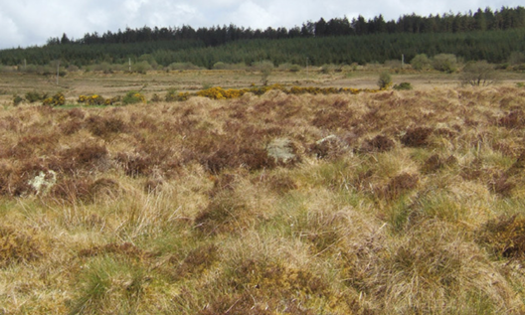

Semi-natural area
What success looks like
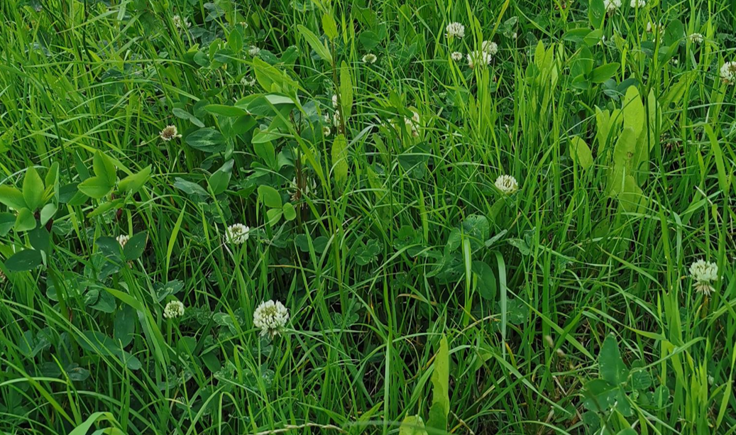
Figure 1: A herbal ley

GUIDANCE
Herbal leys, sometimes called multi species swards, are established using a seed mixture of grasses, legumes and herbs. The grasses contained within the mix provide the main source of energy, while the legumes provide protein and the herbs supply essential minerals (Figure 1).

Benefits to Livestock and Profitability
Extension of grazing season | Herbal leys have been shown to extend the grazing season through the inclusion of deep-rooting species such as chicory and plantain which allows the sward to continue growing during dry periods supporting later autumn grazing when traditional grass leys may struggle. Similarly, improved soil structure and moisture retention can support earlier spring growth.
Better animal performance | The diverse mix of species improves overall forage quality, with higher mineral content and better digestibility compared to standard grass-only swards. This can lead to improved livestock performance, with beef liveweight gain up to 0.7-1.6 kg/ day and lambs gaining 0.31 kg a day and finishing 30 days sooner compared to standard grass-only swards. Dairy cattle experience increased milk production and increased solids. As a result, animals can meet more of their nutritional needs directly from grazing, lowering feed costs and reducing the need for supplementary feeding.
Chemical Fertiliser Requirement Reduced | Herbal leys can reduce or remove the need for chemical nitrogen fertiliser where there is a good proportion of legumes in the mix. Up to 180 kg of nitrogen/ha can be fixed naturally, supporting growth across the sward.  Well-managed herbal leys can achieve similar yields to Perennial Ryegrass without chemical nitrogen, while reducing input costs and lowering the risk of nitrogen leaching and runoff.  Care should be taken to maintain P & K level at 2+ to ensure chicory and clover levels remain.
Anthelmintic Properties | Herbal leys can help reduce parasitic burdens, lowering reliance on artificial wormers and supporting overall livestock performance. Species, such as Sainfoin, Chicory and Bird’s Foot Trefoil, contain tannins with natural anthelmintic (anti-parasitic) properties. These can reduce parasite activity by limiting nematode egg hatching, slowing larval development and reducing larval mobility. Healthier animals lead to better performance.
Bloat | Herbal leys that include a diverse range of species, with Clover kept below around 40% of the sward, can help reduce the risk of bloat compared to high-legume grass leys. Including herbs such as Chicory, which contains tannins, can help reduce this risk, alongside a balanced mix of grasses and other species that support a more stable rumen environment.  However, grazing management remains key. Livestock should be introduced gradually onto herbal leys, avoiding turnout when animals are very hungry or when covers are very lush or wet. Maintaining a consistent grazing rotation, and avoiding very tight grazing, will all help minimise bloat risk. A well-balanced sward combined with good grazing management is essential for safe and effective use of herbal leys.

Benefits to the environment
Soil Structure | The mix of plant species with different root systems, along with their associated fungi, produces a large root biomass that strengthens soil structure. Deep-rooting plants create natural drainage channels, reducing surface water and compaction, while supporting healthy earthworm populations. Increased worm numbers enhance nutrient cycling, stimulate microbial activity, improve organic matter decomposition and boost carbon sequestration.
Water Quality | Swards with a high legume content can help protect water quality by reducing the need for synthetic fertilisers, lowering the risk of nitrogen leaching and runoff. Deep-rooting herbs improve soil structure and water infiltration, helping rainfall soak into the soil rather than washing nutrients into waterways.
Carbon Sequestration | Herbal leys increase carbon sequestration by building soil organic matter through their large and diverse root systems. Deep-rooting species deposit carbon deeper in the soil, while a mix of grasses, legumes and herbs stimulates microbial activity that stabilises organic matter. Regular root turnover and the decomposition of plant residues add further carbon to the soil. Over time, this process helps lock carbon in the soil, improving soil health.
Pollination | The diverse sward provides a wide variety of plants that support pollinators and other wildlife, offering food, nesting sites, and shelter for hibernation. More plant species lead to greater overall biodiversity, enhancing the ecological value of the farm and surrounding landscape.  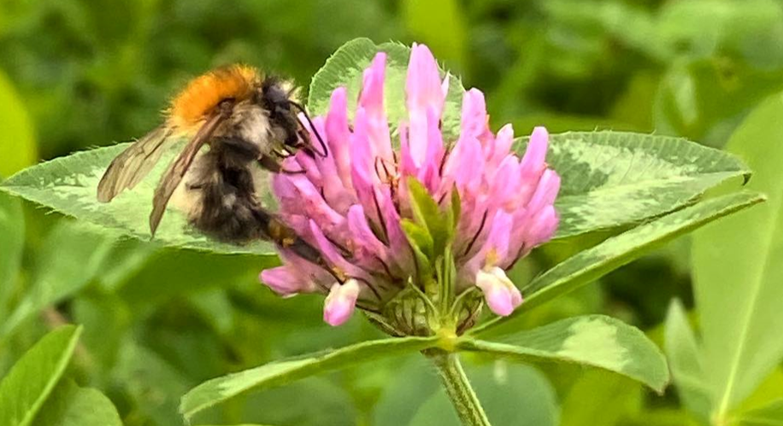

Choosing the right mix
Selecting the right species mix is key to getting the most from a herbal ley. A balanced mix of grasses, legumes and herbs should be chosen to suit soil type, climate and intended use (grazing and/or cutting). Grasses provide yield and ground cover, legumes supply natural nitrogen, and herbs improve soil structure, drought tolerance and mineral content. Including a range of species with different rooting depths increases resilience and helps maintain productivity throughout the season.
There are many suitable species for farm use and these can be selected based on their preferred soil conditions. It is important to choose species that match the soil types on your farm while meeting the minimum mix requirement of the specification. For example, lighter soils suit deep-rooting species such as Cocksfoot, while heavier soils favour species that prefer moisture and fertility, such as Red Clover. Some legumes, including Sainfoin and Lucerne, do not perform well in acidic soils, where alternatives like Alsike Clover or Bird’s Foot Trefoil can be used to maintain diversity (Table 2).
It’s also important to ensure a sufficient but not excessive proportion of legumes, typically below 40% to reduce risks such as bloat while still benefiting from nitrogen fixation.
Choosing persistent, well-adapted species will help maintain sward composition over time, leading to better performance, improved soil health and a more reliable, low-input system.
Table 2: Appropriate Seed Mix for Different Soil Types
 | Lighter soils | Most soil types | Heavier soils
Grass | Cocksfoot  Tall Fescue  Timothy  Festulolium | Festulolium  Timothy  Meadow Fescue  Ryegrass | Timothy  Meadow Fescue  Ryegrass  Cocksfoot
Legume | Sainfoin  Lucerne  Bird’s Foot Trefoil  Alsike Clover | Bird’s Foot Trefoil White Clover  Red Clover  Meadow Vetchling | White Clover  Alsike Clover  Meadow Vetchling Bird’s Foot Trefoil
Herb | Yarrow  Sheep’s Parsley  Chicory  Burnett | Chicory  Ribwort Plantain  Burnet  Yarrow | Chicory  Ribwort Plantain  Burnet  Yarrow

The success of herbal leys can vary with soil type and management. Species diversity will decline over time and be challenging to manage. It is important to maintain suitable phosphorus and potassium levels in the soil. For more advice, consult an agronomist or seed merchant.

Establishment of Herbal Leys
Selecting the right field is essential to the success and durability of a herbal ley.
- Soils should be well‑drained, suitably fertile and in good structural condition to support the range of species within the sward. Fields with high weed pressure, poor drainage or compaction are less suitable, as management options after establishment are limited. Careful field choice helps ensure rapid establishment, good species balance and long‑term performance of the ley.
- Since herbs and legumes are herbicide sensitive, options for chemical weed control within the herbal ley are limited once established. It is strongly recommended to sow into weed free (clean) ground. Problem weeds should be controlled in advance, either through cultivation, grazing, or targeted spraying prior to reseeding.
- A soil pH of around 6.5 is ideal to support the wide range of species in the mix, particularly legumes which are key for nitrogen fixation. Soil fertility should be at least Index 2+ for Phosphorus (P) and Potassium (K). Refer to your most recent soil analysis and where required, soils can be improved ahead of sowing through the application of lime, farmyard manure or slurry or P and K fertiliser. Maintaining these levels is important, but inorganic nitrogen fertiliser must not be used, as it will reduce species diversity and limit the benefits of the ley.
- Avoid heavy, poorly drained soils as these can limit root development, reduce plant persistence and increase the risk of poaching under grazing. Free-draining, well-structured soils are best suited, allowing deep-rooting species to thrive and deliver benefits such as improved drought resilience and soil structure.
Where possible, select fields that are in good overall condition, with low compaction and a history of good management. Addressing issues such as drainage, compaction or low pH and fertility before establishment will greatly improve the chances of a successful and productive herbal ley.

Seed Bed Preparation and Sowing
Establishing herbal leys on your land is a relatively simple process, but there a few key things that you should consider.
- Good seedbed preparation and careful sowing are essential for successful establishment of a herbal ley. Many of the species involved are small-seeded and less competitive than traditional grasses, so attention to detail at this stage is critical.
- Getting the timing of establishment is vital with sowing being most successful in spring (April/May) or late summer (August/early September), when soil temperatures are adequate (8-10°C) and moisture is more reliable. Avoid sowing into cold, waterlogged or very dry conditions. Ideal timing will vary geographically.
- Over-sowing is not a recommended method of establishment.
- The most reliable technique for ensuring successful establishment has been shown to be through conventional reseeding methods (cultivate and harrow) to create a firm, well-consolidated, fine seedbed. The aim is to create a level surface where seeds can be placed shallowly with good soil contact. After cultivation the stale seed bed method can be used to exhaust the population of weed seeds
- Sowing depth is critical. Many herbal ley species such as Clover, Timothy, Chicory and Ribwort Plantain have very small seeds and must be sown very shallow between 5 -10 mm. Sowing too deep is a common cause of failure. Rolling before sowing can help achieve the right level of consolidation. Broadcasting or shallow drilling using a tine harrow, are both suitable methods. Followed by rolling immediately to ensure good seed-to-soil contact and moisture retention which are vital for successful germination.
- Taking care with seedbed preparation and sowing will give the ley the best possible start, leading to a more productive, persistent, and diverse sward.

Post-Establishment and Grazing Management
- Protect new leys for 6 – 8 weeks after sowing, then introduce a light first grazing to encourage tillering and help control weeds. For autumn sowing, light graze before winter.
- Livestock may take a few days to adapt to the taste of herbal leys, so they should be introduced gradually where possible.
Grazing Approach
- Rotational grazing/mob grazing with rest periods has been shown to be the best way to maintain sward diversity and persistence.
- Typical rotations range from 20–40 days (commonly 28–38 days), depending on growth and conditions. Allowing adequate rest is vital to encourage the diverse herbs and legumes to remain in the sward.
- Avoid set stocking, to prevent selective overgrazing, which can damage the crown of species such as Chicory and Red Clover, reducing species diversity over time, as livestock will selectively eat the most palatable species and effectively graze them out, significantly reducing the diverse benefits that the ley can deliver.
- Graze at a height of approximately 50 cm and avoid grazing below 7-10 cm, as this can damage regrowth and reduce persistence of herbs and legumes.
- Allowing the sward to flower and set seed to replenish the seedbank is vital to ensure persistence of the ley.
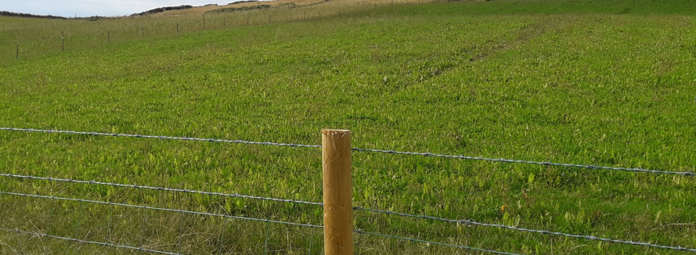
Figure 2: Herbal ley 2 weeks after grazing

Managing Animal Health and Performance
- Avoid frequently moving livestock between herbal leys and standard grass swards, as sudden diet changes can affect rumen function, appetite and performance.
- Provide fibre if needed when grazing lush swards to support rumen stability.

Seasonal Management
- Herbal leys often peak later in the season than perennial ryegrass, helping maintain summer production.
- Plan grazing to make use of growth during drier periods when grass growth may decline.
- Aim to graze off by October/November, then allow the ley to rest over winter to support persistence.
Inputs and Sward Balance
- You must not apply nitrogen fertiliser, as this suppresses legumes and reduces diversity.
- Monitor sward composition and adjust grazing pressure to maintain a balanced mix of species.
Duration
The herbal ley must be retained and managed for at least 3 years to deliver full benefits in terms of soil health, productivity, and biodiversity. Through the Farming with Nature Scheme, you can apply for the Management of Herbal Leys in the year after establishment, to support retention and management. While longer careful management bring further benefits, you are likely to see a decline in species diversity as herb and legume species are relatively short lived. You therefore typically need to re-establish the ley every 3 to 5 years.

Key learnings to maintain a productive and persistent herbal ley
- Select a suitable field, weed free, determine soil type so that the right seed mix can be picked, ensure pH and P and K levels are as required.
- Shallow sow or broadcast into a warm firm seed bed, above 8ºC.
- Lightly graze your herbal ley in the first year after sowing. Light grazing controls annual weeds and encourages plants to bush out.
- After the first year, rotational graze to prevent selective grazing and avoid overgrazing with adequate rest periods is the best ways to manage herbal leys.
- Trial and error - don’t give up! It takes time and experience to get it right.
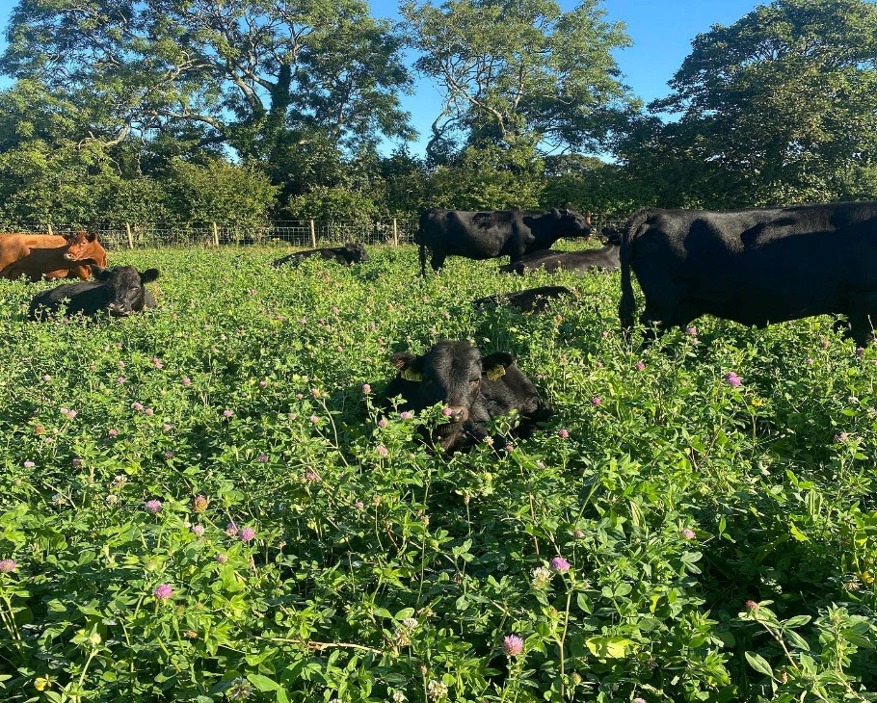
Figures 3: Cattle grazing a herbal ley sward
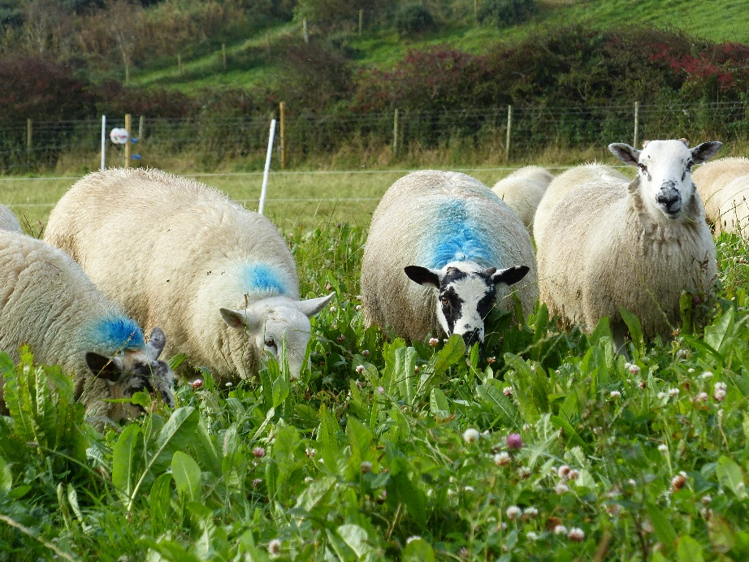
Figure 4: Sheep grazing a herbal ley sward

Silage
Cutting Herbal Leys for Silage
While both herbal ley actions are suitable for grazing, a silage cut is only permitted for the Herbal Ley action. The Herbal Ley - Enhanced Action must not be cut and should be managed through grazing only as the diverse species mix is not suitable for cutting (Figure 5).
Cutting Management
- Avoid cutting too low, as this reduces regrowth and persistence, with a minimum cut high of 8–10 cm being required to protect Clover crowns and herb growing points.
- A cut should not be taken before most of the crop is flowering to encourage plant persistence. Aim to cut when the crop is leafy and digestible, before it becomes too stemmy.
- To ensure some forage is always available for pollinators, a minimum 3 m wide uncut margin should be left around one length of the longest field edge. These margins can then be grazed after the plants have matured from the beginning of August.
Wilting and Dry Matter Targets
- Wilt for 24–48 hours, depending on conditions.
- Target 28–32% Dry Matter (DM) for clamp silage and 35–45% DM for baled silage.
- Mixed swards can be more challenging to ensile than grass-only crops due to variation in species and moisture content.
Handling and Harvesting
- Avoid over-handling the cut sward, especially in hot weather, to reduce leaf loss and maintain protein levels.
- Rake gently and minimise machinery passes.
- Consider reducing or disengaging mower conditioners on high-legume swards.
- Avoid cutting in wet conditions to prevent soil contamination and compaction.
- Fermentation and Additives - herbal leys are typically high in protein and low in sugars, making fermentation more difficult. Use silage additives (e.g. inoculants) to improve fermentation and preservation.
Key learnings to maintain a productive and persistent herbal ley through cutting
- Cut high
- Cut at the right stage
- Wilt carefully
- Handle gently to produce quality silage
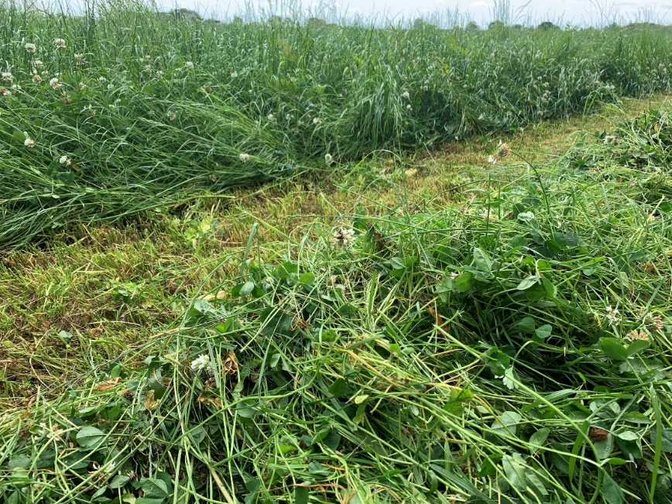
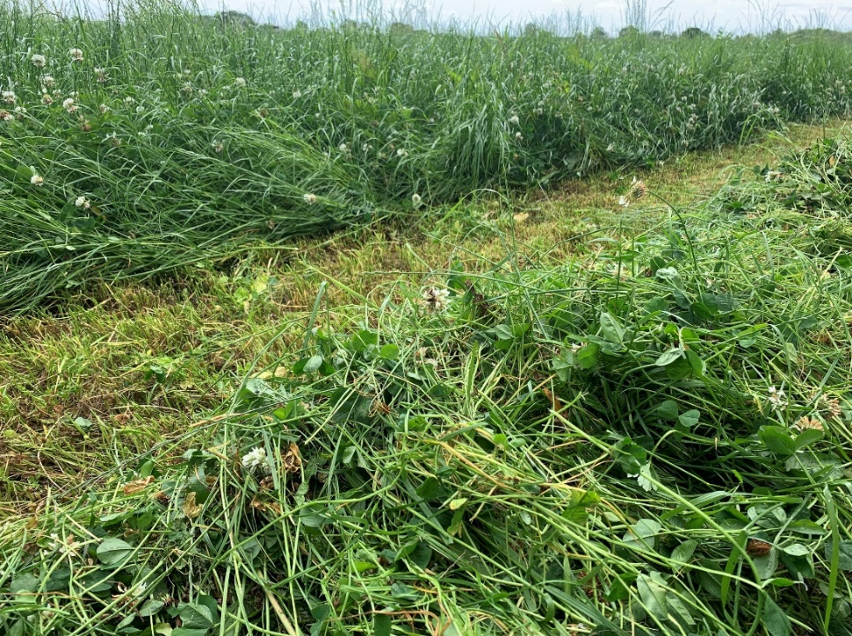
Figure 5: Herbal ley mown for silage

Further reading
www.soilassociation.org/farmers-growers/low-input-farming-advice/herbal-leys/herbal-leys-how-to-guide/Reference

