Arable – Flower Rich Margin (3 m – 12 m)
Requirements and Guidance

Objective
Establishing flower-rich grass margins on arable land creates habitat and foraging sites for invertebrates, including natural crop pest predators, wild pollinators and farmland birds.
The minimum requirements to comply with this action are detailed in the green box below. Additional guidance is also provided to help you to adopt best practice.

Arable – Flower Rich Margin (3 m – 12 m) Requirements

- This action must not be carried out on:
- Fields within an area designated as a Special Area of Conservation, a Special Protection Area, a RAMSAR site or an Area of Special Scientific Interest.
- Northern Ireland priority habitat and species areas*; or
- Permanent Grassland Sensitive areas.
- A flower-rich grass margin, 3 m wide to 12 m wide, must be created along part or for an entire field boundary, where the main field crop is cereal, in line with normal husbandry practice.
- The area allowed is a minimum of 0.1 ha up to the maximum funding available per applicant.
- Establish a flower-rich grass margin using untreated seed from the Irish Native Flower and Grass Seed Mix list.
- Fertilisers (organic and inorganic), lime and plant protection products, except for the spot treatment of noxious and invasive weeds, must not be applied.
- The margin must not be grazed or damaged.
- The margin must be established by the 30 September of the same scheme year.
- Evidence of the seed mix used (labels, invoices detailing mix contents and quantity supplied) must be retained.
- The margin must be retained for at least 5 years.

Table 1: Irish Native Flower and Grass Untreated Seed Mix
Species | Minimum number required | % composition of seed mix
Irish Native, Fine-leaved Grass Species –  - Fescues (Festuca)  - Common bent (Agrostis capillaris)  - Sweet vernal grass (Anthoxanthum odoratum)  - Crested dog’s‑tail (Cynosurus cristatus) | One of each | < 90%
Irish Native Wildflower Species  - Agrimony (Agrimonia eupatoria)  - Betony (Stachys officinalis)  - Birdsfoot Trefoil (Lotus corniculatus)  - Black/Common Knapweed (Centaurea nigra)  - Black Medic (Medicago lupulina)  - Native Bluebell (Hyacinthoides non‑scripta)  - Common Mallow (Malva sylvestris)  - Corn Cockle (Agrostemma githago)  - Cow Parsley (Anthriscus sylvestris)  - Devil’s‑bit Scabious (Succisa pratensis)  - Dropwort (Filipendula vulgaris)  - Field Scabious (Knautia arvensis)  - Great Mullein (Verbascum Thapsus)  - Hedge Bedstraw (Galium mollugo)  - Ivy‑leaved Speedwell (Veronica hederifolia)  - Lady’s Bedstraw (Galium verum)  - Meadow Sweet (Filipendula ulmaria)  - Meadow Vetchling (Lathyrus pratensis)  - Musk Mallow (Malva moschata)  - Oxeye Daisy (Leucanthemum vulgare)  - Ragged Robin (Silene flos‑cuculi)  - Red Campion (Silene dioica)  - Red Clover (Trifolium pratense)  - Ribwort Plantain (Plantago lanceolata)  - Salad Burnet (Sanguisorba minor)  - Self‑Heal (Prunella vulgaris)  - Sheep’s Sorrel (Rumex acetosella)  - Tufted Vetch (Vicia cracca)  - White Campion (Silene latifolia)  - White Clover (Trifolium repens)  - Wild Carrot (Daucus carota))  - Yarrow (Achillea millefolium) | At least 8 | No individual species should make up more than 25% of the total wildflower seed weight

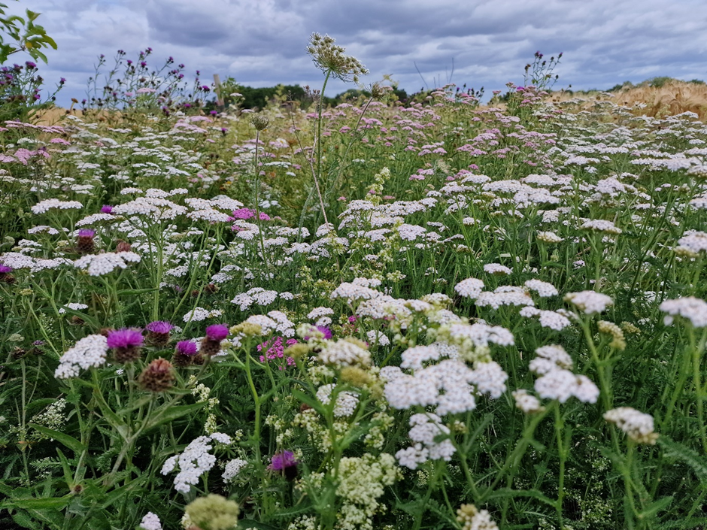
What success looks like

Figure 1: Flower rich grass margin next to arable crop and hedgerow at RSPB Hope Farm (Photo - Georgie Bray, RSPB Hope Farm)

An Arable – Flower Rich Margin will produce flowering plants during the spring and summer months, into early autumn. It will support populations of pest predators, such as hoverflies, whose larvae feed on aphids, and crop pollinators, such as wild bees. This can help to control these pests on nearby crops and boost crop pollination. The general increase in insects attracted to these mixtures in turn provides food for birds and valuable foraging habitat for small mammals. These mammals can provide a food source for hunting raptors.

GUIDANCE

Seed mix

The seed mix for this action is detailed in Table 1. Aim to source Irish Native Wildflower Species of local provenance as they are more likely to germinate successfully, grow stronger and have greater resilience to local weather extremes. You can choose to sow a seed mix containing more wildflower species than this action requires. Using an enhanced mix is likely to mean less frequent re-sowing as more flower species are retained for longer. It can also help to provide a more varied mix of flowers for beneficial insects. Your seed supplier can help you choose a seed mix that is the best match for your land and local conditions.

Where to sow

It will be of greatest benefit to sow the seed mix on sites that receive plenty of sunlight to help plants establish and on sites which are low in soil fertility, as grasses and weeds can dominate fertile areas and will compete with the flowers. Sowing a few margins spaced across your farm will create a network of habitats for beneficial insects.

How to sow the seed mix

Your seed supplier can advise you on an overall sowing rate for the seed mix you choose. The recommended minimum seed rate for flowers in the mix is 2 kg/ha. The seeds are likely to germinate if they are sown into a seedbed that is firm, consolidated, fine, level and weed free. The seedbed must be warm and moist. Wildflowers can grow slowly so try to sow by the end of August to avoid frost damage.

You can either:
- Broadcast the seeds onto the surface of the seedbed to help germination; or
- Shallow-drill the seeds up to a depth of 1 cm, as small seeds usually struggle to germinate when sown deeper than 1cm.

If the soil is dry enough, rolling after you have sown the seeds can improve seed-to-soil contact, retain moisture and reduce the risk of slug damage.

Establishing flower-rich grass margins

During the first spring and summer after sowing, it is advisable to check the margin, regularly to monitor germination. If establishment is poor, you may need to re-sow part or all of it. Your seed supplier can help you if you are unsure of how best to do this.

Cutting the margin

Cutting the margin regularly during the first 12 months after sowing will help to control weeds and allow the sown plants to establish. You can do this whenever the weeds are just above the sown flowers and starting to shade them out.

When cutting the margin:
- Check for signs of nesting birds before you cut – birds, nests and eggs are protected by law, so if you see signs of nesting birds, delay cutting until the 1 September (Figure 2).
- Remove the cut vegetation, where possible to prevent smothering of flower species, limit weeds and maintain low soil fertility, which supports a diverse flowering sward and prevents grasses from becoming dominant. If it is impractical to do this, finely chop and spread cuttings as thinly as possible.

- 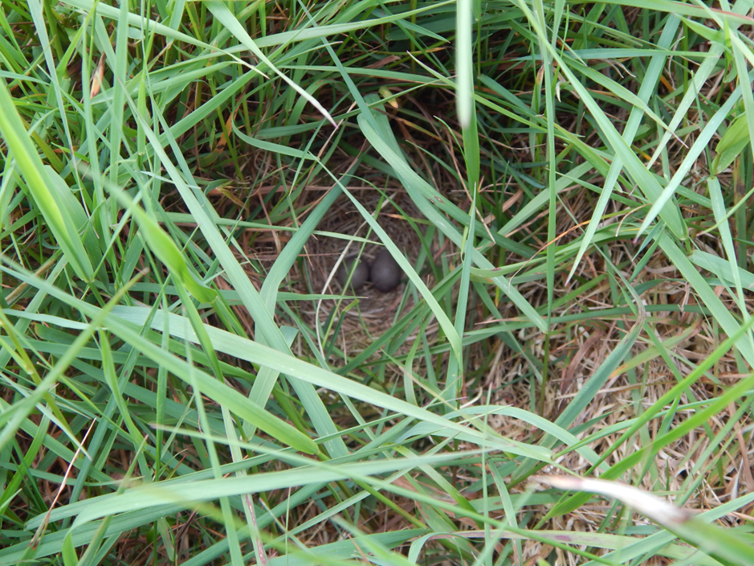
Figure 2: Meadow Pipet nest in tussocky grass (Photo - Mark McCormick RSPB)

Maintaining the established margins

The margin must be retained and managed for at least 5 years. Through the Farming with Nature Scheme, you can apply for the Management of Arable - Flower Rich Margins in the year after establishment, to support retention and management. To do this, undertake some or all the following steps.
- Cut in the spring (usually before the beginning of April), so vegetation is short enough to allow flower species to grow without competition from dominant grasses.
- Cut and remove the summer growth between 1 September and the end of October– this will help reduce soil fertility and boost flower numbers in subsequent years. If it is impractical to do this, finely chop and spread cuttings as thinly as possible.
- Stagger the cutting, so all the margins are not cut at the same time – this will help to provide a constant supply of flowers for invertebrates.
- Leave about 10% area within each margin uncut each year. This will help to provide a refuge for insects and other wildlife over winter.

* Care must be taken to ensure that these actions are not implemented in sensitive semi-natural and species-rich habitats such as Grasslands, Wetlands, Coastal and Moorland habitats. Data from Northern Ireland Environment Agency (NIEA) records of habitats and species has been used within the Farming with Nature application system, but this does not infer the complete coverage of these environmental assets in Northern Ireland.

