Management of Hedgerows – Requirements and Guidance

Objective
The aim of this action is to manage new lengths of hedgerows planted under Farming with Nature in a previous scheme year.
The minimum requirements to comply with this action are detailed in the green box below. Additional guidance is also provided to help you to adopt best practice.
Management of Hedgerows Requirements

- Growth must not be negatively affected by weeds.
- Dead hedge plants must be replaced to maintain an average of 5 plants per metre from the hedge plant species list.
- Hedgerows must be protected from damage by grazing livestock and wildlife on all sides as required.
- Protective fencing funded by FwNT must be maintained in stock-proof condition.
- Work must be completed by the last day of February of the same scheme year.

What success looks
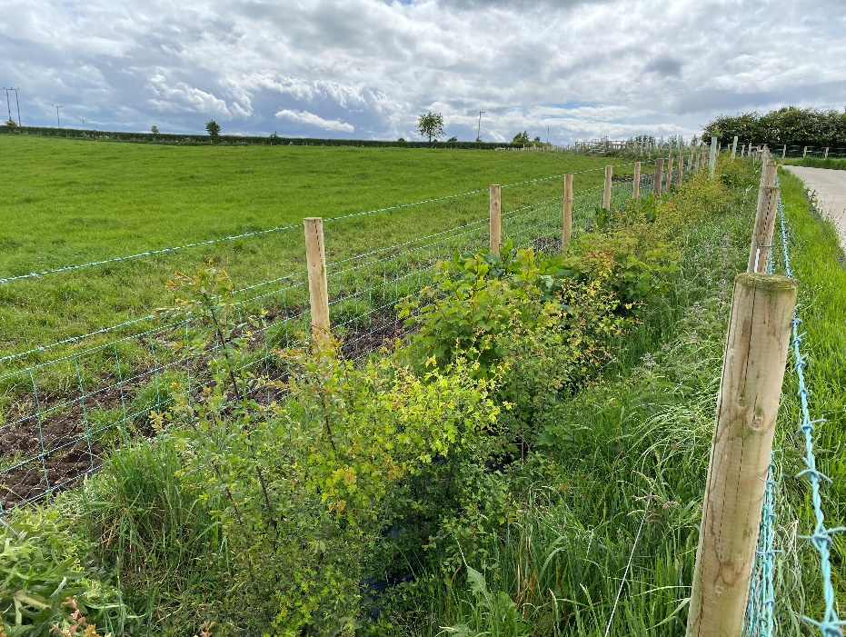
A hedgerow after 3 - 4 years of management
Success means creating a dense hedgerow with a strong base and bushy growth from the bottom of the plants and a healthy structure. This is achieved by weeding the entire length and pruning a third of the growth of the newly planted hedge in the first winter after planting and replacing dead whips.

GUIDANCE
Pruning - Year 1
After a year of establishment, formative pruning should take place in late winter, where individual plants are lightly cut by hand just above a bud by about one-third of the growth to encourage dense, bushy growth from the base.
Shoots extending out from the hedge can also be cut back by about one-third to keep the hedge narrow at this early stage, cutting just beyond a well-placed bud.
Trees within the hedge should be marked/identified to ensure that they are not pruned and allowed to establish fully.
Mechanical Hedge Cutting on a 2- 3 Year Rotation
Mechanical hedge cutting should be carried out in later years, on a 2–3-year rotation, to maximise flowers, berries, and wildlife value. A lot of native hedgerow shrubs only flower and fruit on the previous year's woody growth, so pruning needs to be done every 2 or 3 years to encourage blossom and fruit while improving the hedge's structure and value for wildlife.
Under DAERA’s Farm Sustainability Standard 2 (www.daera-ni.gov.uk/articles/farm-sustainability-standards-fss) hedge, tree or scrub cutting is only permitted in the period between 1st September to the last day of February. To help wildlife, it is best practice to wait until January or February.
Delaying cutting until late winter also ensures that berries persist on the hedge for as long as possible, providing a crucial food source for birds during the hardest part of the winter when alternative forage is scarce.
Ensuring survival of the hedge
- Weeding
- Grass and weeds compete with hedge plants for water and nutrients, dramatically slowing your hedge's growth and eventually killing the hedge.
- Maintain an area free from weeds and grass for about 75cm on either side of the hedge. Hand-pull weeds close to the hedge plants that grow out from under mulch fabric.
- Applying mulch suppresses weeds, preserves soil moisture and increases soil fertility which can boost your hedge's growth rate.
- Mulch can be
  - Grass clippings;
  - Compost or well-rotted manure; or
  - Woodchips or bark chips.
Replacing Dead Plants
It is vital that strong roots are encouraged in a newly planted hedge. In the early stages, hedges are particularly sensitive to drying out and vulnerable to competing weeds. A 100% success rate is difficult to achieve, and dead plants must be replaced with plants from the Hedge Plant Species List to maintain a minimum planting density of 5 plants per metre. Use three or more species to increase hedgerow diversity.
Hedge Plant Species List
- Blackthorn/Sloe
- Dog Rose
- Gorse/Whin
- Guelder Rose
- Hawthorn
- Hazel
- Holly
- Spindle

Hedge Protection
The hedgerow must be protected from damage by grazing livestock and wildlife. particularly deer, on all sides. For this reason, it is essential that protective fences are maintained and any damage repaired.

