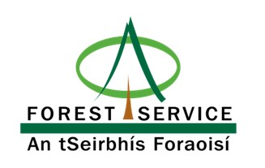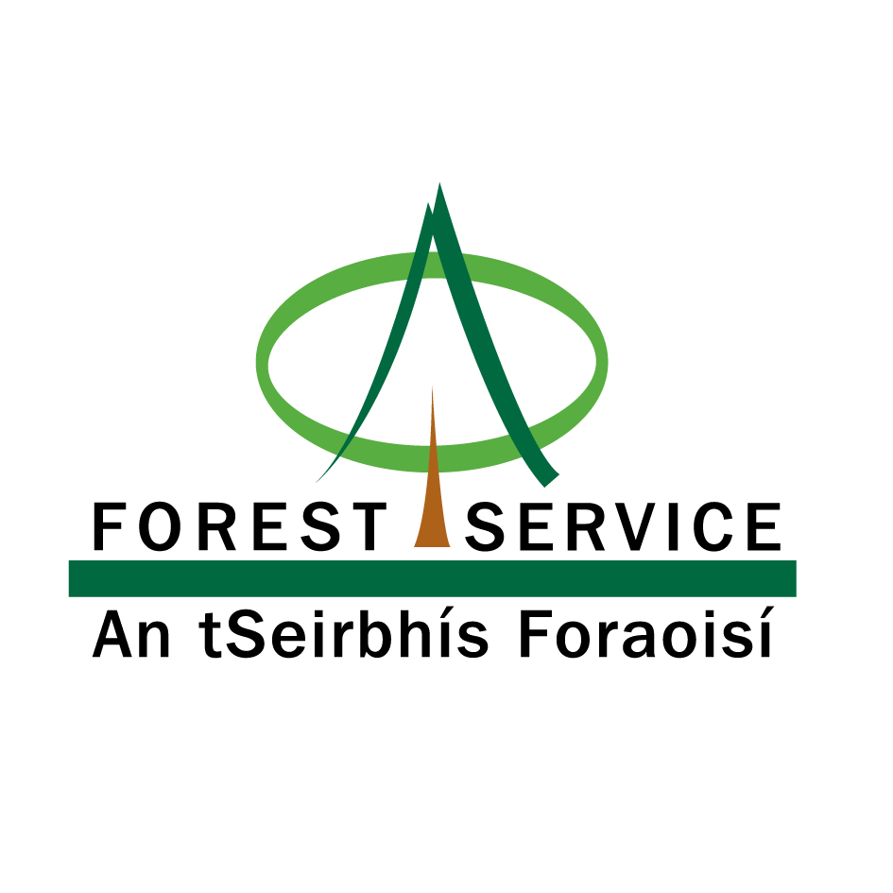

Forests for Our Future

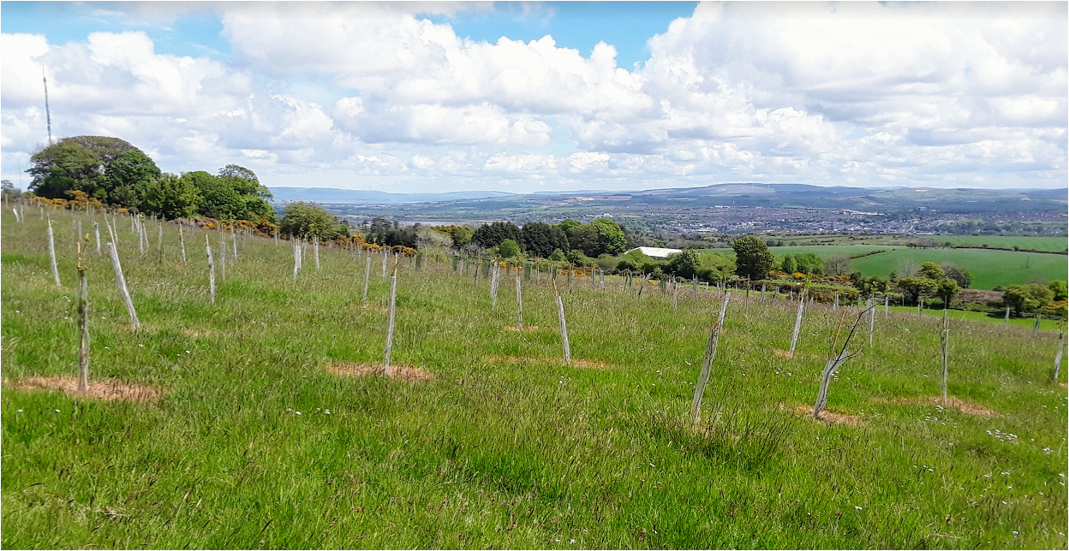

Forest Expansion Scheme
Woodland Creation Plan
2026/27
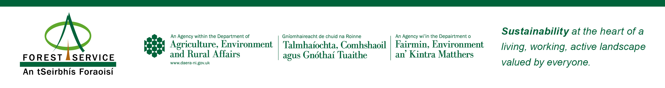

Forest Expansion Scheme
Woodland Creation Plan

- Details

1.1 Applicant(s) Details
Title |  | Forename |  |  |  | Surname
DAERA Business ID |  |  |  |  |  |  | Owner or Tenant
Business Name (checked with Local DAERA Office)

Business Members (checked with local DAERA Office) |  | 1.  2. |  |  |  |  | 3.  4.
Contact Tel No |  |  |  |  |  |  | Mobile Number
Address
Postcode |  |  | Email
VAT registration number or complete section 9.

How would you like us to contact you? |  |  |  |  |  |  |  | Email |  |  | Post

1.2 Agent Details (if you have an Agent)

Title |  | Forename |  |  |  |  | Surname
Organisation
Contact Tel No |  |  |  |  | Mobile Tel No
Address
Postcode |  |  |  | Email
Would you like us to copy correspondence to your agent? |  |  |  |  |  |  |  |  |  | Yes / No

1.3 Woodland Creation Plan

Ten-Year Plan | Start Date 2026/27 | End Date 2036/37
Planting area in hectares (Excluding existing woodland).

User Support: The functionality in this version is compatible with Word 2003.This document is not protected and as such rows can be added & deleted from tables where needed. Blue underlined script within this document denotes a web link.

  - Checklist

Please complete the following checklist using Yes, No or Not applicable (N/A).

All listed members of the Business have completed and signed this application form.

I have mapped the boundary of the project also detailed open space areas, any new fencing, cross drains and access into and around the site.

I have identified, mapped and engaged with all my neighbours and recorded this in section 6. Where appropriate I have attached a written agreement from neighbour/occupier.

I have checked that my project is not to plant on soils with peat exceeding 50cm in depth.

I have checked the Historic Environment Map Viewer and consulted where required with Department for Communities about the impact my project will have on the historic environment.

I have checked the Northern Ireland Environment Agency map viewer DAERA NIEA Natural Environment Map Viewer and have planned my woodland to conserve or enhance biodiversity.

I have engaged with NIE Networks and sought guidance.

I have supplied evidence of agricultural use [see annex 1 below].

I have included a Forest Expansion Scheme – Costs Spreadsheet

Applicant Name(s) |  | Signed |  | Date

Completed application documents to be emailed to:

grants.forestservice@daera-ni.gov.uk

or posted to:
Forest Service Headquarters - Grants Branch
Inishkeen House
Killyhevlin Industrial Estate
Killyhevlin
Enniskillen
Co. Fermanagh BT74 4EJ

Tel: 02866 343145

Applications must arrive no later than the deadline dates as described in the information booklet.

  - Forest Expansion Scheme- Annual Premia

Has any part of the land proposed for woodland creation been the subject of a successful DAERA area-based payment claim since 2023/24? | Yes / No
If you answered no in question 1, please provide evidence of agricultural use on a separate sheet using the guidance in Annex 1. If you do not supply this, we will reject your application for annual premia.

Field Number  E.g. 1/083/069/42/D | LPIS Maximum Eligible Area being planted. | Part or entire field – (specify)

- Woodland Survey
This section is about collecting information relating to your woodland and its location, including any statutory constraints e.g. designations.

3.1 Description
Description of the site (Refer to elevation, vegetation, exposure & slope, present land use)
Location of the site
Soil type(s) - e.g. brown earth, surface water gley, peat including peat depth (if present this must be mapped)
Adjacent habitats or land use e.g. woodland, semi natural habitat, urban or industrial
What is the grid reference for the centre of the woodland? e.g. H 12345, 54321 https://irish.gridreferencefinder.com/
What is the what3words for the centre of the woodland? what3words /// The simplest way to talk about location

  - Environmental Checks
Use this section to identify features or sensitivities that are present within your site or close to your proposed woodland.

Applicants must provide more information at the outset on the proposal’s potential environmental impacts. This includes providing details of any mitigation/protection measures designed to avoid or prevent significant adverse effects on the environment and these will inform our decisions (screening decisions) on whether EIA consent is required and avoid the greater cost and time associated with taking a proposal through the Environment Impact Assessment process. Please state what protection measures will be used to consider any sensitivities identified.

3.2.1 Biodiversity Features

Please use the NIEA Natural Environment Map Viewer (daera-ni.gov.uk) to help locate designations: This is used to produce an Area of Interest Information / Screening Report showing any hazards and sensitivities or constraints.

Feature |  | Within Site: Y/N | Adjacent to Site:  Y/N | Protection (How will you ensure the designated area is maintained in line with your responsibilities in connection to your proposal?)
Special Areas of Conservation
Special Protection Areas

Areas of Special Scientific Interest
Ramsar Sites
Priority Habitats
(Priority Habitat Guides)
Nature Reserve

Local wildlife sites
[Site of Local Nature Conservation Importance]
Peatland
(Deep peat 50cm+)

Area of Outstanding Natural Beauty (AONB)
Other:
3.2.2 Protected Species

Protected Species |  | Within Site: Y/N | Adjacent to Site: Y/N | Protection (How will you ensure the designated area is maintained in line with your responsibilities in connection to your proposal in accordance with the UK Forest Standard)
Birds
e.g. breeding waders, heronry, raptor nests.
Mammals
e.g. bats, badger sett, otter holt.
Butterflies e.g. marsh fritillary
Other

3.2.3 Historic Environment Features

Please use the HED Map Viewer 2024 (arcgis.com) to help locate designations:

Historic Environment | Within Site: Y/N | Adjacent to Site:  Y/N | Protection (How will you ensure that impacts from your proposal on the historic environment are accounted for and mitigated where possible in accordance with the UK Forest Standard)
Scheduled Zones
Sites & Monuments
Historic Parks & Gardens
Areas of Significant Archaeological Interest
Ancient or Veteran Trees
Other

3.2.4 Utilities

Utilities |  | Within Site: Y/N | Adjacent to Site:  Y/N | Protection (How will you ensure the feature is maintained in line with your responsibilities in connection to your proposal?)
Powerlines (over/underground)

Gas - pipeline
Water - pipeline
Sewage – pipeline
Other

4.0 Woodland Protection

Woodlands face a range of risks; this section allows you to consider the potential risks that could affect your woodland(s). You must use the Risk Assessment process below to consider these risks and whether there is a need to take action to protect your woodland.

Main Risks | Protection Measures  (Mitigation measures against the potential impacts posed on the new woodland – short + long term)
Livestock: | Damage by livestock is one of the most common causes of mortality in young trees. All livestock must be excluded. With stock proof fences are maintained around the planting site.
Competing vegetation: | While aiming to minimise chemical use, you need to ensure that trees are suitably free of competing vegetation to allow their establishment.
Herbivores: (Deer, Grey Squirrels, Rabbits, Hares, other) | Herbivores can be a serious problem on planting sites where they are present in large numbers and may require control with regular monitoring. Appropriate fencing or individual tree protection and or management should be used where necessary.
Climate Change Resilience: (Flooding/  Drought/  Pests/Disease) | It is key to planting the right tree in the right place.  The predicted changing climate will lead to some tree species growing better in Northern Ireland than they have in the past, with others doing less well, due to drought stress or pest attacks, for example. The future is uncertain, so planting a wider range of species to maximise resilience is a good way to ensure that the woodland is resilient to climate change.
Fire: | The risk and severity of fires are generally greater on open habitats than within woodland. However, a higher frequency of wildfires in the last decade has increased damage to forests and woodland. Proposals should be discussed in advance with neighbours regards the risks and impact from the adjoining land use.

5.0 Planting Plan
Please provide details of your planned operations by completing the table below. A unique number (i.e. Block Number) must be assigned to all sites which do not have a contiguous boundary, and the site boundaries must be clearly shown on your accompanying map. You must complete a planting plan for each block.

Block Number (Corresponding to area shown on map)
Operation | Work details
Site Preparation including any drainage relating to soil and topography.
Water Protection:
(How will the water environment be protected- watercourses/field drains e.g. buffer zones in line with best practice)
Fencing, Gates and Signage
Tree Guards – state size and type.

Method of planting & planting design (location of species groups and open ground)

Forest Protection (e.g. deer, rabbits, livestock, hares)
Maintenance to year 5 (e.g. control of competing vegetation, insect pests, formative shaping)
Intended maintenance for 5 – 10 year period
Tree Numbers | Please complete the calculator below. Double click to begin, you should fill in the boxes highlighted in blue by either typing a value into the box or selecting an option from a drop-down list provided. Remove unused Species rows when finished for the calculator to complete.

5.1 Prescription
Double click on the spreadsheet below to complete the information.

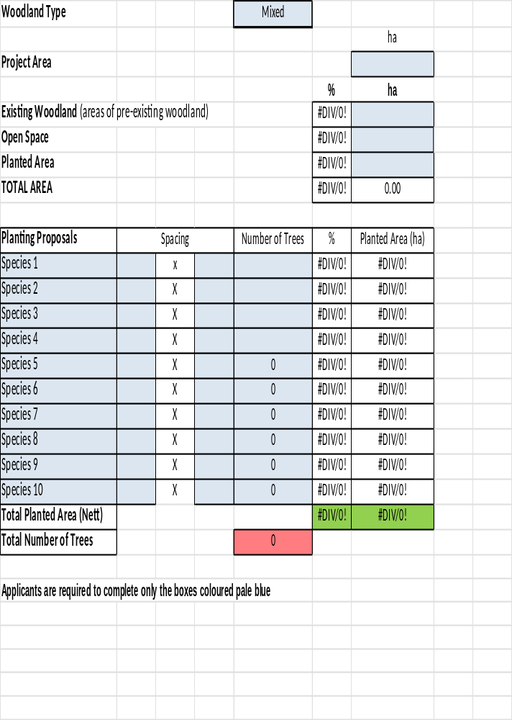

6. Stakeholder Engagement
The UK Forestry Standard includes a requirement that landowners considering planting woodland involve people in the development of forestry proposals who have a recognisable interest in the proposal or its outcomes. Use this section to identify people (e.g. neighbours) or organisations (e.g. Government departments, public utility companies) with an interest in your proposed new woodland and also to record any engagement that you have undertaken, relative to activities identified within the plan.

You must take account of the People section within the Environmental Standards & Regulation section of the Scheme Information Book. This requires a 60m setback from all dwellings except where agreement from the occupier is submitted in writing with your application which allows a 30m minimum setback to be maintained.

 | Individual/ Organisation* | Date Contacted | Response | Proposed Action
e.g 1 | Mr and Mrs Wood (Dwelling) | 01/06/2023 | Concern about woodland design affecting their home. | Planting design respects the 60 metre setback and uses small stature mixed species closest to their home.
e.g 2 | Farmer Jones (Land owner) | 01/06/2023 | Concern about access to maintain hedges. | Include a 5m unplanted buffer along his boundary.
e.g 3 | NIE Networks (NIE Representative) | 01/06/2023 | Written guidance provided. | Apply guidance provided by NIE.

7. Mapping
Your map(s) must be of a scale not less than 1:10,000 with a scale and legend. It must clearly show the boundaries of your proposed woodland, block boundaries (if relevant), planting layout including open space, design and landscape features, access and hazards (e.g. powerlines, steep and uneven ground),constraints (e.g. neighbours, county roads, telephone lines, watercourses and archaeological features) and where public access is proposed, the location of access signs.

Applications must have 2 separate maps, each with a legend:

- A planting design map, including boundary of the project, open space, new fencing, location of each sign and access/egress to and within the project.

- A map showing neighbours and linked to consultation recorded in section 6.

Sylva Foundation is an environmental charity who have provided a free web-based forest mapping tool that you might find is helpful to plan and record your project - https://myforest.sylva.org.uk/

8. Forest Expansion Scheme – Scoring Criteria

Support payments are determined using a competitive bidding mechanism (referred to as a challenge fund mechanism) whereby applicants are assessed by judging which proposals contribute most to delivering the aims of the Forest Expansion Scheme at minimum cost i.e. those projects offering best value for money in the current bidding round will be prioritised and selected for funding. The scheme criteria are listed below and the maximum score available is 38 points.

- 1. Provision of public access close to where people live for the period of payment of the agreement.

Maximum Score Available is 10

Score | Scoring Requirement | Notes
0 | No public access provided.
3 | - Public access is provided and signposted from the public highway. | See signage requirements below.
6 | - Public access is provided and signposted from the public highway.  - The application includes written support from the local council.  - The application clearly demonstrates the need and demand for access from the local community.  - Access will be promoted by the applicant post planting and payment of grant is conditional on this requirement. | - See signage requirements below.  - Must be on headed paper or from an official council email account.  - Takes account of where people live, existing facilities and may include letters of support.  - E.g. advertising in local newspaper or social media associated with an existing business.
7 | - Public access is provided and signposted from the public highway.  - The application includes written support from the local council2.  - The application clearly demonstrates the need and demand for access from the local community.  - Access will be promoted by the applicant post planting and payment of grant is conditional on this requirement.  - The applicant is a local council or an organisation with a primary aim to provide publicly accessible woodland. | - See signage requirements below.  - Must be on headed paper or from an official council email account.  - Takes account of where people live, existing facilities and may include letters of support.  - E.g. advertising in local newspaper or social media associated with an existing business.  - Projects will be scored based on the number of people who live close to the woodland. Projects will be ranked and allocated a score based on quartiles and the ranking will be determined by the number of people recorded in the NI Statistics & Research Agency Small Area Population estimate figures for Small areas that are within 500m of the site entrance.
8
9
10

Signage Specification & Content:

Sizes can vary, A3 is a minimum and generally A2 size is the maximum size that is required. Specification may vary between projects. However, regardless of how a sign is manufactured it should be: robust, weatherproof, legible and located in a suitable place(s) on the public highway and on the site. Note that probably more than one sign will be needed throughout payment period in order to allow for the development of the wood and take into account the natural life span of signage materials.

The size and material of signs must be stated in the Cost Spreadsheet.

The sign must include logos for (i) Department of Agriculture, Environment and Rural Affairs and (ii) Forest Service. These are available from Forest Service. You may wish to include other logos or information on the sign.
2. Carbon Capture (Sequestration)

Maximum Score Available is 8

Forest Service will calculate a carbon sequestration value per hectare for your woodland using the information you submit in your application. The calculation will be completed following the principles described in the Forestry Commissions Woodland Carbon Code.

Score | Measure
2 | Forest Service will calculate on a per hectare basis using and rank projects. Points will be allocated based on quartiles.
4
6
8

3. Resilience

Maximum Score Available is 9

Projects that demonstrate good design maximising opportunities to increase resilience through further species diversification and by reducing woodland fragmentation. To meet minimum Scheme standard consult the Forestry Grant Schemes Information Booklet “Species diversity requirements”.

Score | Measure
2 | Meet minimum scheme standard –  3 tree species with each species component comprising 10% or more of the area (excluding open space).
4 | 5 tree species with each species comprising 10% or more of the area (excluding open space).
6 | 5 tree species with each species comprising 10% or more of the area (excluding open space) and  Your application demonstrates that your proposal extends existing woodland over 0.50 hectares in size and/or connects existing woodlands.
Score  +2 | In addition to the diversity scores of either 2, 4 or 6 if all the project design conforms with the Native Woodland Definitions and Guidance https://www.daera-ni.gov.uk/sites/default/files/publications/dard/woodland-definitions-and-guidance.pdf
Score +1 | In addition to the diversity scores of either 2, 4 or 6 the use of improved planting stock for 60% or more of the trees planted will receive an additional point.  You will need to provide a nursery suppliers document that states the region of provenance, the Master Certificate Number and the total number of trees used with your claim for payment.

4. Scale

Maximum Score Available is 8

Larger well-designed projects will be given preference. All bids that pass essential criteria will be ranked by application area and allocated a score based on quartiles.

Score | Method
2 | Forest Service will rank projects by new woodland area and points will be allocated based on quartiles.
4
6
8

5. Mitigating the impact of flooding

Maximum Score Available is 3

In March 2017 Forest Service published a report on Opportunity mapping for woodland creation to reduce flood risk in Northern Ireland [https://www.daera-ni.gov.uk/publications/opportunity-mapping-woodland-creation-reduce-flood-risk-northern-ireland]. The report identified opportunities for woodland creation to reduce downstream flood risk and where over 50% of the planted area is within the high and/or medium priority areas for planting an additional 3 points will be added to your application.

Forest Service will apply this score to your completed application if appropriate.

Score | Measure
3 | Where over 50% of the planted area is within the high and /or medium priority areas for planting.

Please use the space below to describe your project against the scoring criteria.
- Provision of public access close to where people live [if you are providing public access please demonstrate how your application meets the mandatory requirements]
  - Public access is provided and signposted from the public highway.
  - The application includes written support from the local council.
  - The application clearly demonstrates the need and demand for access from the local community.
  - Access will be promoted by the applicant post planting and payment of grant is conditional on this requirement.
  - The applicant is a local council5 or an organisation with a primary aim to provide publicly accessible woodland.
- Carbon Capture (Sequestration)

-Forest Service will calculate this.

- Resilience

- Forest Service will calculate this.

- Scale

- Forest Service will calculate this.

- Mitigating the impact of flooding

- Forest Service will calculate this.

This is based on maps published on our website www.daera-ni.gov.uk/publications/opportunity-mapping-woodland-creation-reduce-flood-risk-northern-ireland and available from the Department for Infrastructure website (use the 2017 map)

9. VAT Declaration
Grant claimed under the Forest Expansion Scheme must normally be based on expenditure net of VAT. If however, you or your company are not registered for VAT, you may claim grant on gross expenditure. Completion by you of the declaration below (that you or your company are not VAT registered) will allow us to pay grant on your gross expenditure on this project.

I, the applicant declare that, I (or my company), as the applicant for a grant on this project, declare that I am not registered for VAT (Value Added Tax) because:

(a) I am / we are / the company is not eligible to register; or
(b) I / we have decided NOT to apply for voluntary registration.

Further, I / we hereby declare that I am / we are / not registered, nor have any application outstanding for the purposes of VAT and that I / we have not claimed and will not claim deduction or repayment as input tax for any amounts of VAT included in the price paid or expected to pay for goods, services or other expenditure related to this project.

I understand that when examining the above-mentioned claim, DAERA may have to ask HMRC about my VAT registration status, and I have no objection to any such enquiry.

Business Name
Name
Position
Signed
Date

10. Declaration
I/we declare that I/we have read and understood the Forestry Grant Schemes Information Booklets which describe the rules and procedures for the Forestry Grant Schemes.

I/we also declare that the information contained in this application form is correct and complete to the best of my/our knowledge and belief and that there are no legal and/or other restrictions which would prevent the specified work from being carried out.

If tenant making application then land owner must also sign application.

Applicant Name |  | Signed |  | Date
Applicant Name |  | Signed |  | Date
Applicant Name |  | Signed |  | Date
Applicant Name |  | Signed |  | Date

11. DAERA Privacy Notice

The Department (DAERA) takes data protection, freedom of information and environmental information issues seriously. It takes care to ensure that any personal information supplied to it is dealt with in a way which complies with the requirements of the UK General Data Protection Regulation (UK GDPR 2016) and the Data Protection Act 2018

A full copy of the DAERA Privacy Statement can be found here on the Departments website https://www.daera-ni.gov.uk/publications/daera-privacy-statement-document

12. How did you first hear about FES? Please tick -
□ Balmoral Show □ DAERA social media □ Other social media
□ Local Newspapers □ Posters □ Word of mouth
□ Forestry Agents □ Agricultural Agents □ DAERA Website
□ Forest Service Website □ DAERA text service
□ Other - Please detail:

ANNEX 1
The table and information below outlines the evidence that you should provide to verify your agricultural activity on the land during the last three years.

Agricultural Activity | Evidence Required
Selling Silage/Grass | Invoices / Receipts for sale of all products and purchases of inputs.
Selling Silage/Grass | Bank Statements showing financial transactions relating to the invoices and receipts.
Selling Silage/Grass | Farm accounts for your enterprise prepared by an independent qualified accountant. This must clearly relate to the invoices/receipts and bank statements being provided and should include itemised details of income and expenditure. These are management accounts and should cover the period in which your agricultural activity took place.
Selling Silage/Grass | Evidence of the conacre rent obtained in previous years (if land rented in conacre in previous years).
Arable Farming | Invoices / Receipts relating to the crop grown.
Arable Farming | Bank Statements showing financial transactions relating to the invoices and receipts.
Contract Rearing | Contract Rearing Agreement.
Contract Rearing | Invoices / Receipts relating to purchase of inputs.
Contract Rearing | Bank Statements showing financial transactions relating to the invoices and receipts.
Livestock Farming | Farm Accounts prepared by an independent qualified accountant which must include the area being farmed. These are management accounts and should cover the period in which your agricultural activity took place.
Share Farming | Share Farming Agreement
Share Farming | Invoices / Receipts for sale of products and purchases of inputs
Share Farming | Bank Statements showing financial transactions relating to the invoices and receipts.
Maintaining Land in a state suitable for grazing or cultivation. (Good Agricultural and Environmental Condition). | This category applies only to land on which no production activity is being carried out. In your written description of agricultural activity being carried out during the last three years, you should describe precisely what actions you carried out in order to maintain land in a state suitable for grazing or cultivation. A simple statement saying you are doing this will not suffice. Any evidence of expenditure incurred in undertaking these actions should be provided.

DAERA - Forest Service: September 2026

Defined by DAERA Land Parcel Identification System
https://www.nidirect.gov.uk/contacts/local-councils-in-northern-ireland
https://www.nidirect.gov.uk/contacts/local-councils-in-northern-ireland

