Biographies

Chairperson:

Professor Michael Whelan

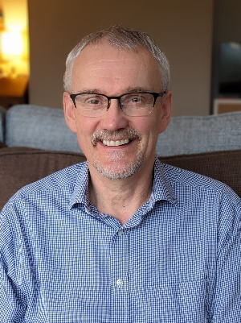

Professor Michael Whelan is a Professor of Environmental Science at the University of Leicester, specialising in numerical modelling of environmental systems and in understanding the behaviour and effects of pollutants and nutrients in soil and water. He has published over 100 papers in peer reviewed journals on topics which include the fate and effects of organic contaminants, catchment hydrology and the influence of land use on diffuse-source transfers of nitrogen and phosphorus to surface waters. He is an Associate Editor for the international peer-reviewed journal Soil Research, a member of the NERC Peer Review College and a member of the UK government’s Expert Committee for Pesticides.

Members:

Professor David Kenny

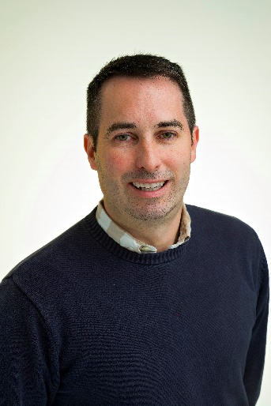
Professor David Kenny is Head of the Teagasc Animal and Bioscience Research Department in Ireland. He has over 25 years of research experience in the biological control of a range of economically important traits to ruminant livestock production systems, including growth and reproductive efficiency, ruminal methanogenesis and the development and functionality of the rumen microbiome. He has supervised the studies of 19 Ph.D. and nine M.Sc. students to completion, as principal supervisor and his research has resulted in the publication of in excess of 200 full length internationally peer reviewed scientific manuscripts and book chapters to-date. He is the current president of the British Society of Animal Science (BSAS), president of the Physiology Study Commission of the European Association of Animal Production and is a member of the management board of the international scientific journal, Animal. He has led many large research consortia and is currently co-ordinator of the recently awarded €5m Horizon Europe project, ‘Towards sustainable livestock systems: European platform for evidence building and transitioning policy (STEP UP)’. He was awarded the prestigious Hammond award by BSAS in 2018 in recognition of outstanding contribution to an improved understanding of how nutrition affects the complex underlying biology regulating economically important traits in cattle, including feed efficiency, rumen methane emissions and male and female reproduction.
He runs a beef and sheep farm in County Mayo, in the west of Ireland and is integrally involved, and is well known, within the beef cattle sector and wider agricultural industry in Ireland
Dr Esther Skelly-Smith
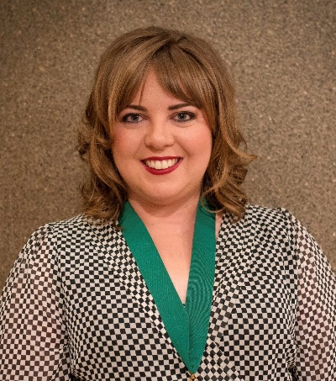
Dr Esther Skelly-Smith is an equine veterinary surgeon with extensive clinical, leadership and governance experience, and particular interests in equine welfare, sports medicine and rehabilitation. She is a Past President and current Council Member of both the North of Ireland Veterinary Association and the British Veterinary Association Northern Ireland Branch. She recently chaired the British Veterinary Association Use of Animals in Sport Working Group, leading the development of UK-wide policy in this area.
Esther is also a Non-Executive Director of the Agri-Food and Biosciences Institute and an Honorary Lecturer at Queen’s University Belfast, where she contributes to undergraduate teaching and postgraduate research supervision. Alongside her veterinary career, she is a working farmer involved in commercial sheep and livestock production, with additional experience in breeding Irish Draught and Irish Sport Horses. This gives her direct insight into the practical application of science, evidence-based policy and regulation within farm businesses, animal health systems and the wider agri-food sector.

Dr Thomas Woolley

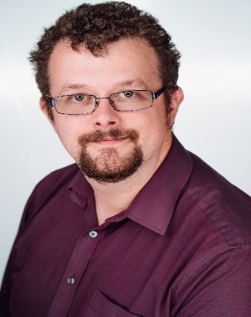
Dr Thomas Woolley studied mathematics at the University of Oxford between 2004-2017 and is now a Reader in Applied Mathematics at Cardiff University. He specialises in translating complex biological and ecological systems into mathematical models. His research spans diverse topics, from understanding fish spots and zebra stripes to optimising ecological resources and analysing bat migration patterns. Recently, his work on COVID-19 modelling for the Welsh Government informed critical public health policies, and he was awarded the Operational Research Society's Griffiths Medal for his contributions to health systems modelling.
Beyond research, Dr Woolley is passionate about public engagement, delivering captivating maths talks nationally and internationally, including appearing at Maths Week Ireland. He has collaborated with the BBC, illustrated Marcus du Sautoy's book, and worked on Dara O'Briain's School of Hard Sums. Previously the Fellow of Modern Mathematics at the London Science Museum, he played a key role in redesigning their mathematics gallery.

Professor Phil Haygarth

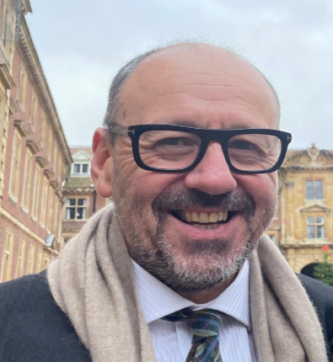
Professor Phil Haygarth is a Professor of Soil and Water Science at Lancaster University in the UK, being a biogeochemist focused on nutrients, studying farm, catchment, national and global scales. He started his research at BBSRC’s North Wyke (now Rothamsted Research) studying the understanding of phosphorus transfer between soil and water. Phil has helped with the underpinning policy for the UK Government and his work defined the nutrient ‘Transfer Continuum’ that has become the well-used for understanding the relationship between agricultural land management and water quality. In doing this, Phil was coordinator for the Defra UK phosphorus research program and initiated and led the first National Diffuse Pollution Inventory project, providing the foundation of policy models that are used today. Between 2010 and 2020 he led the National Demonstration Test Catchment team in the River Eden. Phil has been President of the British Society of Soil Science and between 2015-2024 he led a national Centre for Doctoral Training producing c.40 new Soil Science PhD graduates. Currently, Phil is Director of Lancaster University’s Graduate School for the Environment and provides thought leadership on climate change impacts on nutrient cycles and international databases on soil phosphorus. He is currently endeavouring to help facilitate a sustainable phosphorus future, with a particular focus on Africa.

Professor Maeve Henchion

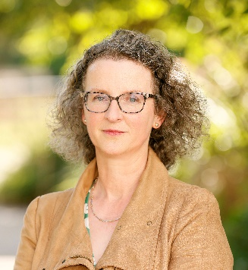
Professor Maeve Henchion (BAgrSc, MAgrSc, PhD) is Principal Research Officer at Teagasc, the Irish Agriculture and Food Development Authority. With significant expertise in leadership and governance, she is currently managing the development of the Teagasc statement of strategy 2025-2028 in addition to leading a large research programme. Since 2018, she has also served as an adjunct professor at University College Dublin. She is a strategic thinker, with a history of shaping policy and inspiring change within the agriculture, food and wider bioeconomy sectors at national and EU level.
Over the past 25 years, she has participated in competitively funded research projects, assembling international multi-disciplinary teams to address the diverse challenges and opportunities facing the agri-food sector including climate change, the circular economy, alternative proteins and the role of livestock in a sustainable food system. She is regularly invited to give presentations at conferences and events that focus on innovation and food system transformation. Prof. Henchion holds a range of other prestigious appointments including:
- Member of Bord Bia Quality Assurance Board (2022 to date)
- Member of the Board Fingal Leader Partnership (2023 to date)
- Member of Golden Jubilee Trust (2023-date)
- Member of SCAR Food Systems Working Group (2021- date)
- Member of Board of Food Safety Promotion Board, 2020-2023
- Member of the High-Level Bioeconomy Implementation Group for the National Policy Statement on the Bioeconomy

Dr Adrian Allen

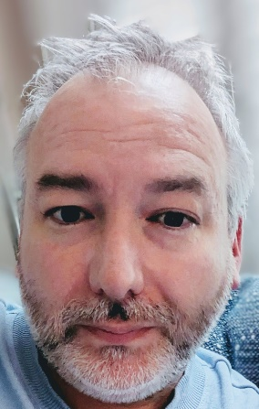
Dr Adrian Allen is a Principal Scientific Officer at the Agri-Food and Biosciences Institute (AFBI) in Belfast where he leads the Pathogen Genomics Laboratory. He is a biochemist / molecular biologist by training and is interested in the population genetics / genomics of zoonotic veterinary pathogens like Brucella abortus and Salmonella, but principally Mycobacterium bovis, the causative organism of bovine tuberculosis.
His current research is directed towards using pathogen genomics to infer epidemiological and evolutionary information that can assist veterinarians to trace the sources of disease outbreaks and improve their control. He also maintains an interest in the genetics of the wildlife and livestock hosts of zoonotic diseases and how such information can aid epidemiological investigations and breeding for disease resistance. He is a US-UK Fulbright Scholar, well published and cited in his field and a contributor to the recent EU funded STAR-IDAZ Disease Control Tools (DISCONTOOLS) and Research Roadmaps for bovine tuberculosis.

Dr Katharine Steentjes

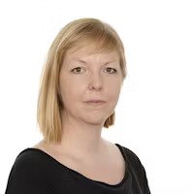
Dr Katharine Steentjes is a lecturer in Environmental Psychology at Swansea University and a UKRI policy fellow. Her academic expertise concerns public perceptions of environmental risks (such as climate change), policy strategies, energy solutions and psychological factors underlying these views and behaviours. Furthermore, Katharine has worked on developing effective engagement and communication strategies facilitating support for personal, community and national action to respond to/or prepare for the impacts of climate change.
Katharine is an affiliate of the Centre for Climate Change and Social Transformation (CAST) and the Tyndall Centre for Climate Change Research.

Dr Gillian Gilbert

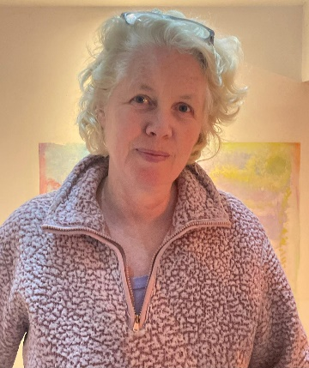

Dr Gillian Gilbert brings over 30 years of experience in conservation science, delivering impactful projects for the Royal Society for the Protection of Birds (RSPB). Her research has informed, species management practices, recovery initiatives, and conservation policies across the UK, Republic of Ireland, and internationally. The last four years she has worked as Principal Scientist for RSPB Northern Ireland. In this role, she provides scientific leadership for RSPB Northern Ireland and covers both terrestrial and marine issues across natural environmental science subjects, including biodiversity prioritization, species recovery, habitat restoration, and new methods to measure conservation outcomes.

Dr Gilbert collaborates with a network of scientists from leading organizations and has co-authored significant publications, such as State of Nature Northern Ireland 2023 and Birds of Conservation Concern for Ireland 4. She regularly engages with policymakers and has been involved in advising government bodies, including Natural England, NatureScot, and the European Commission, on a variety of strategic environmental issues.

Combining scientific expertise in species and habitat conservation with strategic vision, Dr Gilbert is dedicated to addressing the pressing challenges of biodiversity loss in both terrestrial and marine Northern Ireland contexts.

