TB PROGRAMME SUMMARY – July 2026
(Previous summaries filed at AE2-19-18687~4)

- DISEASE STATS UPDATE

The full range of the latest TB stats are available at the following link:

Tuberculosis statistics in Northern Ireland | Department of Agriculture, Environment and Rural Affairs (daera-ni.gov.uk)

Due to reporting issues, not all sections are able to provide up to date statistics regarding their work areas. The most up to date statistics available are published below.

TB reactors
Herd/animal incidence

At the end of July 2026 annual herd incidence was 9.62%, compared to 9.51% in the previous month. Annual animal incidence was 1.084%.

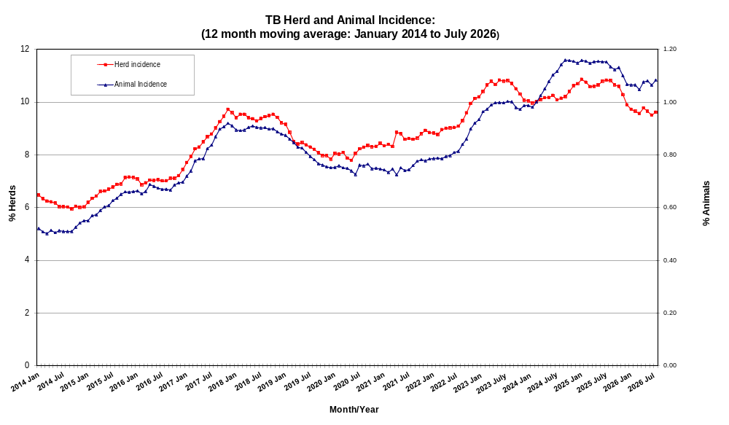

Figure: Annual TB herd and animal incidence (Jan. 2014 – July 2026)

Confirmed Herd TB Prevalence (most recent figures available)

At the end of March 2026, the annual confirmed herd prevalence was 13.73%. Note that the prevalence figures provided are based on the 12-month period 4 months prior to the 12-month period used for the incidence figures.
Number of TB reactors
The number of reactors (n=19,070) disclosed during the 12-month period to the end of July 2026 has increased slightly since last month’s figure (n=18,764); the 12 months to the end of June 2026.

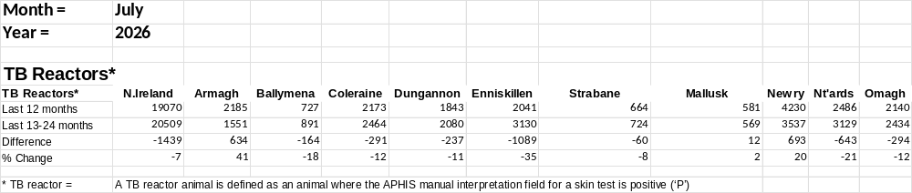

Figure: Number of TB reactors (July 2026)

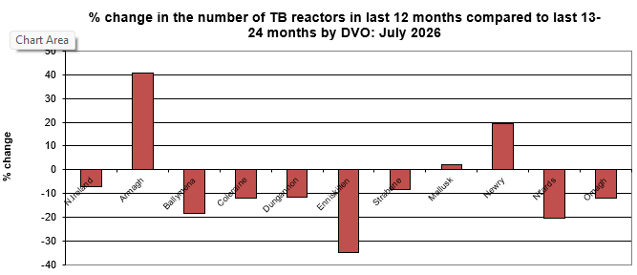

Percentage of TB reactors with positive post-mortem findings
At the end of April 2026, the percentage of TB reactors with positive post-mortem findings was 51.40%.

Reactor animals disclosed per 1000 animal tests (APT)
At the end of July 2026, the number of reactor animals disclosed per 1000 animal tests (APT) (based on the last 12 months) was 5.53%.

****Maria to update****
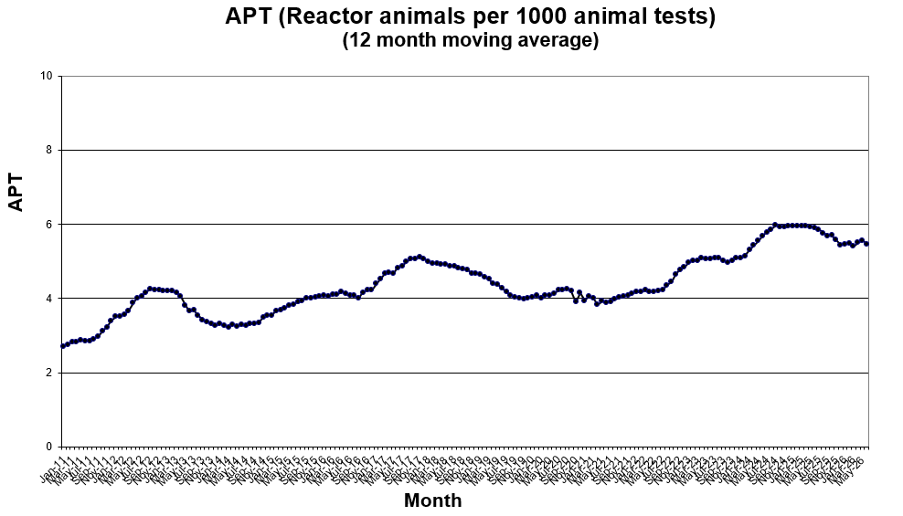

Figure: APT (Reactor animals per 1000 animal tests) (12 month moving average)
(Jan. 2011 – June 2026)

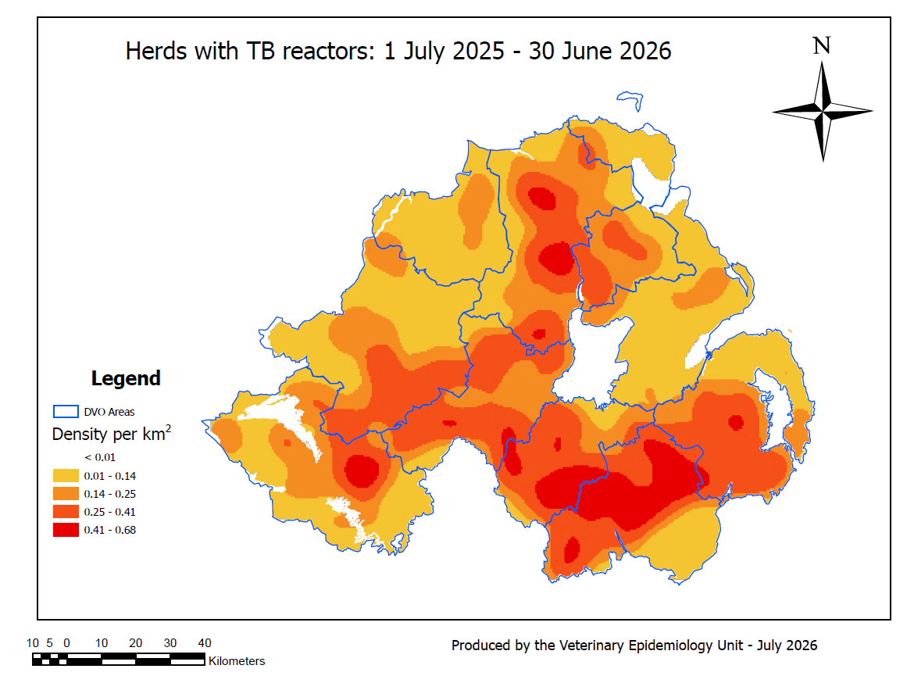
Figure: Herds with TB reactors heat map (Quarter 2, 2026)

Previous TB reactor heat maps can be viewed at AE1/25/660662. For reference, the most recent herd density heat map can be viewed at AE1/25/1445141.
For further reference, the most recent cattle density map can be viewed at AE1/25/1450695.

LRS animals
Not including direct imports there were 125,615 cattle slaughtered in Northern Ireland in the 4th quarter 2025. In total 1,192 animals (0.95%) were submitted as lesioned at routine slaughter (LRS) of which 790 were confirmed by laboratory examination (66.28%). Confirmed LRS animals per 1000 animals slaughtered figures since 2010 are displayed below.

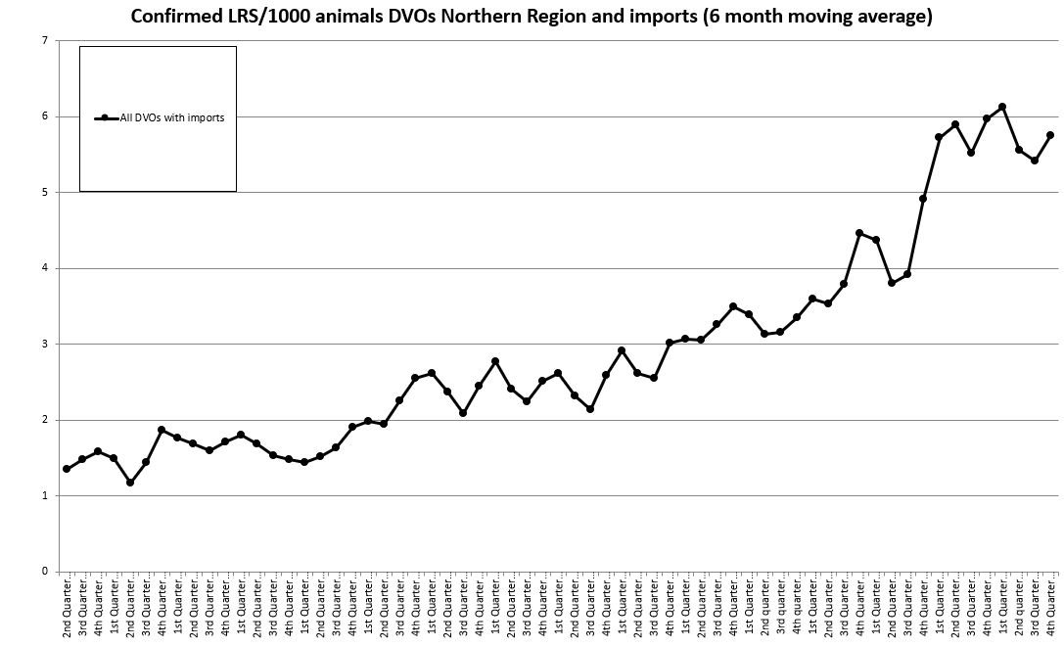

Figure: Confirmed LRS animals per 1000 slaughtered cattle (up to Quarter 4, 2025)

- FINANCE

- REACTOR REMOVAL UPDATE

The most recent figures provided by the Field Delivery Support Unit show that for the month of June 2026, the overall percentage of TB Reactor animals removed within the 15 working day target was 86%.

- WILDLIFE INTERVENTION UPDATE

- TB PROGRAMME AND CONTRACT IMPLEMENTATION UPDATE

IFN-g update:

- RESEARCH UPDATE

- POLICY UPDATE

Strategy Implementation, CVO review, and Blueprint for Eradication

Animal Health Law

Stakeholder Liaison

DEFRA/ DAFM/ Devolved Administrations Liaison

- OTHER JURISDICTIONS UPDATE

DEFRA
Separate herd incidence figures are produced for England, Scotland and Wales, and for High, Edge and Low risk areas.
These TB statistics for Great Britain are available on-line at:
https://www.gov.uk/government/statistics/incidence-of-tuberculosis-tb-in-cattle-in-great-britain

DAFM
DAFM now publish annual herd incidence figures routinely. At the end of June 2025 herd incidence was 6.40%, up from 5.17% on the figure for the preceding 12 months. Full TB statistics for the Republic of Ireland are available on-line at www.bovinetb.ie
(Follow the links for ‘National Bovine TB statistics’ to find a useful summary Infographic).

