Annex A – Application system screenshots
To make your application to FwNH go to the DAERA website and log in to the online services, as outlined in section 5 laid out above.
Once you click ‘Submit Application’ you will not be able to make any further changes to your application.
Information from your current EFS T5 and/or current FwNH 2026 agreement will be pre-populated.
When you log in you will see an icon ‘Farming with Nature’ on your dashboard, select this to proceed and you will see the following screen:
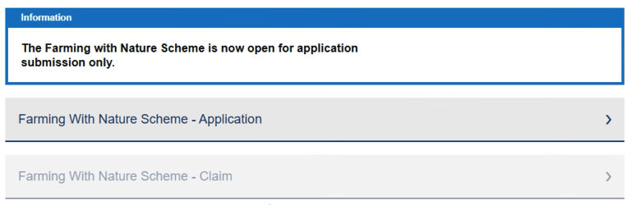
From here select ‘Farming with Nature Scheme – Application’ and you will be brought through to the welcome screen.
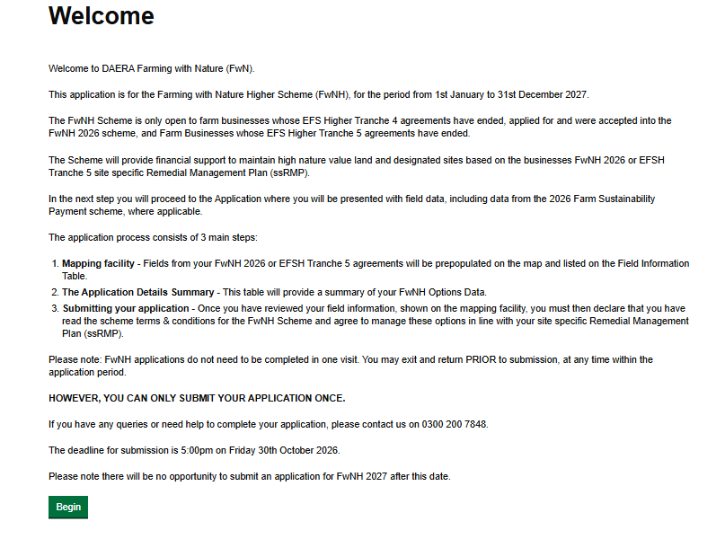
Once you have read the information provided select the green button that says ‘Begin’ to proceed. You will be brought through to the application screen where you will see information from your current EFS T5 and/or current FwNH 2026 agreement pre-populated on the map and the Field Information table (FIT) table.
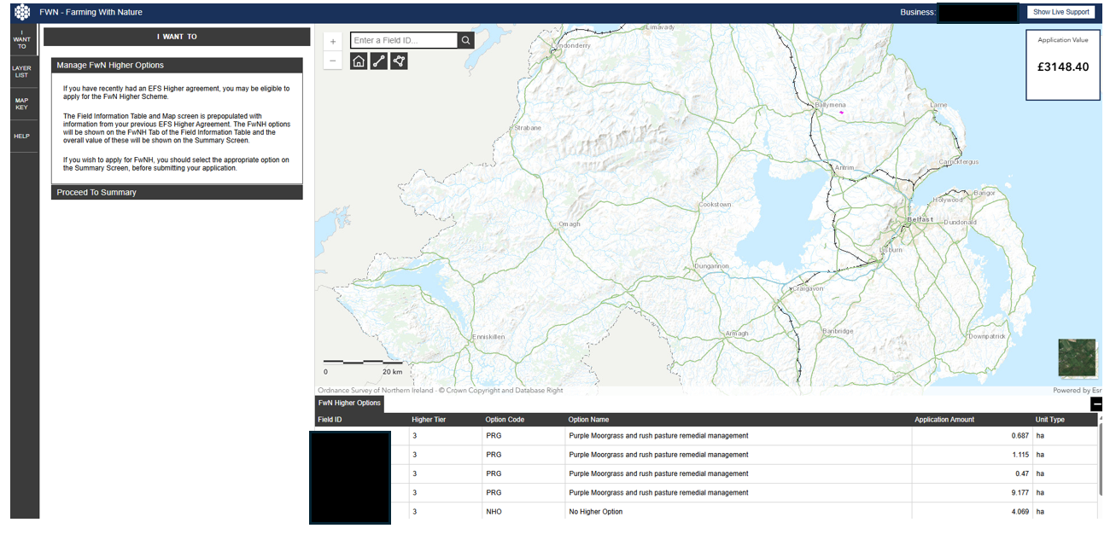

On the left-hand side of the screen you will see a number of options. ‘I want to’ will guide you through what to do.
Click on ‘Manage FwN Higher Options’ on the left-hand side of the screen.
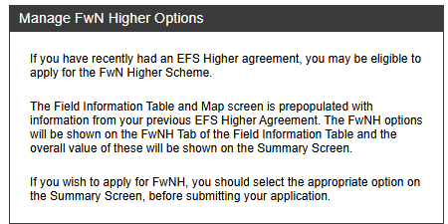
You will not be able to make any changes to the pre-populated information on the screens.
Click on the Proceed to Summary tab. This will bring you to a summary of your application.

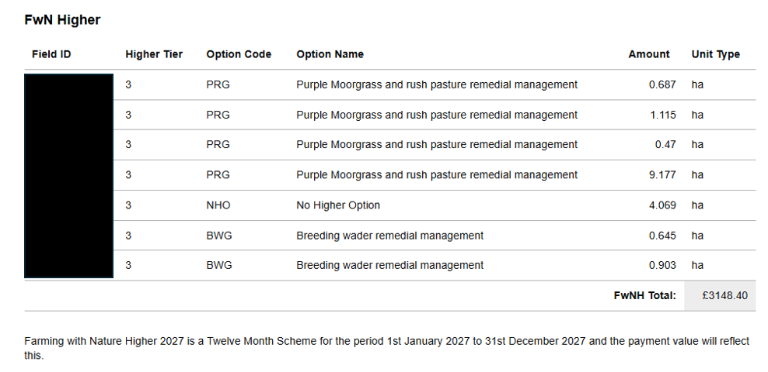

Applicants will have a decision to make prior to submitting their application. These are:

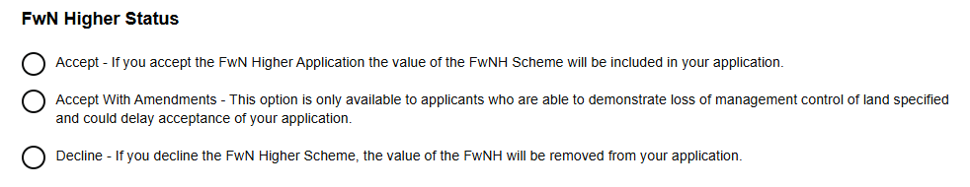
If you select Accept or Accept with Amendments, you then need to click on the appropriate link to the terms and conditions and tick the relevant box prior to submitting your application.
If you select Decline, then no further action is required, and you may exit the application.

