Consultation on the Draft Air Quality (Amendment) Regulations (Northern Ireland) 2026 to tighten annual average particulate matter (PM₁₀ and PM_{2.5}) limits, targets and objectives in Northern Ireland

Synopsis of responses
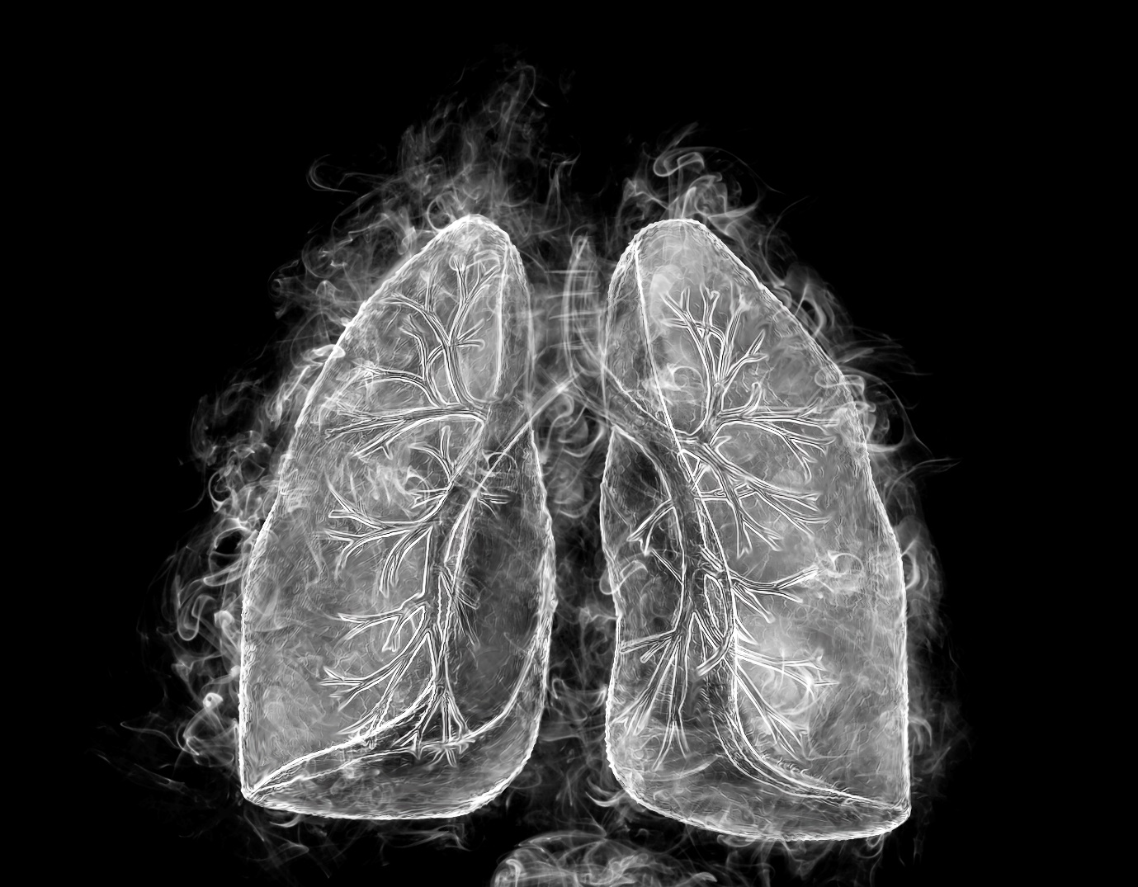

Alternative Formats
This document is also available on the DAERA website at:
https://www.daera-ni.gov.uk/consultations/consultation-draft-air-quality-amendment-regulations-northern-ireland-2026
You can request a copy of this document in other formats, such as:
- Paper Copy
- Large Print
- Braille
- Other Languages

To get a copy of this document in another format contact:
Air and Environmental Quality Branch
Department of Agriculture, Environment and Rural Affairs
1st Floor Clare House
303 Airport Road West
Belfast
BT3 9ED
E-mail: AEQTeam@daera-ni.gov.uk

1. Executive Summary 3
2. Background 5
3. High level summary of responses 8
4. Analysis of Consultation Respondents 9
5. Proposed new annual average limits for PM₁₀ 10
6. Proposed new annual average objectives for PM₁₀ 11
7. Proposed new annual average limit values for PM_{2.5} 13
8. Proposed new annual average target value for PM_{2.5} 14
9. Proposed compliance date of 1 January 2028 15
10. Impact Assessments 17
11. Additional comments 19
12. Conclusions 19

Executive Summary
The consultation on the draft Air Quality (Amendment) Regulations (Northern Ireland) 2026 received 25 responses, comprising 23 organisational and 2 individual submissions. Overall, respondents expressed strong support for the proposed tightening of particulate matter (PM₁₀ and PM_{2.5}) standards, with an average support level of 84% agreement across the four key proposals.
There is widespread support for the proposed annual average limits and targets, as an important interim milestone. For PM₁₀, the current limit and objective of 40 µg/m³ would be halved to 20 µg/m³. For PM_{2.5}, the limit would reduce from 25 to 10 µg/m³, with a new, stricter target value of 8 µg/m³. Public health bodies, environmental organisations, researchers and some local authorities, called for the Department to develop a clear long-term roadmap towards achieving the World Health Organization (WHO) guideline levels of 15 µg/m³ for PM₁₀ and 5 µg/m³ for PM_{2.5}. Several respondents noted that current monitoring data indicate most monitoring sites already comply with the proposed standards and argued for more ambitious future targets.
There was strong support for the development and publication of the draft Northern Ireland Clean Air Strategy, which is currently out for Public Consultation, alongside coordinated cross-government action addressing key emission sources.
Local authorities generally supported the policy direction but also highlighted the influence of background and transboundary pollution on particulate concentrations, limitations in existing monitoring coverage, and the need for additional funding, monitoring infrastructure, technical guidance and clarification of responsibilities under Local Air Quality Management arrangements.
Views on the proposed compliance date of 1 January 2028 were more mixed than for the emissions standards themselves. Public health, environmental and academic stakeholders largely supported the proposed date, however several local authorities considered the timeframe challenging.
Responses to the Rural Needs Impact Assessment and Equality and Disability Screening were generally supportive, although many respondents considered both assessments could more fully reflect the particular circumstances of rural communities and vulnerable groups.

Background
This consultation proposed strengthening Northern Ireland’s legal air quality standards for particulate matter (PM₁₀ and PM_{2.5}) to better protect public health and align with more up‑to‑date international guidance, particularly from the World Health Organization (WHO). Particulate pollution is a major health concern in Northern Ireland, contributing to respiratory and cardiovascular disease, cancer, and an estimated 936 premature deaths each year. Although emissions have declined since 2005, mainly due to cleaner technologies, domestic fuel burning and transport remain key sources, and existing standards are based on older EU limits that are now considered insufficient.
The proposals would tighten annual average limits, targets and objectives. For PM₁₀, the current limit and objective of 40 µg/m³ would be halved to 20 µg/m³. For PM_{2.5}, the limit would fall from 25 to 10 µg/m³, with a new, stricter target value of 8 µg/m³. These changes would bring Northern Ireland in line with WHO Interim Target 4 and closer to longer term guideline levels. Alongside these updates, the draft regulations include administrative changes such as updating the names of Competent Authorities, removing outdated legislation, and clarifying monitoring requirements.
Evidence from recent monitoring (2019–2024) suggests these tighter standards are achievable. Most monitoring sites already meet the proposed limits, and any exceedances have been small, with full compliance recorded across all sites in 2023–2024. The policy also aligns Northern Ireland with tightening air quality standards across the UK and Ireland, supporting cross-border consistency and contributing to wider environmental strategies such as the Environmental Improvement Plan, draft Clean Air Strategy, and draft Climate Action Plan.
The new standards are proposed to take effect from 1 January 2028, with compliance tracked through existing reporting and local authority review systems. Impact assessments indicate no significant adverse effects on equality groups or rural communities. The 12-week public consultation gathered stakeholder views ahead of finalising the legislation. Overall, the proposals represent a practical, evidence-based step towards improving air quality and reducing health harms while moving closer to international best practice.

2.1 Consultation Process
The Department launched the consultation on the draft Air Quality (Amendment) Regulations (Northern Ireland) 2026 on 8 June 2026 and it ran until 31 August 2026. The public consultation gave the public and interested stakeholders the opportunity to provide their views on the proposals made by the Department and on the Department’s assessment of the impact of proposed new Regulations.
Information on the consultation and links to the consultation document were provided to statutory consultees and relevant air quality stakeholders through the issuing of consultee letters. The consultation was also advertised on the Department’s website.

2.2 Consultation - Structure of Questions
There were several ways in which consultees could provide their views on their responses to the consultation. The main method was through citizen space, however consultees could also respond via email or by post.
The consultation sought views from consultees through a series of 14 consultation questions to help inform the development of the regulations. Questions 1 to 6 related to information about the respondent, Questions 7 to 11 related specifically to proposed new annual average limits, targets and objectives for particulate matter (PM₁₀ and PM_{2.5}), Questions 12 and 13 related to impact assessments and Question 14 provided the opportunity to provide any additional comments. Respondents did not have to answer every question and were able to skip topic areas where they were less familiar or had no view.

2.3 How Responses Were Processed
Following the closure of the consultation, all responses were logged, categorised and assigned a unique reference number in line with General Data Protection Regulation (GDPR) requirements.

The report draws on two types of analysis:
- Quantitative analysis
This covers the numerical results from seven questions that used a five-point agreement scale. For each question, the report sets out the number and percentage of respondents selecting each category (Strongly Agree, Agree, Neutral, Disagree, Strongly Disagree, and Did Not Answer). Percentages may not total 100% due to rounding. Each relevant section includes a chart to support interpretation, and detailed results are provided in Annex A.
- Qualitative analysis
All substantive comments submitted through Citizen Space (including the questions that asked for comments) and email responses were included in the qualitative analysis. Themes were identified through a structured review process to ensure that every respondent’s views were treated fairly. Comments that provided a rationale, such as personal experience, cost concerns, or community impacts, were accepted as valid evidence.
Across both methods, the aim was to capture the breadth of views expressed, without weighting one type of response over another. All responses, including AI generated responses, were included in the analysis. Two responses generated by the same AI Chatbot were considered and given appropriate weight, but excluded from the quantitative analysis.

2.4 How to Use This Report
This summary is intended to help stakeholders understand the views submitted during the consultation. It presents themes and perspectives rather than drawing conclusions or making recommendations. While strong patterns emerged in some areas, it is recognised that the analysis is based on 25 consultation responses and should not be interpreted as representative of the wider population.
As part of the consultation, we specifically asked respondents to provide further views, suggestions or comments and we are grateful for the high quality, constructive information received. The breadth and depth of this feedback has been invaluable in challenging our thinking and strengthening the development of these regulations. While not all proposals can be incorporated, many offer important insights and approaches that we will continue to consider as we develop other air quality policies. The contributions have created a rich evidence base that will inform ongoing policy development, and we remain committed to working collaboratively with stakeholders as this programme evolves.

2.5 Consultation Responses - Amount and Format
In total, the consultation received 25 responses via citizen space, and direct email submissions.
The following is a breakdown summary of the profile of the 25 responses to the consultation which were received by DAERA.
- 15 were received via citizen space; and
- 10 were received via emails to the DAERA mailbox.
- 23 responses were from organisations.
- 2 represented individual responses.
- In addition, a further 2 responses were received via email from an AI Research Agent (advanced chatbot). These were considered separately and excluded from the quantitative analysis as they did not address the questions.

High level summary of responses
From the consultation responses there was overwhelming support across the four PM Regulations proposals with an average of 84% agreement.
Q7. Proposed new annual average limit value of 20 µg/m³ for PM₁₀
Q8. Proposed new annual average objective of 20 µg/m³ for PM₁₀
Q9. Proposed new annual average limit value of 10 µg/m³ for PM_{2.5}
Q10. Proposed new annual average target value of 8 µg/m³ for PM_{2.5}

Where the respondents disagreed, all called for more ambitious limits, targets and objectives.

Councils largely consider the 1 January 2028 deadline challenging, whilst health, environmental and research organisations generally support the date because current monitoring data suggest the standards are already being met.
There was also broad agreement with the conclusions of the impact assessments, with an average of 74% either in agreement or neutral.
- Analysis of Consultation Respondents
Q 4. “Please tell us if you are responding as an individual or on behalf of an organisation. If you are responding on behalf of an organisation, please confirm the name of the organization and you have the authority to respond on behalf of the organisation”.
The vast majority of respondents were responding on behalf of an organisation with only two responses received from individuals. The organisations who responded are:
- Administrative Data Research Centre Northern Ireland (ADRC-NI) Queen’s Business School (QBS) research team, Queen’s University Belfast
- Chartered Institute of Environmental Health (CIEH)
- Clean Air Fund
- DAERA - Air Quality and Biodiversity Unit
- Environmental Justice Network Ireland
- Friends of the Earth
- Healthy Air Northern Ireland
- Ministerial Advisory Group for Architecture & Built Environment NI
- PEACE-Air (Partnership for Evidence and Action on Clean Air) Consortium
- Public Health Agency
- Royal College of Physicians, Edinburgh, Air Quality Working Group
- Royal Society of Ulster Architects
- UK Faculty of Public Health
- Antrim and Newtownabbey Borough Council
- Ards and North Down Borough Council
- Armagh City, Banbridge and Craigavon Borough Council
- Belfast City Council
- Derry City and Strabane District Council
- Fermanagh & Omagh District Council
- Lisburn and Castlereagh City Council
- Mid and East Antrim Borough Council
- Mid Ulster Borough Council
- Newry, Mourne and Down District Council

Proposed new annual average limits for PM₁₀
Q7. “To what extent do you agree with the proposed new annual average limit value of 20 µg/m³ for PM₁₀?”
Respondents broadly support the proposed PM₁₀ limit of 20 µg/m³, but many view it as an interim step rather than a final goal. The strongest recurring recommendation is for DAERA to commit to a future pathway towards the WHO guideline of 15 µg/m³, supported by stronger cross-government policies addressing transport, domestic combustion, agriculture and wider background pollution.

Top Recurring Themes

1. Support for the proposal, but calls for greater ambition
Many respondents indicated that 20 µg/m³ is not ambitious enough because it reflects the WHO Interim Target 4 rather than the WHO guideline of 15 µg/m³.

2. Current monitoring data already meets the proposed standard
Many respondents noted that most or all monitoring sites are already below 20 µg/m³.

3. Need for additional policy measures across government
Meeting tighter standards will require action beyond local air quality management.

4. Significant role of background and transboundary pollution
Achieving compliance will depend on regional and national interventions.

Proposed new annual average objectives for PM₁₀
Q8 “To what extent do you agree with the proposed new annual average objective of 20 µg/m³ for PM₁₀?”
Respondents broadly support the proposed new annual average objective of 20 µg/m³ for PM_{10,} but many believe it should be accompanied by a stronger long-term strategy, tighter future WHO-aligned targets, better monitoring, stronger action on agriculture/ammonia, and additional resources and policy support for implementation.

Top Recurring Themes

1. Greater ambition and alignment with WHO guidelines
Respondents called for a roadmap to achieve WHO guideline levels for PM₁₀ of 15 µg/m³, with future statutory reviews and tighter targets by 2035 or 2040.

2. Need for broader policy action beyond regulations
Respondents emphasised the need for a published Northern Ireland Clean Air Strategy, cross-departmental action and measures targeting transport, domestic solid fuel burning, agriculture, industry and planning.

3. Agriculture, ammonia and livestock emissions
Respondents identified agriculture as a major contributor to particulate pollution and argued that meaningful PM reductions will require stronger agricultural measures.

4. Monitoring network and evidence gaps
Respondents highlighted concerns about insufficient geographic coverage and the need for more monitoring stations.

Proposed new annual average limit values for PM_{2.5}
Q9. “To what extent do you agree with the proposed new annual average limit value of 10 µg/m³ for PM_{2.5}?”
Respondents strongly support introducing a 10 µg/m³ annual PM_{2.5} limit value and highlighted that this reflects air quality currently achieved at most monitoring sites.

Top Recurring Themes

1. Strong support for tighter PM_{2.5} standards
Respondents highlighted links between PM_{2.5} exposure and respiratory disease, cardiovascular disease, premature mortality, and wider health impacts.

2. Proposal seen as a positive first step, but not ambitious enough
Many respondents identified that 10 µg/m³ aligns with WHO Interim Target 4 but falls short of the WHO guideline of 5 µg/m³.

3. Monitoring data suggest the target is already largely achieved
Many respondents noted that most Northern Ireland monitoring stations already meet the proposed 10 µg/m³ limit.

4. Need for wider policy interventions
Respondents consistently stressed that achieving and maintaining lower PM_{2.5} levels requires action beyond air-quality regulation alone.

Proposed new annual average target value for PM_{2.5}
Q10. “To what extent do you agree with the proposed new annual average target value of 8 µg/m³ for PM_{2.5}?”
Responses showed strong support for the proposed 8 µg/m³ PM_{2.5} target and again argued for a clear pathway to the WHO guideline of 5 µg/m³ with supporting policies across transport, agriculture and domestic heating.

Top Recurring Themes

1. Broad support for a tighter PM_{2.5} target
The majority of respondents welcomed the reduction from the existing target and described a stricter 8 µg/m³ target as a positive and ambitious step forward.

2. Calls for greater ambition and alignment with WHO guidelines
Numerous respondents indicated that Northern Ireland should set a pathway towards the WHO Air Quality Guideline of 5 µg/m³, with many suggesting dates between 2035 and 2040.

3. Health protection as the primary justification
Respondents repeatedly highlighted the health impacts of PM_{2.5}, including Respiratory and Cardiovascular disease, premature mortality and impacts on children, older people and those with existing health conditions.

4. Achievability concerns linked to background pollution
Local authorities again noted that a substantial proportion of PM_{2.5} concentrations comes from regional/background pollution and transboundary sources

Proposed compliance date of 1 January 2028 for these new limit values, target values and objectives for PM₁₀ and PM_{2.5?}

Q11. To what extent do you agree with the proposed compliance date of 1 January 2028 for these new limit values, target values and objectives for PM₁₀ and PM_{2.5}?
Councils largely consider the 1 January 2028 deadline unrealistic without substantial new policies, funding, and lead-in time, while health, environmental and research organisations generally support the date because current monitoring data suggest the standards are already being met. There is broad agreement that additional policy action, stronger coordination, and a long-term roadmap towards full WHO air quality guidelines are necessary.

Top Recurring Themes

1. 2028 is viewed as too ambitious or unrealistic by many local councils
A significant number of district councils indicated that the proposed compliance date does not provide sufficient lead-in time for policy development, monitoring, assessment, Air Quality Management Area (AQMA) designations, and implementation of mitigation measures.

2. Many health and environmental organisations support the 2028 date
Public health bodies, environmental groups, and academic respondents generally supported retaining the proposed 1 January 2028 compliance date, indicating that most monitoring sites already meet the proposed limits.

3. Proposals are seen as achievable because current monitoring data already meet the standards
Many highlighted that Northern Ireland is already largely compliant with the proposed PM₁₀ and PM_{2.5} standards, making the proposed compliance date reasonable and attainable.

4. Need for supporting policies and resources
There was strong consensus that compliance will depend on new policy interventions, cross-departmental coordination and adequate funding and resources.

Impact Assessments
Q12. “Do you agree or disagree with the conclusions of the Rural Needs Impact Assessment (RNIA)?”
Respondents generally accepted the RNIA conclusions but some highlighted concerns around agricultural emissions and ammonia pollution, dependence on solid fuel heating in rural households and greater reliance on private transport.

Top Recurring Themes

1. Broad agreement that the Regulations themselves are unlikely to have major direct rural impacts
Many respondents agreed that the proposed PM₁₀ and PM_{2.5} standards were unlikely to create direct disproportionate effects on rural communities.

2. Concern that the RNIA understates indirect rural impacts
Some respondents indicated that future policies designed to reduce emissions may have distinct consequences for rural communities.

3. Reliance on solid fuel heating in rural areas
Respondents noted that future restrictions on wood, coal or other fuels could affect rural households more than urban households.

4. Agriculture and ammonia emissions as major rural considerations
Several respondents indicated that achieving cleaner air will require stronger action on agricultural emissions.
Q13. “Do you agree or disagree with the conclusions of the Equality and Disability screening?”
Most respondents either agreed with the Equality and Disability Screening conclusions or selected neutral or not answered. A significant minority indicated that the screening did not go far enough in assessing the unequal impacts of air pollution on vulnerable groups.

Top Recurring Themes

1. Air pollution disproportionately affects vulnerable groups
Respondents highlighted that children, older people, people with disabilities, people with respiratory or cardiovascular conditions, pregnant women and people living in deprived communities are more vulnerable to the health impacts of poor air quality and would benefit most from tighter particulate matter standards.

2. Equality impacts may be underestimated
Some highlighted that the screening assumes the policy is broadly beneficial and therefore does not require a full Equality Impact Assessment (EQIA).

3. Socioeconomic deprivation and health inequalities
Many respondents emphasised the link between air pollution and deprivation.

4. Rurality and disability require greater consideration
Several councils disagreed with the screening because they felt it inadequately considered the interaction between rural living, disability, transport limitations, and access to services.

Additional comments
Q14. “Do you have any additional comments you wish to raise with regards to the draft Regulations or consultation documents?”
Overall, respondents were broadly supportive of the regulations but consistently viewed them as a starting point rather than an end goal, calling for a more ambitious long-term programme to achieve WHO air-quality guidelines and deliver measurable public health improvements.

Top Recurring Themes
- Support for tighter standards but desire for WHO-aligned future targets.
- Publication of a Clean Air Strategy and long-term roadmap.
- Stronger controls on agriculture, ammonia, transport and domestic burning.
- Expanded monitoring and improved evidence gathering.
- Additional funding, guidance and support for councils.
- Recognition of health and equality benefits of cleaner air.
- Need to review other pollutants and wider air-quality legislation.

Conclusions
Following review and analysis of the consultation responses, DAERA concludes that there is widespread support for the proposed annual average limits and targets, as an important interim milestone. Current monitoring data indicates most monitoring sites already comply with the proposed new standards. Public health bodies, environmental organisations, researchers and some local councils have called for a clear long-term roadmap towards achieving the more ambitious World Health Organization guideline levels of 15 µg/m³ for PM₁₀ and 5 µg/m³ for PM_{2.5}.
There is strong support for the development and publication of the draft Northern Ireland Clean Air Strategy, which is currently out for Public Consultation, alongside coordinated cross-government action addressing key emission sources.
Local councils support the policy direction but also highlight the influence of background and transboundary pollution on particulate concentrations.
Public health, environmental and academic stakeholders largely support the proposed compliance date of 1 January 2028, however several local councils considered the timeframe challenging.
DAERA will now begin the process of laying the groundwork to bring forward legislation to support the implementation of the proposed annual average limits, objectives and targets.


For further information:
DAERA
Air and Environmental Quality Branch
Clare House
303 Airport Road West
Belfast
BT3 9ED
Email: AEQTeam@daera-ni.gov.uk
Website: www.airqualityni.co.uk

