REVIEW OF HIGHER EDUCATION TUITION FEES AT THE COLLEGE OF AGRICULTURE, FOOD AND RURAL ENTERPRISE (CAFRE)

April 2018

Table of Contents
1. Introduction 5
2. Strategic Context 7
2.1. Programme for Government (PfG) 7
2.2. Northern Ireland Economic Strategy 7
2.3. Economy 2030 – Industrial Strategy for Northern Ireland 8
2.4. Innovation Strategy for Northern Ireland 2014 – 2025 8
2.5. Investment Strategy for Northern Ireland 2011 – 2021 8
2.6. Draft DAERA Strategic Plan 9
3. Need for the Review 10
4. CAFRE 12
4.1. Background 12
4.2. Student Numbers 12
4.3. Student Domiciliary Position 14
4.4. Qualitative performance measures 15
4.5. Higher Education Awarding Bodies 15
4.6. Retention and Destination Data 16
4.7. Student Satisfaction 17
4.8. Student Accommodation 17
4.9. Class sizes 18
4.10. Net Operating Costs 18
4.11. Income 19
4.12. Efficiency Measure 19
4.13. Research 21
4.14. Links to Industry 21
4.15. The Economic Impact of Graduates and Students 22
4.16. Benefits of CAFRE Higher Education graduates to the Northern Ireland economy. 24
5. Student experience of CAFRE HE provision 26
5.2. Key Findings 26
6. Current Tuition Fee Policy 29
6.1. DAERA Education Policy 29
6.2. Full-time Undergraduate Tuition Fees Policy 29
Northern Ireland 29
Other Regions 31
6.3. Comparison of Full-time Undergraduate Tuition Fees Levels 33
6.4. Part-Time Undergraduate Tuition Fees Policy and Levels 36
6.5. Postgraduate Tuition Fees Policy and Levels 37
6.6. Northern Ireland Future Direction 38
7. Comparison with Other Land Based Educational Providers 40
Myerscough College, Lancashire 40
7.1. Background 40
7.2. Curriculum Development and links with Industry 41
7.3. Research 41
7.4. Widening Access and Participation Plans 42
7.5. Links with Defra 42
7.6. Accommodation 42
7.7. Higher Education Tuition fees 43
Harper Adams 44
7.8. Background 44
7.9. Curriculum Development and Links with Industry 45
7.10. Links with FE Providers 46
7.11. Research 46
7.12. Widening Access and Participation Plans (WAPP) 46
7.13. International Linkages 47
7.14. Accommodation 47
7.15. Tuition fees 47
8. Consideration of differing approaches to setting tuition fees and potential impact on enrolments 49
8.1. Differential Fees 49
8.2. Research on willingness to pay 50
8.3. International approaches 51
9. Summary of findings from the review 52
10. Glossary 53
11. Annex 1 – Higher Education Courses at CAFRE 2016/17 54
12. Annex 2 - CAFRE Student Survey to inform DAERA Education Policy -Summary of Results 56
13. Annex 3 – Tuition Fees Level Comparison Table Academic Year 2017/18 71

Table of Figures

Figure 1 -Total Student Number 2016/17 by Discipline (Further and Higher Education) 13
Figure 2 - Higher Education Student Numbers 2016/17 (Full and Part-time) 13
Figure 3 - Higher Education Student Numbers 2006/07 - 2016/17 14
Figure 4 – Higher Education Student Domiciliary Position 2015/16 – 2017/18/18 15
Figure 5 - Table of CAFRE Net Operating Costs 2015/16 19
Figure 6 – Table of Full-time student equivalents (FTSE) 2015/16 by discipline 20
Figure 7 - Minimum and Maximum Fee Levels for Full-time Undergraduates in Northern Ireland (Home Students)……………………………………………………….30
Figure 8 - Tuition Fee Levels for Full-time Honours Degree 2017-2018 (Home Students) 34
Figure 9 - Tuition Fee Levels for Full-time Foundation Degree 2017/18 (Home Students) 35

Introduction

    - DAERA provides a range of full and part-time further and higher education courses as well as industry short courses at the College of Agriculture, Food and Rural Enterprise (CAFRE). The courses cover agriculture, food, equine, horticulture and Business for Agri-Food and Rural Enterprise (BAFRE).

    - In 2017, DAERA developed a Knowledge Framework that sets out the rationale for its involvement in education, training and technology exchange provision, what it seeks to achieve and the nature of its interventions. The Framework maintains that the DAERA’s involvement in education, knowledge and skills, innovation and technology transfer should be driven by policy objectives and strategic goals and that wherever possible, encouraging knowledge and skills should be included within all of DAERA’s work.

    - One of the key principles within the Knowledge Framework is ‘Affordability’. The Framework states that ‘provision of knowledge represents a significant investment by DAERA. Therefore, this investment will be targeted so that it delivers the best possible returns in terms of achieving DAERA’s strategic objectives’. With that in mind it is appropriate to carry out a review of DAERA higher education tuition fee policy at CAFRE.

    - The review outlines the current DAERA tuition fee policy for Northern Ireland students at CAFRE and compares this to wider tuition fee policy in Northern Ireland and other regions (within the UK and Republic of Ireland) for home students. This review includes details of two case studies of institutions providing similar courses to CAFRE. The review provides detailed evidence in respect of student enrolments, destination data and student experiences. It covers the cost of CAFRE education delivery, the benefits to the student and the wider benefits to the land based and agri-food sector in Northern Ireland. Finally the review outlines possible options for a future DAERA higher education tuition fee framework at CAFRE.

    - The review aims to identify policy options for Higher Education tuition fees that are consistent with the objectives of the Knowledge Framework, equitable, support future investment and quality provision of higher education at CAFRE, for implementation in academic year 2020/2021.

Strategic Context

A number of cross-departmental instruments have a significant bearing on the provision of higher education at CAFRE:-

Programme for Government (PfG)

    - Key indicators in the draft Programme include;
- Improve the skills profile of the population
- Increase the competitiveness of the economy
- Increase innovation in our economy

Northern Ireland Economic Strategy

    - The overarching goal of the Northern Ireland Economic Strategy was to improve the economic competitiveness of the Northern Ireland economy. Within that Strategy, the economic vision for 2030 is outlined as ‘An economy characterised by a sustainable and growing private sector, where a greater number of firms compete in global markets and there is growing employment and prosperity for all’.

    - In order to deliver the longer term priority of the Executive, five strategic rebalancing themes were developed. These themes are:

- Stimulating innovation, R&D and creativity;
- Improving employability and the level, relevance and use of skills;
- Competing in the global economy;
- Encouraging business growth; and
- Developing our economic infrastructure.

    - The Strategy recognises agri-food as one of the areas in Northern Ireland which has the greatest potential for growth. It highlights the need to develop a world class education and skills system which is critical for economic growth, and indicates that improving the skills and employability of the entire workforce will allow people to progress up the skills ladder, thereby delivering higher productivity and increased social inclusion. The associated Comprehensive Action Plan recognises the Department’s investment in education and training provision in the land based, food and rural sectors as helping to achieve the objective of improving productivity by increasing the skill levels of the workforce.

Economy 2030 – Industrial Strategy for Northern Ireland

    - Education, skills and employability feature prominently in the draft Strategy, as does the role and importance of the CAFRE.

Innovation Strategy for Northern Ireland 2014 – 2025

    - The Innovation Strategy for Northern Ireland 2014-2025 reflects the Northern Ireland Executive’s desire to place innovation at the core of its drive to rebalance the economy, suggesting that to transform our economy into one of the UK’s leading high-growth regions we need better educated and a more highly skilled workforce (it notes that if firms invest in skills, leadership, design, branding, training or marketing they are investing in innovation).

Investment Strategy for Northern Ireland 2011 – 2021

    - Reflecting the priorities in the Programme for Government, the Investment Strategy for Northern Ireland 2011-21 outlines the investment achievements to date, ongoing projects and proposed future projects for seven key sectors in Northern Ireland (networks; skills; health; social; environment; productive; and justice). In terms of skills, the Strategy reaffirms the necessity to have a schools / college system that will produce a well educated workforce as this will be essential in encouraging investment, and in helping local businesses to grow and compete in an increasingly global marketplace. The Strategy notes that investment in the further and higher education estates will also help to ensure that the infrastructure exists to deliver high quality courses to create a skill pool and the research capabilities that are essential to support the expansion of home-grown businesses and also to attract inward investment.

Draft DAERA Strategic Plan

    - At a Departmental level the draft DAERA Strategic Plan is in line with the wider NI strategic context, noting the following outcomes;

    - Sustainable agri-food, fisheries, forestry and industrial sectors;
    - A clean, healthy environment, benefitting people, nature and the economy;
    - A thriving rural economy, contributing to prosperity and wellbeing.

    - In 2017 DAERA developed a Knowledge Framework that sets out the rationale for DAERA’s involvement in education, training and technology exchange provision, what the Department seeks to achieve and the nature of its interventions. The draft Framework maintains that DAERA’s involvement in education, knowledge and skills, innovation and technology transfer should be driven by policy objectives and strategic goals and that wherever possible, encouraging knowledge and skills should be included within all of DAERA’s work.

    - The Framework aims to ensure that individuals, organisations, and businesses within the agri-food industry have access to high quality, relevant and accessible education, training and technology exchange to improve productivity, resilience, environmental performance and sustainability.

Need for the Review

    - The need for the review is primarily driven by three key factors namely (i) the ongoing variation in fees charged within CAFRE for higher education courses, and the variation with fees charges elsewhere in Northern Ireland; (ii) the ongoing costs associated with delivery of higher education courses at CAFRE coupled with increasing pressure on departmental budgets; and (iii) the strategic policy direction of the DAERA Knowledge Framework.

    - In 1998, in line with the Department for Employment and Learning (DEL) (now part of the Department for Economy (DfE)) tuition fees were introduced for CAFRE students attending full-time courses of higher education (HE). The legislative basis for these charges is the Agriculture Act (Northern Ireland) 1949 (as amended in 2006).

    - Currently, CAFRE students pay varying tuition fee rates depending on the type of higher education course studied at CAFRE. Full-time honours and foundation degrees in equine and food and foundation degrees in horticulture and agriculture are charged at the basic tuition fee (as set out in DfE Regulations and copied across to DAERA Regulations) of £1,595 per annum. A full-time honours degree in agricultural technology is charged at the maximum level permitted by DfE Regulations, at £4,030 per annum. Part-time degree courses and postgraduate courses are not charged a tuition fee (although a small validation fee may be required). The tuition fee variation extends to comparison with Ulster University and Queen’s University Belfast, with these two institutions charging the maximum amount permitted under the DfE Regulations for undergraduate degree courses. Such variation in fees requires a review to establish if there is a rationale to continue with these differences.

    - The cost of higher education provision at CAFRE is in the main borne by DAERA. CAFRE annual net operating costs are approximately £20 million per annum with education services accounting for about £9 million of that cost. Income from tuition fees accounts for about £850,000 per annum. With increasing pressure on Departmental budgets in the future, as evidenced by the publication of the briefing on Northern Ireland Budgetary Outlook 2018- 2020, a review of tuition fees will determine whether it is justifiable to increase fees to ease financial pressures.

    - Finally, one of the key principles within the draft Knowledge Framework is ‘Affordability’. The Framework states that ‘provision of knowledge represents a significant investment by DAERA. Therefore, this investment will be targeted so that it delivers the best possible returns in terms of achieving DAERA’s strategic objectives’. With that in mind, and given the funding environment in Northern Ireland it is appropriate to carry out a review of DAERA higher education tuition fee policy.

CAFRE

Background

    - CAFRE develops and delivers programmes of education, training and knowledge and technology transfer. CAFRE has three campuses located at Antrim (Greenmount), Cookstown (Loughry) and Enniskillen and courses are provided in agriculture, food, horticulture, equine and Business for Agri-Food and Rural Enterprise (BAFRE).

    - Education courses are provided at further (up to Level 3) and higher (Level 4 upwards) education levels. Each campus specialises by subject area: Greenmount in agriculture and horticulture, Loughry in food and BAFRE and Enniskillen in equine. A full list of courses offered in 2016/17 can be found at Annex 1.

Student Numbers

    - In 2016/17 1,660 students were enrolled at CAFRE on further and higher education courses. 539 full-time and 165 part-time students made up the higher education cohort. To put this in context Queens University Belfast, Ulster University and the Open University together enrol over 54,000 students per annum and the six further education colleges enrol over 11,500 higher education students per annum. Figure 1 outlines the breakdown of student numbers by discipline and further and higher Education level. It demonstrates that agriculture courses attract the highest student numbers, followed by food, horticulture and equine. BAFRE courses attract the lowest numbers, likely due to the fact that these are offered at Postgraduate level only.
Figure 1 -Total Student Number 2016/17 by Discipline (Further and Higher Education)

    - Figure 2 demonstrates higher education student numbers by discipline and full/part-time basis. Food courses attracted the highest numbers, followed by agriculture, horticulture and BAFRE.

Figure 2 - Higher Education Student Numbers 2016/17 (Full and Part-time)

    - Figure 3 demonstrates trends in higher education student numbers over the last 10 years. There has been a general trend of increasing full-time students at CAFRE. The opposite is true for part-time students with an overall slight decline in numbers.

Figure 3 - Higher Education Student Numbers 2006/07 - 2016/17

Student Domiciliary Position

    - Figures 4 demonstrates that the vast majority of higher education students ordinarily reside within Northern Ireland. Students from the Republic of Ireland most frequently undertake studies in the equine discipline at the Enniskillen campus. There are very small numbers from GB/EU (these figures do not include student exchange programmes).

Figure 4 – Higher Education Student Domiciliary Position 2015/16 – 2017/18/18

Qualitative performance measures

    - Each year all of further and higher education programmes are reviewed by the relevant teaching teams, and the Teaching and Learning Committees (one for further education and one for higher education), which meet at least once per semester to discuss, review, evaluate, and monitor all formal and non-formal education programmes and initiate appropriate action as necessary to ensure the quality of courses.

    - In addition courses are audited by a dedicated internal quality management team and verified / moderated by external verifiers from the Awarding Bodies and Validators.

Higher Education Awarding Bodies

    - CAFRE does not have degree awarding body status. It delivers its higher education courses via franchise agreement with QUB (solely for BSc (Hons) Agricultural Technology) and via a validation agreement with Ulster University for all other HE courses. Consequently, HE CAFRE students who successfully pass their courses are awarded their degrees from QUB and UU.

Retention and Destination Data

    - CAFRE conduct annual surveys to ascertain retention and destination data. Whilst response rates very, the results provide useful indications of trends.

    - For the 2015/16 year the retention rate across all further and higher education programmes was 89% with 90% of students achieving their target qualification, giving an overall success rate of 80%.

    - A destination survey of CAFRE HE graduates in 2015/16 found that six months after graduation 78% went into employment and 20% had continued with further study or training (this covers both full and part-time course graduates). This compares well to NI and UK averages for the same period. In NI 79% of full-time leavers were in employment and 16% had continued with further study or training six months after leaving HE. In the UK, 74.2% of UK-domiciled first degree graduates were in employment six months after graduation and 15.7% had continued with further study or training.

    - The destination survey also revealed that, of those who reported on their current salary, 80% of graduates were earning more than £15,000 per annum (this covers both full and part-time course graduates). This exceeds expectations of current students who responded to the student experience survey carried out for this review (Section 5) which found that 67% of those who responded expected to earn more than £15,000 in the first year after leaving CAFRE.

    - The destination survey also revealed that of graduates in employment, over 75% found employment in Northern Ireland. At discipline level this varies from 40% of equine graduates in employment to 90% of horticulture graduates. Over 80% of agriculture, food and agri-business graduates in employment are based in Northern Ireland. 56% of equine graduates in employment are based in the Republic of Ireland.

    - Of those students in employment, an average of 51% declared themselves to be in graduate level employment. Across the disciplines the percentages of employed students in graduate level jobs varies as follows; 26% of employed agriculture graduates, 32% of employed equine graduates, 69% of employed food graduates, 70% of employed horticulture graduates and 100% of employed BAFRE graduates.

    - An average of 84% of graduates declared themselves to be in employment related to their course. Across the disciplines the percentage varies as follows; 67% of employed BAFRE graduates, 72% of employed equine graduates, 82% of employed agriculture graduates, 90% of employed food graduates and 100% of employed horticulture graduates.

Student Satisfaction

    - Students’ views on courses are regularly sought through evaluation surveys. All students are invited to participate in an on-line confidential satisfaction survey. The results showed a satisfaction rating of 95% against a target of 90% indicating a very high level of satisfaction with CAFRE’s educational provision.

Student Accommodation

    - On-site accommodation is offered at all three campuses with priority given to students under 18 years of age, students with special needs and first year students.

    - Greenmount Campus has accommodation for 200 students in halls of residence, self-catering student lodges and a number of three bedroom cottages. Loughry Campus has 95 study bedrooms whilst Enniskillen Campus has accommodation for 70 students in single study bedrooms and student bungalows.

    - Facilities available for those living on campus include recreation rooms, gym access, laundry facilities, snack bars and wifi broadband access. In the most recent Learner Voice survey (for Academic Year 2016/17), of those FE and HE respondents living in CAFRE accommodation, 64% agreed that the accommodation was of a good standard and was good value for money.

Class sizes

    - CAFRE class sizes for HE courses vary depending on discipline, nature of the learning and course demand.

    - The National Union of Teachers recommend a maximum of 18 students for practical classes. In line with health and safety consideration, CAFRE practical classes can vary from a smaller scale of 6-8 students when dangerous equipment is in use to up to 25 in a laboratory setting.

Net Operating Costs

    - CAFRE had a net operating cost of approximately £20.1m in 2015/16. Figure 5 shows the cost allocation against CAFRE functions. Education provision accounted for 44% of total Net Operating Costs.

Figure 5 - Table of CAFRE Net Operating Costs 2015/16
Function | 2015/16  (£’000)
Education | 8,821
Development Services | 8,769
Technical support to Policy colleagues | 1,077
Community Education | 94
Other | 1,406
Total | 20,167

Income

    - CAFRE secures income from farming activities, training and tuition fees, and student accommodation.

    - Total annual income from tuition fees is approximately £0.84m. This is comprised of approximately £0.6m from UU validated courses and £0.24m from the QUB franchised course. Students registered on the BSc Agricultural Technology course are classified as QUB students and are therefore liable for fees sets by QUB. CAFRE receives the fees for the period of study at Greenmount Campus (Year 1 and Year 2).

Efficiency Measure

    - The key efficiency measure in Education Service is the cost of delivering education programmes per full-time student equivalent (FTSE). Figure 6 shows that in 2015/16 the total number FTSE was 1,143.

    - Distilling the cost of HE courses proves difficult across the HE sector. It is accepted however that some courses can cost more to deliver than others and there can be “a big transfer of funding from students studying classroom subjects to others”. However, higher education institutions have been reluctant to publish costings related to courses.

    - Figure 6 shows the cost of delivering courses by FTSE by discipline. Although it is not possible to differentiate HE and FE provision in the disciplines (except for BAFRE which is offered at HE only), these figures give some indication of the costs involved in delivering education courses.

    - There is a significant variation in the total cost of delivering horticulture and equine courses in comparison to agriculture, food and BAFRE. This is mainly attributable to estate management costs.

Figure 6 – Table of Full-time student equivalents (FTSE) 2015/16 by discipline
 | 2015/16
 | No. of Full-time Student Equivalents | Direct Cost per FTSE (£) | Total Cost per FTSE (£)  Includes  estimated estate overheads
Agriculture | 541 | 3,150 | 6,000
Horticulture | 127 | 5,250 | 10,000
Food | 277 | 3,400 | 7,400
Equine | 143 | 4,450 | 12,650
BAFRE | 55 | 5,950 | 8,100
 | Total  1,143 | Weighted Average  3,750 | Weighted Average  7,700
Note – figures are for HE and FE courses
Figures rounded to nearest £50

Research

    - Although CAFRE do not have a research function they are heavily involved in knowledge and technology transfer across the disciplines. The three campuses are used extensively by DAERA technologists and advisers to demonstrate and promote the adoption of the latest technological advances within the agri-food, horticulture and equine sectors. Furthermore, all students enrolled on honours degrees must complete research projects as part of their studies.

Links to Industry

    - CAFRE has well established links with businesses and organisations across the island of Ireland, many of whom employ CAFRE graduates. They show their support by providing work placements, guest lecturers and real-life course projects. They also donate over 50 bursaries per annum to help fund the cost of getting a degree.

    - CAFRE also supports the Agri-Food sector through industry training, knowledge & technology transfer, benchmarking and business development planning.

    - CAFRE provides a range of training programmes aimed at farmers & growers, and those who work in the land based industries. These training opportunities allow participants to learn and develop new technical and practical skills.

    - CAFRE also assists the Northern Ireland food manufacturing sector through the provision of technology support services to all of the major commodity sectors. The College also has dedicated teams devoted to food technology development and innovation. Training programmes are also available to food businesses.

The Economic Impact of Graduates and Students

    - Higher Education is central to economic development, prosperity, and quality of life. The higher education sector plays a key role in meeting the skills needs of the local economy, by providing a supply of highly qualified graduates. Graduate level skills are increasingly important for economic growth.

Graduates

    - The former NI Department for Employment and Learning (DEL) published a report: The Influence of Graduate Qualifications on Average Wages and Productivity across the UK which examined the relationships between the proportion of graduates in the employed labour force and the levels of wages and productivity.

    - One of the report’s conclusions was that wage levels are closely associated with the proportion of graduates in the labour force, and that UK regions with higher proportions of graduates had higher average wages and productivity.

    - Comparing the average wages and the proportion of working-age people with graduate qualifications across a number of UK regions, the report found that a 10% increase in the workforce who are graduates working in the private sector led to 30% higher wages for all workers (i.e. not only for the graduates themselves). The direct impact of the wages of the graduates themselves accounts for less than one quarter of the general rise. Hence, the wages of non-graduates will also be higher in areas with large numbers of graduates in the private sector.

    - In 2013, the National Union of Students (NUS) published a paper on ‘Student contributions to the UK economy’ which states that for each pound of public money invested in higher education, graduates return £3.22 of cashable benefits to the economy over the course of their lifetimes.

Students

    - In January 2015, DEL published a report: The economic impact of higher education on the Northern Ireland economy which sets out an analysis of the economic impact of higher education institutions (HEIs) and their students on the Northern Ireland economy.

    - The report concluded that student expenditure is also important to the economy. Student expenditure contributes to the economy in two main ways:

- On-campus; e.g. fees, university accommodation, campus catering etc. The HEIs then re-spend the money (the impact of these payments by students is captured within the report’s analysis of HEI impact).
- Off-campus; e.g. private rent, local supermarkets, cafes, snack bars, pubs and other shops (the impact of student off-campus spending is set out in the table below):

Economic impact on Northern Ireland of the off-campus expenditure of students 2012/13

Student Numbers | Estimated Expenditure | Output Generated | Employment Generated | Regional  GVA Generated
51,715 | £655.6m | £681.2m | 6,918 (FTE) jobs | £329.2m

    - A 2017 report by Universities UK International stated that international students at Queen’s University Belfast and Ulster University generated £123m for the Northern Ireland economy in 2014/15.

Benefits of CAFRE Higher Education graduates to the Northern Ireland economy

    - Although the number of annual graduates from CAFRE is small compared to the output from other higher education institutions in Northern Ireland, these graduates make a vital contribution to the Northern Ireland economy.

    - Agriculture defines much of the rural landscape character in Northern Ireland with approximately 80% of the total land area being in agriculture use. Agriculture makes a very important contribution to the Northern Ireland economy accounting for 1.4% of GVA. In June 2015 there were 16,637 full-time and 13,431 part-time self-employed farmers in Northern Ireland. A further 3,463 people were employed as farm workers on a full-time basis and 3,971 on a part-time basis. The 2013 Farm Structure Survey showed that there were approximately 24,500 farm businesses in Northern Ireland. Farms were largely family owned with 54% being run on a part-time basis. Notably as farm business size increased there was a greater tendency for farms to be managed by younger farmers. A significant number of farmers on very small holdings had some form of off-farm employment.

    - The Food and Drink manufacturing and processing sector in particular is an important employer, accounting for over one quarter of all manufacturing jobs in Northern Ireland.

    - Horticulture is becoming increasingly complex with ongoing technological advances and the industry needs able, well qualified and versatile people to utilise these advances. The future success of the Northern Ireland horticulture industry depends on the development of young people with the ability, training and leadership skills to realise the opportunities for the industry to grow.

    - The destination survey of CAFRE graduates in 2015/16 found that 83.6% of CAFRE graduates who were in employment were working in the subject area they had studied. This ranged from 66.7% of BAFRE graduates working in the areas they studied up to 100% of employed horticulture graduates working in the horticulture industry.

    - CAFRE has developed strong links with companies and organisations across Ireland allowing CAFRE students to benefit from valuable placements during their degree. A significant number of bursaries are also available from these organisations to support undergraduates across all disciplines at CAFRE.

    - The strong links established by CAFRE with industry and the destination of the majority of CAFRE students into employment within their study discipline shows that there is a clear demand, and recognition of the value, of CAFRE graduates within the agriculture, horticulture, food and equine sectors.

Student experience of CAFRE HE provision

    - As part of the review of higher education tuition fees a survey was conducted to collect current HE students’ experience of studying at CAFRE.

    - A pilot was carried out on a number of staff who have previously studied at CAFRE. The pilot survey was carried out between 12 October 2017 and 2 November 2017. The survey was amended to account for feedback received.

    - The updated and amended survey was issued online to all CAFRE higher education students on 3 November 2017 with a closing date of 30 November 2017.

    - Following regular reminders throughout the survey period, a completion rate of 51% of higher education students was achieved.

    - A full summary or the survey results can be found at Annex 2. Key findings are summarised below.

Key Findings

Respondent Details
- Over 50% of the CAFRE HE students polled completed the survey.

- Over 90% of those who completed the survey were under 24 years old.

- 91% normally reside in the UK.

- 60% met the entry requirements of their higher education course through ‘A’ Level qualifications.

Accommodation
- Over 25% live or have lived in CAFRE accommodation.

- Around 60% were positive about the CAFRE living experience. Most negative feedback focussed on the kitchen/canteen facilities.

Why choose CAFRE?
- When choosing CAFRE, the most important factors noted were courses on offer, the content of the courses and the quality of the teaching. This was followed by the cost of tuition fees.

- When choosing their course, personal interest in the subject and the help it would provide in attaining employment were stated as the most important factors.

Student Experience
- Over 90% were satisfied with the teaching and motivational skills of lecturers and CAFRE’s IT/library facilities. Over 80% were satisfied with the careers advice and the feedback they received from coursework.

- Overall 90% of students who completed the survey revealed that in regard to their expectations before starting CAFRE, their student experience was satisfactory.

Value for Money
- 70% earn less than £5K per annum while studying at CAFRE.

- In the first year after CAFRE, 80% anticipate earning between £10,001 and £20,000 per annum. 67% anticipate earning more than £15,000.

- Five years after CAFRE, 80% anticipate earning between £20,001 and £40,000 per annum.

- If CAFRE fees remained at £1,600, 91% would remain on the same course.

- If CAFRE fees rose to £2,500, 71% would remain on the same course.

- If CAFRE fees rose to £4,000, 47% would remain on the same course. Approximately 30% stated that they would change their mind and seek employment instead.

- If CAFRE fees rose to £7,000, 17% would remain on the same course. Approximately 57% stated that they would change their mind and seek employment instead.

- If CAFRE fees rose to £9,000, 14% would remain on the same course. Approximately 70% stated that they would change their mind and seek employment instead.

- Taking full-time and part-time students together, agriculture students were more likely to remain on their current course up to fees of £4,000. Food and Equine students were more likely to remain on their course up to a tuition fee of £2,500. Horticulture students were more likely to remain on course at current fee level of £1,600.

- Full- time CAFRE agriculture students (excluding BSc Agricultural Technology students) were more likely than not to study their current course up to a tuition fee level of £2,500 to £4,000 per annum. Full- time CAFRE equine, food and horticulture students were more likely than not to study their current course up to £2,500 per annum fee.

- Over 90% thought the tuition fees they pay for their courses is good value for money.

Current Tuition Fee Policy

DAERA Education Policy

    - In 1985, the Department developed a Policy on Education & Training for Agricultural Production and Food Processing. This document stated that the Department should co-operate at a policy level with other education and training authorities.

    - A major review of the Education and Training Policy in Agriculture, Horticulture and Food Technology was completed in 1991. This recommended that the Department’s future policy should be based firmly on existing policy modified and refined as appropriate to reflect the changing needs of industry and the community. In particular, Departmental policy and practice was to be compatible with policy and practice of the then Department of Education for Northern Ireland and the Department of Economic Development as implemented through the Education & Library Boards and Training & Employment Agency.

    - A paper entitled “Education & Training – Towards the Year 2000” endorsed the position that higher and post-graduate education should be administered in line with general practice in Northern Ireland.

    - In summary, there is a long standing policy position in DAERA of mirroring the wider education policy in Northern Ireland.

Full-time Undergraduate Tuition Fees Policy

Northern Ireland

    - Student fees for full-time HE courses were first introduced across the UK in 1998. Variable tuition fees (i.e. HE providers to charge a tuition fee between a lower minimum and an upper maximum fixed each year in subordinate legislation) were introduced for academic year 2006/2007 in line with legislation and the modernisation of student finance. Students can borrow finance and defer repayments until earning over a set threshold.

    - Consistent with the wider policy position, and to ensure parity of treatment across Northern Ireland, DAERA adopted the same variable fee framework.

    - In 2011 when tuition fees were to be raised significantly in England, the Northern Ireland Executive froze tuition fees for local full-time undergraduate students, subject to inflationary increases. Since then, DEL/DfE has increased HE tuition fees for colleges and universities in Northern Ireland on an annual basis in line with inflation and DAERA has followed suit. The minimum and maximum fee levels for Northern Ireland since 2012/13 are shown in Figure 7.

Figure 7 - Minimum and Maximum Fee Levels for Full-time Undergraduates in Northern Ireland (Home Students)

    - The DfE regulations stipulate that any institution charging above the basic, minimum fee must complete a Widening Access and Participation Plan (WAPP).

    - Since the introduction of variable tuition fees, DAERA has always charged the minimum allowed within the framework (and it is this which has been set each year in subordinate legislation). Therefore, while operating within the same framework as other HE providers, DAERA has been charging the minimum fee, whereas other HE providers invariably opt for a higher fee. This is explored further in section 6.3, Comparison of Full-time Undergraduate Tuition Fee Levels.

    - As stated earlier in the review, a disparity exists with regards to students undertaking the BSc Honours Degree in Agricultural Technology which is jointly delivered by Queen’s University, Belfast (QUB) and CAFRE. The first and second years of the programme are delivered at CAFRE, followed by a period of work placement, with the final year based at QUB. Students wishing to undertake the course apply to QUB, and as such are liable for tuition fees at the level set by QUB for the entirety of the course.

Other Regions

    - Higher education is a devolved matter, and as such each UK administration can set its own tuition fee levels.

    - In England full-time tuition fees are regulated by the Department for Education. In 2012 the maximum tuition feels level was raised to £9,000 in England. The Higher Education and Research Act 2017 allowed Universities and colleges with a successful Teaching Excellence Framework (TEF) award to increase fees for full-time courses, in line with inflation in 2017/18. Providers in Scotland, Wales and Northern Ireland are able to take part in the TEF, with no direct impact on their tuition fees.

    - In February 2018, Prime Minister Theresa May announced a major review of post 18 education. The review, which will be informed by an independent panel, will look at choice in the post 18 education sector, value for money from higher education, access to higher education and skills provision. Under value for money it is expected that the review will look at the current tuition fee framework in England and in particular the costs of delivery of higher education courses, the benefits to the student from different higher education courses and the benefit to the country and economy. The government hopes to conclude the review in early 2019.

    - In Wales fees were also raised to a maximum of £9,000 in 2012.

    - Scottish Government regulations set the tuition fee for full-time undergraduates in 2017/18 at £1,820 for students who normally live in Scotland (or EU students). Eligible home students can apply to Student Awards Agency for Scotland (SAAS) to have these fees paid by the Scottish Government for their full period of study for their first degree.

    - The Department of Education and Skills in the Republic of Ireland regulate fees for undergraduate full-time programmes. Under the terms of the Free Fees Initiative, the Irish Exchequer will pay tuition fees to the University on behalf of students registered for the first time on qualifying, full-time, undergraduate degree programmes for eligible students. Students who qualify for the Free Fees Initiative may still be liable for a student contribution of €3,000 (approx. £2,640) and a student levy of €254 (approx. £224).

    - Administrations that provide for grant support to cover tuition fees, such as Scotland and the Republic of Ireland, usually require that students must have been ordinarily resident in the home administration (or an EU/EEA/Swiss State) for a minimum period.

    - Administrations can also set different fee levels for students from other parts of the UK. For example, a Northern Ireland student may be liable for fees of up to £9,250 to study at an English university or up to £9,000 to study at a Scottish university. Likewise, students from England, Scotland and Wales can pay fees of £9,250 per annum to study at a Northern Ireland higher education institution (HEI).

Comparison of Full-time Undergraduate Tuition Fees Levels

Honours Degree
    - An honours degree represents 360+ credits of study typically over three years full-time and often contains a substantial project or dissertation during the final year of study. It is equivalent to a Level 6 qualification in the Frameworks for Higher Education Qualifications in England Wales and Northern Ireland.

    - To inform the review, a sample of 24 institutions offering HE courses across the UK and Ireland was selected and relevant tuition fees identified. The sample included all HEIs in Northern Ireland and institutions that provide similar course provision in England, Scotland, Wales and the Republic of Ireland. Full details are included at Annex 3.

    - Figure 8 compares the tuition fee levels for honours degree home students in 2017/18.

    - CAFRE is currently the only education institute in Northern Ireland to charge the basic lower fee. All other institutions charge the maximum tuition fee (with the exception of North West Regional College).

    - Nearly all sampled institutions in England charge the maximum allowed in relevant legislation of £9,250. Welsh institutions are allowed to charge a maximum of £9,000 in 2017/18, although there was consideration of raising this to £9,295, it was announced in October 2017 the upper limit will remain at £9,000.

    - The chart details the cost to ‘home’ students, meaning that for Scotland and the Republic of Ireland, the cost to students qualifying for available support is shown.

Figure 7 - Tuition Fee Levels for Full-time Honours Degree 2017-2018 (Home Students)
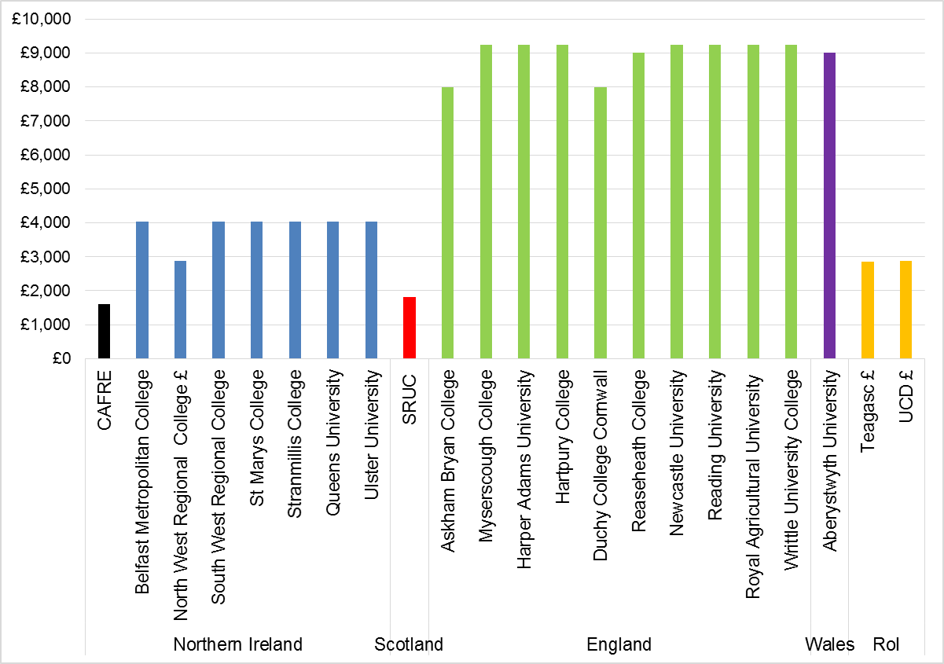
Notes:
- CAFRE figure excludes tuition fee charged for BSc Agricultural Technology degree as it is set by QUB.
- Teagasc and UCD figure converted from euros.
- North West Regional College converted from euros (degree course provided in partnership with Letterkenny Institute of Technology).

Foundation Degrees
    - A foundation degree represents 240+ credits of study typically over two years full-time. It is equivalent to a Level 5 qualification in the Frameworks for Higher Education Qualifications in England Wales and Northern Ireland.

    - Figure 9 demonstrates that in Northern Ireland tuition fees for foundation degrees are generally lower than those for an Honours Degree. The average fee is approx. £2,500.

    - The position in England, Wales, Scotland and the Republic of Ireland is similar to that for Honours degrees, with the majority of providers charging the maximum allowed by respective regulations.

Figure 8 - Tuition Fee Levels for Full-time Foundation Degree 2017/18 (Home Students)
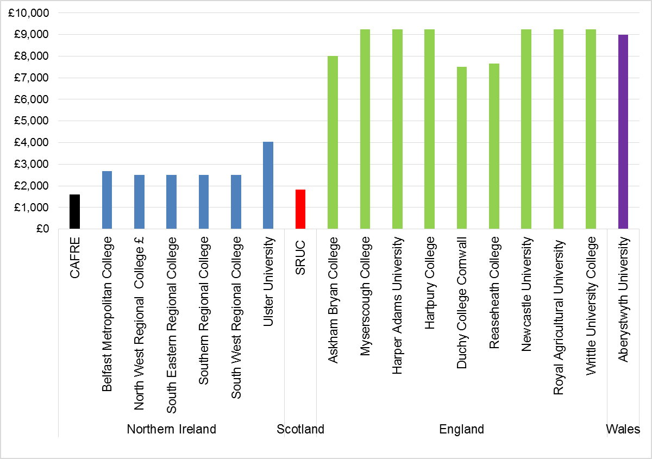
Notes:
- CAFRE figure excludes tuition fee charged for BSc Agricultural Technology degree as it is set by QUB.
- North West Regional College converted from euros (degree course provided in partnership with Letterkenny Institute of Technology).

Part-Time Undergraduate Tuition Fees Policy and Levels

    - Historically tuition fees for part-time undergraduates have not been regulated by DfE. This position was revisited within a consultation on part-time and postgraduate student finance in June 2015.

    - The consultation noted that ‘Some providers in Northern Ireland link part-time fee levels to full-time fees, based on intensity of study using credit points. This approach ensures that part-time students are charged roughly the same amount over the lifetime of their course as full-time students’.

    - In response to the consultation, DfE concluded that it was not deemed necessary to regulate part-time undergraduate tuition fee levels at that time. Fee levels would be monitored and if in the future it was deemed necessary, legislative steps to regulate fee levels would be introduced. In line with the wider policy position, DAERA has not regulated part-time undergraduate tuition fees to date.

    - DfE also announced that to ensure parity of treatment between part-time undergraduates and their full-time counterparts, a new, non-income assessed ‘top up’ tuition fee loan for part-time undergraduate students would be available from 2017/18.

    - In England tuition fees for part-time HE courses have been capped since 2012 (£6,500 per annum in 2017/18 for institutions not taking part in the Teaching Excellence Framework (TEF) and £6,935 per annum for those that achieve a rating of ‘Meets expectations’ under the TEF).

    - Most of the institutions sampled in this review charge per module or credit basis on a pro rata basis.

    - As outlined above, DAERA does not regulate part-time undergraduate tuition fees. In the absence of a legislative basis, no tuition fees have been levied from part-time students studying at CAFRE.

Postgraduate Tuition Fees Policy and Levels

    - Similar to part-time undergraduates, postgraduate tuition fees have historically not been regulated in Northern Ireland by DfE. This position was also explored in a 2015 consultation undertaken by DfE.

    - DfE announced it was deemed not necessary to regulate postgraduate fee levels at that time, on the basis that local providers were unlikely to charge above the maximum finance available for standard courses. As with the part-time undergraduate position, DfE committed to monitor postgraduate fee levels and to take the necessary legislative steps to cap fees in the future if required.

    - As with part-time students, DfE announced a new, non-income assessed tuition fee loan for new taught postgraduate students from 2017/18. The maximum loan available was initially set at £5,500 (or the actual fee charged if less), which was deemed broadly reflective of fees charged at the postgraduate level at local HEIs. Post graduate maintenance loans are not available from the government, however post graduate students can apply for a Professional and Career Development Loan available from the Cooperative Bank. The loans have reduced interest rates and the government will pay the interest during the study period.

    - There is wide variation in Postgraduate tuition fees. In Northern Ireland fees range from £5,290-£5,500 for most postgraduate taught courses, although there are some exceptions with an MBA at QUB costing around £20,000. In England fees are generally higher. For postgraduate taught courses in sampled institutions annual fees range from £6,000 to £7,900.

    - As with part-time undergraduates, DAERA does not charge postgraduate tuition fees. However, postgraduate students are required to pay a small administration charge to the accreditation body of their postgraduate programme.

Northern Ireland Future Direction

    - The Big Conversation was a public engagement exercise carried out by DEL/DfE in 2015. It was designed to raise awareness of, and seek solutions to, the various challenges facing Northern Ireland’s higher education system.

    - Responses received helped identify a range of options for the future delivery and funding of higher education in Northern Ireland that were published in the paper titled ‘Securing a Sustainable Solution for Higher Education in Northern Ireland: An Options Paper’. The options proposed different combinations of public and individual contributions to meet the proposed costs of higher education. Each option was geared towards providing the requisite funding to, as a minimum, protect the quality of provision at current levels.

    - The paper did not advocate any particular option. Rather, it was intended to aid consideration of these issues by a new Executive after the 2017 Northern Ireland Assembly election and inform a decision on the preferred way forward.

    - As an Executive has not been functional since the 2017 elections, the options paper has not been considered by Ministers.

    - In December 2017, the Department of Finance published a briefing paper on the Northern Ireland budgetary outlook for 2018-2020. The paper included options that may need to be considered by incoming Ministers through the use of three possible budget reduction scenarios. Options included within the paper include increasing tuition fee levels. The paper notes that any increase could only be introduced for the academic year 2020-21 at the earliest.

    - If the policy position of maintaining parity with DfE continues, it should be noted that any future changes will also apply to CAFRE students.

Comparison with Other Land Based Educational Providers

Myerscough College, Lancashire

Background

    - Myerscough College is a land-based higher and further education college dating back to the 19th century. Its main site is in Bilsborrow outside Preston, Lancashire, and it has a number of additional sites in Blackburn, Burnley, Liverpool, Manchester and Dorset.

    - Subjects available include motorsports, machinery engineering, sports and leisure, golf, arboriculture, landscape design, animal care, equine studies, horticulture, and farriery. Short courses for industry range from crane handling to crop spraying, and short leisure courses from caravan manoeuvring to floristry.

    - In 2015/16 there were approximately 7,000 students, of whom 2,500 were full-time. Over 1,000 are studying higher education degrees (undergraduate and postgraduate) in partnership with the University of Central Lancashire (UCLan).

    - Myerscough is an Associate School of UCLan and all University Centre Myerscough programmes are awarded by UCLan. The college was also recently awarded the title “University Centre”.

    - Students are drawn mainly from the North West of England, however there are small numbers of students from elsewhere, including Northern Ireland, the rest of GB and internationally.

    - Myerscough College also houses the Rural Business Centre, which provides support for rural business in the form of courses, advice, links and the Rural Business Incubator units (16 units) to facilitate start-up businesses.

Curriculum Development and links with Industry

    - Although traditionally a specialist land-based college, course provision is developed in line with demand and to maximise opportunities.

    - The college has strong links with industry. Technical Advisory Boards (which are subject specific) meet at least once a year and advise on the suitability of courses. The Boards comprise local employers, local farms, estate managers and National Farmers Union.

Research

    - The FFIT (Food and Farming Innovation & Technology) Centre, on the site of Myerscough’s Lodge Farm, is a major flagship build for agriculture and associated courses at Myerscough. The main FFIT Centre comprises of a red brick, two-storey building to house the research and teaching facilities that link with the various technologies in the nearby Livestock Innovation Centre and farm. The FFIT Centre also has facilities to support food research and development with the aim of creating a resource that both local businesses and students can use to investigate opportunities to process and add value to on-farm produce.

    - This includes specialist teaching, demonstration and research facilities including a teaching laboratory, soil laboratory, instrumentation room, production development kitchen, as well as a conference room, general teaching rooms, offices, a dining area and changing facilities.

The £7.5 million complex is also home to a Livestock Innovation Centre, which provides new livestock production facilities with embedded technology to promote precision farming practices.

    - Research forms a strong part of HE courses. All undergraduate students are required to undertake a research project as part of their degree.

    - Research helps to maintain the college’s position at the forefront of the industries it serves, whilst also adding value and diversity to the curriculum content and styles of teaching. The college’s research specialisms are: Sports Performance, Sustainable Agriculture and Arboriculture, Animal Welfare and Equine Performance & Teaching and Learning.

Widening Access and Participation Plans

    - Although not a requirement for further education, Myerscough has developed a plan for the full range of their course provision.

Links with Defra

    - The college actively encourages contact with Defra officials, however lobbying on the importance of land-based education is usually carried out by Landex (a subscriber organisation made up of 39 colleges and universities across the UK delivering education and training in land based occupations).

Accommodation

    - Myerscough offers accommodation for over 650 students in a range of single, twin and self-catering rooms with shared or en-suite bathrooms in 26 different halls of residence. In the last Ofsted inspection of residential provision in 2014, Myerscough was rated as “Outstanding”.

    - At Myerscough College, all students have the opportunity to live in while they study. It has halls of residence for under 18s and over 18s. First year students are guaranteed a room. Priority for accommodation is also given to students living outside of a 15 mile radius from college. Around one fifth of further education students live on campus. Students who live in have higher success rates in examinations than non-residential students.

    - Residential fees for higher education students range from £3,960 for a single en-suite room on a self-catering basis to £5,809 for a single en-suite room with full-board catering – both on 36 week contracts.

Higher Education Tuition fees

    - 2017-18 higher education tuition fees are in line with the fees charged by UCLan.
Foundation Degrees
(Full-time UK and EU Students)
Full-time | £9,250/year
Part-time  (all taught 'on campus', on-line or blended learning undergraduate awards - UK Students) | £900/module
Honours Degrees
(Full-time UK and EU Students)
Full-time | £9,250/year
Part-time | (all taught 'on campus', on-line or blended learning undergraduate awards - UK Students) £900/module
Sandwich / Placement Year | £1,500/year
Postgraduate
(Full-time UK and EU Students)
Masters Degrees - Taught | £6,000/year
Part-time | (all taught 'on campus', on-line or blended learning post-graduate awards - UK Students) £625/module

    - Despite increasing fees since their introduction, there has been no identifiable negative impact on enrolments.

    - Myerscough offer a £500 cash incentive to students who have completed their further education studies at Myerscough and who stay to complete higher education courses.

    - International fees are charged in line with UCLan international fees.

Harper Adams

Background

    - Harper Adams was founded 1901. It is set on 550 hectare farm outside Telford and had 3,050 higher education students enrolled in 2016/17. It has been placed in the top six higher education institutions in the UK in the 2017 National Student Survey results, achieving an overall satisfaction rate of 93 per cent. Harper Adams is one of the top 10 universities in the UK and has the sixth highest percentage of qualified staff (78%).

    - The university was also awarded gold in the 2017 Teaching Excellence Framework.

    - Harper provides undergraduate courses in Agriculture, Animal Sciences, Applied Biology, Business & Agri-Food, Countryside, Environment Wildlife and Geography, Engineering, Food Science, Technology and Innovation, Rural Estate, Property and Land Management, Vet Nursing, Vet Physiotherapy & Zoology.

    - It also offers extended foundation degrees for those who don’t hold entry qualifications (in Agriculture, Animal Management and Welfare, Business Management & Marketing, Countryside Management). It operates as a preparatory year (or year zero), and if a student performs well, they can transfer to a foundation/degree course. Entry via this route may require 4-5 years study including a year work placement. Progression rates are excellent, with around 94% staying on to the foundation or higher degree.

    - On campus Harper has invested in cutting-edge facilities such as a £2.93 million Agricultural Engineering Innovation Centre and a £4 million Food Innovation Centre.

    - It has 98% graduate employment, joint highest in England.

    - A small number of students come from NI (less than 1%), and about 1-2% from ROI.

Curriculum Development and Links with Industry

    - Whilst many other English Universities have withdrawn placement years (in order to reduce costs of total tuition fees to students), Harper Adams has retained them. Results show that students who return for their final year after a year’s practical experience are more driven towards achievement in their final year.

Although it is the ultimate responsibility of students to secure the placement, Harper Adams invest significant resources to assist students. The University arrange a very large annual placement fair, with in excess of 130 businesses attending. A dedicated office work on placement provision and support (e.g. visits whilst on placement).

    - Feedback from placement visits is a useful source of information for curriculum development. Employers of placement students and graduates are also surveyed regularly to ascertain the appropriateness of student skills to employer needs. Course development teams invite industry to sit on focus groups to input to curriculum development. As course development requires a lengthy lead in time, future proofing is a key consideration.

    - Harper Adams also like to recruit academics from industry to complement their career academics.

Links with FE Providers

    - Currently Harper accredit higher education Courses for Askham Bryan College, Yorkshire (land based college) and Reaseheath College, Cheshire (land based college). Similar to CAFRE arrangements, students apply directly to the FE Colleges, but all degrees are awarded by Harper Adams.

    - In England there are ongoing policy changes at a higher level to allow more providers to award HE courses. As a result Reaseheath College, Cheshire has decided to sever links with Harper Adams over the next three years.

    - The policy changes aim to encourage new providers into the sector.

Research

    - In the latest Research Excellence Framework (REF2014), 100 per cent of Harper Adam’s research was declared of international quality, with more than 50 per cent either world leading or internationally excellent. Harper has a well-established research function and as well as publishing research papers carry out a number of projects for both government and industry. Research is also a key part of the student experience with all students completing a research project.

Widening Access and Participation Plans (WAPP)

    - Harper have to prepare and submit WAPPs to the Office for Students(OfS) to show how they will encourage students from a range of backgrounds. This can be challenging given the difficulties of identifying pockets of deprivation in rural areas (where the bulk of students come from).

International Linkages

    - Harper Adams attracts around 185 non-EU students annually, from approximately 30 countries.

    - Particularly strong links exist with Beijing & Huazhong Agricultural Colleges and Harper Adams has exchange programmes with institutions in America, New Zealand, Japan and the EU.

Accommodation

    - 800 students live on campus and Harper was voted 2nd best in the UK for accommodation, clubs and societies and Students' Union (Whatuni 2016).

    - Halls of residence or Harper Adams University house accommodation costs for 2017/18 range from £3,710 - £5,969.

    - Students usually stay on a 32/33 week contract on a package that includes full catering provision. Increasing numbers of students from the Midlands however are now staying at home and commuting to the University.

Tuition fees

    - Fees for full-time UK and EU undergraduate students starting at Harper Adams University in 2017/18 and 2018/19 are:
Honours Degrees, Foundation degrees and Extended foundation Degrees
(Full-time UK and EU Students)
Full-time | £9,250/year
Part-time | Pro rata basis of the full-time equivalent
Sandwich / Placement Year | £1,850
Postgraduate
Full-time Post Graduate and Research UK and EU Students) | £5,400 per 180 credits to  £10,500 per 180 credits.

    - When tuition fees rose there was no negative impact on full-time enrolments. There was a noticeable impact, however, on part-time enrolments. Harper Adams worked intensively to communicate what the change meant in real terms to students and parents/guardians (e.g. delayed repayments).

    - Full-time Post Graduate and Research fees for Non EU new entrants in 2017/18 range from
- £10,900 per 180 credits to
- £17,900 per 180 credits.

Consideration of differing approaches to setting tuition fees and potential impact on enrolments

Differential Fees

    - A recent report by the Higher Education Policy Institute investigated the concept of differential fees. It considered several options for the basis of differentiation; cost of delivery, potential for student lifetime earnings or by academic institution.

    - The report noted a European Commission study of the different fee and funding arrangements available in 2016/17 for full-time first-time students. The study found that, as well as varying between countries, fees can differ markedly within countries according to the field of study, the intensity of the course and the personal characteristics of students.

    - The report also noted that in Australia courses that are cheaper to teach (such as Humanities) and courses that tend to produce lower graduate salaries (such as Nursing and Education) are in the lowest student contribution category. Courses that are more expensive to deliver (such as Medicine and Veterinary Science) and courses that are deemed to produce higher graduate salaries (like Accounting) are in the highest student contribution category.

    - Whilst demonstrating that differential fee frameworks can and do operate effectively in other countries, the report concluded that the evidence does not demonstrate that such a structure will solve policy problems.

Research on willingness to pay

    - Following the increase to tuition fees in England in 2012, an academic paper considered the potential impact by analysing the decision-making and changing behavioural dynamics of potential higher education students. A survey of 1,549 year 12 students from four institutions spread geographically across England was conducted. Consideration of cheaper higher education alternatives abroad was within the scope of the analysis.

    - The paper concludes that there was potential for the English higher education system to be confronted with significant changes in student choice patterns, given the findings of high levels of anxiety and consequently consider a much broader range of study options.

    - A House of Commons briefing paper produced on Tuition Fee statistics in 2018 reported that in the UK there were three major falls in higher education applicants in 1998 (when tuition fees were introduced), 2006 (when variable fees were introduced) and 2012 (when the fee cap was lifted to £9,000). These falls have not changed the overall upward trend in applications.

    - UCAS data for Northern Ireland applicants studying to apply in NI institutions from 2003/4 to 2016/17 showed a similar trend with a drop in applicants following the increase in fees in 2006/7. The data also showed a drop in applications in 2012/13, the year the fees increased to £9,000 in England, despite the increase in fees not applying in Northern Ireland. In the longer term however the level of fee has had little effect on the general trend of increasing applications to higher education institutions.

International approaches

    - The House of Commons briefing paper also noted that in 2015/16 the OECD compared tuition fees across a range of countries. The subsequent OECD report noted that the complexity of tuition fee frameworks in many countries (variations by subject, type of course, type of institution, students’ circumstances and state support to meet fees) means that direct comparisons are not straightforward.

    - The OECD report also found that students were generally liable to pay tuition fees at public/Government supported higher education institutions in the majority of OECD countries. The headline average undergraduate tuition fee in England at £9,000 was the highest of any OECD or ‘partner’ country (for public or government-dependent private institutions). It was only below the average levied at independent private institutions in the US ($21,200). Average fees for independent institutions in Australia were the next highest behind England at $10,200, followed by Japan and Korea in the $8,200 to $8,400 range.

    - The House of Commons briefing paper stated that the “OECD figures confirm the assessment……that average fee levels for new students in England from 2012 were likely to be the highest for public or state-dependent private institutions in the developed world.”

Summary of findings from the review

    - There is significant disparity in fees charged at CAFRE, ranging from no fees charged for part-time and postgraduate courses (except for registration fees), £1,595 per annum charged for full-time honours in equine and food and foundation degree agriculture and horticulture and £4,030 for honours degree in agricultural technology.

    - CAFRE fees are currently the lowest of all educational providers in Northern Ireland and all sampled institutions in Scotland, Wales, England and the Republic of Ireland.

    - CAFRE students would more likely than not be willing to pay in the range of £1,600 - £4,000.

    - Although a small college, a significant amount of CAFRE graduates are finding employment in their subject area in the local economy.

    - CAFRE graduate prospects are comparable to other higher education institutions both in Northern Ireland and in the rest of the UK for students entering employment or further education after graduation.

    - CAFRE courses and the student experience are viewed favourably by CAFRE students.

    - CAFRE has established strong mutually exclusive links with the agri-food, horticulture and equine industries across the island of Ireland.

Glossary

BAFRE | Business for Agri-food and Rural Enterprise
BSc | Batchelor of Science Degree
CAFRE | College of Agriculture, Food and Rural Enterprise
DARD | Department of Agriculture and Rural Development
DAERA | Department of Agriculture, Environment and Rural Affairs
Defra | Department of Environment, Food and Rural Affairs.
DEL | Department for Employment and Learning
DfE | Department for the Economy
Fd | Foundation Degree
FE | Further Education
FEIs | Further Education Institutions
HE | Higher Education
HEIs | Higher Education Institutions
Home student | Student who ordinarily resided locally – in certain administrations home students are eligible to pay university tuition fees at a lower rate than students from other areas of UK or international students
MSc | Masters Degree
QUB | Queens University Belfast
Regional Colleges | Six Regional Colleges in Northern Ireland: Belfast Metropolitan College, North West College, South West College, Northern Regional College, Southern Regional College and South Eastern Regional College.
SRUC | Scotland’s Rural College
UCD | University College Dublin
UCLAN | University of Central Lancashire
UU | Ulster University

Annex 1 – Higher Education Courses at CAFRE 2016/17

Agriculture Higher Education Courses
Full-time
Foundation Degree Agriculture & Technology
BTEC HND Agriculture / Foundation Degree Ag RS Year 3
BSc Agricultural Technology
Part-time
Foundation Degree Ag & Technology PT
Horticulture Higher Education Courses
Full-time
Foundation Degree in Horticulture
Part-time
Foundation Degree in Horticulture
Equine Higher Education Courses
Full-time
Foundation Degree in Equine Studies Year 1
BSc Equine Studies (New Programme) Year 1
Food Higher Education Courses
Full-time
Foundation Degree in Food
BSc Food Technology
BSc Food Design & Nutrition
BSc Food Business Management (Previously Bsc Food Management & Marketing)
Part-time
FdSc in Food
BSc Food Technology
BSc Food Design & Nutrition
BSc Food Business Management
BSc Food Management & Marketing
Adv Prof Cert in Environmental Health Food Law Enforcement
Business for Agri-Food and Rural Enterprise Courses
Full-time
MSc in Business (including PhD)
Part-time
Business Course
Graduate. Cert. In Business Communication

Note –students may also be registered on courses no longer offered

Annex 2 - CAFRE Student Survey to inform DAERA Education Policy -Summary of Results

Section A – Respondent Details

- 240 higher education students completed the survey – out of a possible 472 students. This represents a completion rate of 51%. By discipline the responses were as follows:

Discipline | Surveys Completed | Max no of Students | Completion Rate %
Food | 92 | 184 | 50%
Agriculture | 71 | 144 | 49%
Equine | 54 | 76 | 71%
Horticulture | 19 | 68 | 28%
Total | 236 | 472
4 students did not identify what discipline they were from.

- 165 females completed the survey compared to 74 males.


- Over 75% (182 respondents) were in the 17-20 yr old age group when they started their course at CAFRE. Over 90% (218 respondents) were under the age of 24 when they started their course.
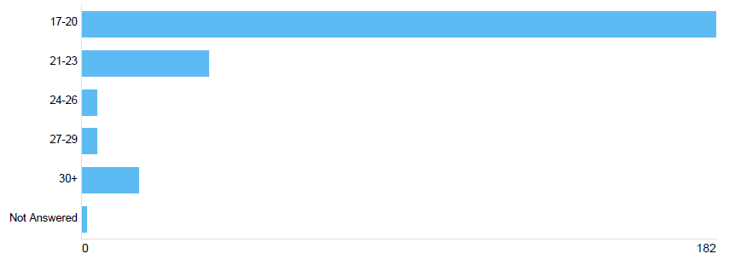

- 91% (219 respondents) are normally resident in the UK.

- Almost 73% (175 respondents) do not live in CAFRE accommodation during term time.
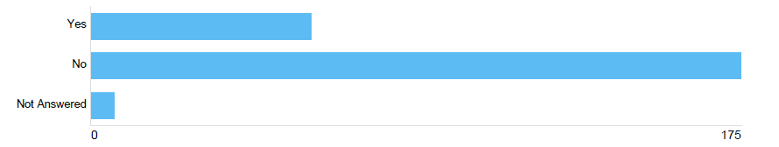

- Almost 60% (142 respondents) met the entry requirements of their higher education course through A Level qualifications.


Section B – Accommodation

- Students were asked a series of questions on what they thought was important when choosing CAFRE accommodation. Figure 1 details the results.

Figure 9 - Factors of importance when choosing CAFRE accommodation

- A total of 65 respondents indicated what factors were important when choosing whether to use CAFRE accommodation. The overwhelming majority, on average 84% of those who responded to the question, stated that reduced travel costs, proximity of classes, infeasibility of travel from home, comparatively inexpensive accommodation and conduciveness of study were important factors. On average 66% confirmed that being with friends and independent living were also important factors. Access to sporting facilities was noted as being an important factor by 40% of respondents.

- Respondents had the opportunity to note any negative associations with living in CAFRE accommodation. While 63% (41 students) of those who responded to the question, stated no negative association in their experience, 24 students chose to comment on their experience. The majority of comments related to the limited kitchen facilities, cost and limited choice of catering, the lack of heating in the rooms and the noise at night.

Section C – Why choose CAFRE?

- Students were asked a series of questions on what they thought was important when choosing CAFRE as their institution of learning. Figure 2 details the results.

Figure 10 - Factors of importance when choosing CAFRE

- Over 90% (on average 221 respondents) indicated that subjects on offer, the content of the courses, quality of teaching and success of CAFRE students in gaining employment were important factors in their decision making.

- The next most important factors were noted by an average of 83% (199 respondents) as cost of tuition fees, assistance with industry placements and entry requirements.

- Duration of course, advice of family & friends, location of college/campus and student welfare services were noted as important by an average of 63% (151 respondents).

- Cost of accommodation was noted as important by 46% (107 respondents).

- Around 42% (102 respondents) of those who responded to the question, stated that they did not consider studying at any other institution. Of the 58% (138 respondents) who confirmed that they had considered studying elsewhere, 45% considered studying in an alternative institution in Northern Ireland, 36% considered studying at an institution in England or Wales, 6% in Scotland and 13% at an institution in the Republic of Ireland.

- Students were asked the most important factors when choosing which course to study. Figure 3 details the results.

Figure 11 - Factors of importance when choosing course

- The most important factors noted were to improve chances of getting a job (93% or 223 respondents) and a personal interest in the subject (95% or 225 respondents).

- Figure 3 details results from students of all disciplines. When analysed for agriculture students, 51% (36 respondents) of those who responded to the question, noted that preparing to join the family farm was an important factor.

- When analysed for food students, 10% (9 respondents) of those who responded to the question, noted that preparing to join the family food business was an important factor.

Section D – Student Experience

- Students were asked a series of questions on their student experience and levels of satisfaction. Figure 4 details the results.

Figure 12 - Student Experience Satisfaction

- Over 95% (on average 229 respondents) were satisfied with their induction in the first week, the help and support of CAFRE staff, timetabled sessions, IT/Library facilities and the overall quality of the course.

- Over 91% (218 respondents) indicated that they were satisfied with teaching and motivational skills of lecturers.

- In addition to this, over 88% (on average 208 respondents) confirmed that they were satisfied with CAFRE’s expertise in communicating messages e.g. changes to timetables, the signposting of student support services and the marking framework for exams and coursework assessments. Approximately 82% (193 respondents) of students stated that they were satisfied with the careers advice and feedback from course work they received and the time taken to mark assessments.

- Over 88% (176 respondents) of students who responded to the question, indicated that they were content with the level of supervision and support while on placement. Similar numbers expressed satisfaction with the range of clubs and societies on offer and the mix of entertainment and social events.

- Over 90% (224 respondents) stated that they were satisfied with regard to expectation before starting their course.

Section E – Value for Money

- A total of 206 respondents confirmed that they were working either part-time/full-time or had a holiday job. This represents nearly 86% of all respondents to the survey. Of these 70% (144 respondents) earn £5,000 or less per annum. A further 19% (39 respondents) earn between £5,001 and £10,000.

- This trend was true of agriculture, food and equine students. In respect of horticulture students there was a more equal distribution of students earning in each of the response brackets between £5,000 or less (25% of horticulture respondents) up to £30,000 - £35,000 (19% of horticulture respondents). This probably reflects the fact that the majority of horticulture students are studying part-time.

- When asked what salary they anticipated to be earning in the first year after leaving CAFRE, 67% of those who responded expected to earn more than £15,000 in the first year after leaving CAFRE. 75% (191 respondents) believe they will earn between £10,001 and £25,000 and over 9% (22 respondents) believe they will earn above £25,001.
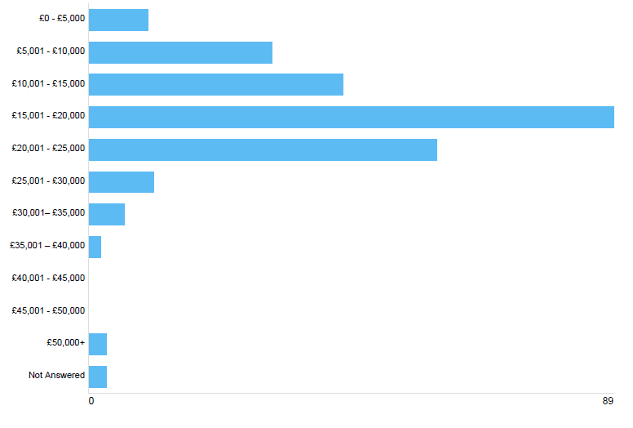

- When assessed by discipline the most commonly anticipated salary in the first year after leaving was £15,001-£20,000 for agriculture, horticulture and food students and £10,001-£15,000 for equine students.

- When asked what salary they anticipated to be earning five years after leaving CAFRE, 75% (188 respondents) believe they will earn between £20,001 and £40,000 and 11% (28 respondents) believe they will earn above £40,001.

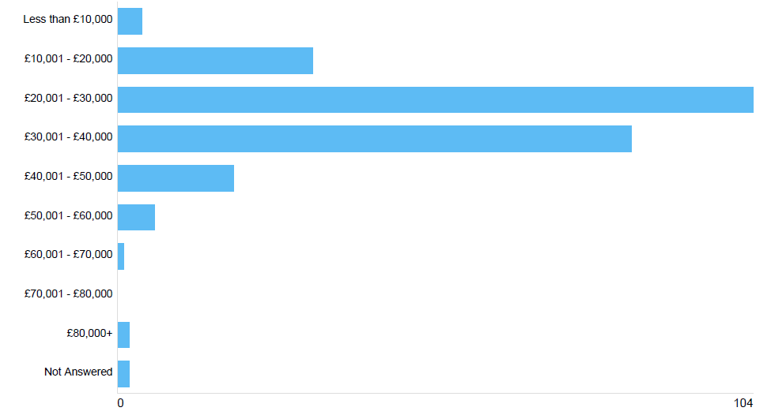

- When assessed by discipline, the most commonly anticipated salary five years after leaving was £20,001-£30,000 for all disciplines.

- Students were asked to consider the personal and financial benefits they anticipated receiving from completing the course they were currently enrolled in and indicate how they would react to a series of tuition fee scenarios if they were applying for their course again. In all cases they were asked to assume that costs are on a full-time basis (and would be pro-rated for part-time students) and that a student loan is available to cover the full cost of fees while they are studying. The students were given three options:
- No change in your decision – do current degree course.
- Change your decision – do a different degree course.
- Change your decision – get a job instead of doing a degree

Figure 5 details the results.

Figure 13 - Tuition Fee Scenarios
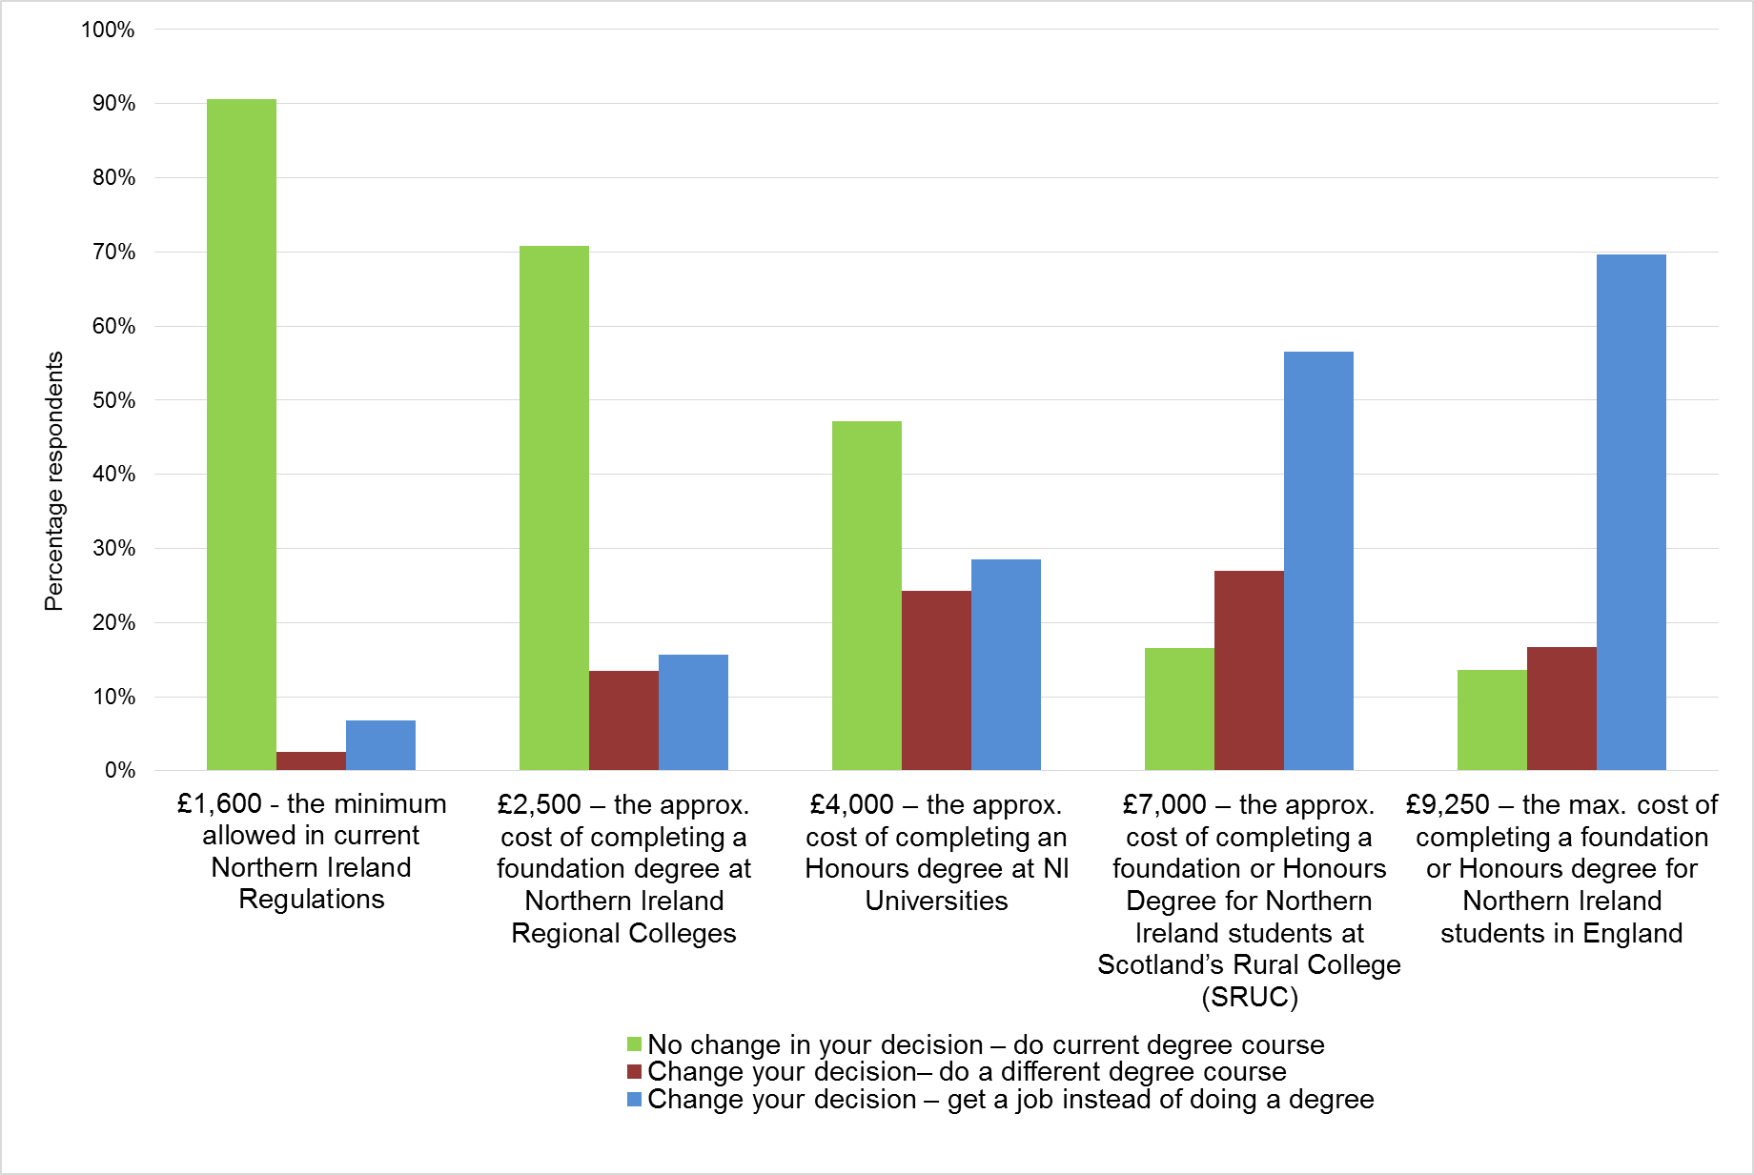

- The first scenario was that the fees remained at £1,600. Of those who responded to the question, 91% (213 respondents) stated that they would not change their decision and would remain on the same course.

- The second scenario proposed annual fees of £2,500, the approximate annual cost of completing a Foundation Degree course at a Northern Ireland Regional College. Approximately 71% (163 respondents) stated that they would not change their decision and would remain on the same course. Approximately 16% (36 respondents) stated they would change their decision and seek employment instead.

- The third scenario proposed annual fees at £4,000, the approximate annual cost of completing an Honours Degrees at a Northern Ireland university. Approximately 47% (109 respondents) stated that they would not change their decision and would remain on the same course. Approximately 29% (66 respondents) stated they would change their decision and seek employment instead.

- The fourth scenario proposed annual fees of £7,000, the approximate cost of completing a foundation or Honours Degree for Northern Ireland students at the Scotland Rural College (SRUC). Approximately 17% (38 respondents) stated that they would not change their decision and would remain on the same course. Approximately 57% (130 respondents) stated they would change their decision and seek employment instead.

- The fifth and final last scenario proposed annual fees at £9,250, the maximum cost of completing a foundation or Honours degree for Northern Ireland students in England. Approximately 14% (32 respondents) stated that they would not change their decision and would remain on the same course. Approximately 70% (163 respondents) stated they would change their decision and seek employment instead.

- Figure 6 details the same results when analysed by discipline.

Figure 14 - Fee scenarios (by discipline)
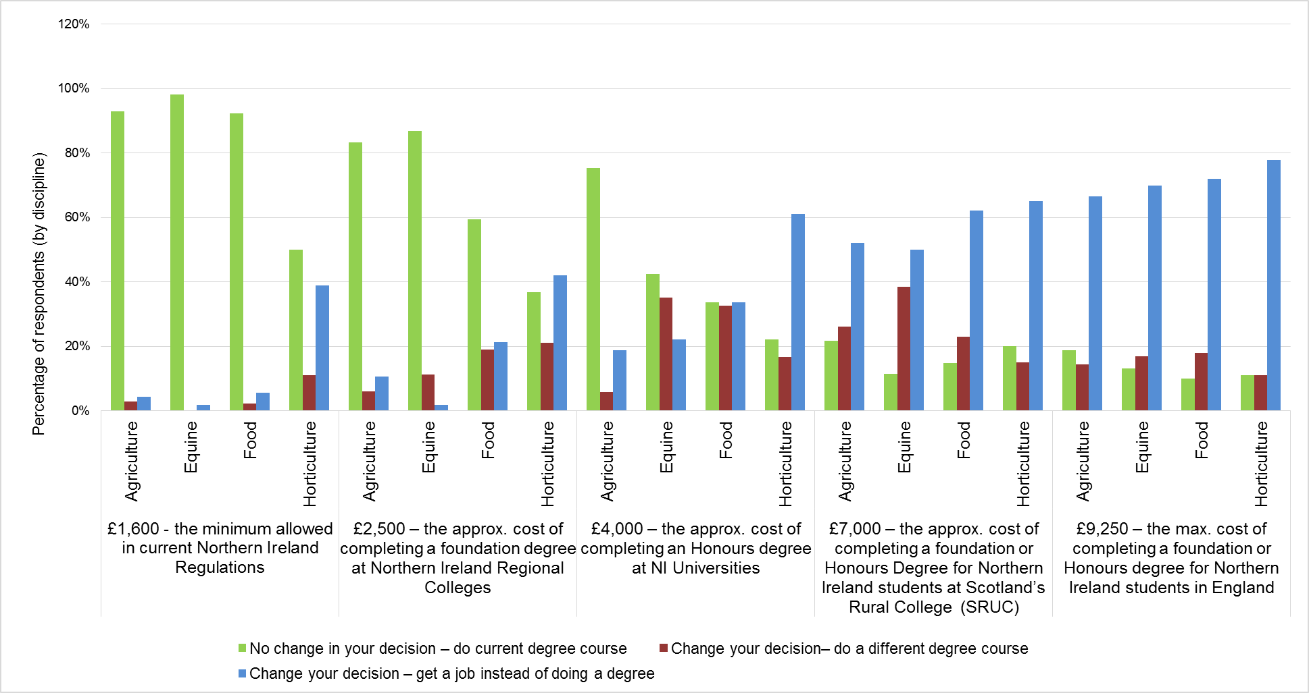

- At £1,600 (the current full-time fee level) almost 40% of horticulture students would change their decision and get a job instead of studying their current course. (The majority of horticulture respondents are currently studying on a part-time basis, and therefore do not currently pay any tuition fees.)

- At a tuition fee rate of £2,500 again around 40% of horticulture students would get a job instead of studying their current course, however over half of students in other disciplines would remain on their course.

- At £4,000 over 60% of horticulture students would get a job instead of studying their current course and only 20% would remain of their course. At this rate agriculture students would be the most likely to stay on their course.

- A tuition rate of £7,000 sees a significant shift in response as at least 50% of respondents in all disciplines would find a job instead. They are also more likely to do a different course in three out of the four disciplines rather than stay on their current course.

- A tuition rate of £9,250 shows that well over 60% of students across the disciplines would seek a job instead of studying their current course.

- The responses show that agriculture students are more likely than not to study their current course up to a tuition fee level of £4,000 per annum. Equine students are more likely than not to study their current course up to £2,500 per annum tuition fee. Food students, similar to equine, are more likely than not to study their current course up to £2,500 per annum fee. Finally horticulture students are more likely than not to study their current course at the current fee of £1,600 per annum.

- Part-time students and those registered as QUB students (BSc Agricultural Technology students) are currently not subject to the same charging framework as full-time CAFRE students. To test if this impacted on the results of the fee scenarios, the results were analysed with those students removed. Figure 7 details the results.

Figure 15 - Tuition Fee Scenarios by Discipline (excluding part-time and QUB students)
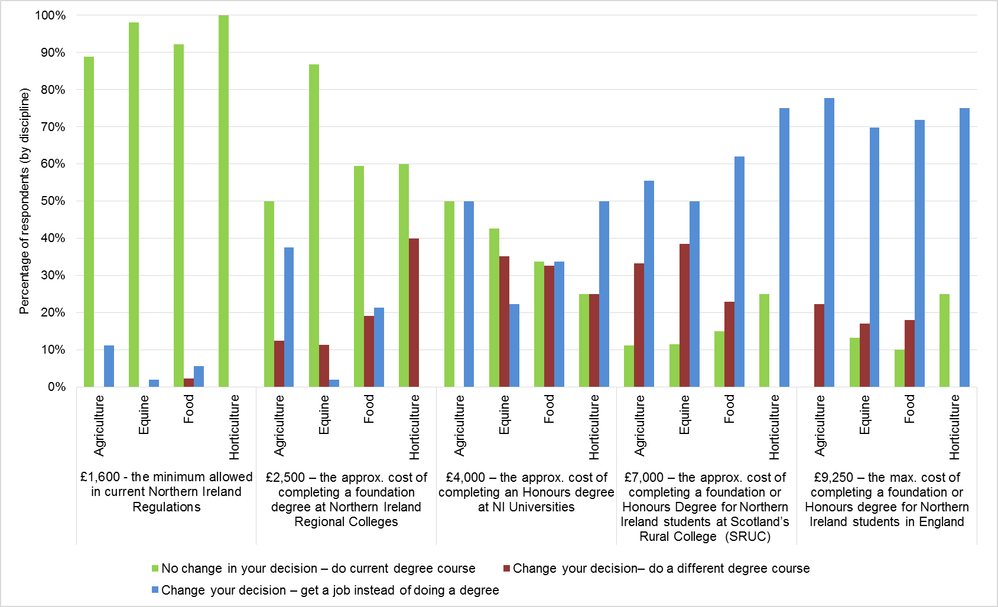

- At £1,600 (the current full-time fee level) the vast majority of students in every discipline would not change their decision and would continue to study their current course.

- At a tuition fee rate of £2,500 around 50 % of agriculture and 60% of horticulture and food students would get a job instead of studying their current course, however 87% of equine students would remain on their course.

- At £4,000 over 60% of horticulture students would get a job instead of studying their current course and only 20% would remain of their course. At this rate agriculture students would be the most likely to stay on their course.

- A tuition rate of £7,000 sees a significant shift in response as at least 50% of respondents in all disciplines would find a job instead. They are also more likely to do a different course in three out of the four disciplines rather than stay on their current course.

- A tuition rate of £9,250 shows that over 70% of students across all the disciplines would seek a job instead of studying their current course.

- The responses show that full- time CAFRE agriculture students are more likely than not to study their current course up to a tuition fee level of £2,500 to £4,000 per annum. Full- time CAFRE equine students are more likely than not to study their current course up to £2,500 per annum tuition fee. Similarly full- time CAFRE food students and full- time CAFRE horticulture students are more likely than not to study their current course up to £2,500 per annum fee.

- The penultimate question asked the students to consider how they would rate the value for money of their CAFRE course for the fees that they pay. Approximately 90% (216 respondents) rated the value for money as very good or good. Approximately 10% (25 respondents) rated value for money as poor or very poor.

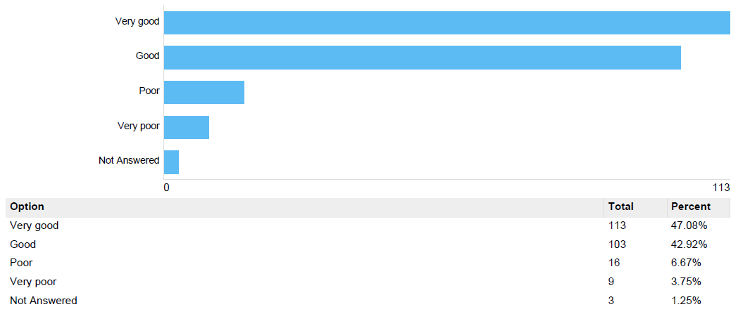

- The last question asked students if they had any additional comments to make regarding value for money at CAFRE. There were 30 responses to the question. The most common comment was that CAFRE currently offers very good value for money.

Annex 3 – Tuition Fees Level Comparison Table Academic Year 2017/18

Figures included for courses provided by a selected sample of institutions. If a sampled institution does not provide a course ‘Not available’ has been detailed.

Euro to Sterling conversions calculated using exchange rate from July 2017.

 |  | Honours Degree |  |  |  |  | Foundation Degree
 |  | Home Student | Other UK | Other EU | International |  | Home Student | Other UK | Other EU | International
Northern Ireland | CAFRE | £1,595 | £9,000 | £1,595 | n/a |  | £1,595 | £9,000 | £1,595 | n/a
Northern Ireland | Belfast Metropolitan College | £4,030 | £4,030 | £4,030 | £6,360 |  | £2,685 | £2,685 | £2,685 | £6,360
Northern Ireland | Northern Regional College | Not available | Not available | Not available | Not available |  | £2,500 | £2,500 | £2,500 | £6,000
Northern Ireland | North West Regional College - Partnership with Letterkenny IT - € | *€ 3,260 | *€ 3,260 | *€ 3,260 | € 9,000 |  | N/A | N/A | N/A | N/A
Northern Ireland | North West Regional College £ | £2,868 | £2,868 | £2,868 | £7,950 |  | £2,500 | £2,500 | £2,500 | £8,000
Northern Ireland | South Eastern Regional College | Not available | Not available | Not available | Not available |  | £2,500 | £2,500 | £2,500 | £5,500
Northern Ireland | Southern Regional College | Not available | Not available | Not available | Not available |  | £2,500 | £2,500 | £2,500 | £6,500
Northern Ireland | South West Regional College | £4,030 | £4,030 | £4,030 | £6,500 |  | £2,500 | £2,500 | £2,500 | £6,500
Northern Ireland | St Marys College | £4,030 | £9,000 | £4,030 | £13,945 |  | Not available | Not available | Not available | Not available
Northern Ireland | Stranmillis College | £4,030 | £9,000 | £4,030 | £13,945 |  | Not available | Not available | Not available | Not available
Northern Ireland | Queens University | £4,030 | £9,250 | £4,030 | £15,100 - £34,800 |  | Not available | Not available | Not available | Not available
Northern Ireland | Ulster University | £4,030 | £9,000 | £4,030 | £13,240 |  | £4,030 | £9,000 | £4,030 | £13,240
Northern Ireland | Open University | £1,916 | £5,728 | £5,728 | £5,728 |  | £1,916 | £5,728 | £5,728 | £5,728
Scotland | SRUC | £1,820 | £6,950 | £1,820 | £12,000 |  | £1,820 | £230 per module | £1,820 | £12,000
England | Askham Bryan College | £8,000 | £8,000 | £8,000 | £9,500 |  | £8,000 | £8,000 | £8,000 | £9,500
England | Myserscough College | £9,250 | £9,250 | £9,250 | £11950 - £12950 |  | £9,250 | £9,250 | £9,250 | £11950 - £12950
England | Harper Adams University | £9,250 | £9,250 | £9,250 | £10,200 |  | £9,250 | £9,250 | £9,250 | £10,200
England | Hartpury College | £9,250 | £9,250 | £9,250 | £11,250 |  | £9,250 | £9,250 | £9,250 | £11,250
England | Duchy College Cornwall | £8,000 | £8,000 | £8,000 | £9,500 |  | £7,500 | £7,500 | £7,500 | £9,500
England | Reaseheath College | £9,000 | £9,000 | £9,000 | £10,350 |  | £7,650 | £7,650 | £7,650 | £8,800
England | Newcastle University | £9,250 | £9,250 | £9,250 | £17,935 |  | £9,250 | £9,250 | £9,250 | £17,935
England | Reading University | £9,250 | £9,250 | £9,250 | £18,860 |  | Not available | Not available | Not available | Not available
England | Royal Agricultural University | £9,250 | £9,250 | £9,250 | £10,000 |  | £9,250 | £9,250 | £9,250 | £10,000
England | Writtle University College | £9,250 | £9,250 | £9,250 | £11,400 |  | £9,250 | £9,250 | £9,250 | £11,400
Wales | Aberystwyth University | £9,000 | £9,000 | £9,000 | £13200 - £14750 |  | £9,000 | £9,000 | £9,000 | £13200 - £14750
RoI | Teagasc € | €3250 | €3250 | €3250 | €10245 |  | Not available | Not available | Not available | Not available
RoI | Teagasc £ | £2,860 | £2,860 | £2,860 | £9,015 |  | Not available | Not available | Not available | Not available
RoI | UCD € | €3260 | €3260 | €3260 | €23800 |  | Not available | Not available | Not available | Not available
RoI | UCD £ | £2,868 | £2,868 | £2,868 | £20,942 |  | Not available | Not available | Not available | Not available

£1 = €1.136

Students ordinarily domiciled in the region where they are studying
https://www.northernireland.gov.uk/topics/work-executive/economic-strategy
https://www.northernireland.gov.uk/topics/work-executive/economic-strategy
https://www.economy-ni.gov.uk/consultations/industrial-strategy
https://www.economy-ni.gov.uk/articles/northern-ireland-innovation-strategy
http://isni.gov.uk/PDFs/Investment%20Strategy.pdf
http://www.legislation.gov.uk/apni/1949/2/contents
Academic year 2017/18
Academic year 2017/18
https://www.finance-ni.gov.uk/publications/briefing-northern-ireland-budgetary-outlook-2018-20 (accessed 21 February 2018)
https://www.gov.uk/what-different-qualification-levels-mean/list-of-qualification-levels
How education is delivered factsheet – https://www.economy-ni.gov.uk/sites/default/files/consultations/del/he-big-conversation-factsheet-2.pdf
https://www.economy-ni.gov.uk/publications/destinations-leavers-uk-higher-education-institutions-northern-ireland-analysis-201516
Higher Education Statistics Agency - Destination of Leavers from Higher Education survey (DLHE) www.hecsu.ac.uk/current_projects_what_do_graduates_do.htm (accessed 21 February 2018)
https://local.teachers.org.uk/templates/asset-relay.cfm?frmAssetFileID=5512
Simon Baker, ‘Subject cost data add fuel to England’s variable fees debate’, Times Higher Education, 5 October 2017 https://www.timeshighereducation.com/news/subject-cost-data-add-fuel-englands-variable-fees-debate
https://www.economy-ni.gov.uk/sites/default/files/publications/del/Influence%20of%20graduate%20qualification%20on%20average%20wages%20and%20productivity%20across%20the%20uk.pdf
https://www.nus.org.uk/Global/Student%20contribution%20to%20the%20UK%20economy.pdf
https://www.economy-ni.gov.uk/sites/default/files/publications/economy/Economic-Impact-of-HE-on-ni-economy.pdf
https://www.daera-ni.gov.uk/sites/default/files/publications/dard/fss-2013.pdf
http://www.legislation.gov.uk/ukpga/2017/29/contents/enacted/data.htm
Participating higher education providers receive a gold, silver or bronze award reflecting the excellence of their teaching, learning environment and student outcomes. Further information available at http://www.hefce.ac.uk/lt/tef/whatistef/
http://www.qaa.ac.uk/publications/information-and-guidance/publication?PubID=2718#.WeX2EU0Uku6
http://gov.wales/newsroom/educationandskills/2017/maximum-tuition-fee-in-wales-will-remain-9000-kirsty-williams/?lang=en
http://www.qaa.ac.uk/publications/information-and-guidance/publication?PubID=2718#.WeX2EU0Uku6
https://www.economy-ni.gov.uk/consultations/part-time-and-postgraduate-student-finance
https://www.economy-ni.gov.uk/consultations/higher-education-big-conversation
https://www.economy-ni.gov.uk/sites/default/files/consultations/del/HE%20options%20paper.pdf
https://www.finance-ni.gov.uk/publications/briefing-northern-ireland-budgetary-outlook-2018-20
According to data which was collected between 2014 and 2015, released by the Higher Education Funding Council for England (Hefce) and analysed by the Higher Education Statistics Agency (HESA).
https://www.harper-adams.ac.uk/why-harper/
OfS came into effect on 1 April 2018 as a result of the merger of the Higher Education Funding Council for England and the Office for Fair Access
http://www.hepi.ac.uk/2018/02/22/two-thirds-students-reject-differential-tuition-fees-different-courses/
Wilkins, S., Shams, F. and Huisman, J., 2013. The decision-making and changing behavioural dynamics of potential higher education students: The impacts of increasing tuition fees in England. Educational Studies, 39 (2), pp. 125-141 (available at http://opus.bath.ac.uk/29537/)
http://researchbriefings.files.parliament.uk/documents/SN00917/SN00917.pdf
Annual UCAS News releases (www.ucas.com)
http://researchbriefings.files.parliament.uk/documents/SN00917/SN00917.pdf
Education at a Glance 2017, OECD. Table B5.1 (http://www.oecd.org/education/eag2017indicators.htm)

