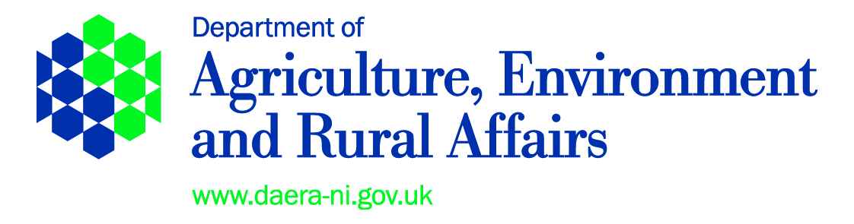

DEPARTMENT OF AGRICULTURE, ENVIRONMENT AND RURAL AFFAIRS

THE ARTIFICIAL REPRODUCTION OF ANIMALS (NORTHERN
IRELAND) ORDER 1975 (AS AMENDED)

ARTIFICIAL INSEMINATION (PIGS) REGULATIONS (NORTHERN IRELAND) 1978
ARTIFICIAL INSEMINATION OF PIGS (EEC) REGULATIONS (NORTHERN IRELAND) 1993

PIG AI COLLECTION CENTRE APPLICATION FORM

1. Applicant details:

(a) Applicants Name
(b) Name of Company
(c) Address
Postcode
(d) Telephone No
(e) Email
2. I being the applicant at 1(a) hereby: -
(a) | apply for |  | renewal of |  |  | (tick as applicable)
a Pig AI Centre licence for premises which are to be used for the collection, storage and sale of porcine semen to licensed DIY operators, located at:-
 |  |  |  |  |  |  | Postcode

(b) nominate as the Veterinary Surgeon under whose control and supervision the operations of the above premises shall be carried out:
(i) Name of Veterinary Surgeon |  |  |  | MRCVS
(ii) Address
 |  | Postcode
(iii) Telephone No
(c) declare that in applying for this licence I –
(i) agree to abide by all conditions and specifications set by the Department (copy attached);
(ii) agree that the information provided in this application form or any related inspection reports may be used in support of any function of the Department of Agriculture, Environment and Rural Affairs;
(iii) understand that as the holder of a licence issued in respect of this application if I fail to comply with any conditions subject to which it has been granted or contravene any provisions of the Regulations or knowingly or recklessly makes a statement false in a material particular for the purposes of obtaining the Licence, I shall be guilty of an offence and shall be liable on summary conviction to a fine not exceeding currently £5,000.
3. I enclose the licence fee of £141.00 (Cheques payable to “DAERA Corporate account”)

Sign: |  | Date:
Print:

The completed application form and fee should be sent to:
Department of Agriculture, Environment and Rural Affairs, Exports and Animal Diseases, Ballykelly House, 111 Ballykelly Road, Ballykelly, Limavady BT49 9HP
Note: The information in this document or any related inspection report may be used in support of any function of the Department of Agriculture, Environment and Rural Affairs and may be made available to other Departments/Agencies for the purposes of detecting crime.

Fraud Hot Line No. 0808 1002716

DAERA PRIVACY NOTICE (FORMERLY FAIR PROCESSING NOTICE)

The Department takes data protection, freedom of information and environmental information issues seriously. It takes care to ensure that any personal information supplied to it is dealt with in a way which complies with the requirements of the Data Protection Act 1998. This means that any personal information you supply will be processed principally for the purpose for which it has been provided. However, the Department is under a duty to protect the public funds it administers, and to this end may use the information you have provided for this purpose. It may also share this information with other bodies responsible for the audit or administration of public funds, in order to prevent and detect fraud.

In addition, the Department may also use it for other legitimate purposes in line with the Data Protection Act 1998, Freedom of Information Act 2000 and Environmental Information Regulations 2004.

These include:

- Administration of the Common Agricultural Policy and other aid schemes;
- Administration of the Common Fisheries Policy;
- The production and safety of food;
- Management of land and other environmental controls;
- Animal health and welfare;
- Occupational health and welfare;
- The prevention and detection of fraud or maladministration (e.g. The Comptroller & Auditor General and HM Revenue & Customs.)
- Compilation of statistics;
- Disclosure to other organisations when required to do so; and
- Disclosure under the Freedom of Information Act 2000 or the Environmental Information Regulations 2004 where such disclosure is in the public interest.

