DAERA guidance For Remote certification of dairy exports and Sealing
A Evidence required when seal numbers are inserted on Export Health Certificates
B Other sealing

A
- If the exporter requires a seal number(s) to be included on the Export Health Certificate, (EHC) the exporter must upload photographic evidence of the seal(s) and the corresponding shipping container number(s), see examples of different seal types below and photographic evidence required.

EXAMPLE 1

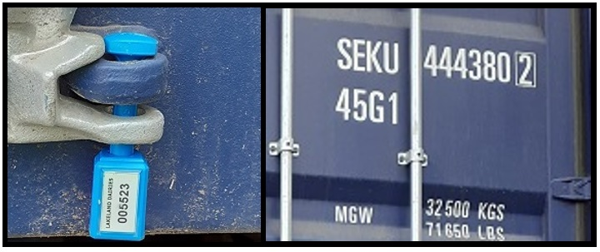
Two photographs should be uploaded. One of the seal and another of the container number

- These photographs should be sent to DECOL using the upload links contained within the notification for the initial EHC application. The photo files must be uploaded to the Supporting Documents section of the application.

PLEASE NOTE - Photographs must be named to allow easy identification and should include the Application Number in the following format:

21.3.123456

- The photographs must show the numbers clearly. Blurred or partially shown numbers will not be accepted.

EXAMPLE 2
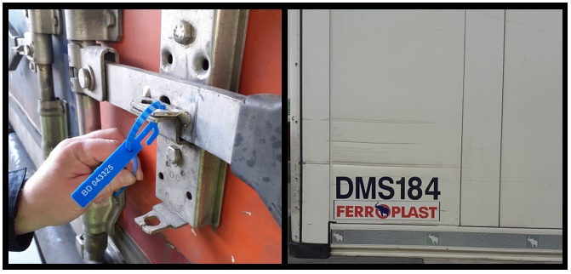
The photographs should focus on the numbers and not on the entire door or container wall

EXAMPLE 3

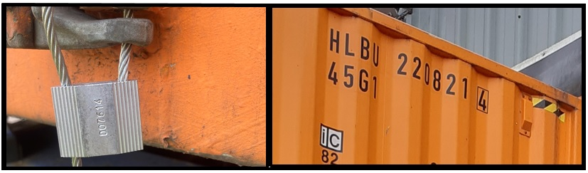
If the numbers are not clear, sharp and in focus, delays to certification may occur

- When a seal is entered on the EHC and photographic evidence needs to be provided by the exporter but evidence is not provided, the certifying officer has been instructed to remove the seal number from the EHC to prevent problems at ports.

B
- Commercial Seals: The exporter may choose to apply a seal to a means of transport without providing supporting evidence. The exporter may do this but this seal number must not be entered on the EHC. The exporter may want to record the seal number on the commercial document instead.

- Note: Some Third Country (EHC) Guidance requires that the application of the seal is officially supervised by DAERA. This will be carried out by DAERA where applicable and only if the exporter notifies DAERA in time to organise this. In these cases, certification cannot be provided if the application of the seal is not supervised by DAERA.

