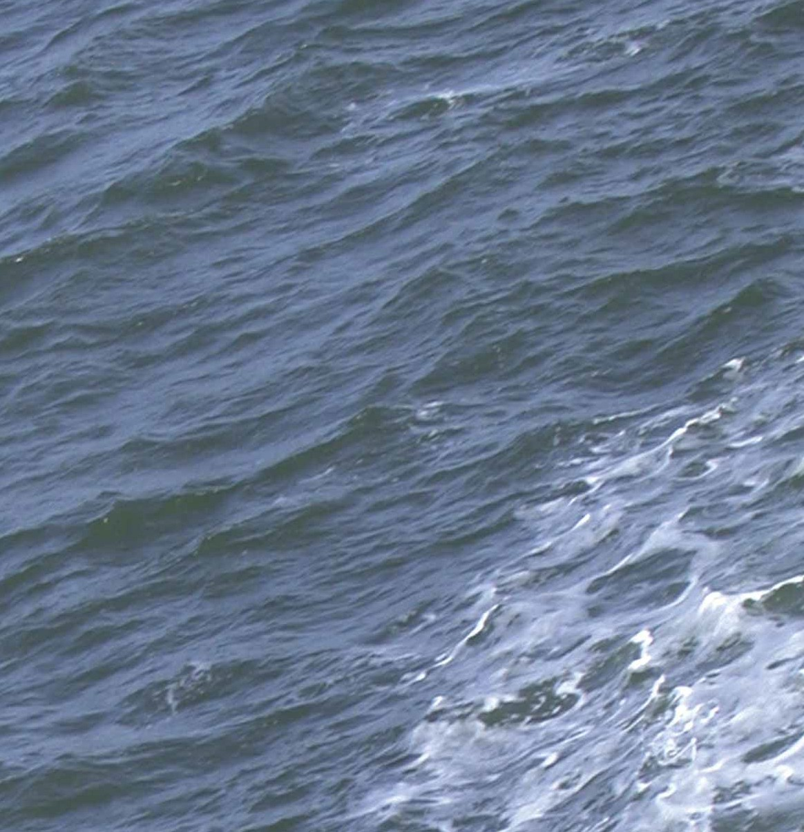
.

Department of Agriculture Environment and Rural Affairs

Aquatic Animal Health Regulations
(Northern Ireland) 2009 (As Amended)

EC Directive 2006/ 88/ EC on Aquatic Animal Health

Northern Ireland has had long-standing controls on aquatic animal diseases that have made a significant contribution to the high health status of our fish and shellfish resources.
EC Directive 2006/88/EC (‘the Directive’) has been brought forward to reflect changes in the aquaculture sector in the European Union. The Directive has been implemented in Northern Ireland by the Aquatic Animal Health Regulations (Northern Ireland) 2009 (‘the AAH Regulations’).

Authorisation of APBs

Under the AAH Regulations all Aquaculture Production Businesses (APBs) in Northern Ireland must be authorised by the Department of Agriculture, Environment and Rural Affairs
(‘the Department’).

Under the definition of APB the following types of businesses will normally be required to be authorised; finfish farms, shellfish farms, crustacean farms, shellfish dispatch centres, shellfish purification centres, processing establishments processing aquaculture animals for disease control purposes, premises holding ornamental aquatic animals with direct contact with natural waters and any other installations holding aquaculture animals other than those required to be registered. It will be an offence to operate an APB without a valid authorisation from 1 August 2009. An official register of APBs will be made available on the Department’s website.

1

Registration of Put and Take Fisheries and Non-Commercial Installations

The Directive provides for a derogation from the authorisation requirements in respect of certain types of lower-risk APBs and allows for these to be registered with the Department rather than authorised. The derogation will be implemented under the AAH Regulations in respect of fisheries stocked with aquaculture animals for angling purposes only (referred to in the AAH Regulations as Put and Take Fisheries) and other APBs in which aquatic animals are kept with no intention of placing them on the market (referred to in the AAH Regulations as Non-Commercial Installations). It will be an
offence to operate an unregistered Put and Take Fishery or Non-Commercial Installation from 1 August 2009.

Applications for Authorisation or Registration

Applications for authorisation or registration should be made to the Department. If you are not clear as to whether your business is required to be authorised or registered you should seek advice from the Department’s Fisheries Inspectorate.
Application forms may be obtained from the DAERA website or by contacting the Department.
Applicants refused an authorisation will have the right of appeal.

Conditions of Authorisation

The Directive requires that APBs must:

- participate in a risk based surveillance scheme;

- operate in accordance with a documented biosecurity plan;

2

- keep a record of all movements of aquaculture animals and products into and out of the site or business;

- keep a record of mortality in each epidemiological unit as relevant for the type of production unit;

- keep a record of the results of any surveillance carried out;

- notify the Department of any increased/unexplained mortality on site;

- notify the Department of any suspicion of disease.

These requirements will be implemented through conditions
of authorisations. The Department may also attach such other conditions as it considers appropriate.

Surveillance Scheme

All APBs will be assessed for risk and undergo routine periodic inspections by the Fisheries Inspectorate based on their risk category. The purpose of these inspections is to examine stocks for signs of disease, to ensure compliance with the conditions of authorisation and to ensure that
appropriate disease control and biosecurity measures are maintained on the site.

Biosecurity Plan

The Directive requires all APBs to adopt good hygiene
practice which incorporates good biosecurity. The Department will, therefore, require APBs to operate in accordance with a documented biosecurity plan which should include an

assessment of disease risks, details of risk mitigation measures, training and development of personnel in disease awareness and controls on access to sites. Further
information on biosecurity plans may be obtained from the Fisheries Inspectorate. A biosecurity plan should be submitted with all applications for authorisation.

Fish Culture Licences

Even if your fish farm already holds a fish culture licence granted by the Department under the Fisheries Act (Northern Ireland) 1966 as amended, an authorisation granted under the AAH Regulations will also be required to operate the fish farm. The authorisation will regulate issues relating to aquatic animal health while the fish culture licence will continue to regulate all other aspects of the fish farm operation. If you are commencing a new operation and require a fish culture licence (or an aquaculture licence granted by the Foyle, Carlingford and Irish Lights Commission in the Foyle and Carlingford areas) you will also need to apply to the Department for an authorisation.

Transport

The AAH Regulations recognise the movement of aquatic animals pose a significant risk of spreading disease.
To protect the health of aquatic animals, any person transporting aquaculture animals is required to ensure that the duration of the journey is as short as possible and that the means of transport is cleaned and disinfected before
dispatch. Aquaculture animals must also be transported in conditions that minimise the risk of spreading disease to the aquatic animals being transported and to any aquatic animals

at any place of transit or at the place of destination. Any person who transports aquaculture animals is also required to keep certain records including records of any mortalities, water exchanges and premises visited during transit.

The Diseases

The main purpose of the AAH Regulations is to prevent and control the spread of serious diseases of aquatic animals across the EU. The Diseases covered by the Directive include:

Non Exotic Diseases | Exotic Diseases
Fish
Viral haemorrhagic septicaemia (VHS) | Epizootic haematopoietic necrosis
Infectious haematopoietic  necrosis (IHN) | Epizootic ulcerative syndrome
Infectious salmon anaemia (ISA)
Koi herpes virus disease (KHV)
Molluscs
Infection with Bonamia ostreae | Infection with Bonamia exitiosa
Infection with Marteilia refringens | Infection with Perkinsus marinus
 | Infection with Microcytos mackini
Crustaceans
White spot disease | Taura syndrome
 | Yellowhead disease

Northern Ireland has also obtained from the European Commission additional guarantees to protect our aquatic
animal health against the following diseases of fish which are not covered by the Directive:

  - Bacterial kidney disease (BKD)

  - Spring viraemia of carp (SVC)

  - Gyrodactylus salaris (GS)

Enforcement

The Fisheries Inspectorate will be responsible for enforcing compliance with conditions of authorisation and with the AAH Regulations. Powers are provided for the Fisheries
Inspectorate to issue enforcement notices in respect of any non-compliance, while for serious non-compliance there are also powers to suspend and revoke authorisations. There will be the right of appeal. Where disease in aquatic animals is suspected the Fisheries Inspectorate will apply appropriate disease control measures in accordance with the AAH Regulations.

Main Features of the AAH Regulations

- authorisation of APBs and registration of put and take fisheries;

- a public register of APBs;

- a risk based approach to disease surveillance;

- disease prevention requirements for transporters of aquaculture animals;

- statutory controls on exotic and non-exotic diseases of aquatic animals;

- statutory requirement to notify the Department of any suspicion of disease;

- rules for the placing of aquaculture animals on the market.

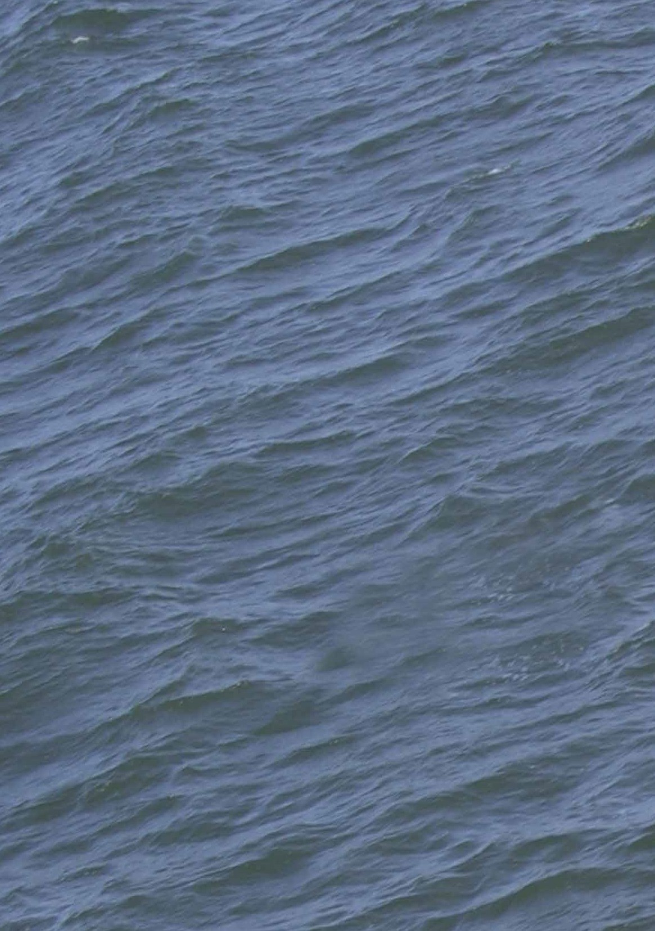

Contact Information and Requests for Application Forms

DAERA Marine and Fisheries Division
Rathkeltair House
Market Street
DOWNPATRICK
BT30 6AJ
Telephone: 028 4461 8059
Email: fish.health@ daera-ni.gov.uk

Fisheries Inspectorate Telephone: 028 4461 8089

www.daera-ni.gov.uk/fish-health

DMS 08.09.194

